Experiment 14 (Deploying a Static HTML Website and download the image on machine)

1. Create a html file (index.html) which we want to deploy on nginx server.

<h1>Hello World</h1>

1. Create a Dockerfile in which you have to write the following:

FROM nginx:alpine

COPY . /usr/share/nginx/html

1. Run the command ‘docker build -t <imgname>:<tag>’

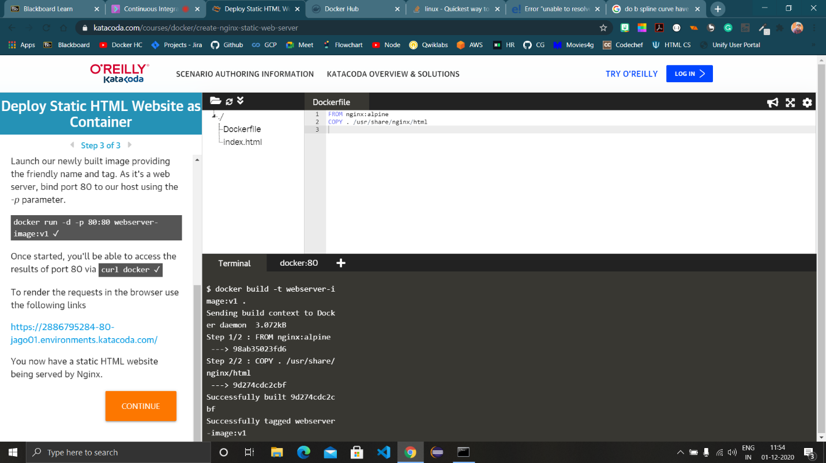

1. Run ‘docker images’ command to see the newly created image.

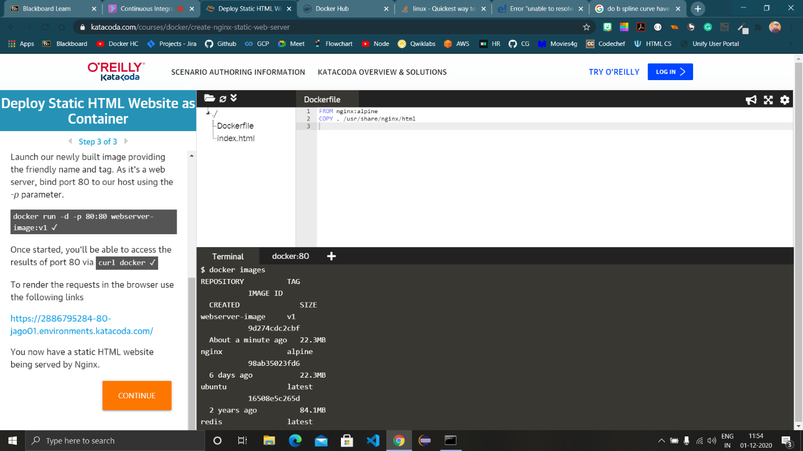

1. Run the ‘docker run -d -p 80:80 <imgname>:<tag>’ to run the newly created image.
2. Use ‘curl docker’ command to view the html page after running the

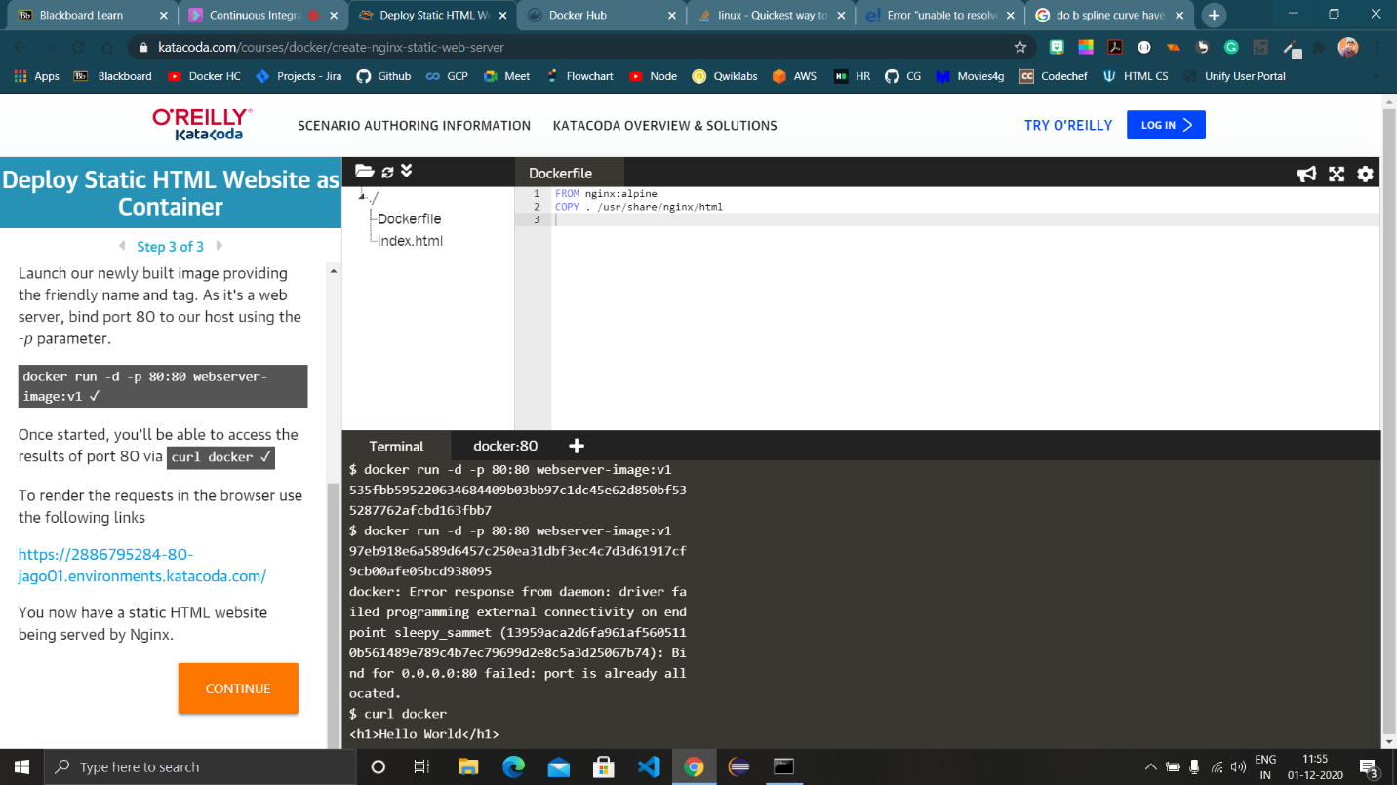

1. Login to the credentials of the docker hub in the terminal using ‘docker login –username <username>’ and tag the image created with the image that will be available on docker hub.
2. Run ‘docker images’ to view the image.

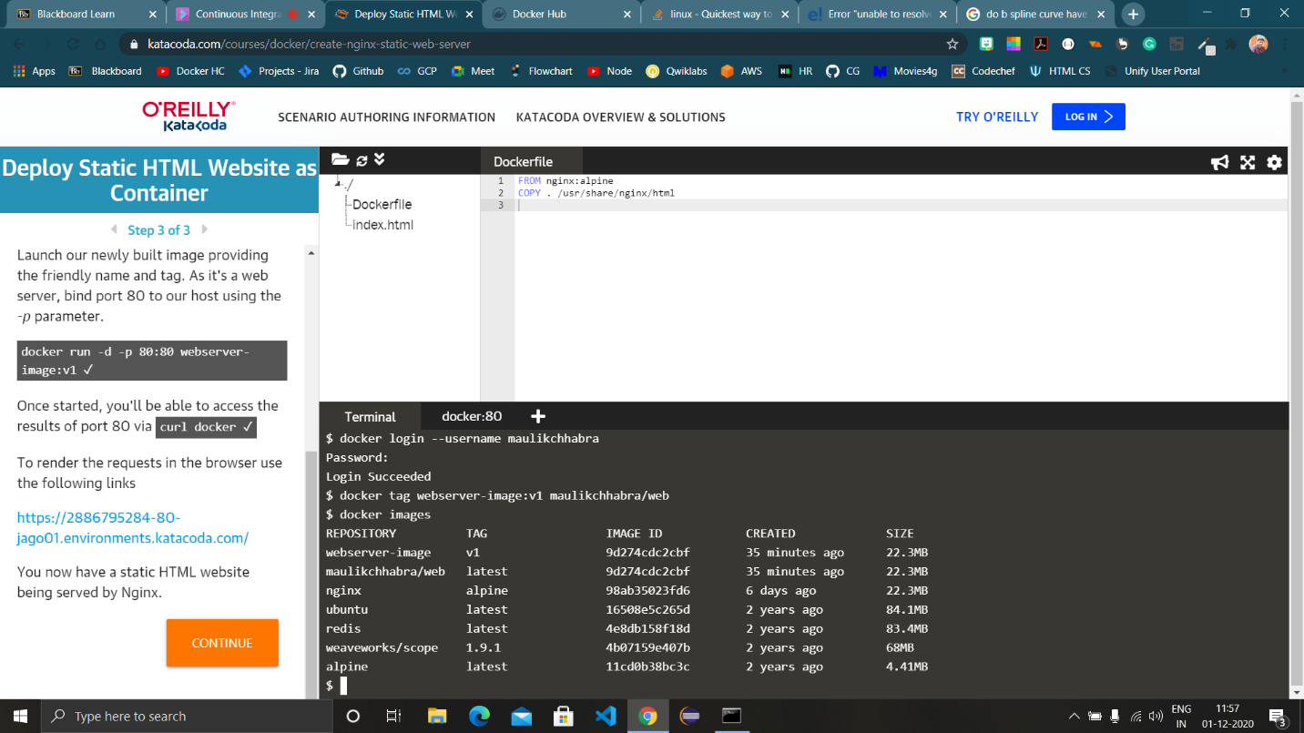

1. Push the image in docker hub using the command ‘docker push <imgname>’.

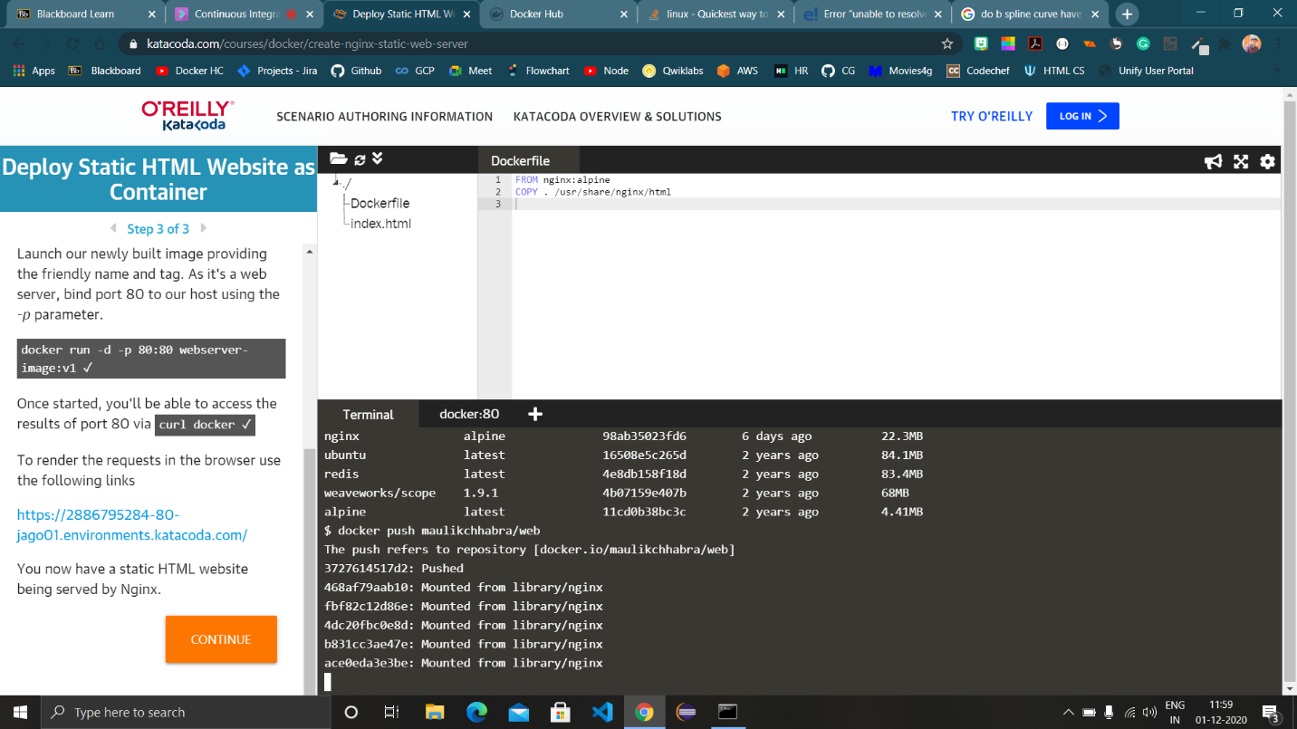

1. Refresh the docker hub in order to view the image.

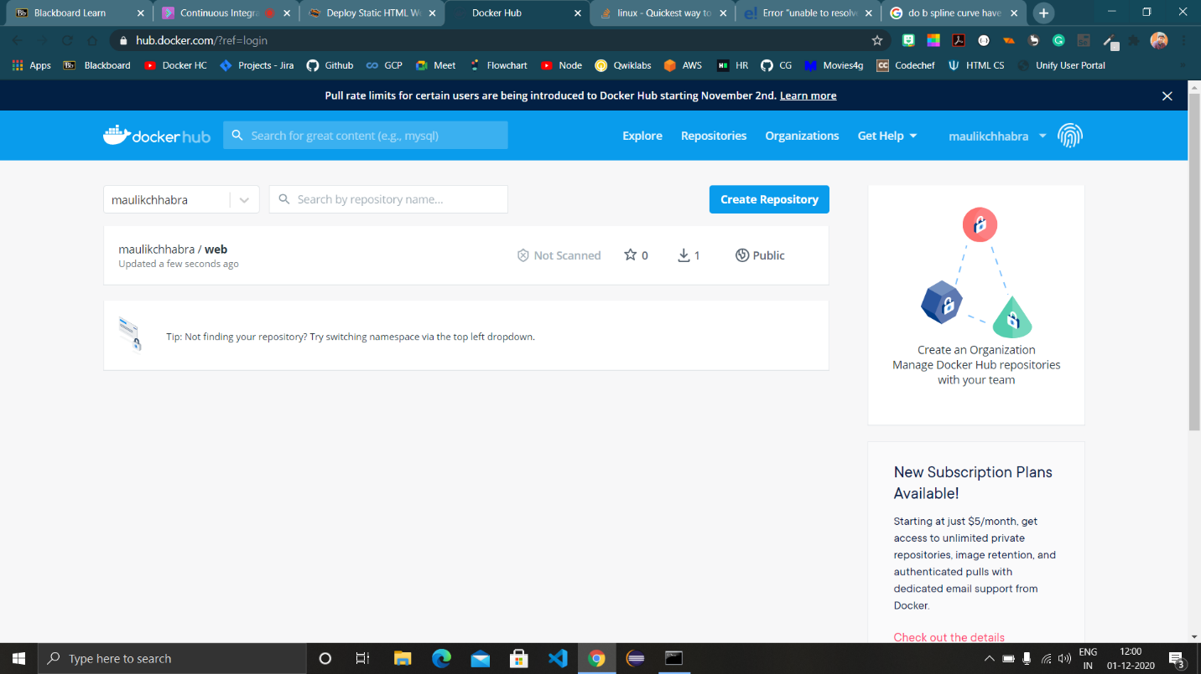

1. Open a fresh instance and run ‘docker images’, as we can see there is no image that we created as it is a fresh instance.
2. Run the image available on the docker hub.

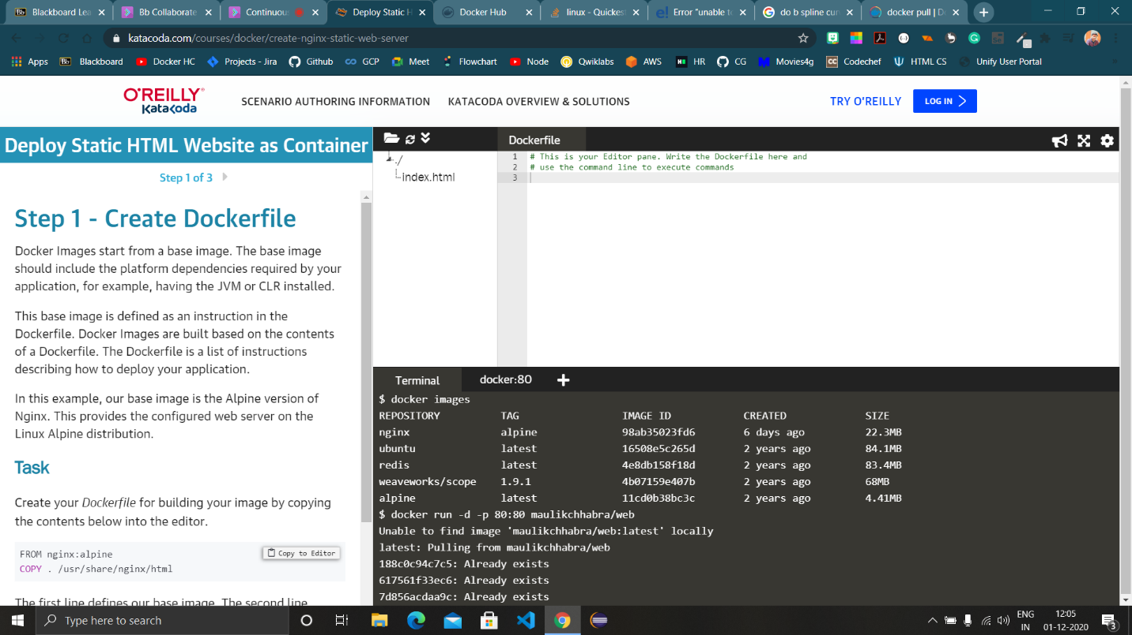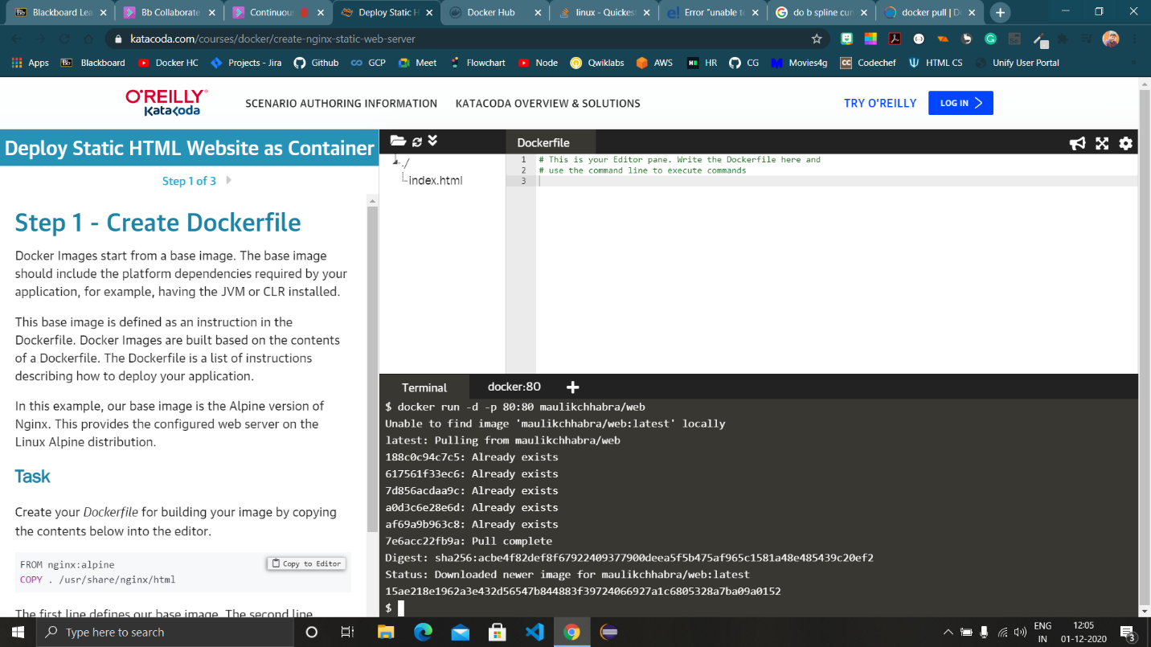

The new image is now available locally.

