**Experiment-15**

**Static Code Analysis Using Sonarqube**

**Step 1:- Navigate to the folder Where You Have Installed StartSonar Batch file**

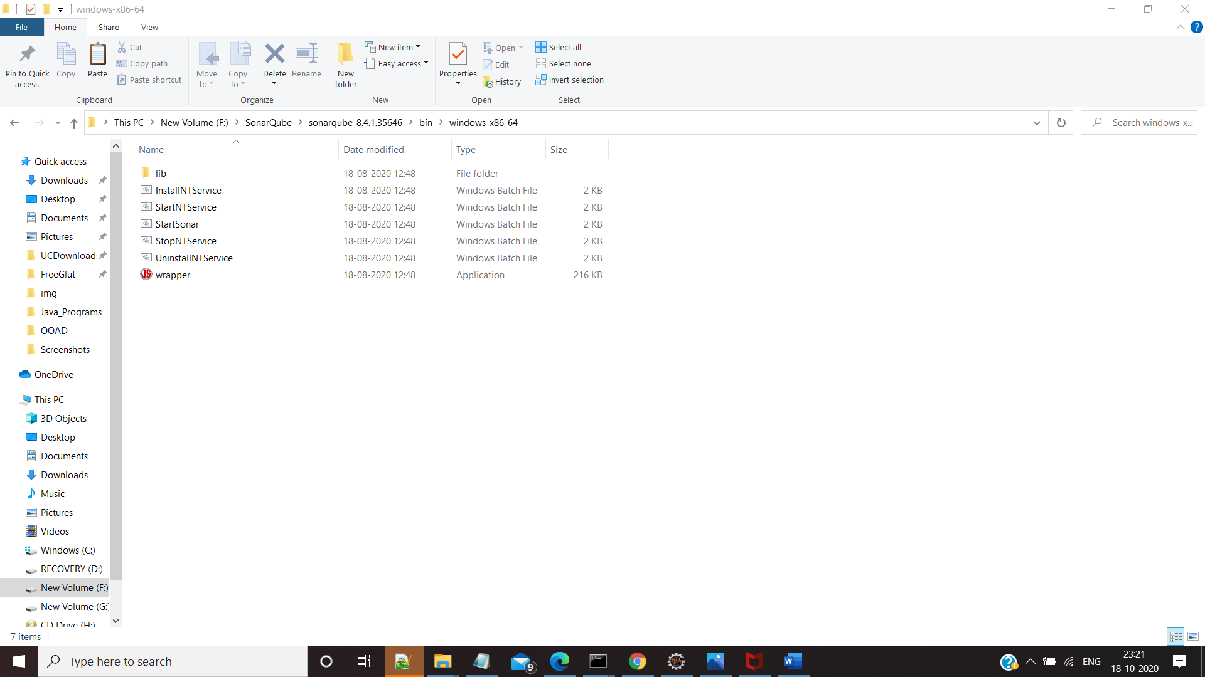

**Step 2: Run StartSonar Command from the Cmd (You Will need jdk 11 for Running Sonarqube Else it Will give an Error)**

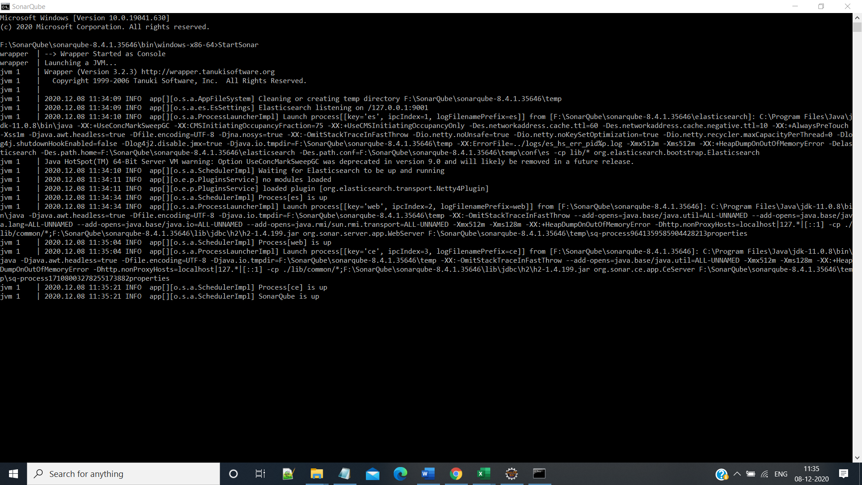

**Step3 :- Go to The Url** [**http://localhost:9000**](http://localhost:9000) **as it the default port for Sonarqube ,You Will be Redirected to Sonarqube Home Page,login using default id and Password**

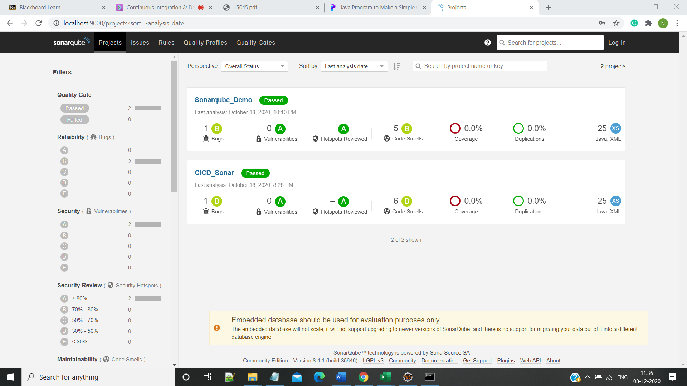

**Step 4:-Create a Maven Project**

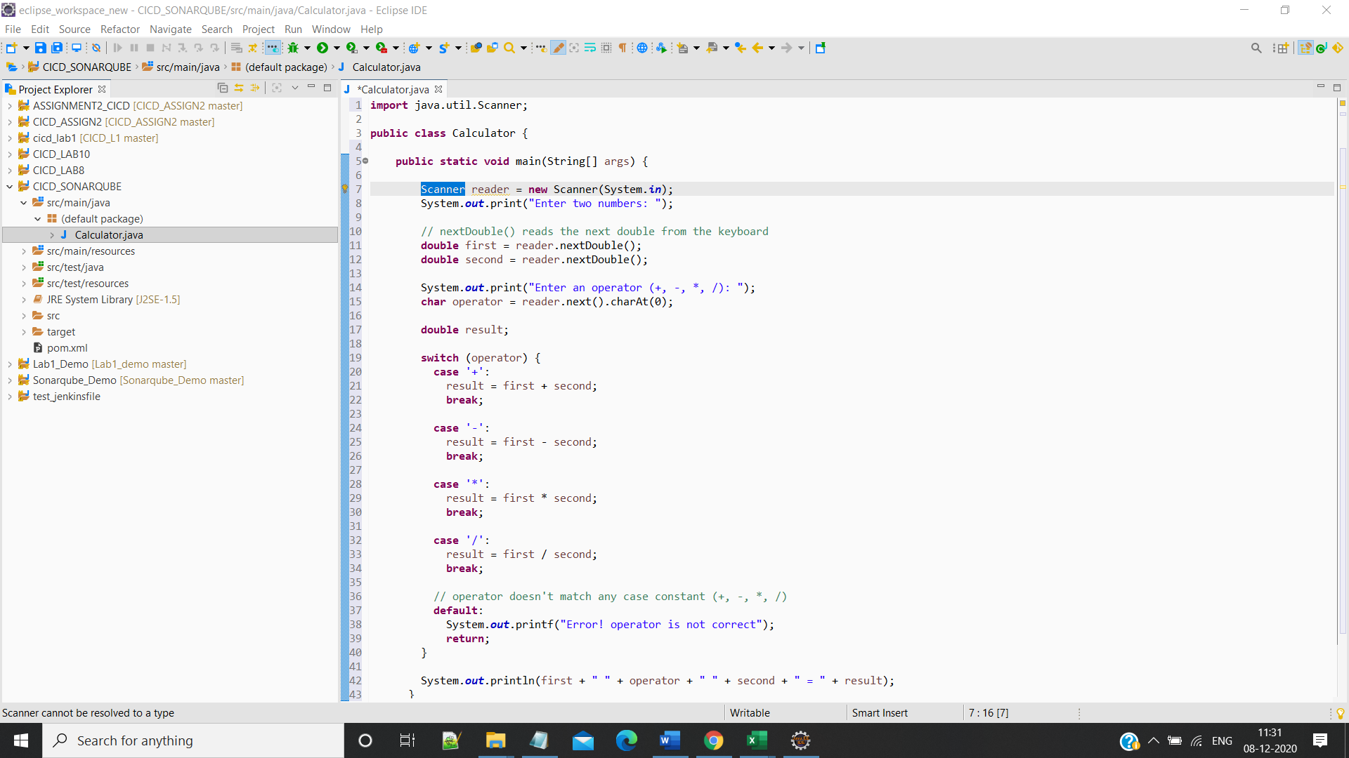

**Step 5:- : Navigate to the folder Where your Maven Project Resides and run the Command:**

**mvn clean install sonar:sonar -Dsonar.host.url=http://localhost:9000 -Dsonar.analysis.mode=publish**

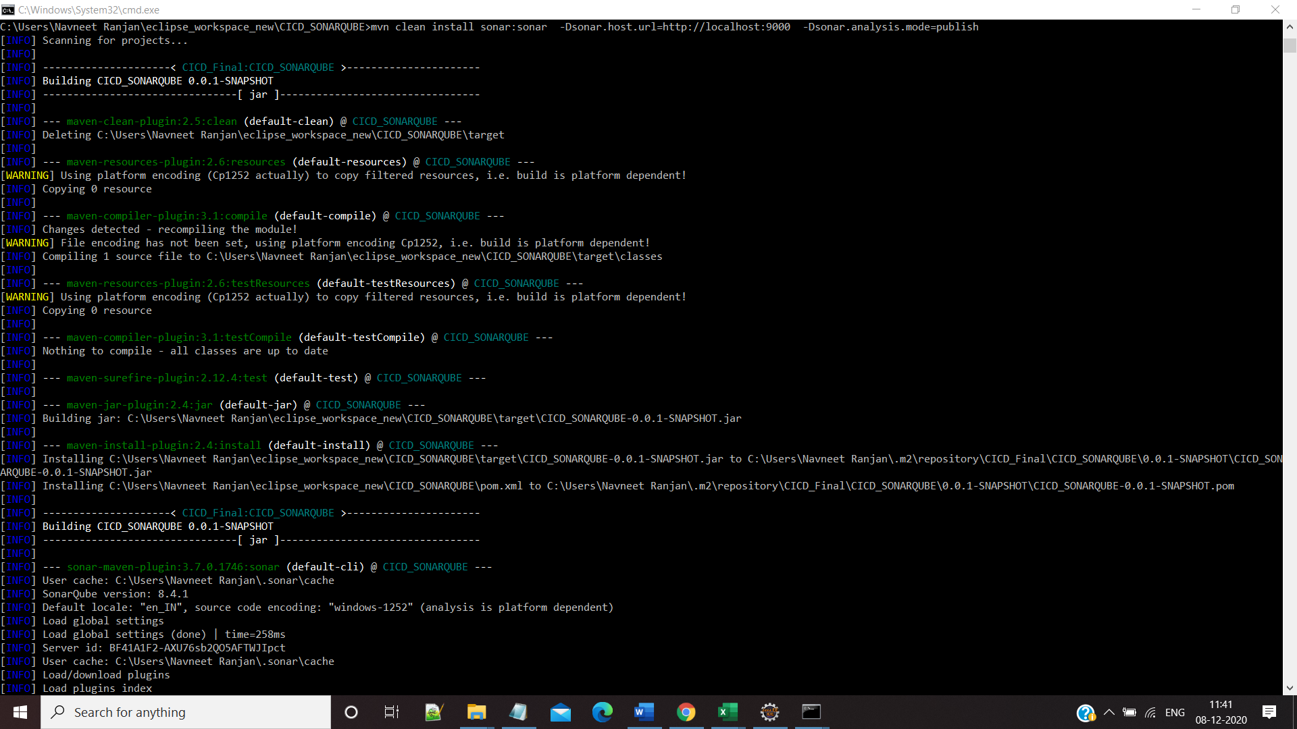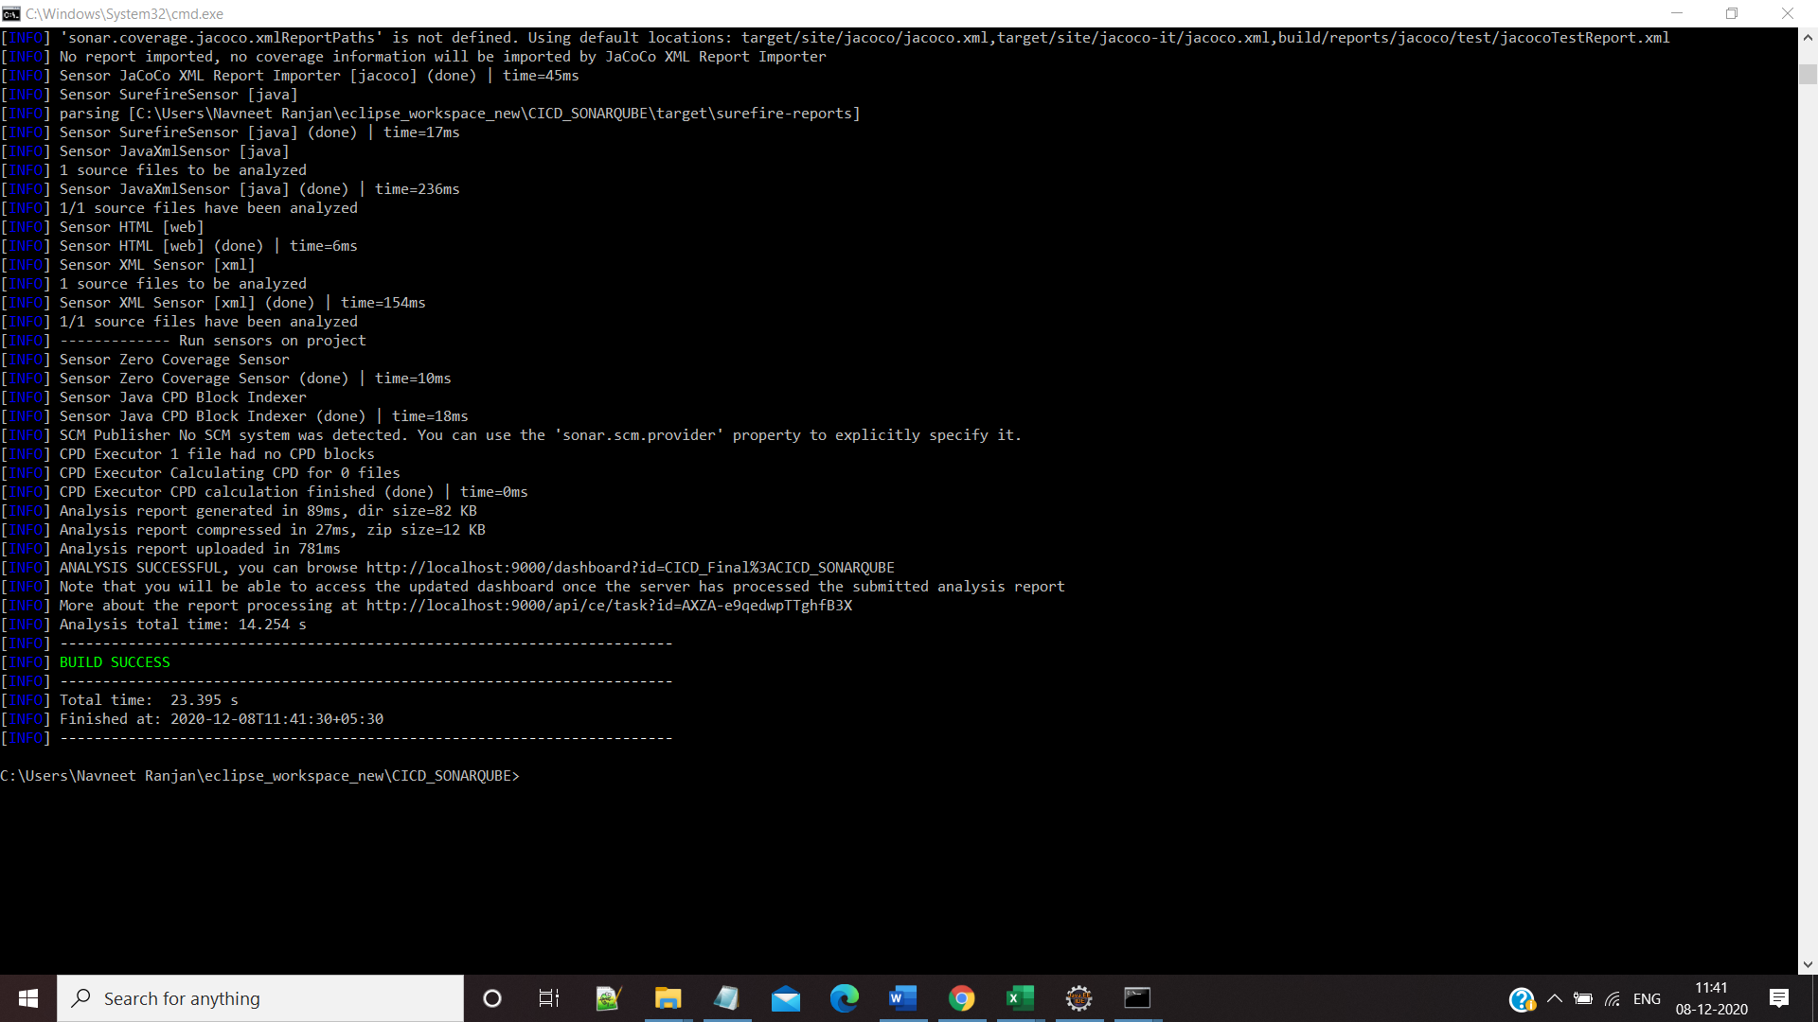

**Step 6:- Navigate to SonarQube and Check the Project**

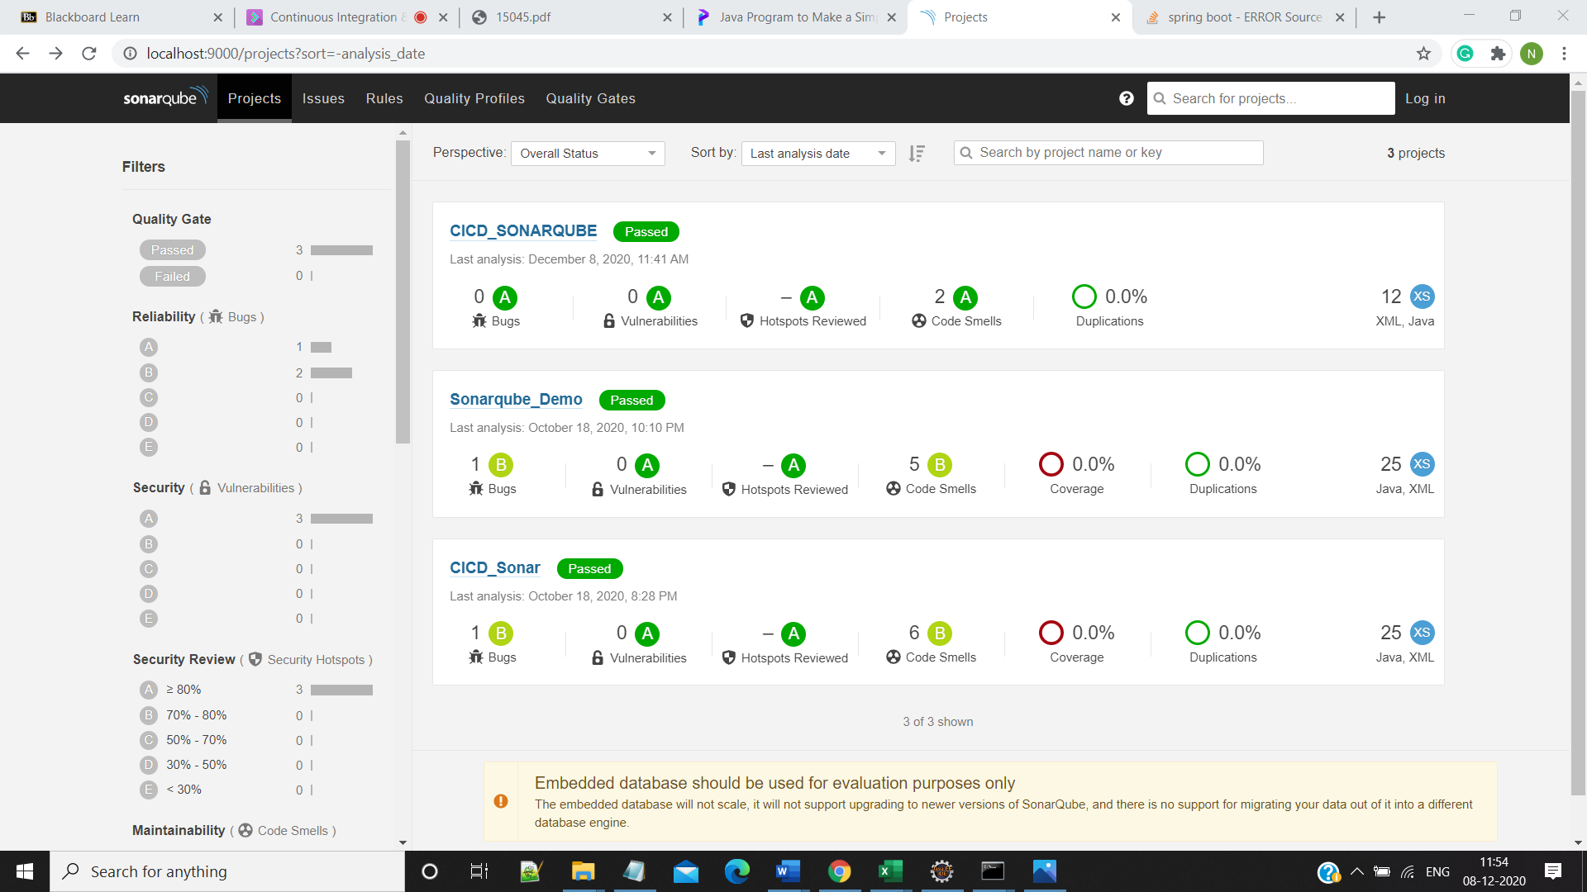

**Step 7:-Check for Code Smells,bugs,vulnerabilities**

