**Name:Piyush Vishnoi**

**Roll no:R171218071**

**Sap id:500067083**

**Semester: Devops 5th sem**

Experiment : 14

**Step-1:** Create your *Dockerfile* for building your image by copying the contents below into the editor.

FROM nginx:alpine

COPY . /usr/share/nginx/html

The first line defines our base image. The second line copies the content of the current directory into a particular location inside the container.

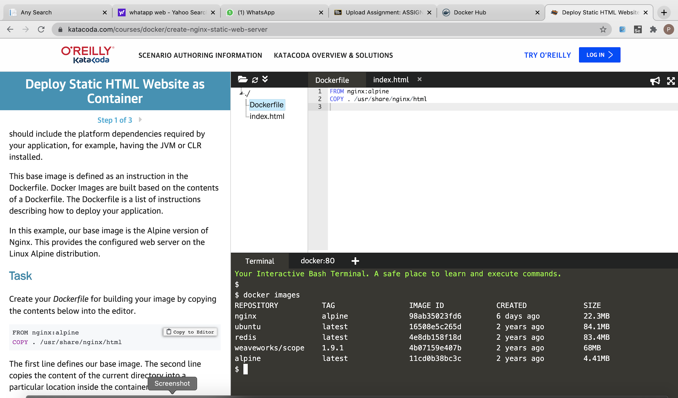

Step-2: Build our static HTML image using the build command below.

**docker build -t web:v2 .**

You can view a list of all the images on the host using **docker images.**

The built image will have the name web with a tag of v2.

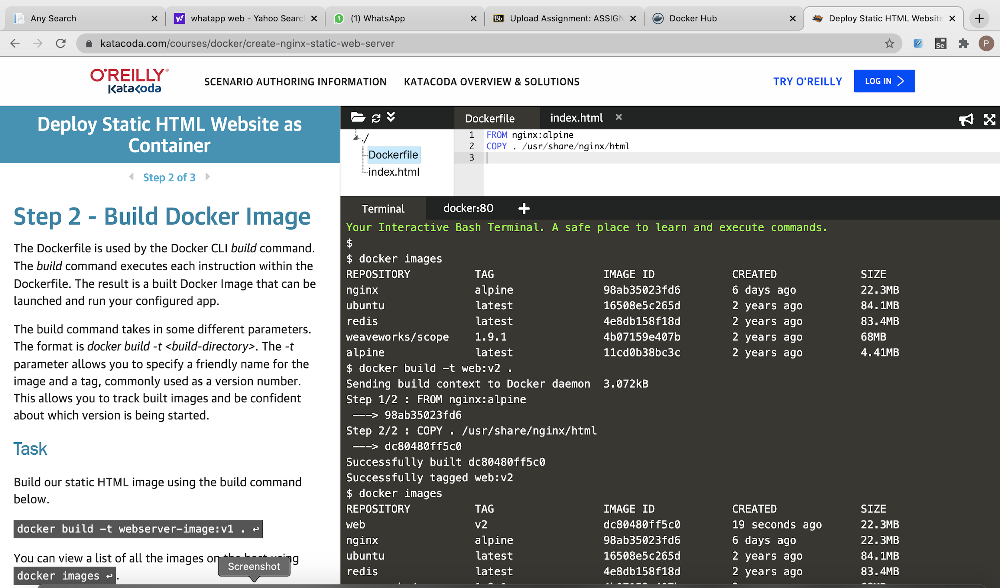

Step-3: Launch our newly built image providing the friendly name and tag. As it's a web server, bind port 80 to our host using the -p parameter.

**docker run -d -p 80:80 web:v2**

Once started, you'll be able to access the results of port 80 via **curl docker**

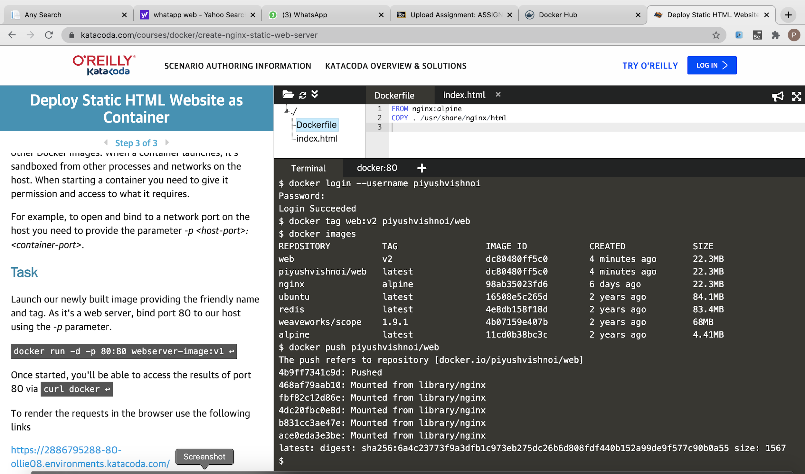

Step-4: Push image to docker hub

**docker push piyushvishnoi/web**



