* **Getting familiar with Docker Commands.**

1. **docker search:** 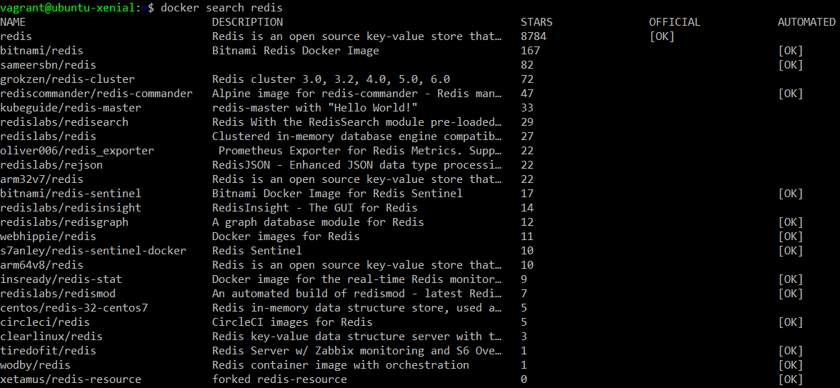

**docker images**



**docker pull <image-name>:**

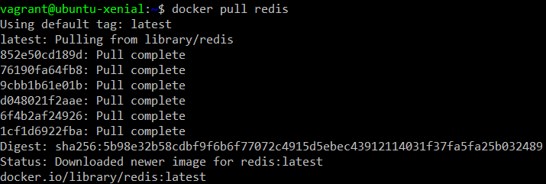

**Dockerps**



**docker run <image>:**



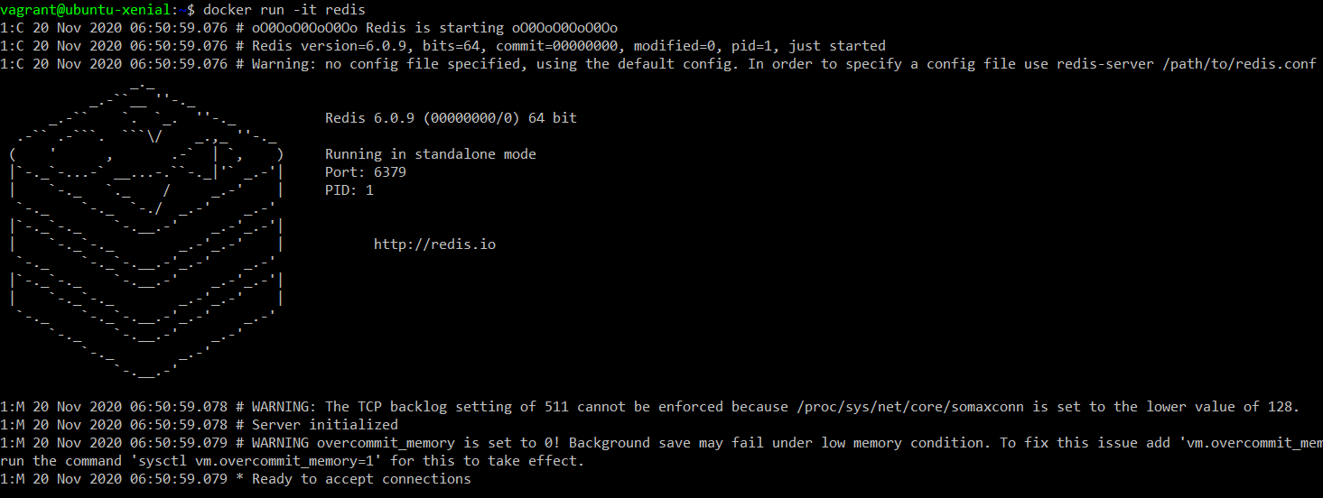

**docker start <container-id>:**

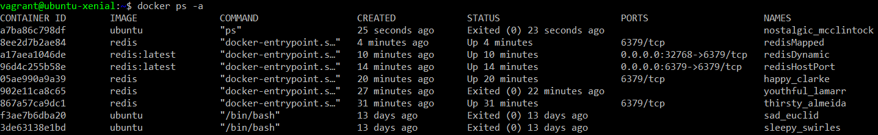

**docker attach <container-id>:**

