**Name: Prashasti Gupta**

**Roll No: R171218077**

**SAP ID: 500068493**

**Experiment: 14**

**Dockerfile**

1. Create your Dockerfile for building your image by copying the contents below into the editor.

FROM nginx:alpine

COPY . /usr/share/nginx/html

2. Build the static HTML image using the build command below.

docker build -t webserver-image:v1 .

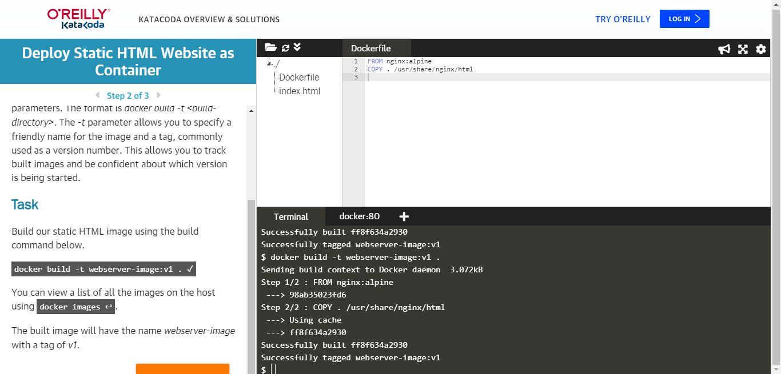

You can view a list of all the images on the host using the following command:

 docker images

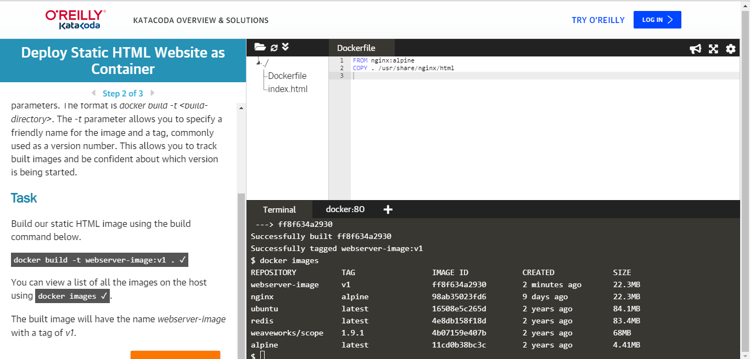

3. Launch our newly built image providing the friendly name and tag. As it's a web server, bind port 80 to our host using the -p parameter.

docker run -d -p 80:80 webserver-image:v1

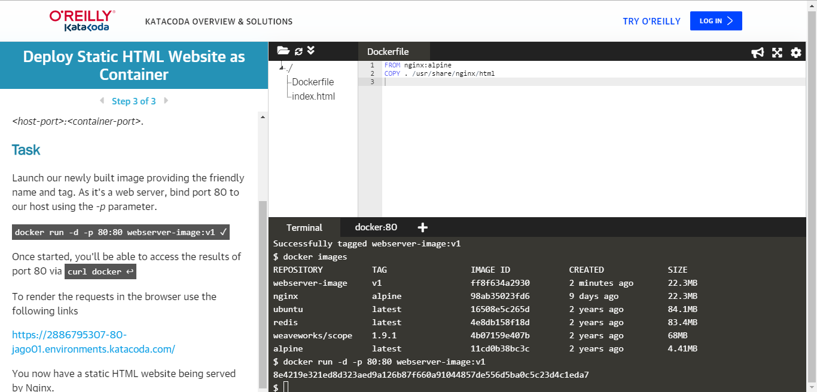

Once started, you'll be able to access the results of port 80 via curl docker

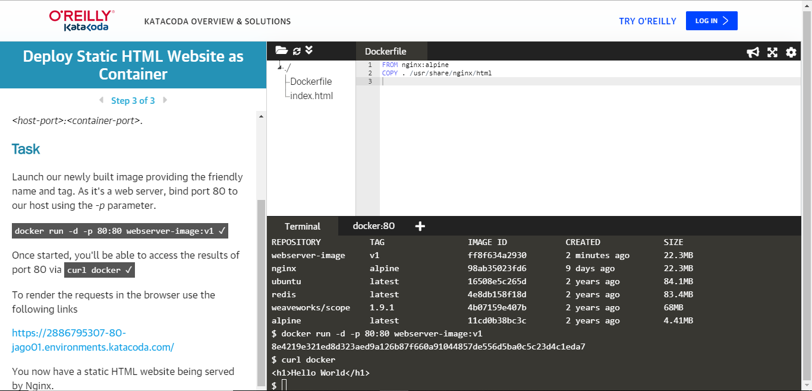

4. Push the image to Docker Hub.

