

**UNIVERSITY OF PETROLEUM & ENERGY STUDIES**

**Dehradun**

**Continuous Integration and Continuous Deployment**

**Final Lab Assessment**

**Name: Shashwat Kumar**

**Course: B-Tech CSE DevOps (2018-22)**

**Roll number: R171218093**

**Sap ID: 500068392**

**Create a Simple Maven project and create its Build using Jenkins Dashboard**

* **Open a terminal and start the Jenkins server using java -jar jenkins.war**

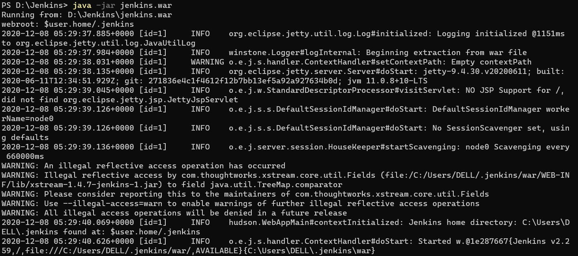

* **Open the Jenkins dashboard at localhost:8080**

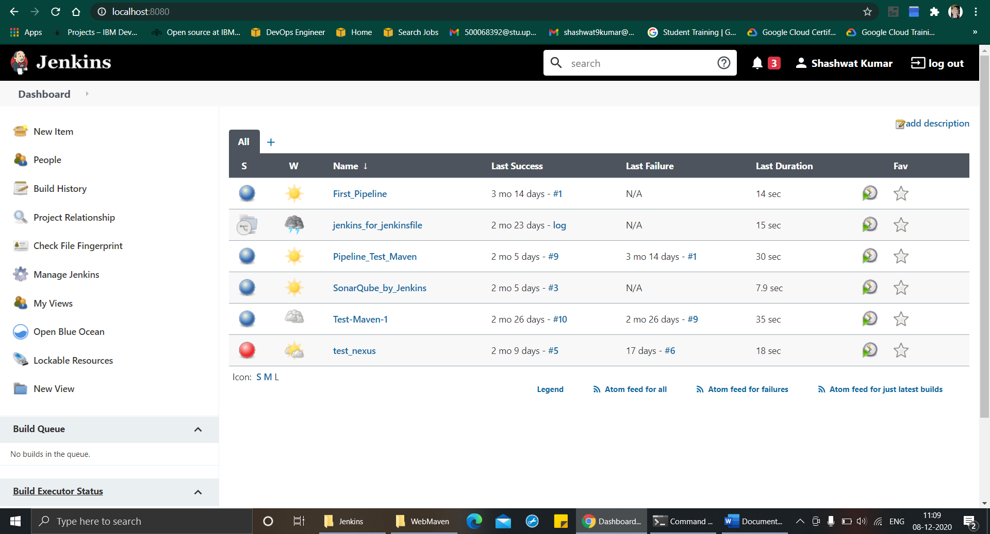

* **Click on new Item**

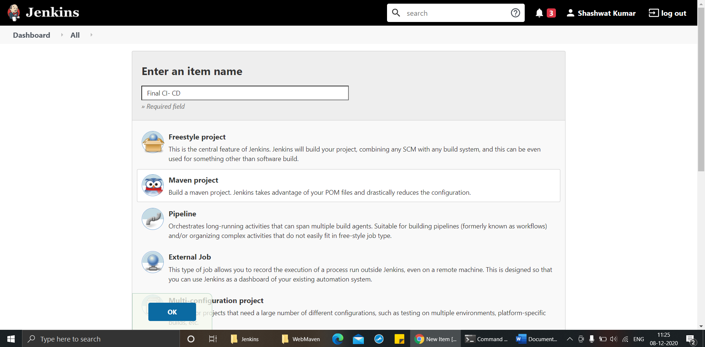

* **Find the project on GitHub, whose build is to be created an copy it path**

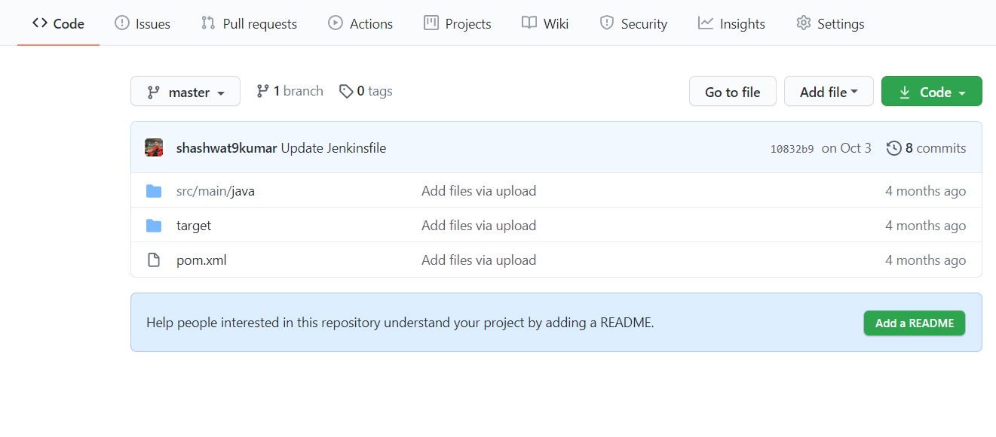

* **In the Source code section of the new Jenkins item, give the location of the GitHub repository**

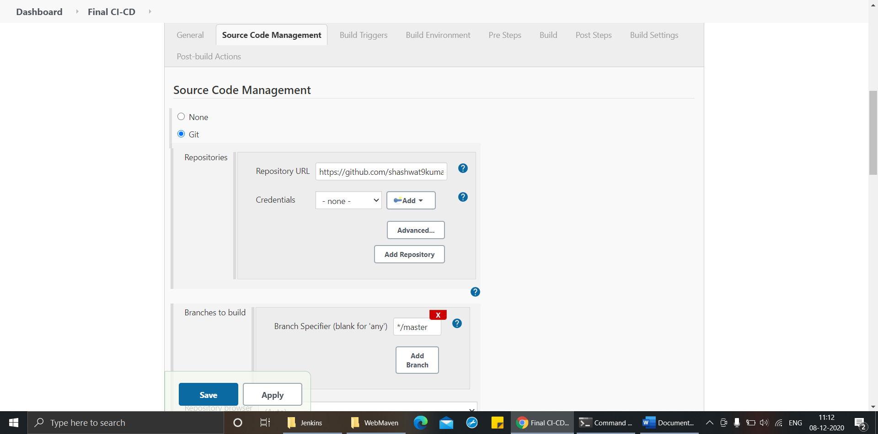

* **In the goals and options give the maven goals as “clean install”**

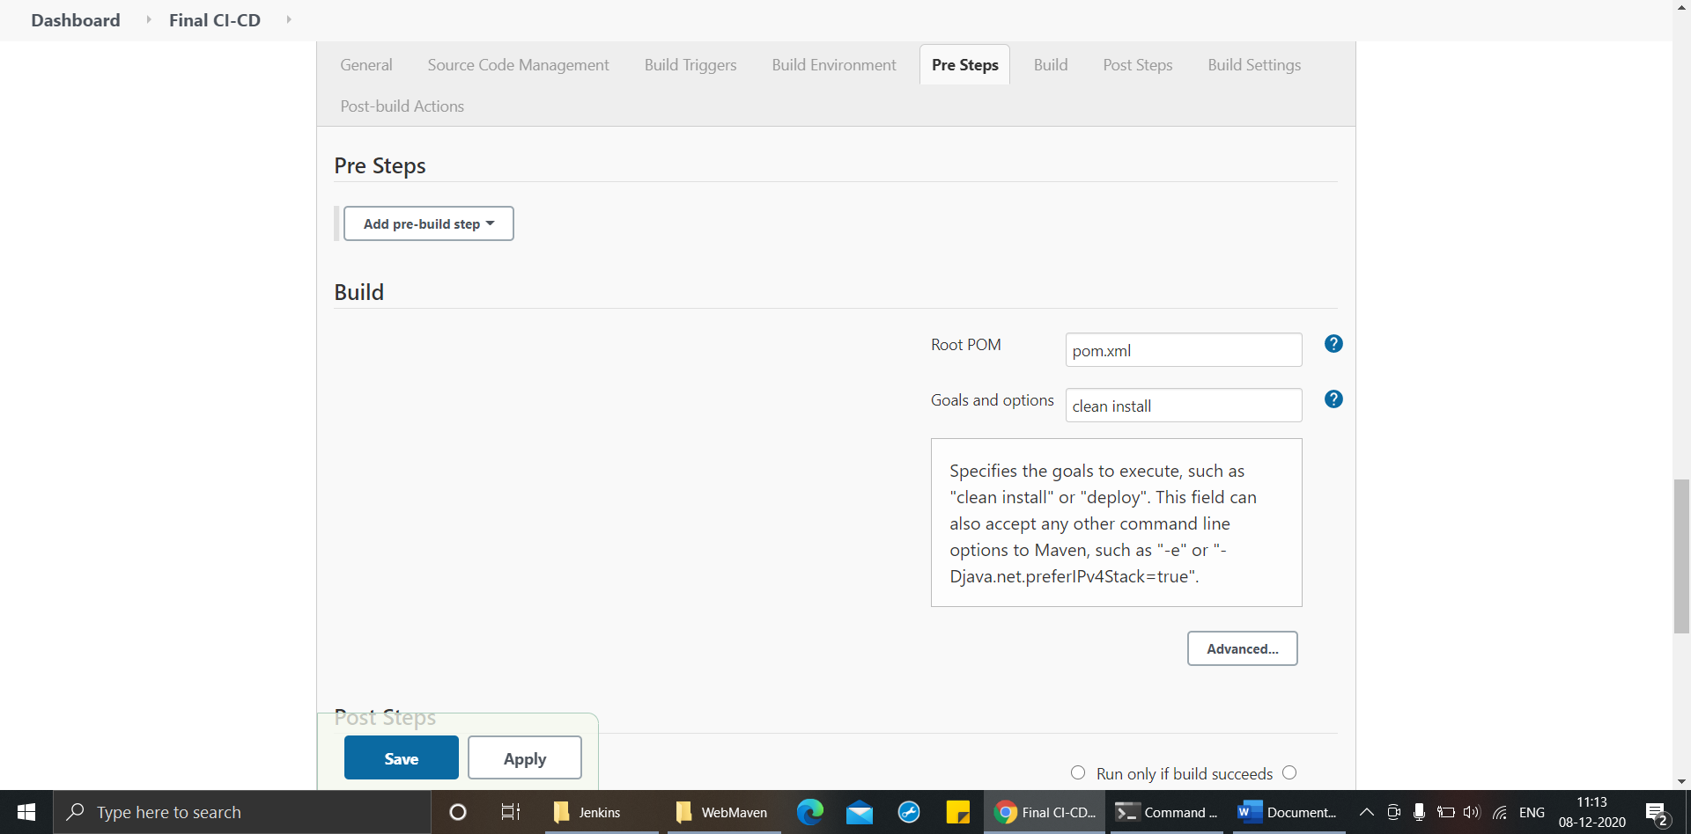

* **Click save to reach to pipeline page.**

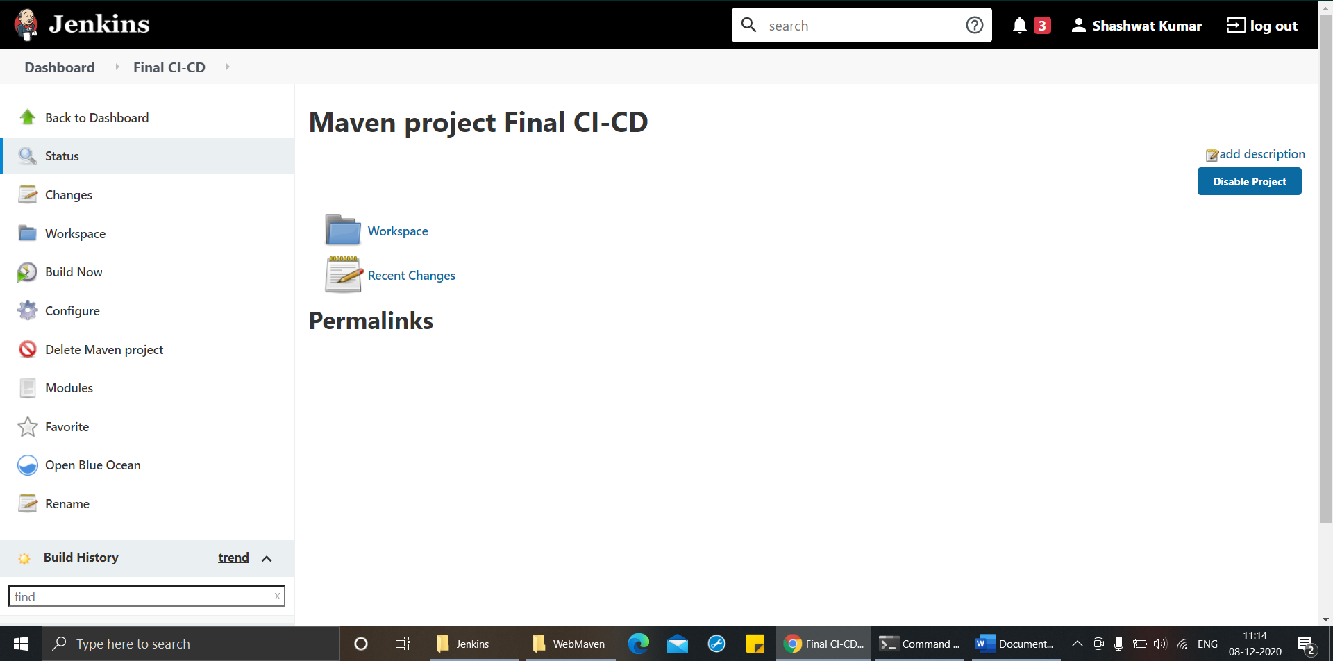

* **Click on build now to start the build process**

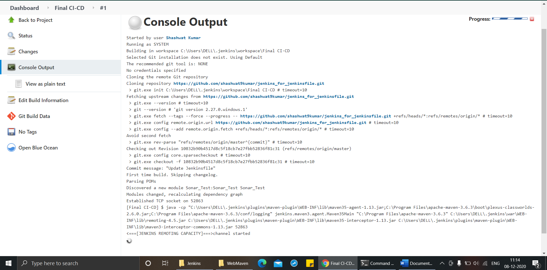

* **Once the build happens successfully, it returns “Build Success”**

