**Name: Kushagra Bansal**

**Roll Number: R171218116**

**SAP ID: 500067414**

**Experiment 13-Deploying your first Docker Container**

**Solution:**

**Step 1 - Running A Container**

docker search <name>

docker search redis

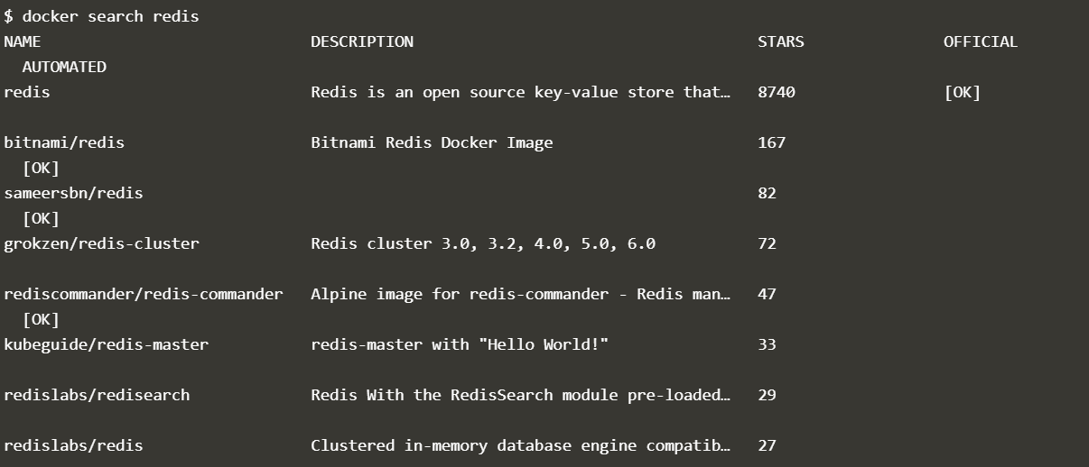

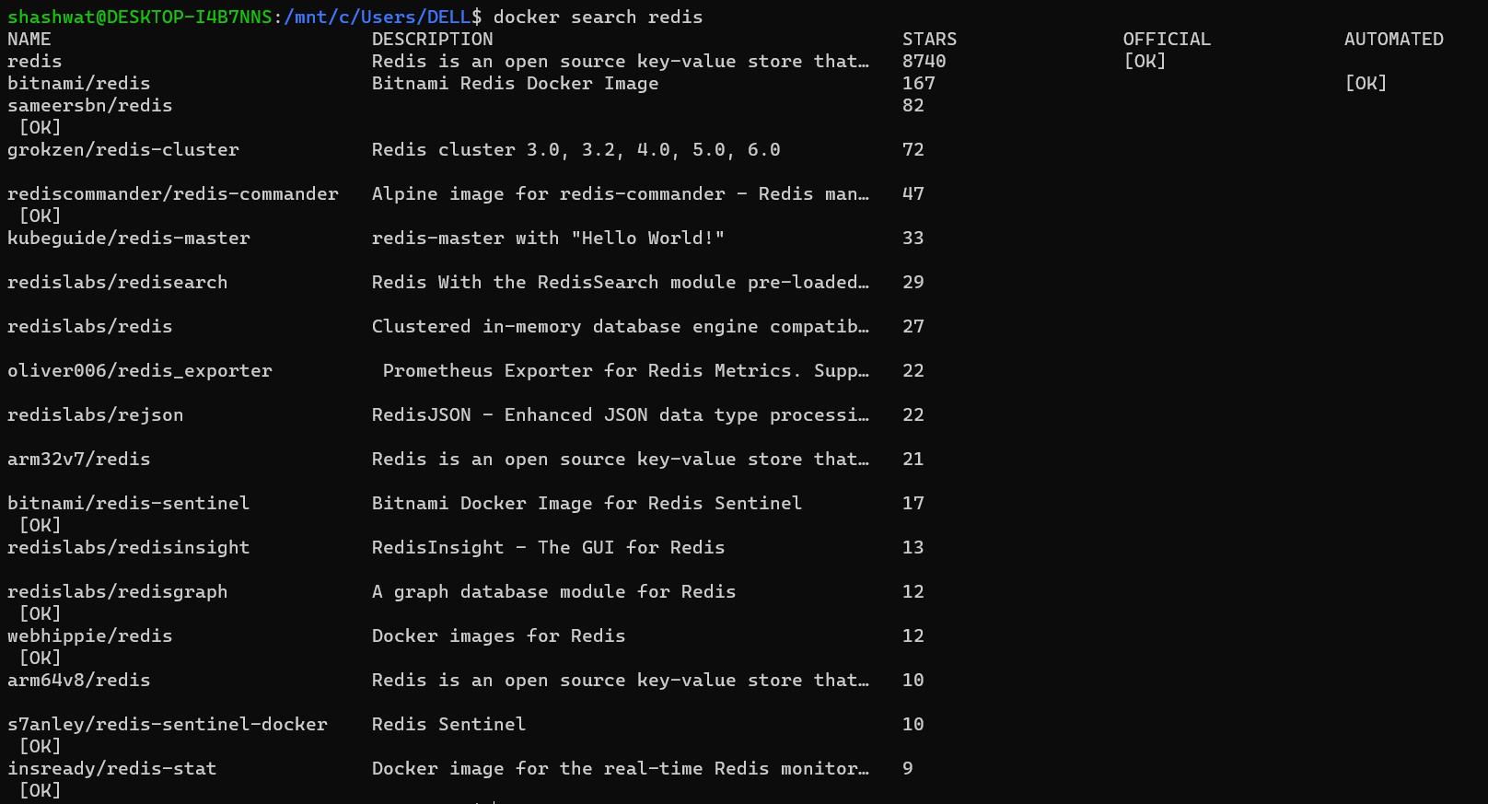

docker run <options><image-name>

docker run -d redis



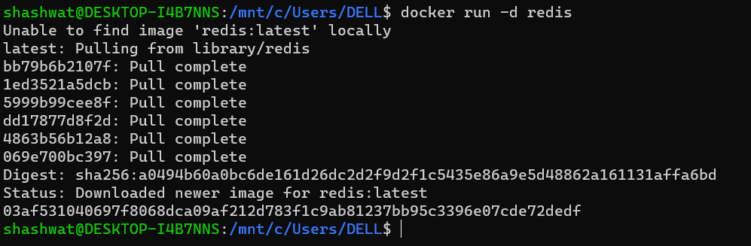

**Step 2 - Finding Running Containers**

docker ps

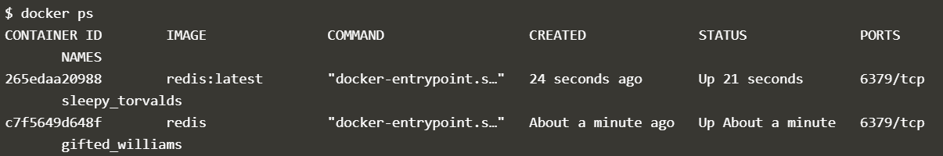



docker inspect <friendly-name|container-id>

docker logs <friendly-name|container-id>

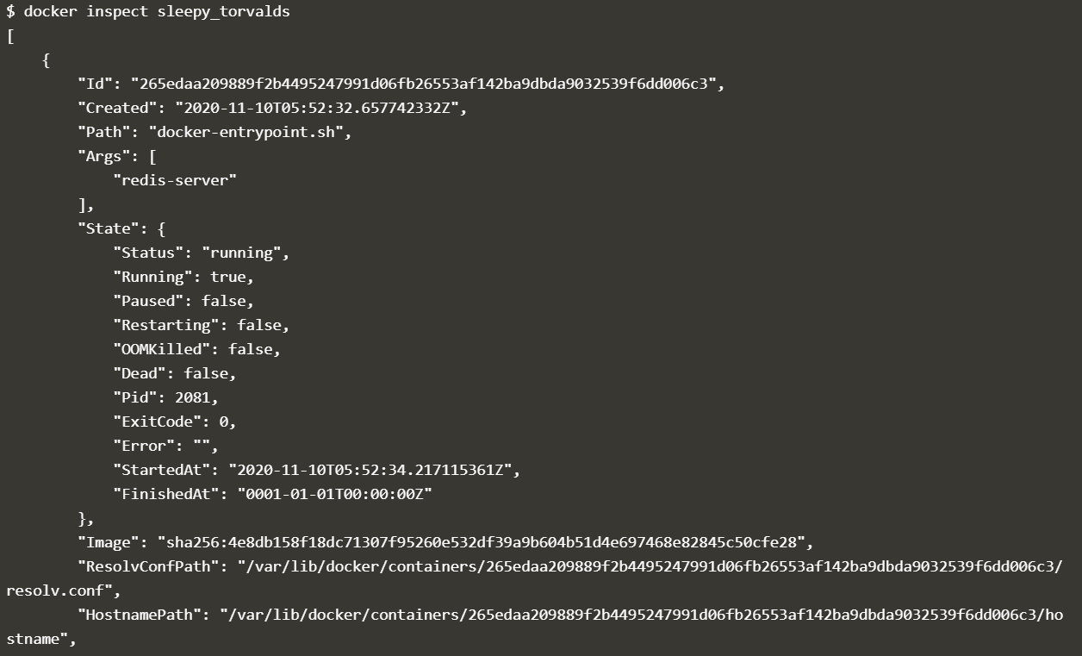

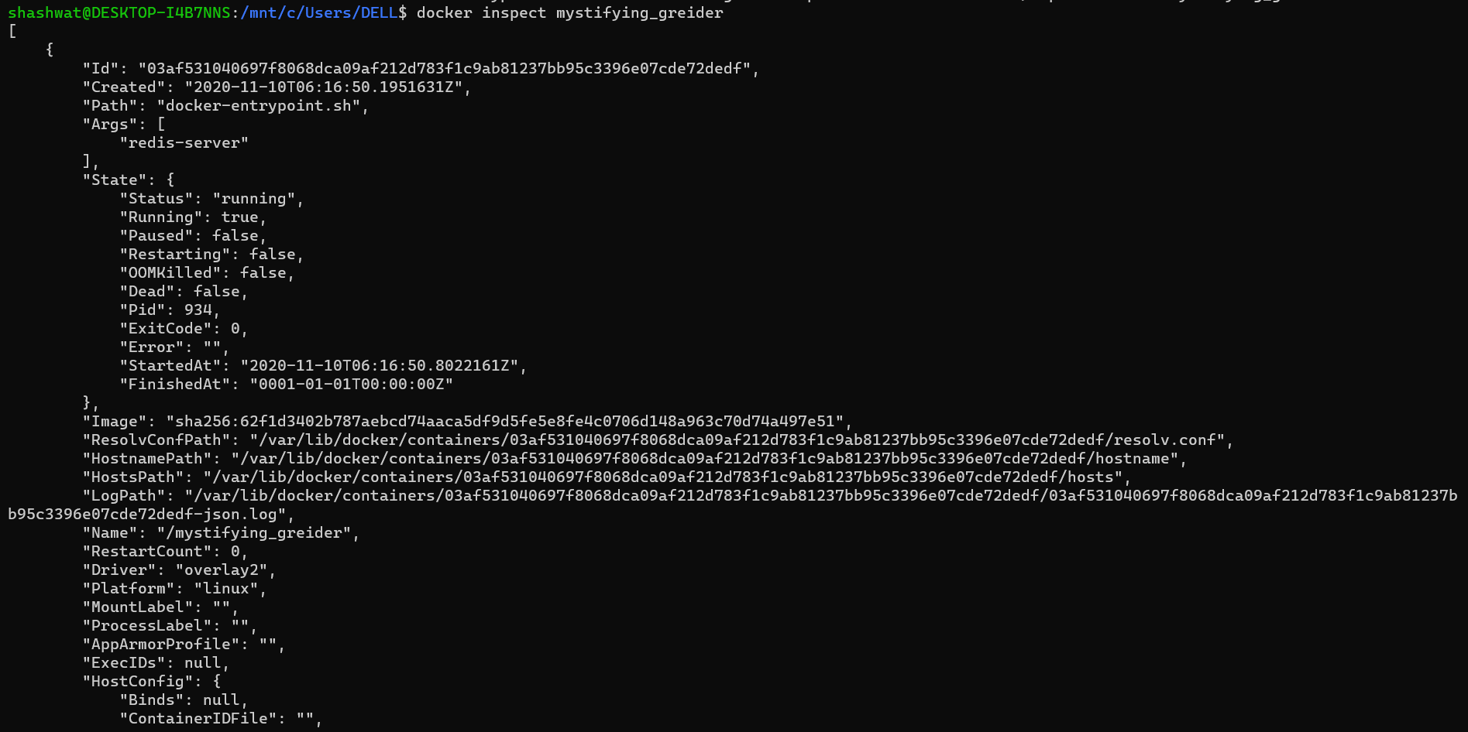

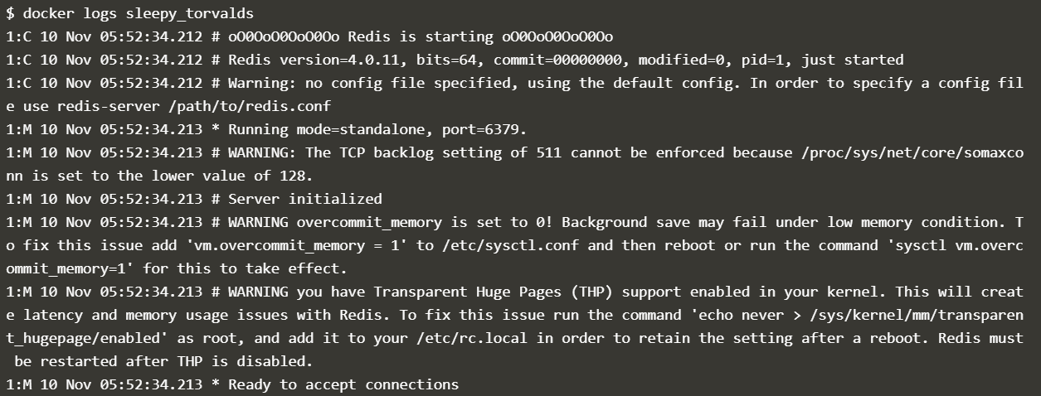

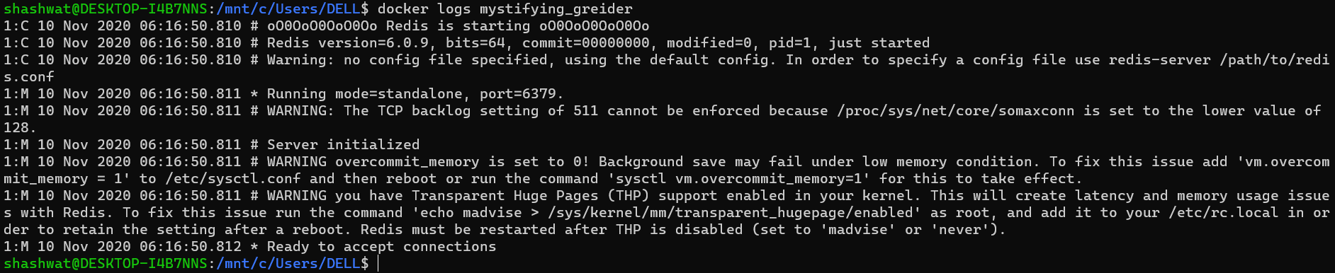

**Step 3 - Accessing Redis**

docker run -d --name redisHostPort -p 6379:6379 redis:latest





**Step 4 - Accessing Redis**

docker run -d --name redisDynamic -p 6379 redis:latest

docker port redisDynamic 6379

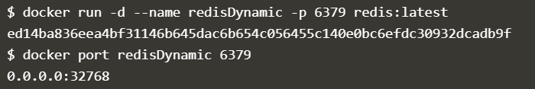

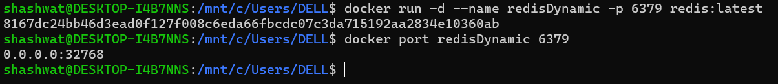

docker ps

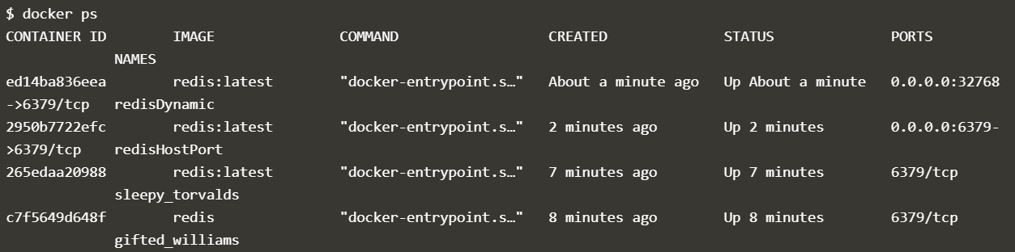



**Step 5 - Persisting Data**

docker run -d --name redisMapped -v /opt/docker/data/redis:/data redis





**Step 6 - Running A Container In The Foreground**

docker run -it ubuntu bash

