**Name – Kushagra Bansal**

**Roll.No – R171218116**

**SAP ID – 500067414**

**CICD LAB- Experiment-14 (Docker Image)**

This base image is defined as an instruction in the Dockerfile. Docker Images are built based on the contents of a Dockerfile. The Dockerfile is a list of instructions describing how to deploy your application.

In this example, our base image is the Alpine version of Nginx. This provides the configured web server on the Linux Alpine distribution.

**Task**: Create your *Dockerfile* for building your image by copying the contents below into the editor.

FROM nginx:alpine

COPY . /usr/share/nginx/html

The first line defines our base image. The second line copies the content of the current directory into a particular location inside the container.

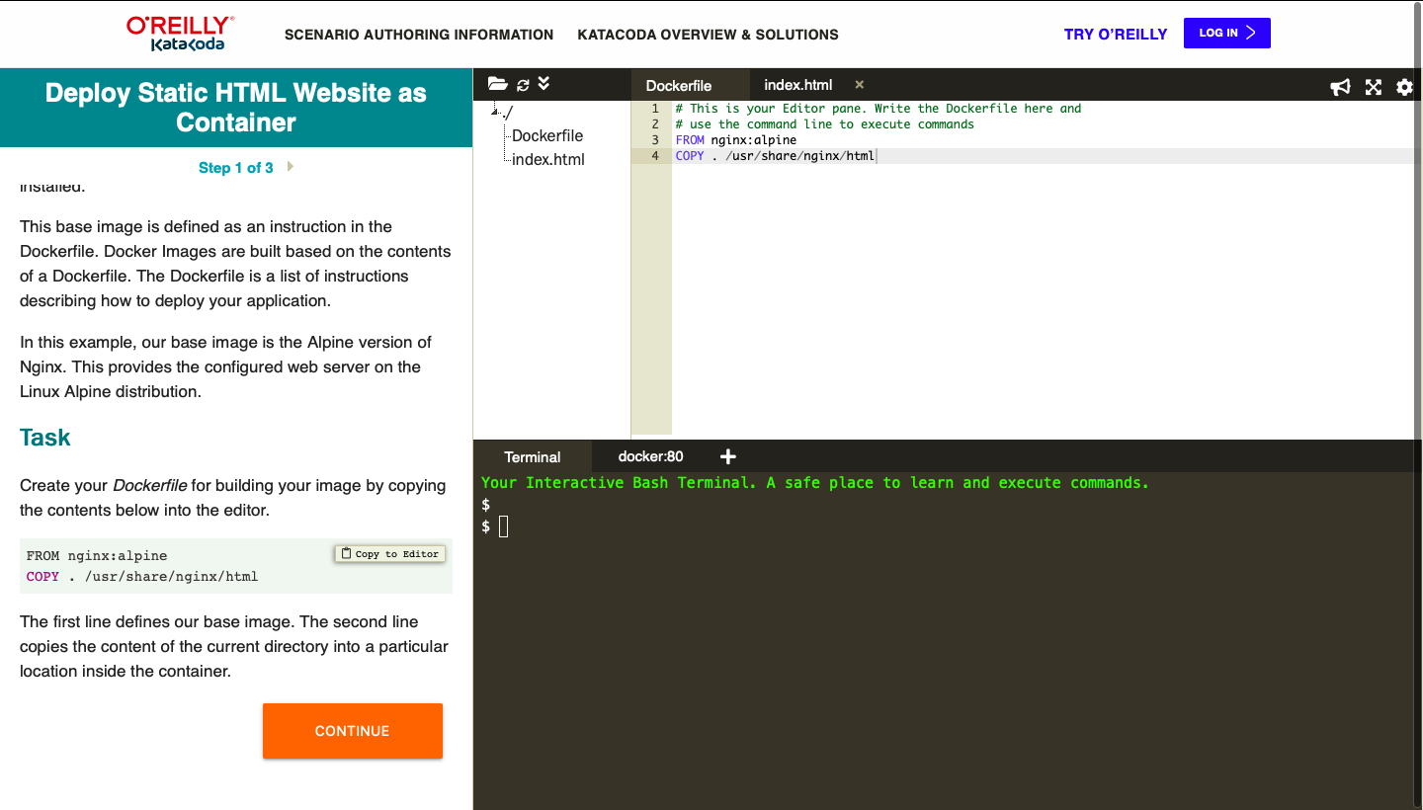

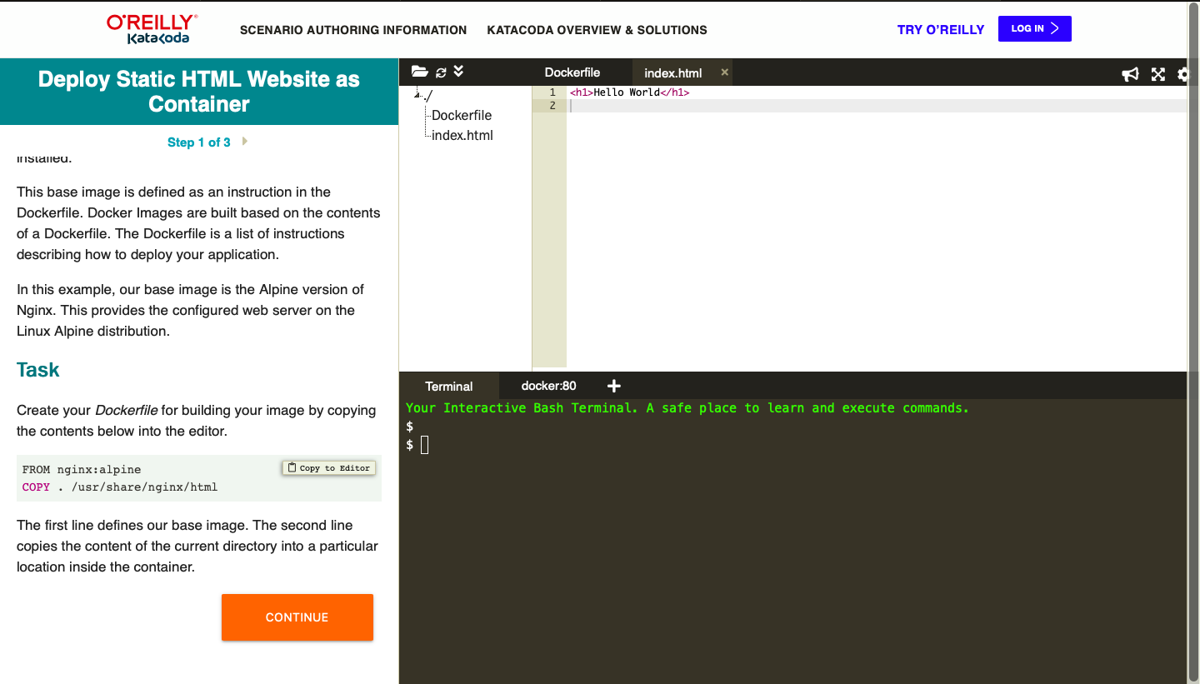

The Dockerfile is used by the Docker CLI build command. The build command executes each instruction within the Dockerfile. The result is a built Docker Image that can be launched and run your configured app.

The build command takes in some different parameters. The format is docker build -t<build-directory>. The -tparameter allows you to specify a friendly name for the image and a tag, commonly used as a version number. This allows you to track built images and be confident about which version is being started.

Task: Build our static HTML image using the build command below.

docker build -t web:v1 .

You can view a list of all the images on the host using docker images.

The built image will have the name webserver-image with a tag of v1.

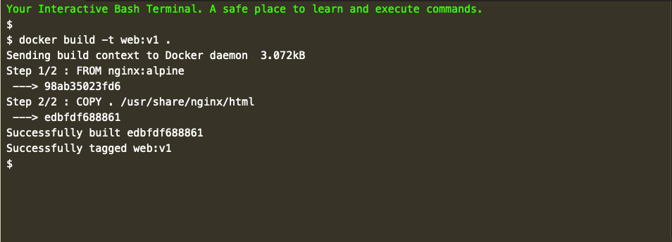

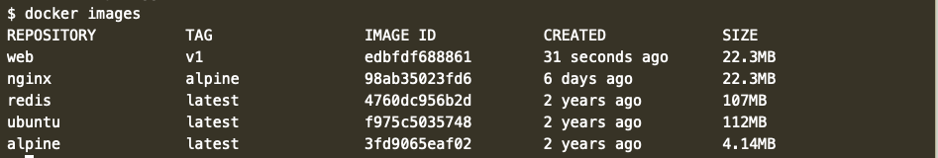

Launch our newly built image providing the friendly name and tag. As it's a web server, bind port 80 to our host using the -p parameter.

docker run -d -p 80:80 webserver-image:v1

Once started, you'll be able to access the results of port 80 via curl docker

Then Provide the credential of dockerhub as mentioned below:-

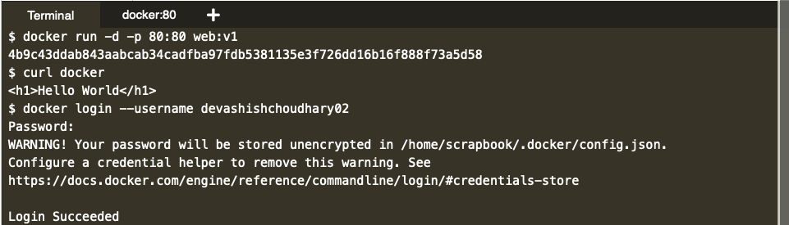

Push to the dockerhub as mentioned below:-

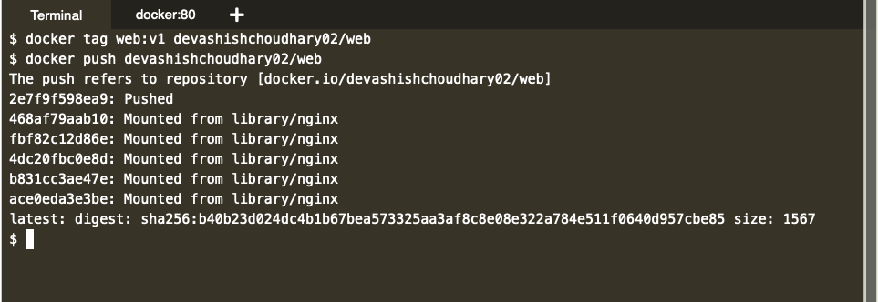

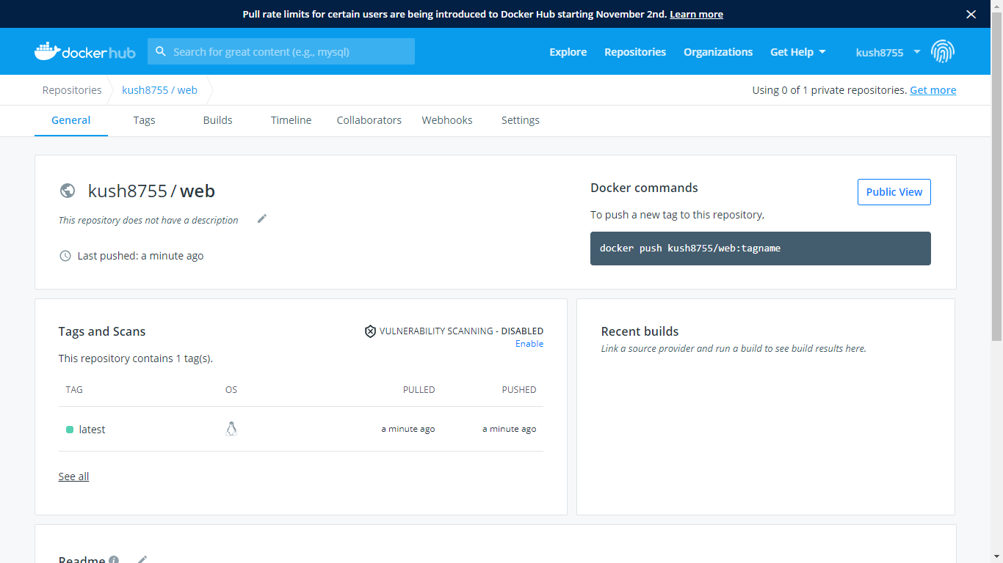

Download the docker image from remote location if its not available within the system as shown below:-

