***Name: Devashish Choudhary***

***Roll No: R171218122***

***SAP ID: 500070510***

***Lab: Viva 3 (CICD)***

***Create a simple Maven Project and Build the Project using Jenkins***

***Steps are mention below:***

* ***Start the Jenkins service using the java -jar jenkins.war command in the command prompt. Go to the Jenkins dashboard at localhost:8080***

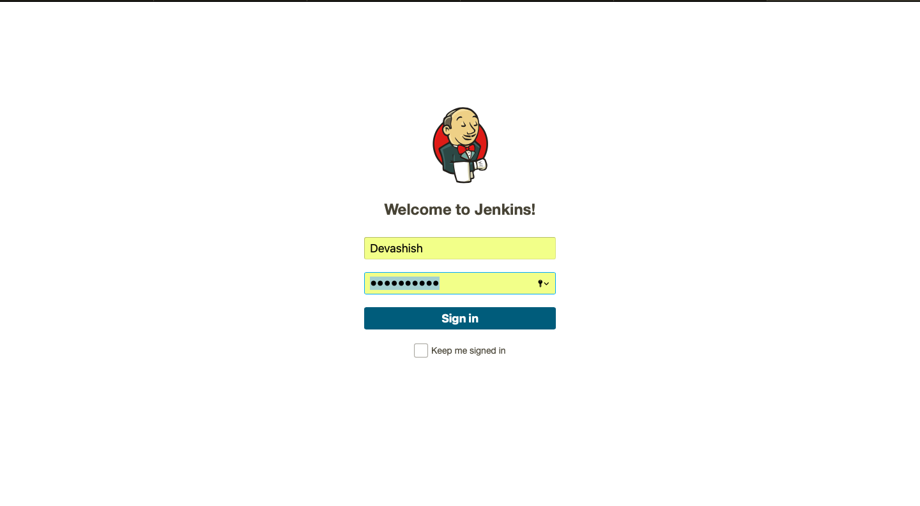

* ***Click on the new item option, Select the maven project option, Give a name to the project, Click ok.***

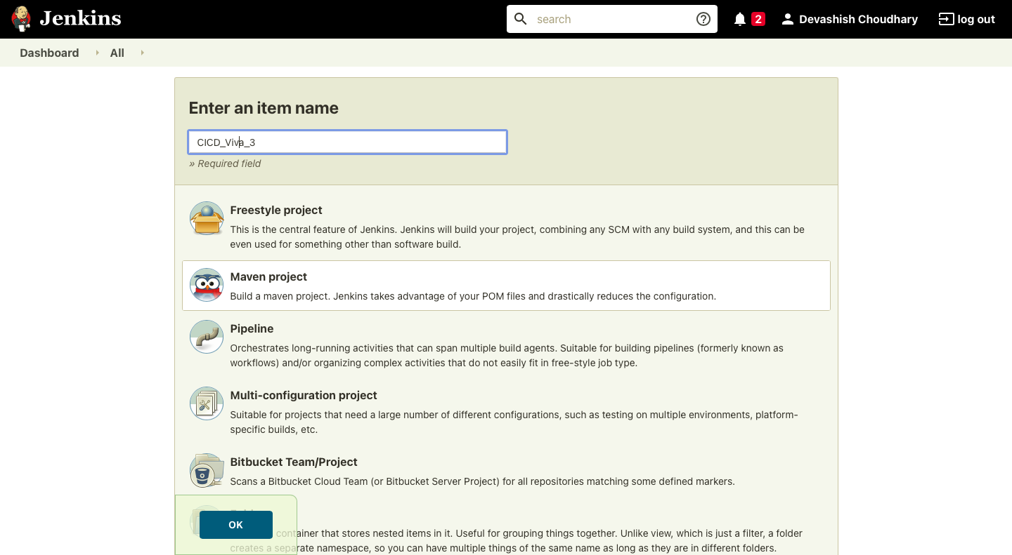

* ***Then you will redirect to this page as shown below.***

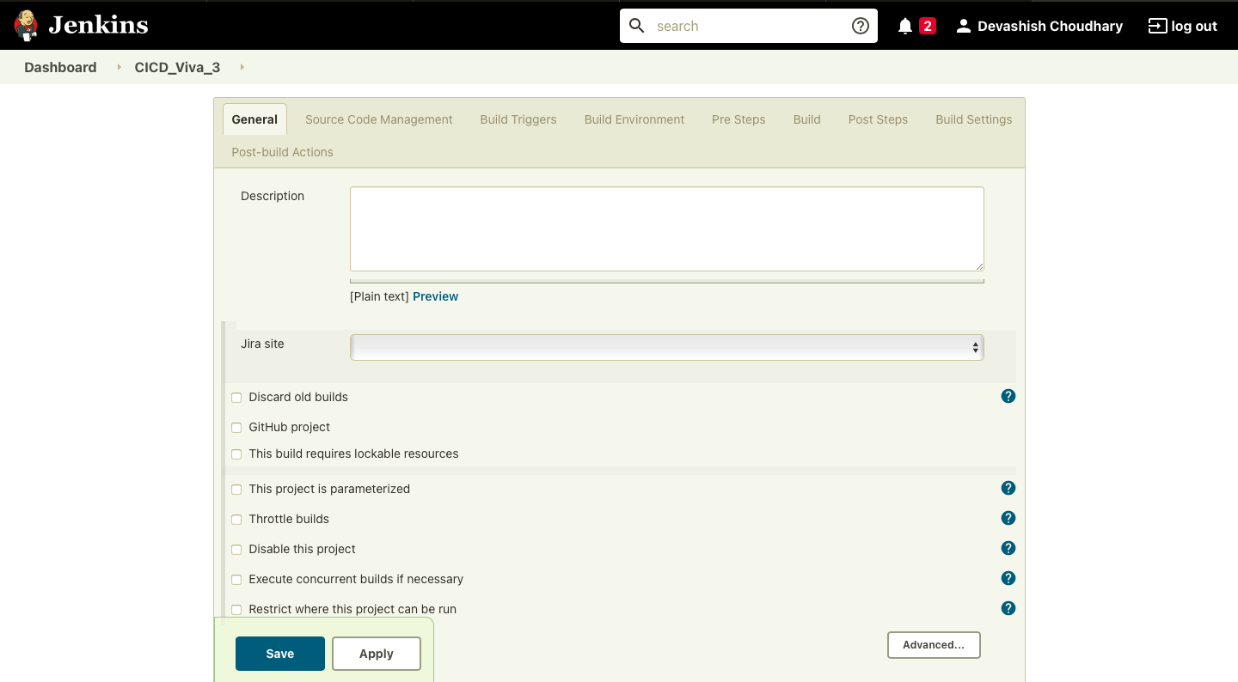

* ***After that go to the maven project and select the path of the pom.xml file of the project.***

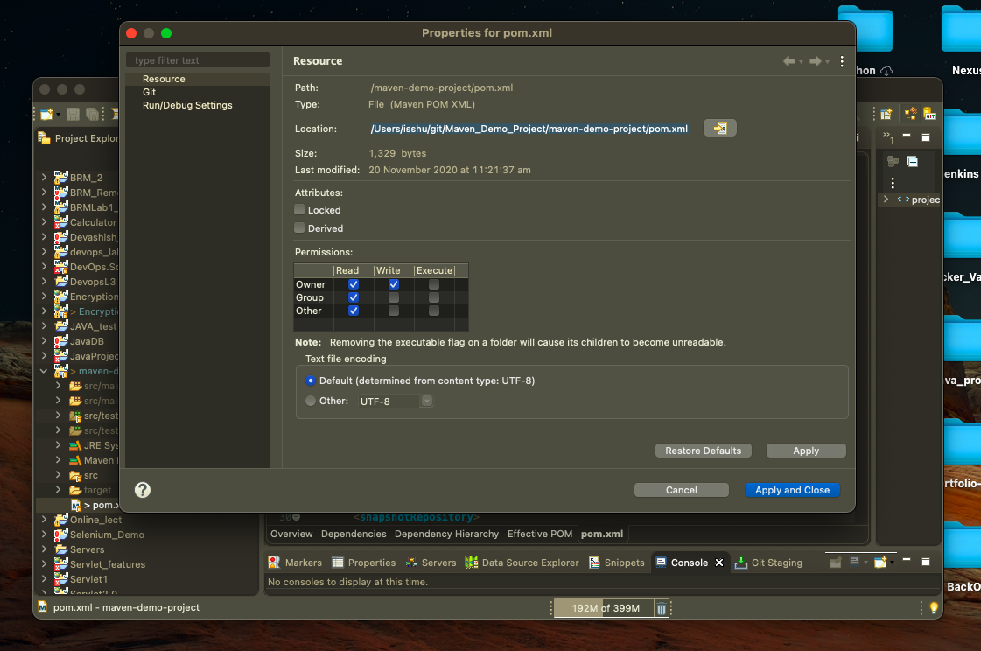

* ***Then put the path of the pom.xml file in the “Root POM” tab and define the goal in the “Goals and Options” tab and Click on “Save” as shown Below.***

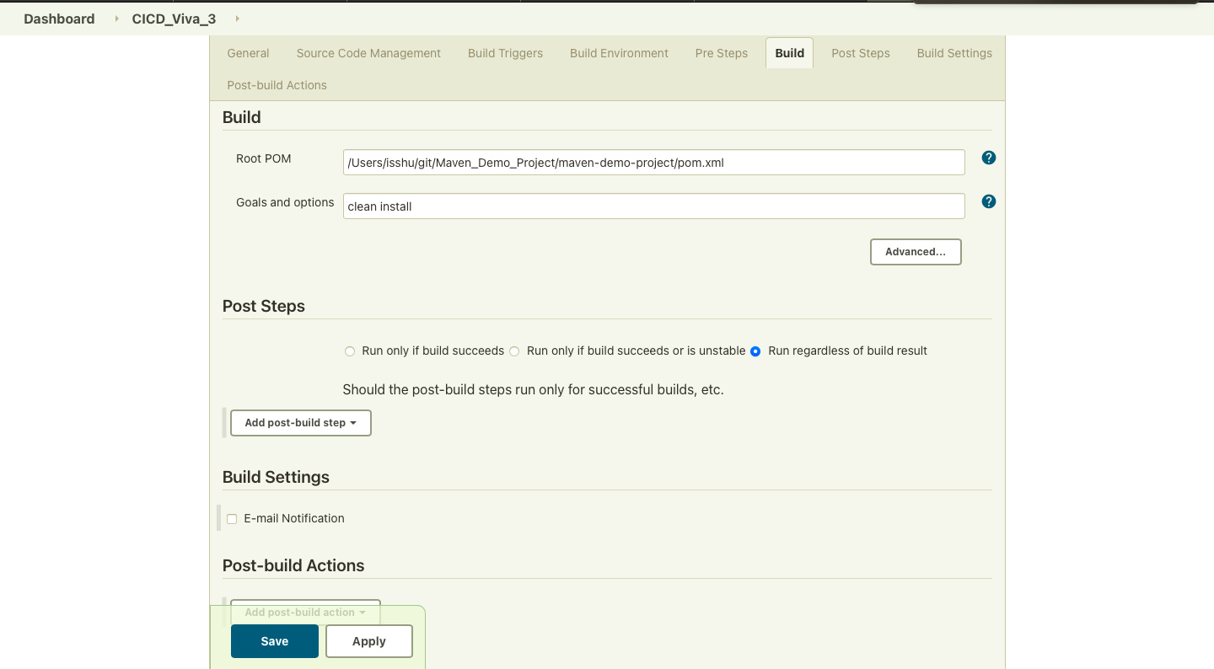

* ***Then Click on “Build Now” to build the maven project on the basis of define golas.***

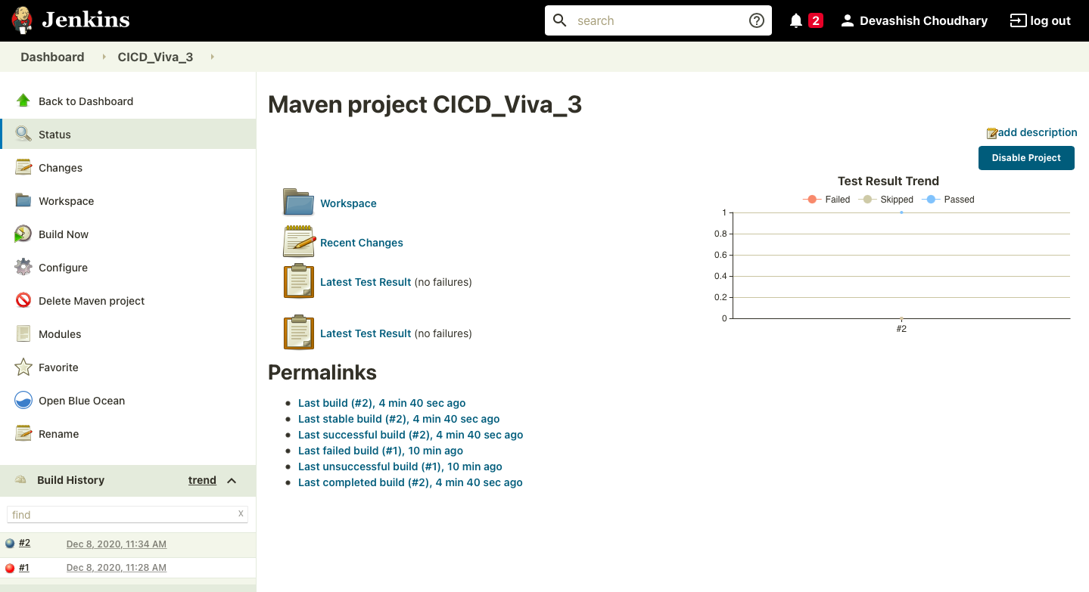

* ***The console output shows that the build successful for the Maven Project.***

