**CI/CD**

**LAB EXPERIMENT 14**

**SUBMITTED BY:**

NITISH KUMAR SINGLA

500071913

R171218126

**SUBMITTED TO:**

HITESH KUMAR SHARMA SIR

**Deploy Static HTML Website as Container**

This is Dockerfile

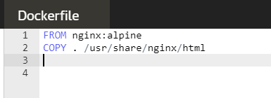

$docker build is used to build an image from dockerfile

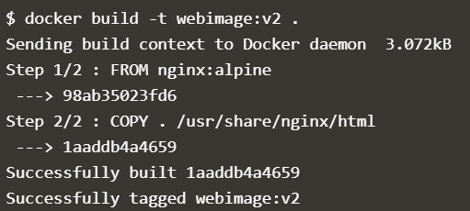

Use $docker images command to check the docker images available in your machine.



Use $docker run -d <imagename> to run the docker image and -d is used to keep it running in the background. Same images can also run multiple times.



Use $curl docker to see the output of the HTML Page



Use $docker login --username <username> to connect console to docker hub account.

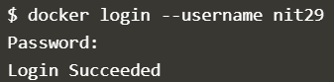

Now, push the image to the docker hub.

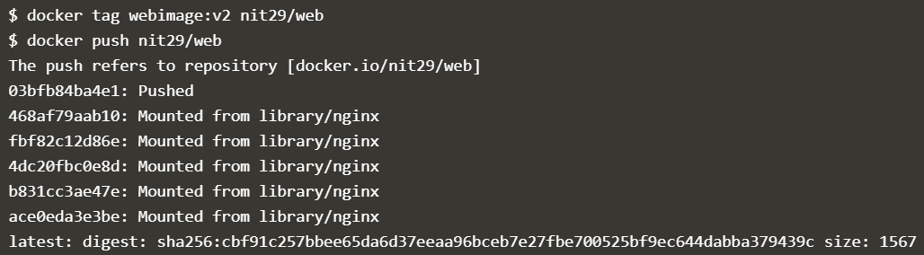

Docker hub account and the image has been pushed to the repository named web.

