**Lab Exercise 6–Job Chaining in Jenkins**

Below is a lab exercise that will help you understand and practice job chaining in Jenkins:

# Task 1: Installation and Setup

• Install Jenkins on your local machine or server. You can follow the instructions provided on the Jenkins website for installation.

# Task 2: Creating Jobs

• Create multiple Jenkins jobs, such as Job1, Job2, and Job3, to simulate job chaining and sequential execution.

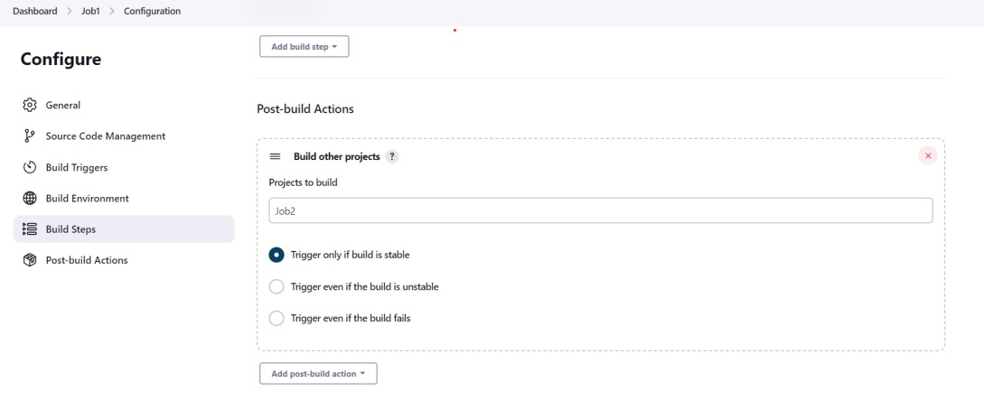

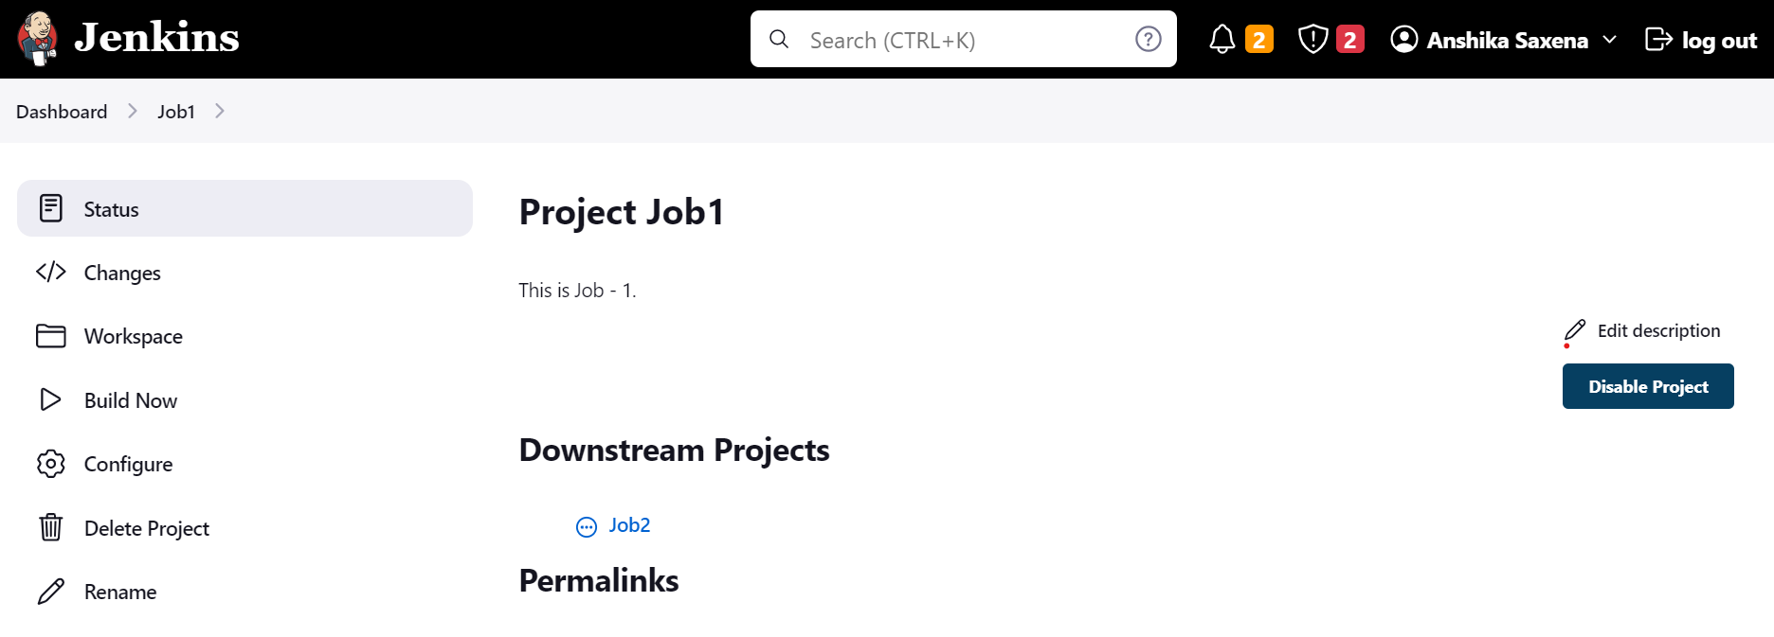

# Task 3: Configuring Job Dependencies

* Configure the Job2 to be triggered automatically when Job1 is completed successfully.
* Configure the Job3 to be triggered automatically when Job2 is completed successfully.

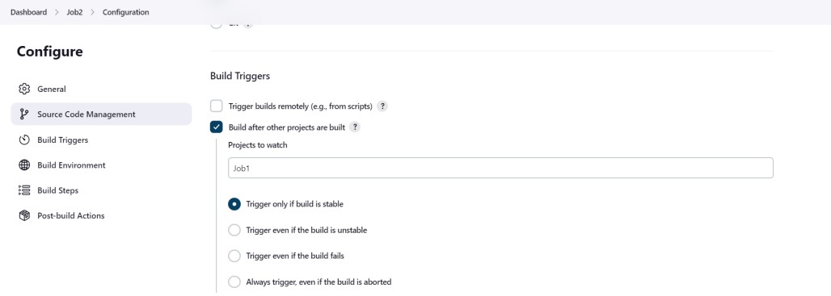

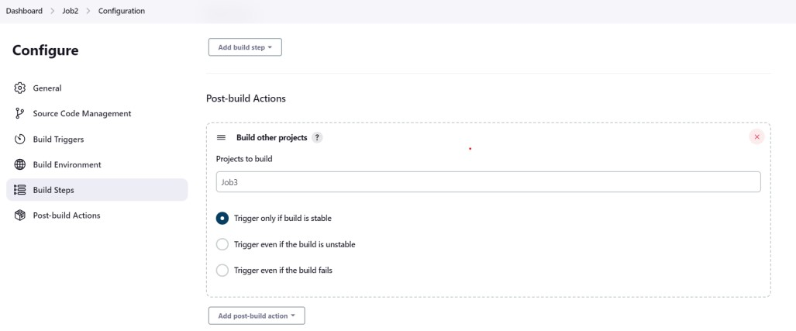

# Task 3: Running the Jobs

* Run the Job1 and verify that it triggers Job2 upon successful completion.
* Monitor the execution of Job2 and ensure it triggers Job3 upon successful completion.

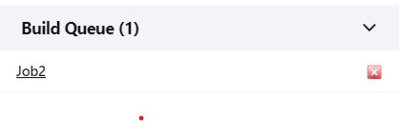

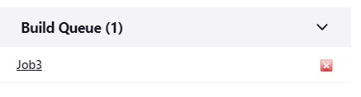

# Task 7: Viewing Console Output and Logs

• View the console output and logs of each job to understand the sequence of execution and any potential issues.

