**Lab Exercise 6–Job Chaining in Jenkins**

NAME- ARSHPREET KAUR

SAP ID- 500094140

BATCH-B2, DEVOPS NON-HONS

**Task 1: Installation and Setup**

* Install Jenkins on your local machine or server. You can follow the instructions provided on the Jenkins website for installation.

**Task 2: Creating Jobs**

* Create multiple Jenkins jobs, such as Job1, Job2, and Job3, to simulate job chaining and sequential execution.

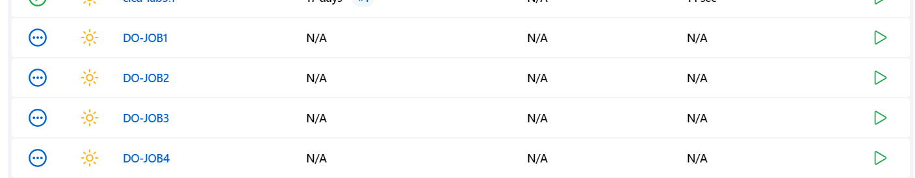

**Task 3: Configuring Job Dependencies**

* Configure the Job2 to be triggered automatically when Job1 is completed successfully.

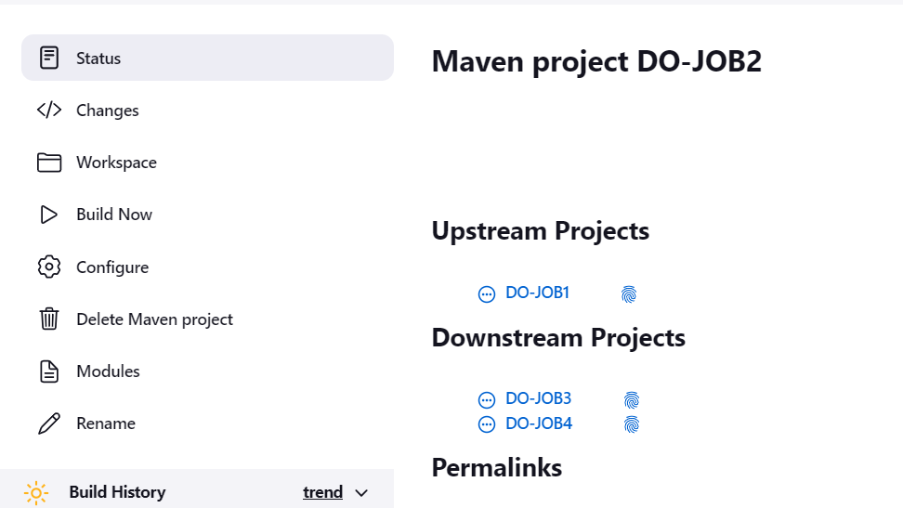

* Configure the Job3 to be triggered automatically when Job2 is completed successfully.

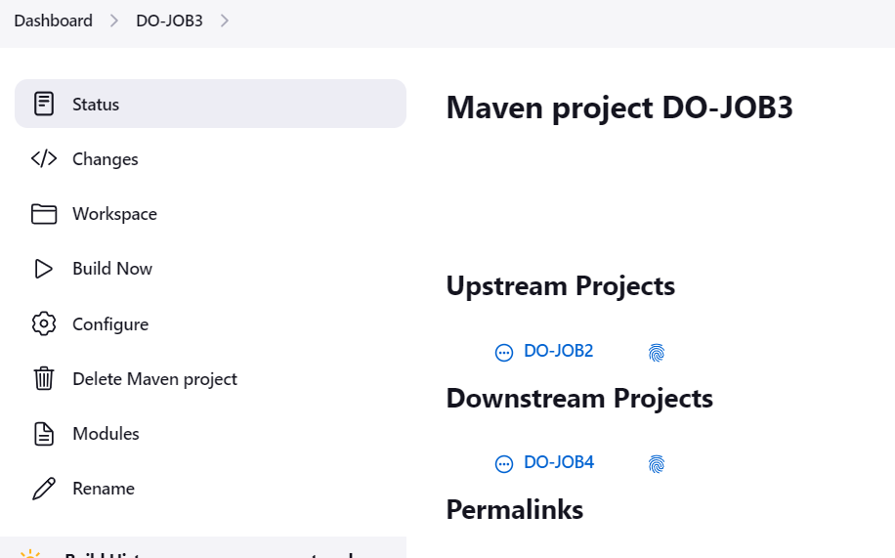

**Task 4: Setting Up Build Triggers**

* Configure build triggers for each job to automatically trigger downstream jobs upon successful completion of the upstream jobs.

JOB2-

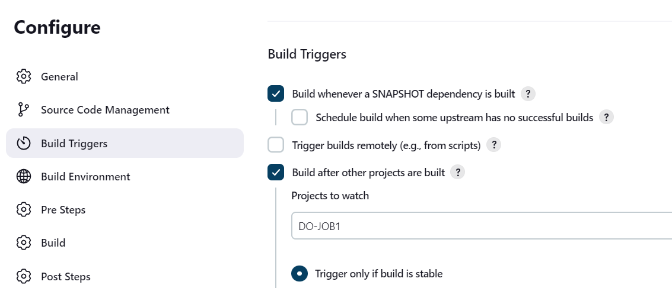

JOB3-

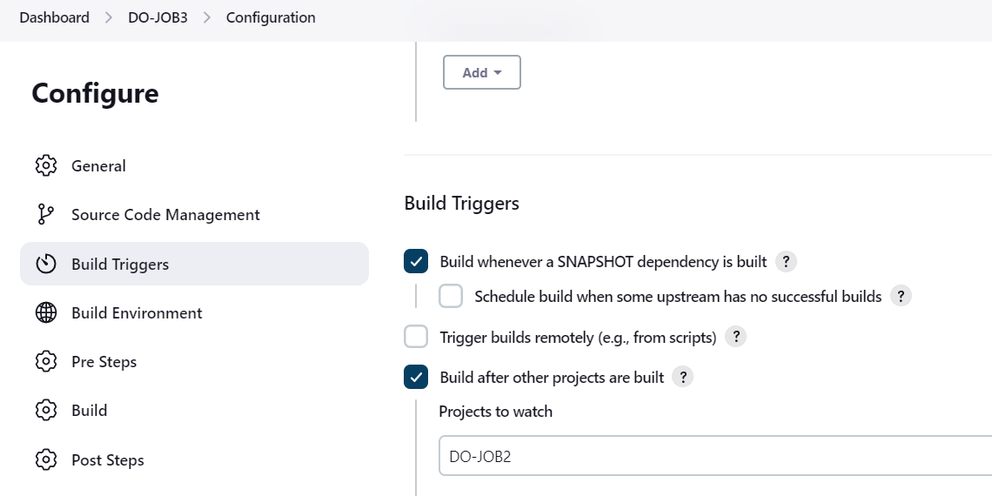

JOB4-

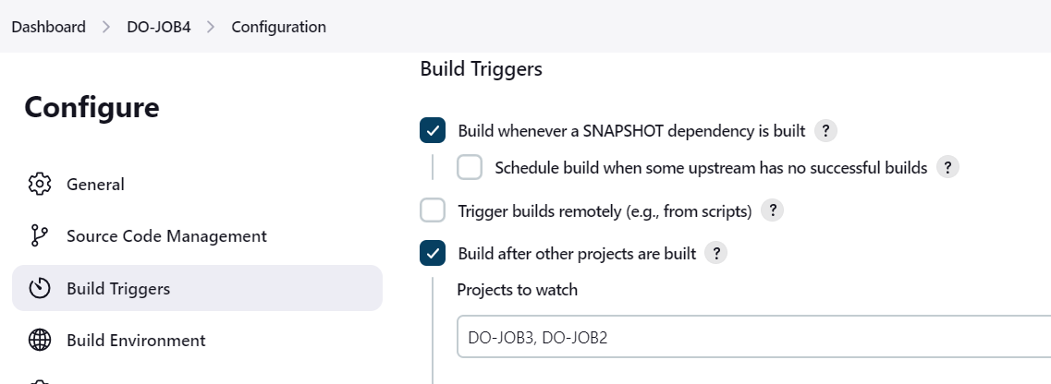

**Task 5: Defining Build Steps**

* Define the build steps for each job. You can use simple shell commands or execute complex build scripts depending on the requirements of each job.

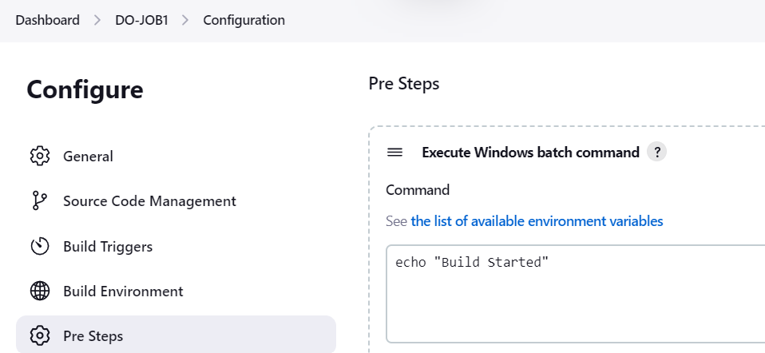

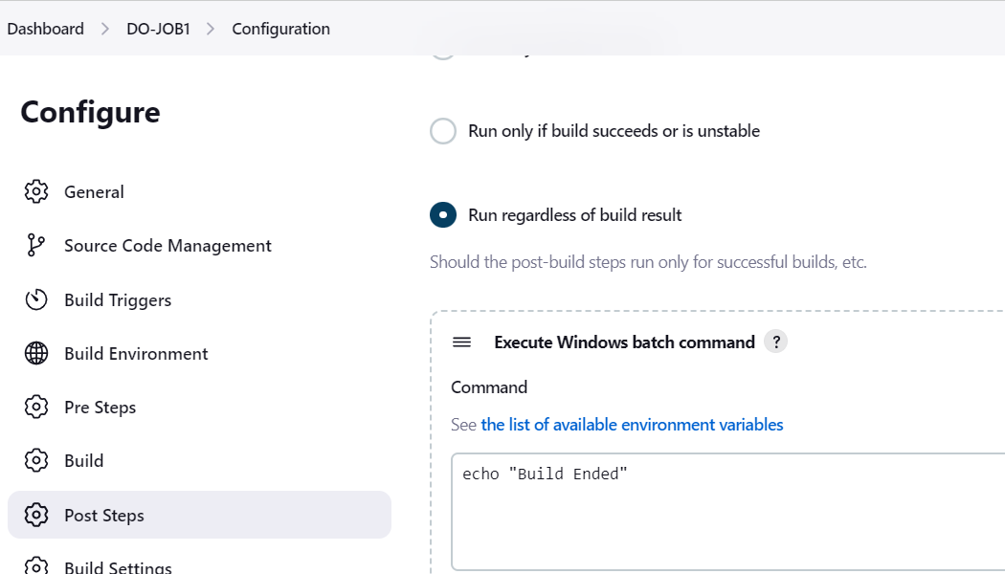

**Task 6: Running the Jobs**

* Run the Job1 and verify that it triggers Job2 upon successful completion.

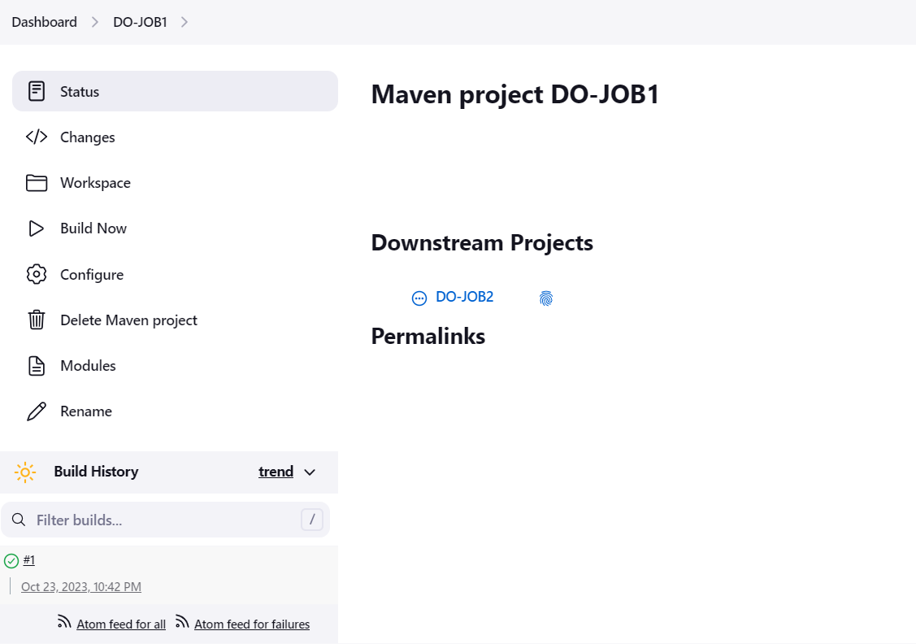

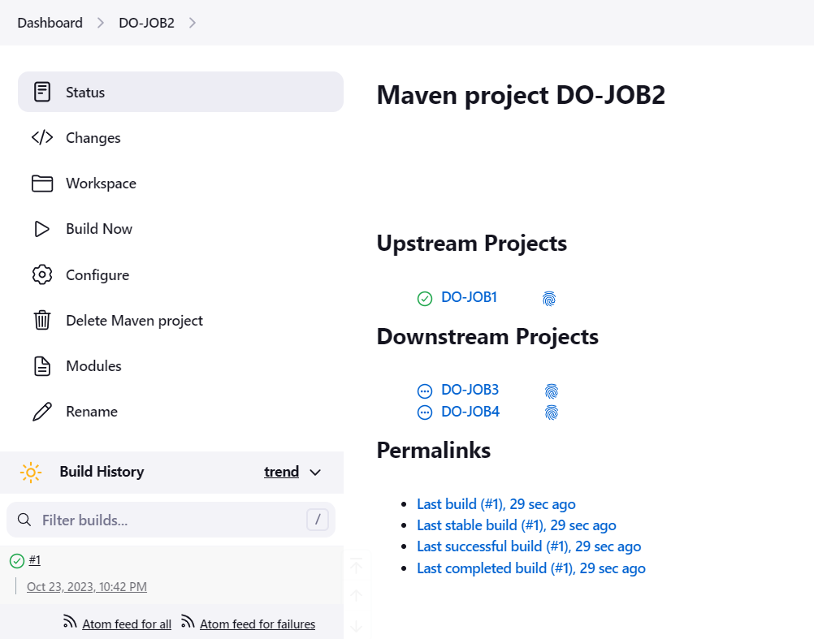

* Monitor the execution of Job2 and ensure it triggers Job3 upon successful completion.

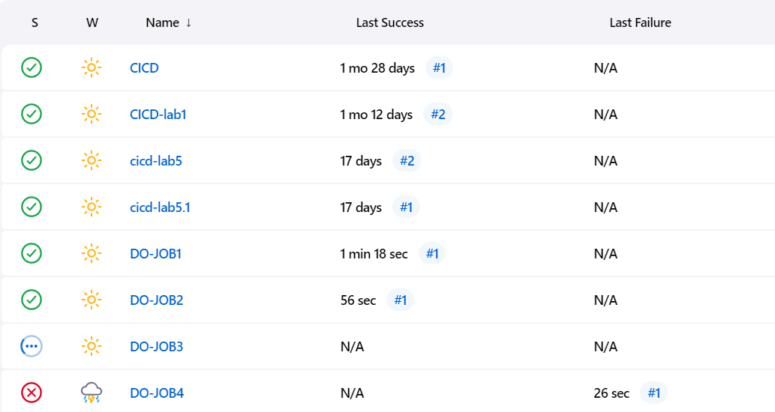

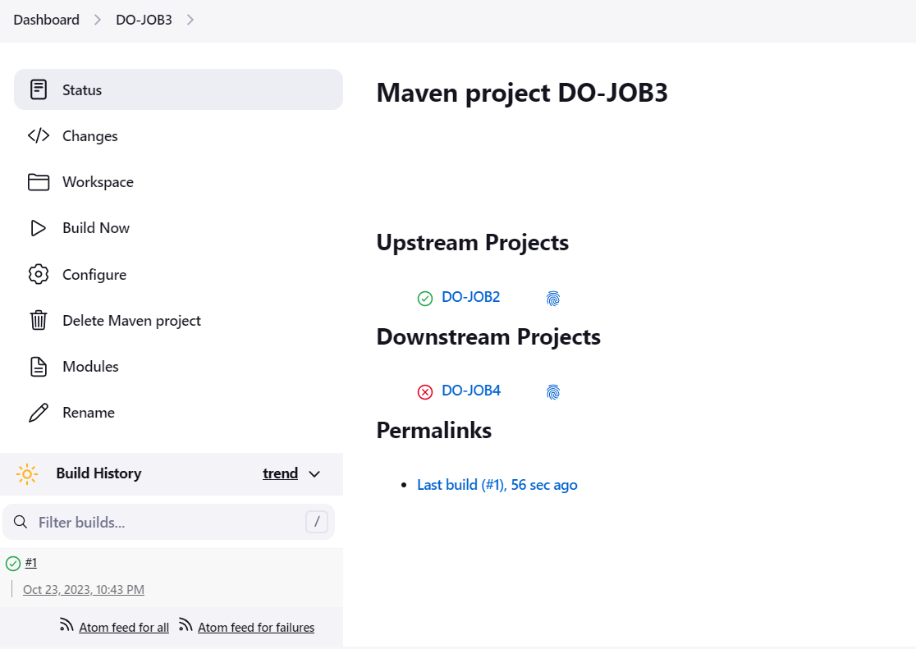

**Task 7: Viewing Console Output and Logs**

* View the console output and logs of each job to understand the sequence of execution and any potential issues.

JOB1-

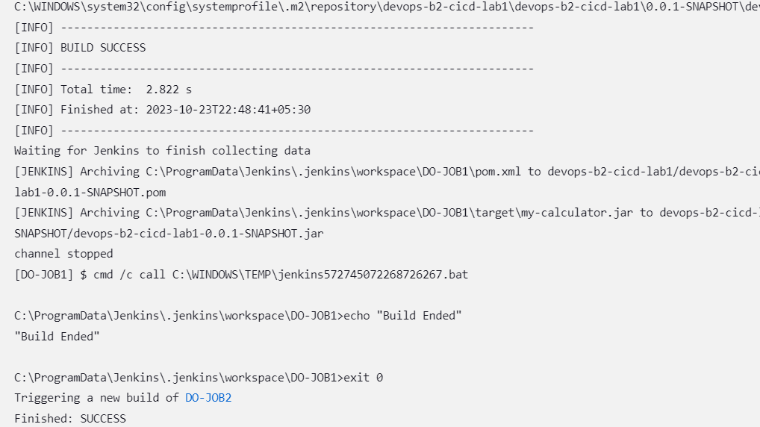

JOB2-

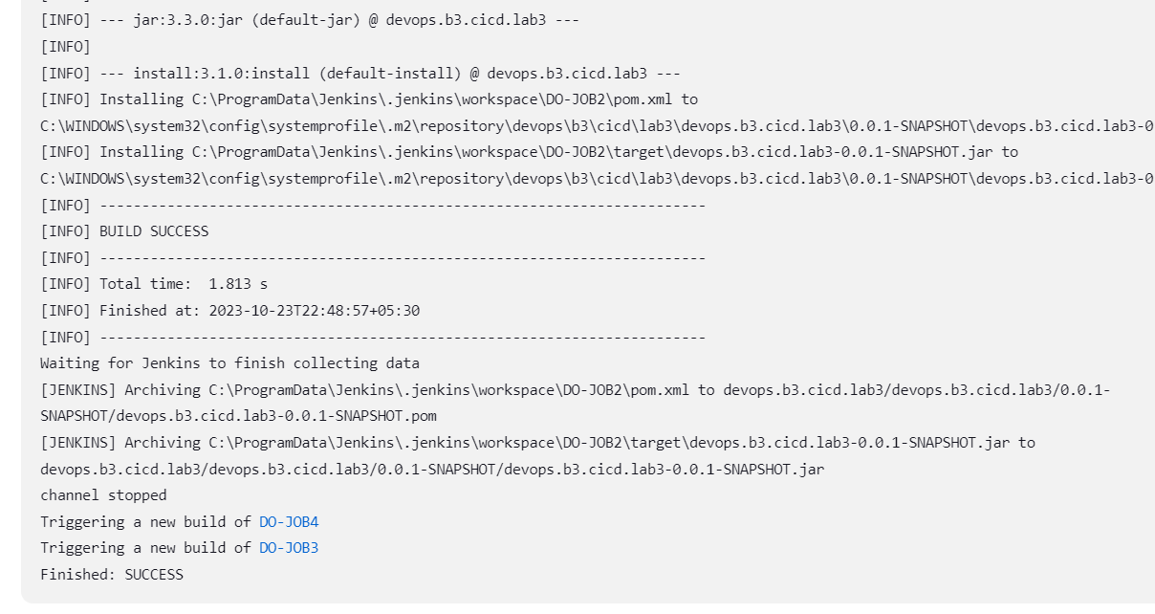

JOB3-

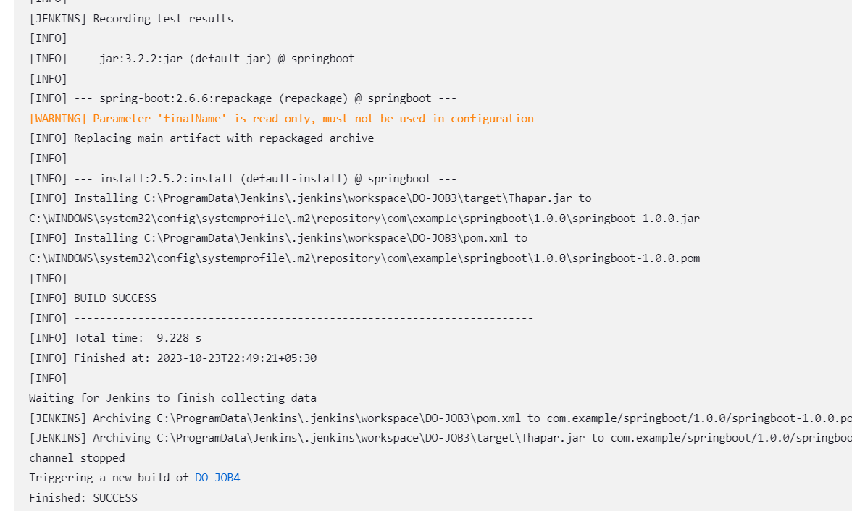

**Task 8: Cleanup**

* Delete the jobs that were created during the exercise to clean up the Jenkins environment.

A better understanding of how to configure job chaining in Jenkins and effectively manage the execution of dependent jobs.