**Lab Exercise 7–Email Notification in Jenkins**

NAME- ARSHPREET KAUR

SAP ID- 500094140

BATCH- B2, DEVOPS, NON-HONS

**Task 1: Installation and Setup**

Install Jenkins on your local machine or server. You can follow the instructions provided on the Jenkins website for installation.

**Task 2: Configuring SMTP Server**

* Configure the SMTP server settings in the Jenkins system configuration to enable email notifications. Provide the necessary SMTP server details, such as the host, port, and credentials.

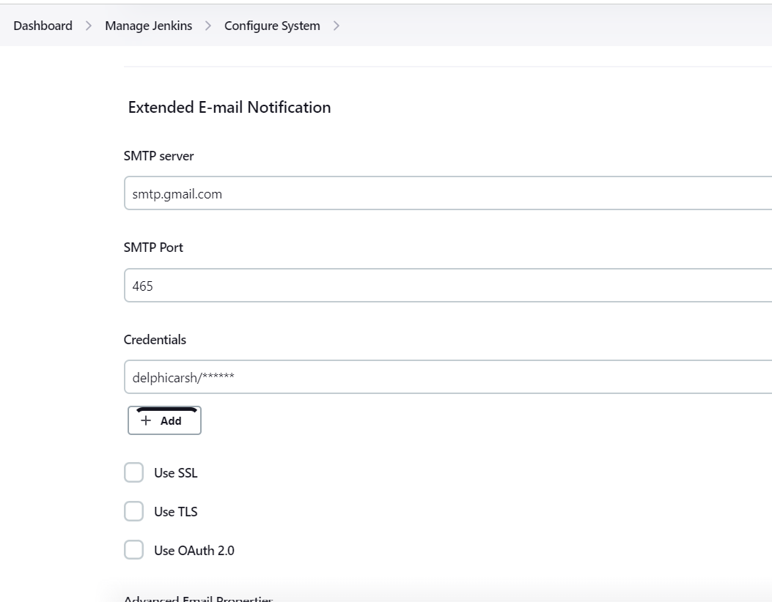

**Task 3: Installing Email Notification Plugin**

* Install the Email Extension plugin in Jenkins. Navigate to the Jenkins dashboard, click on "Manage Jenkins," select "Manage Plugins," and search for the "Email Extension" plugin. Install the plugin and restart Jenkins if necessary.

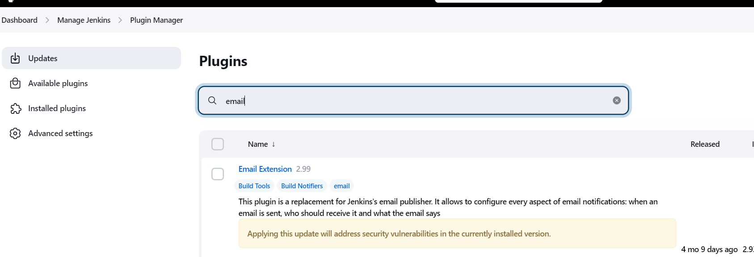

**Task 4: Configuring Email Notifications in Jobs**

* Open an existing Jenkins job or create a new one.
* Configure the job to send email notifications upon successful or failed builds.
* Specify the recipients' email addresses, subject, and email content in the job configuration.

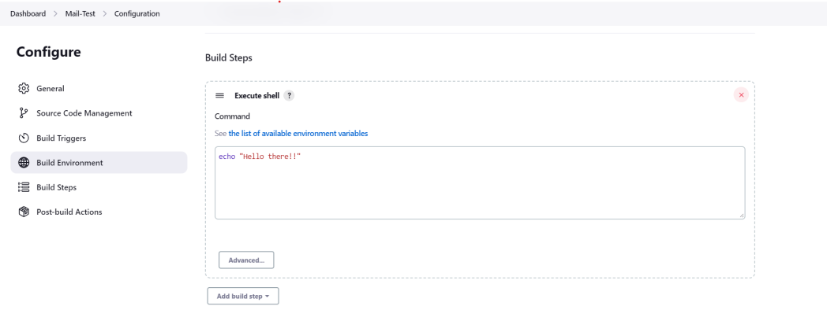

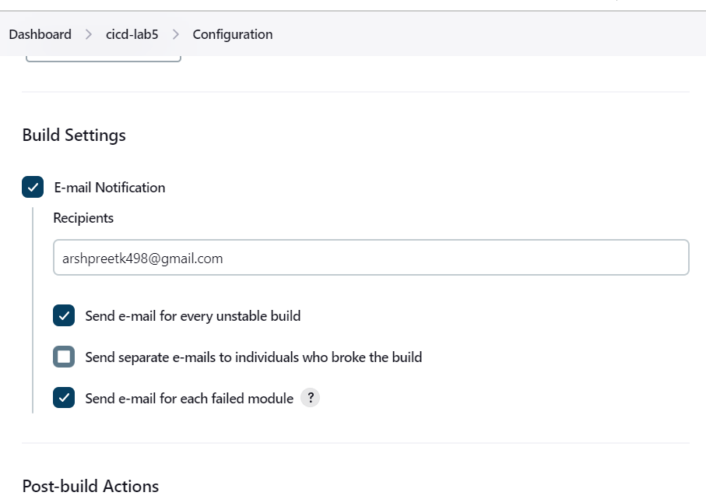

* Run the job and verify that the email notifications are sent upon build completion.
* Check the email inbox of the recipients to confirm that they received the notifications.