**Lab Exercise -8**

**Remote Triggering of a Parameterized Build**

Name- Arshpreet Kaur

SAP ID- 500094140

Steps to be followed:

1. Configure a parameterized build in Jenkins
2. Trigger a parameterized build remotely

**Step 1: Configure a parameterized build in Jenkins**

* 1. Open the browser and go to **Jenkins dashboard** by typing **localhost:8080** in your browser.

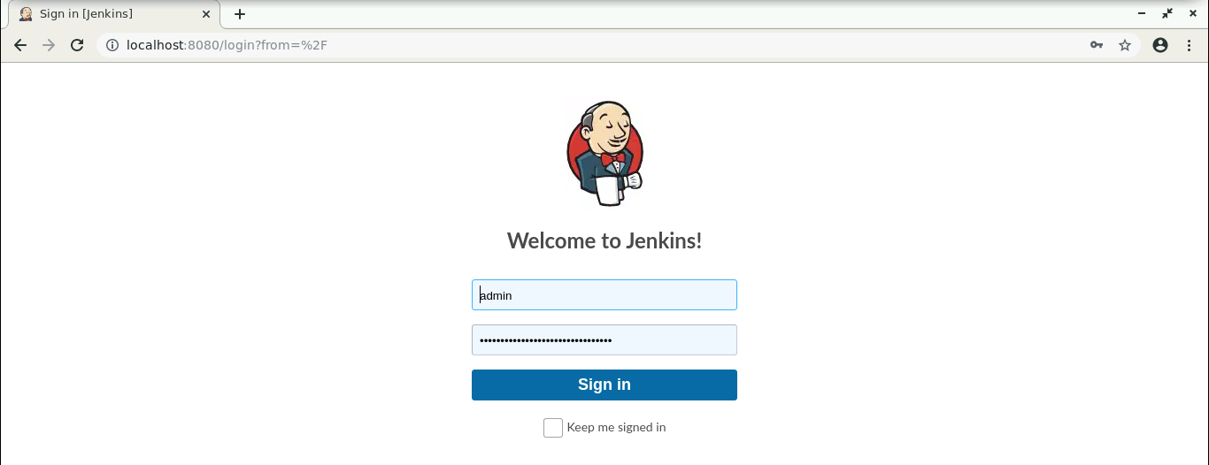

* 1. Provide the credentials and click on **Sign in**.
  2. Click on **Manage Jenkins**. From the list of options, choose **Manage Plugins**.
  3. 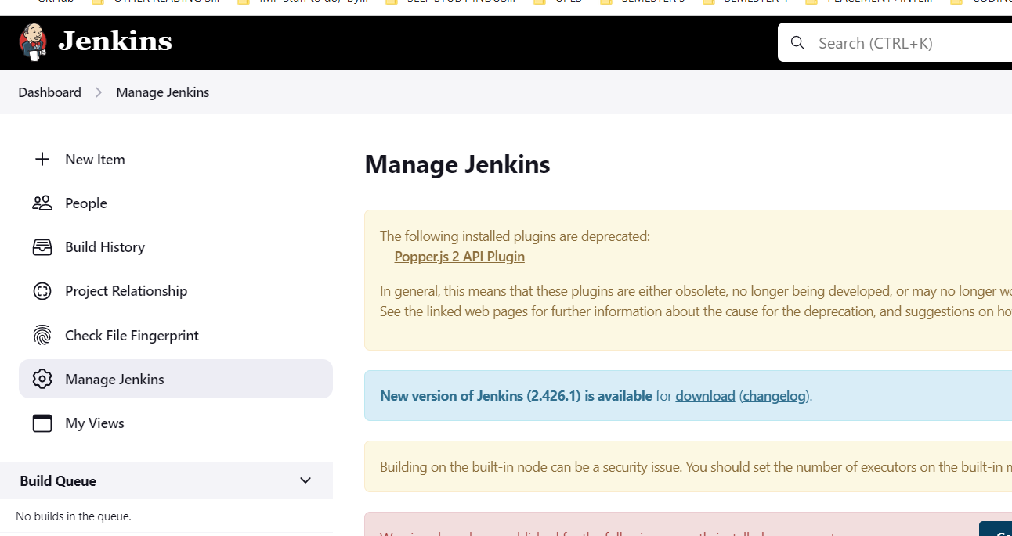

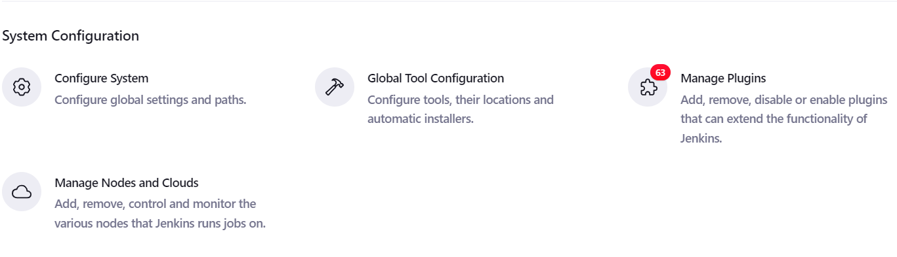

* 1. Under the **Available** tab, search for **Build with Parameters** Plugin. 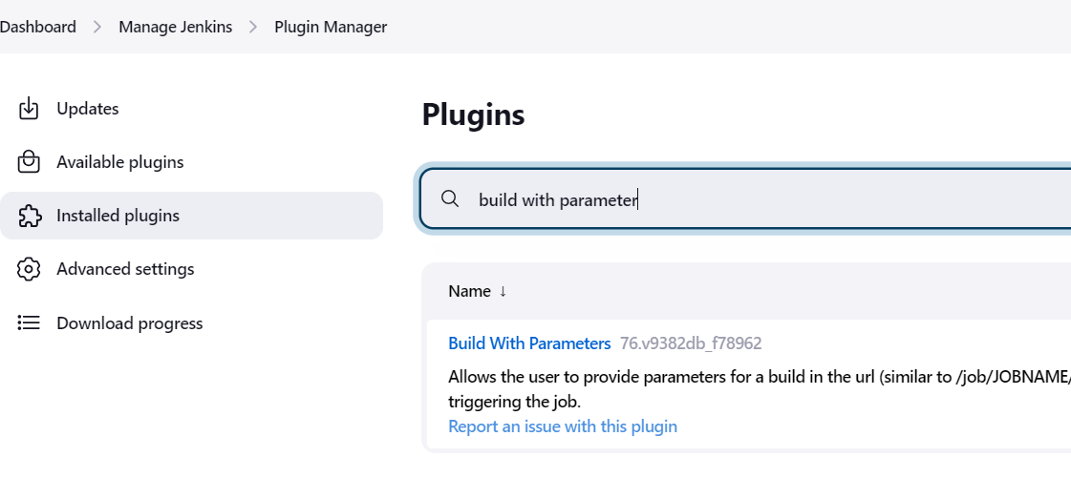
  2. Select the checkbox in front of the **plugin**and click on the **Install without restart** button.
  3. Go to the Jenkins Dashboard, click on **New Item** in the Jenkins dashboard.
  4. Enter a name for your project.
  5. Select the **Freestyle project** as the build job type.

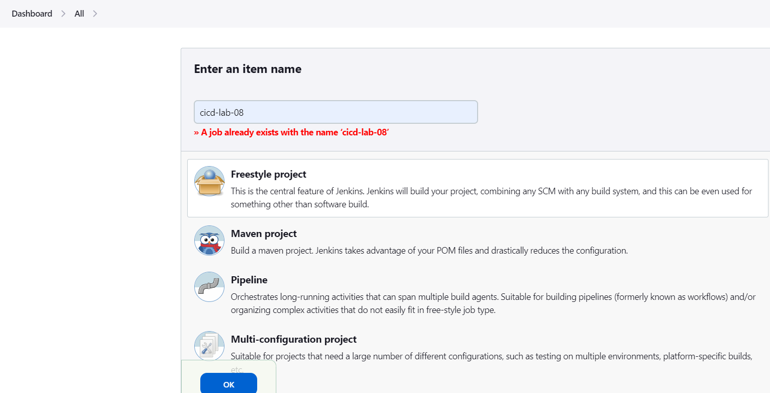

* 1. Click on **OK**.
  2. On the configuration page, select the checkbox next to text that states,**This project is parameterized.**
  3. Click on the **Add parameter** button that appears.

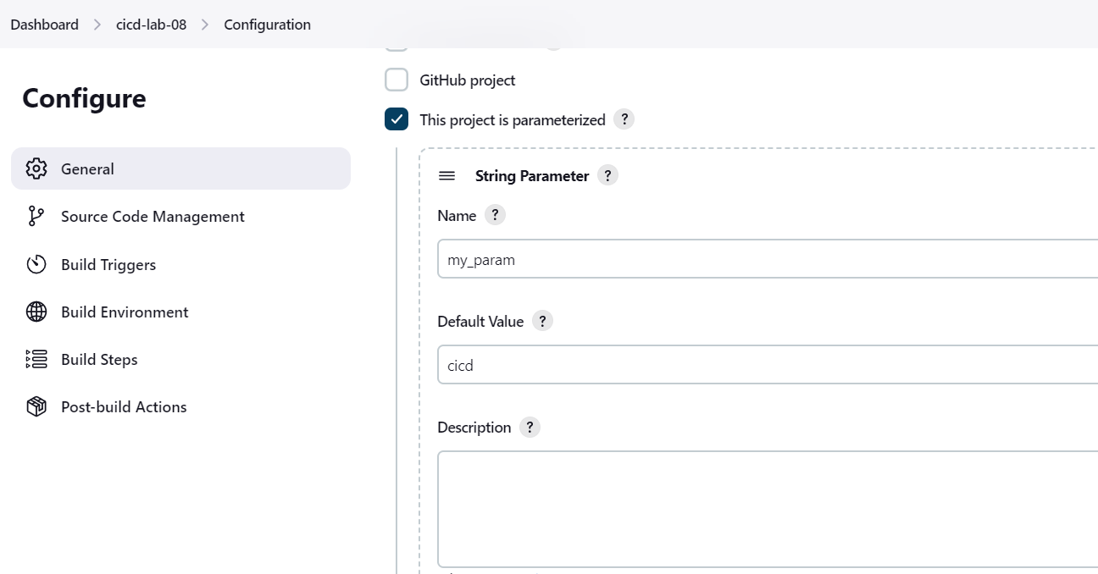

From the drop-down menu that appears, select **String Parameter**.

* 1. Enter the Name of the parameter as **my_param**, and enter the **Default Value*.***
  2. Under the Build Triggers section select **Trigger builds remotely** and type **Sam** as the token value.

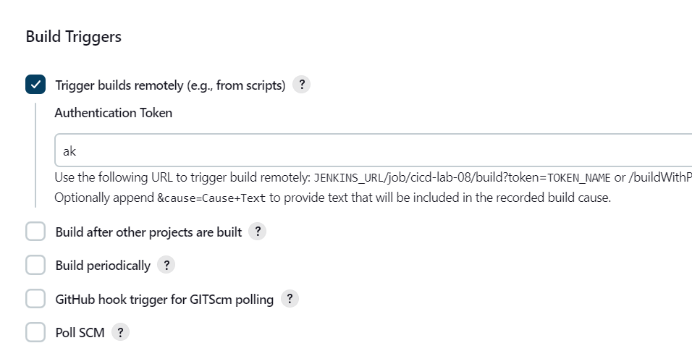

* 1. Scroll down to the **Build** section and click on **Add build step**.
  2. Select **Execute Shell Command** from the drop down that appears.

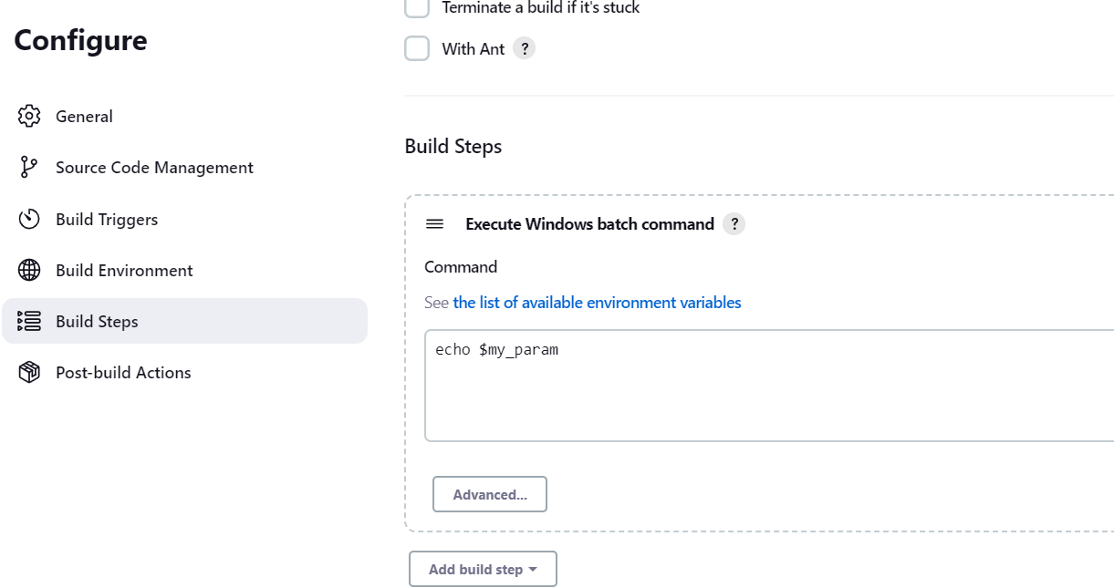

* 1. In the text input area that appears, enter the following text:

***echo $my_param***

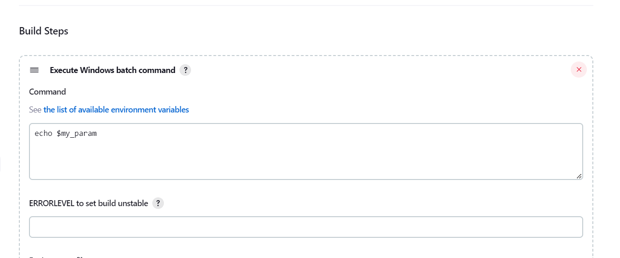

* 1. Click **Save**.

**Step 2: Triggering a parameterized build remotely**

* 1. Copy the **URL** to the job from the project window.

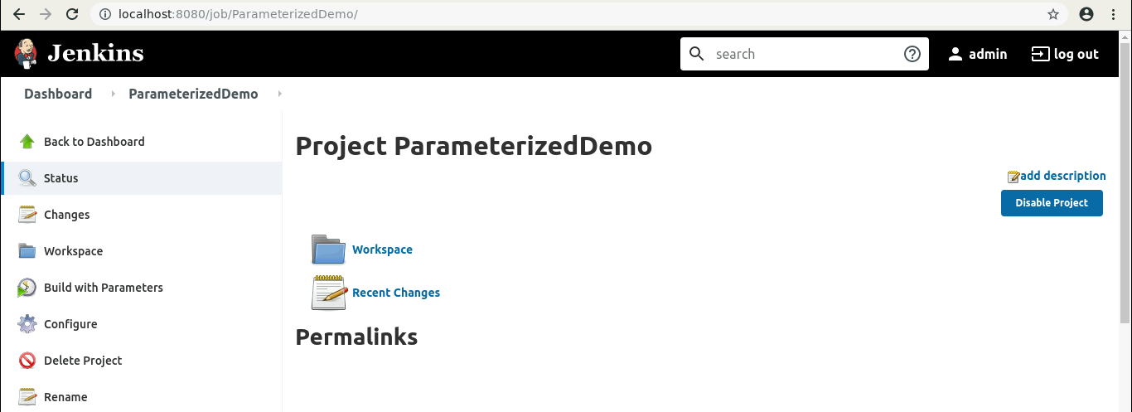

* 1. Open the terminal.
  2. Suffix the parameter and its value to the URL copied in the previous step and send a *GET* request using *Curl*.

***curl -X GET http://localhost:8080/job/cicd-lab-08/ buildWithParameters?token=ak*** **

In case you get an authentication error, check your security settings in Manage jenkins > Configure Global Security . It should be configured as shown below:

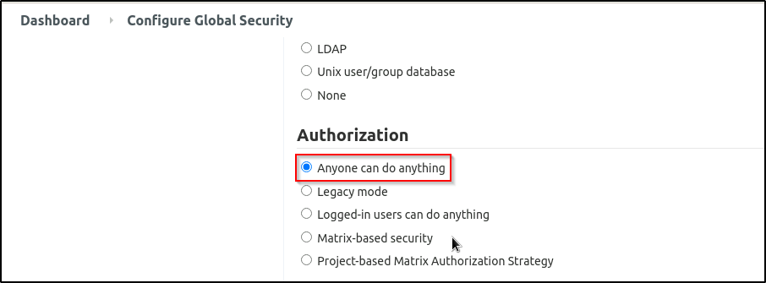

* 1. Open the job in the Jenkins UI.
  2. Click on the Build Historyto view the build results.
  3. Click on the Console Output to view the build logs.
  4. The parameter value will be displayed in the console output.

