# School of Computer Science

## UNIVERSITY OF PETROLEUM AND ENERGY STUDIES DEHRADUN, UTTARAKHAND



Continuous Integration and Continuous Delivery Lab

# Lab File (2023-2024)

**for**

**5th Semester**

## Submitted To:

Dr. Hitesh Kumar Sharma

## Submitted By:

Arman Bisht

B. Tech. CSE [DevOps] 500093031

R2142210141

B2- Devops (Non-Hons)

## LAB EXERCISE - 1

**Aim:**

1. **Create a Maven Project in eclipse.**

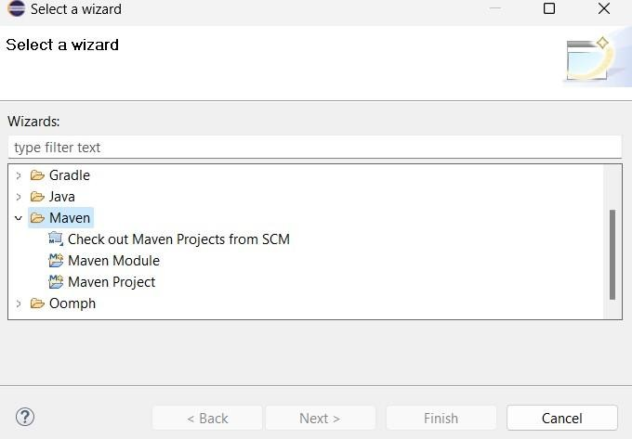

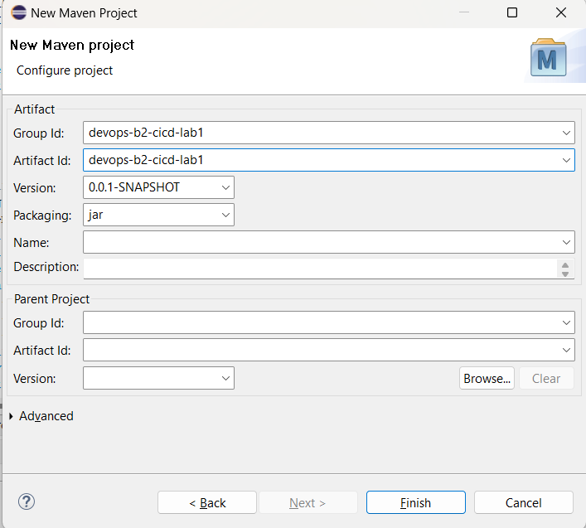

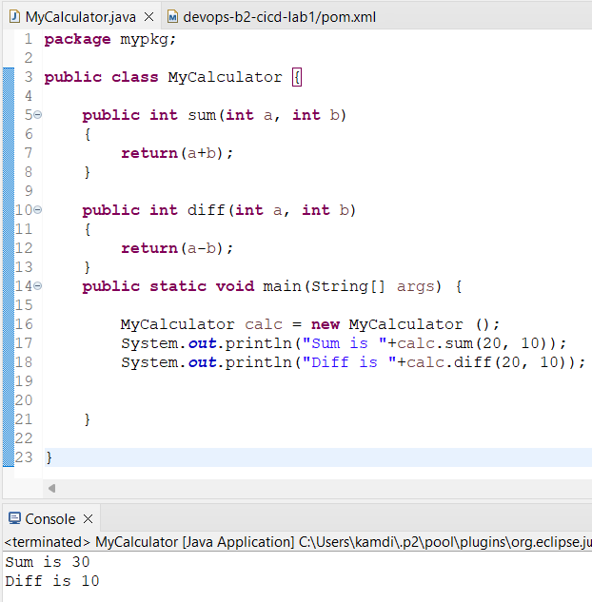

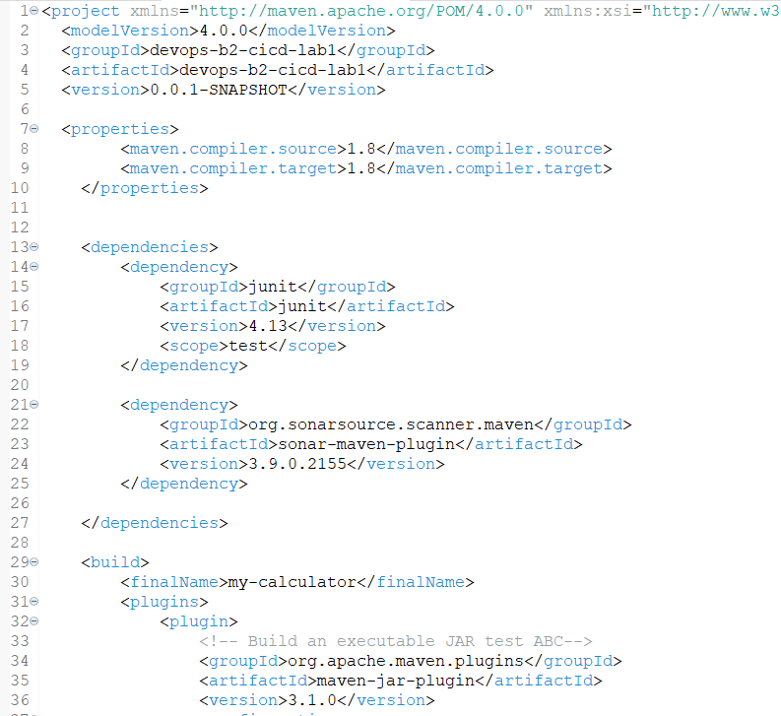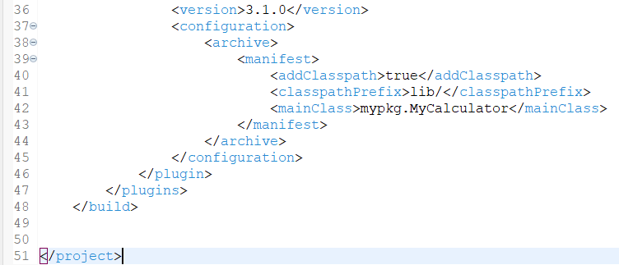

1. **Push project on github.**

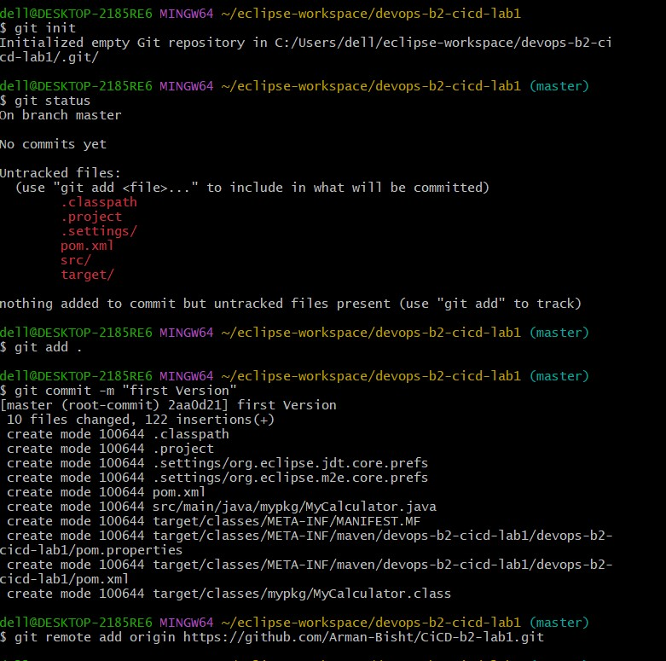

1. **Start Jenkins and add maven Integration Plugin and create a maven project name as “Cicd-lab1” and add URL of our repo in github and configure it.**

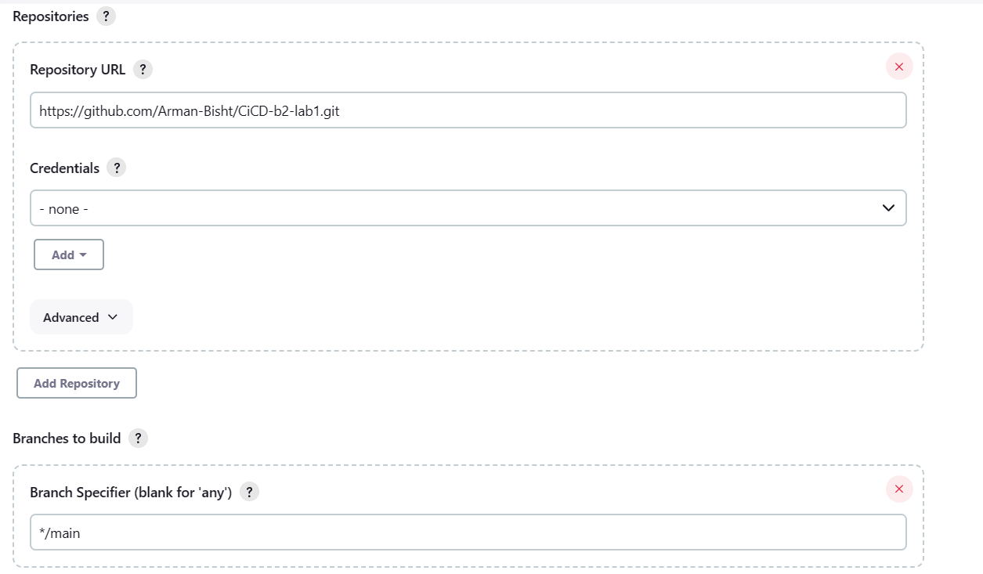

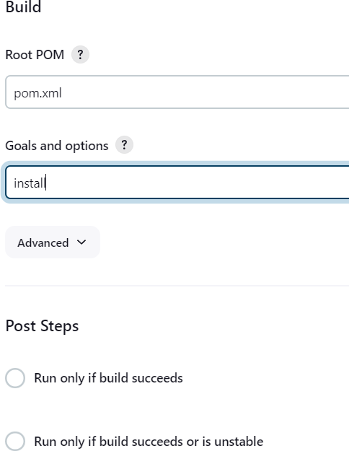

1. **Now Build it.**

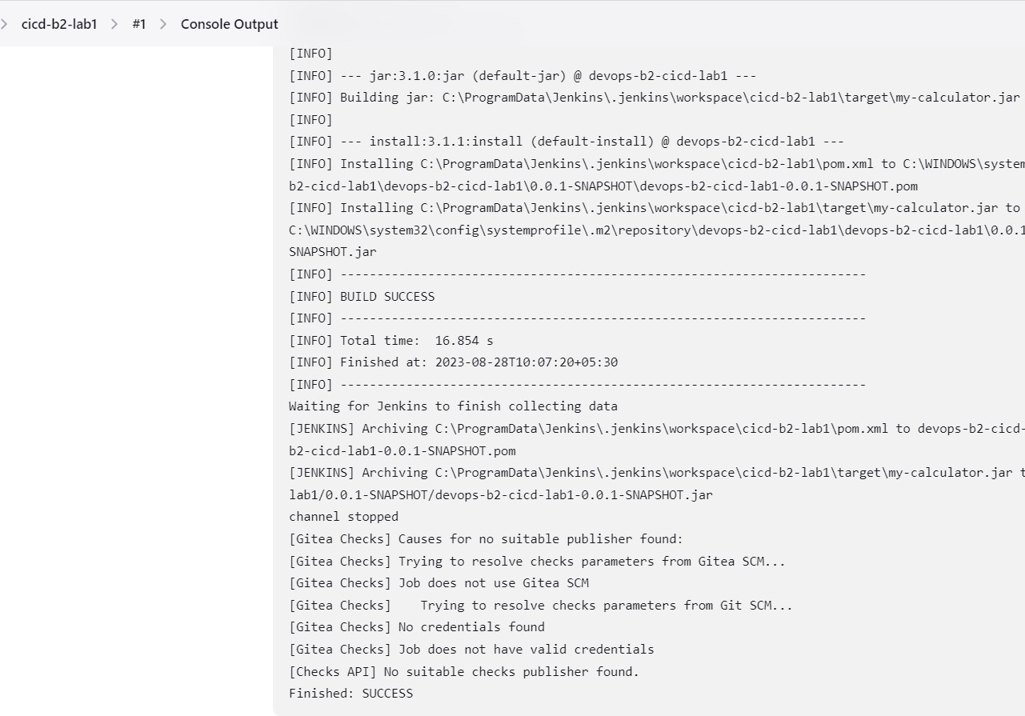

1. **edit the code and add poll scm in jenkins configuration then again commit and push it.**

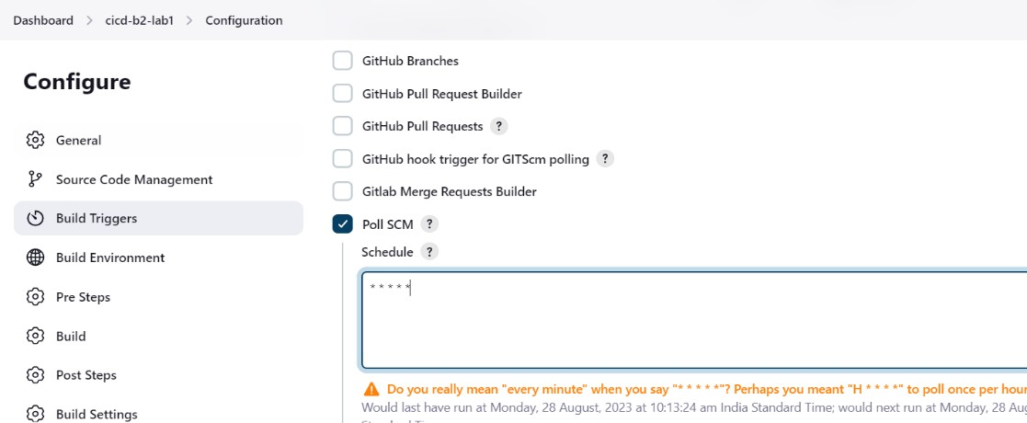

1. **After push we can see it will make automatic build.**

