EXPERIMENT – 2

|  |
| --- |
| Name: - Arman Bisht |
| Batch – 2 [DevOps Non-Hons] |
| SAP ID- 50009031 |
| Subject – Continuous Integration and Continuous Delivery Lab |

**Aim: Creating a Jenkins Pipeline with a Jenkins file.**

1. **Create a Maven Project in eclipse.**

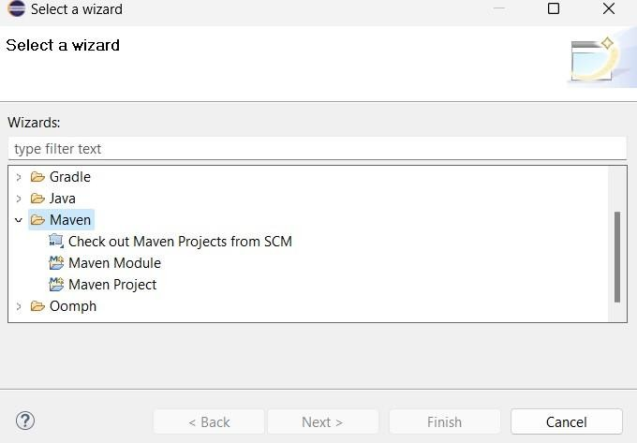

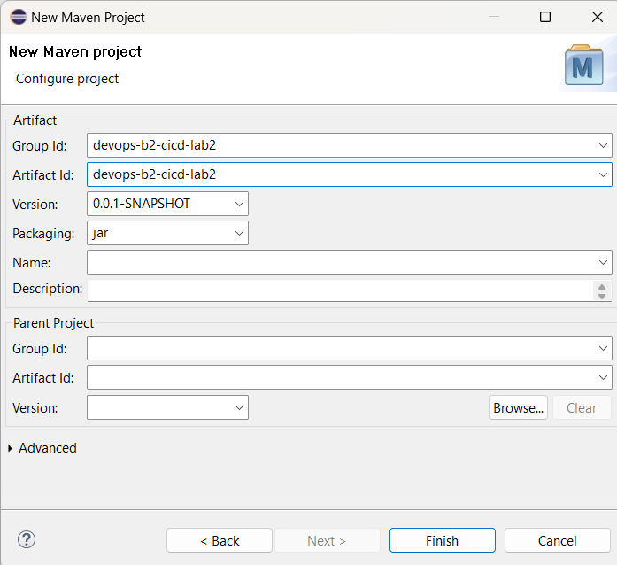

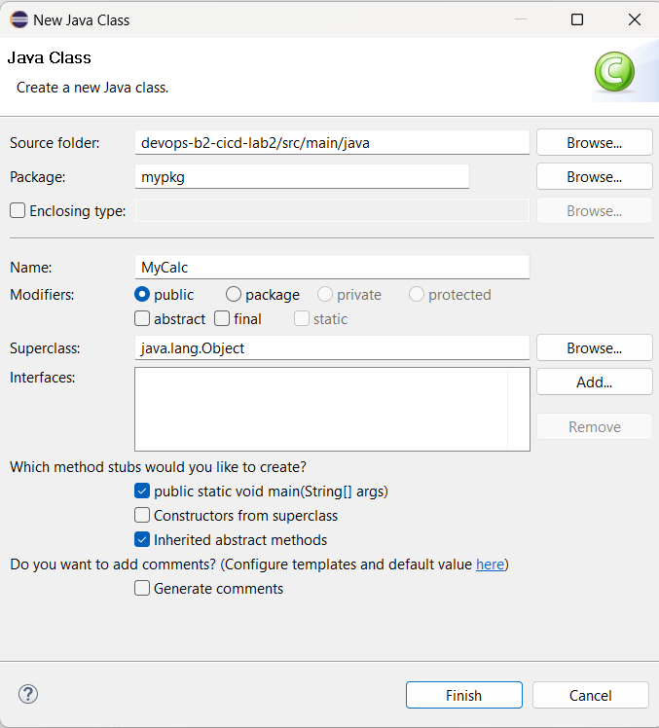

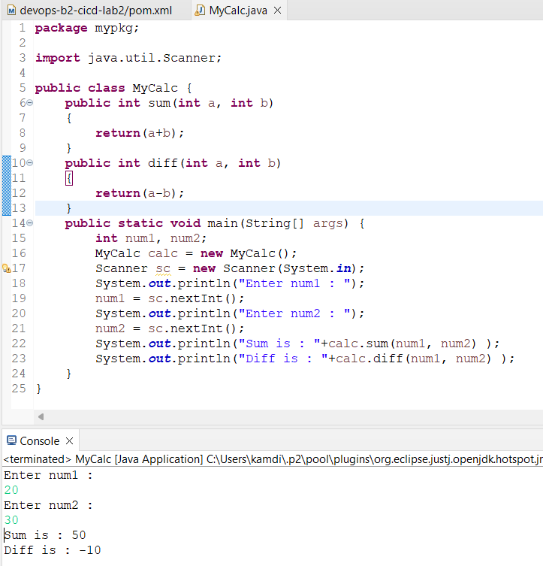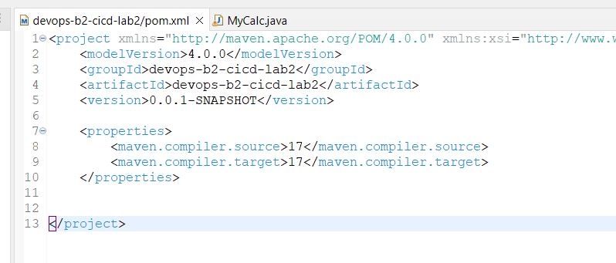

1. **Make a repo name as “CICD-Lab2_Jenkinsfile” and Push project on github.**

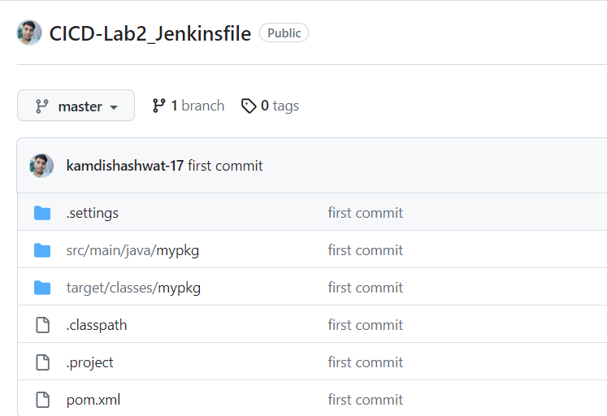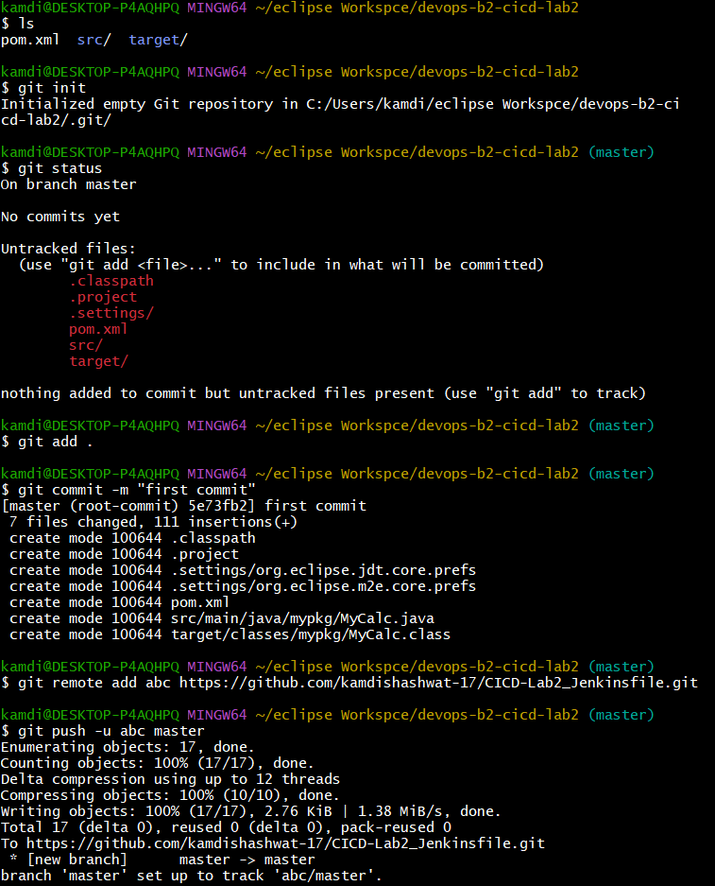

1. **Add Maven integration and Git plugin in Jenkins , configure repo and make a build**

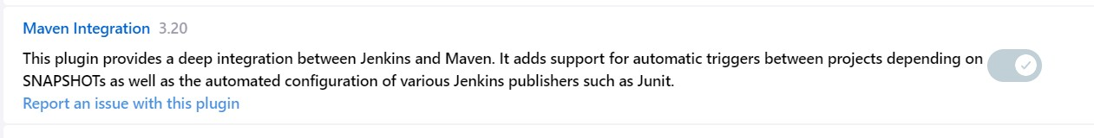



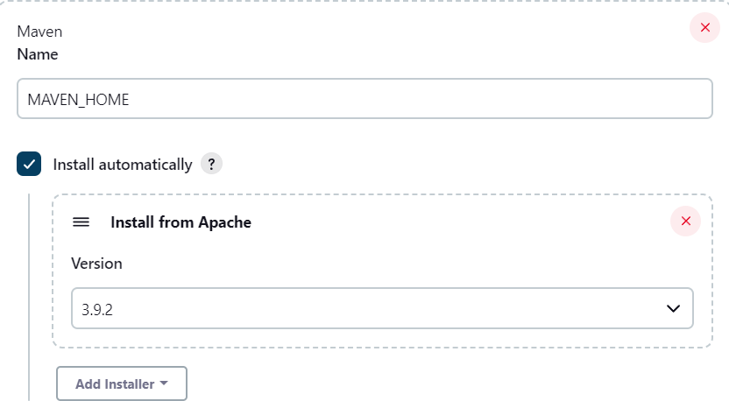

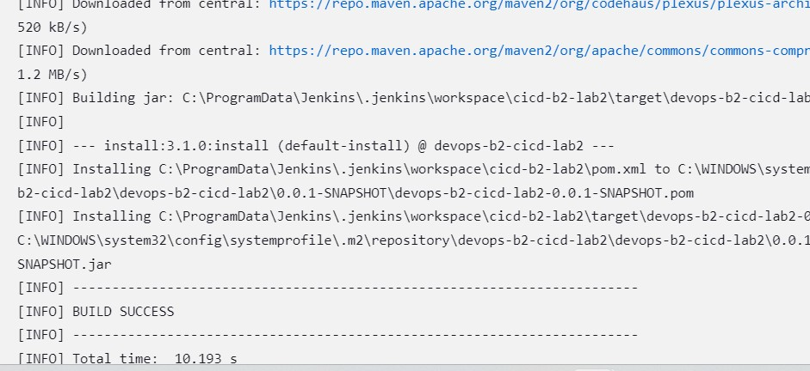

1. **edit the code ,add mul funcion and add poll scm in jenkins configuration then again commit and push it.**

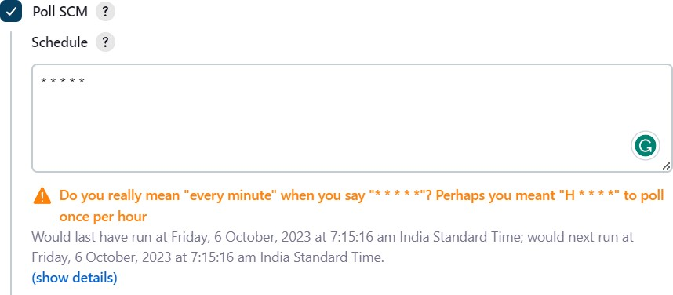

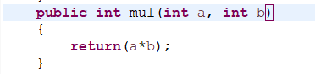

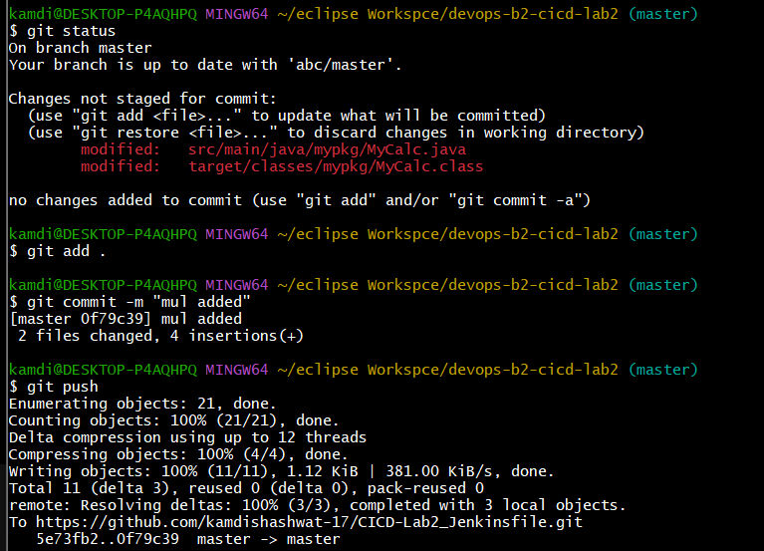

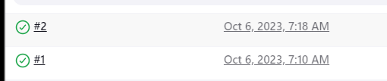

1. **Add Jenkins file then commit and push it , In Jenkins make pipeline add configure it. When you create a pipeline. The pipeline will start.**

