EXPERIMENT – 5

|  |
| --- |
| Name: - Arman Bisht |
| Batch – 2 [DevOps Non-Hons] |
| SAP ID- 500093031 |
| Subject – Continuous Integration and Continuous Delivery Lab |

**Aim: Master/Slave concept in Jenkins**

1. Create Salve1 and Slave2 folder in your Local drive.

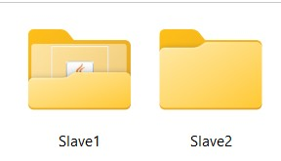

1. Create a New Node and assign node name as Slave1.

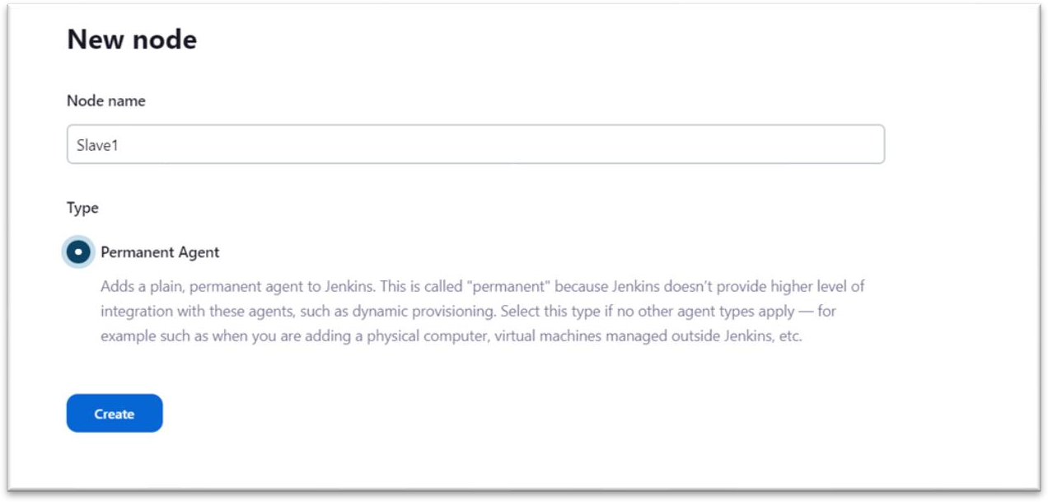

1. Run Agent slave1 command on our command line windows.

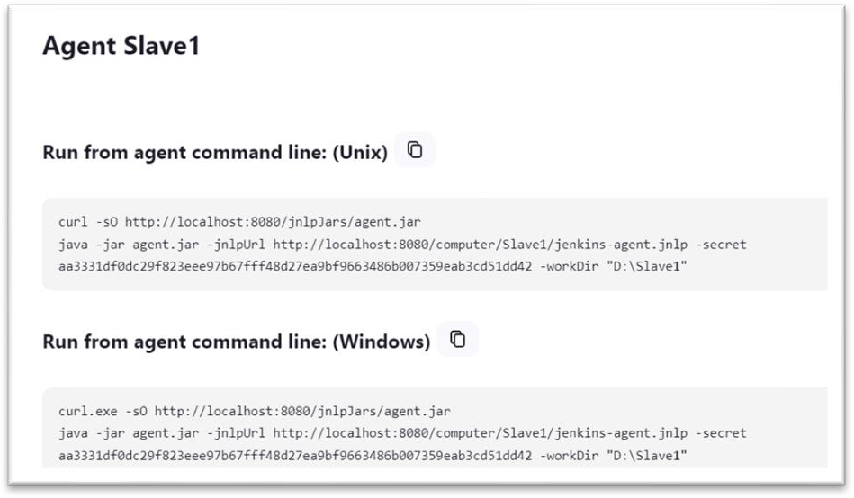.

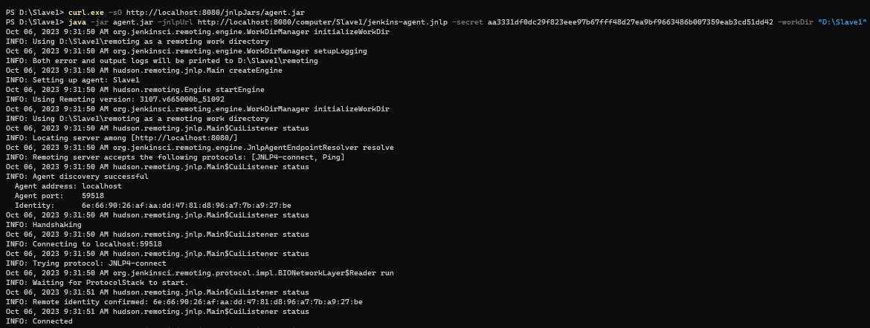

1. On your Jenkins create a new maven project name as cicd-lab5.

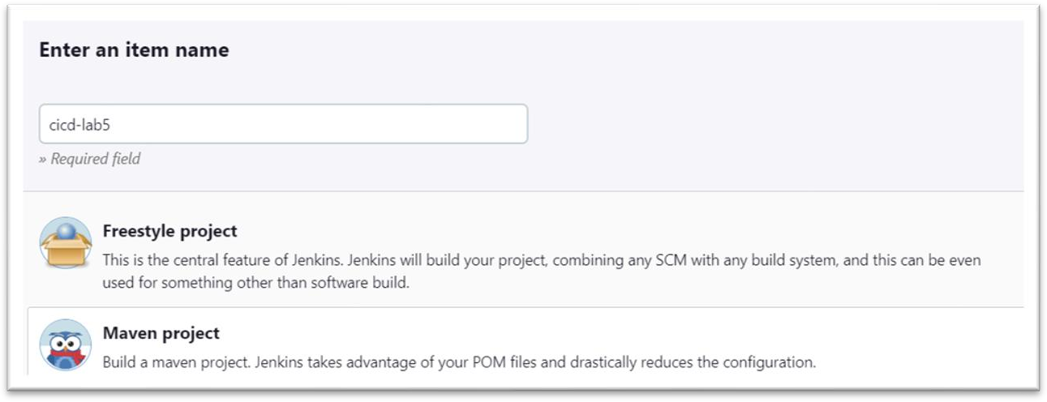

1. Configure it.

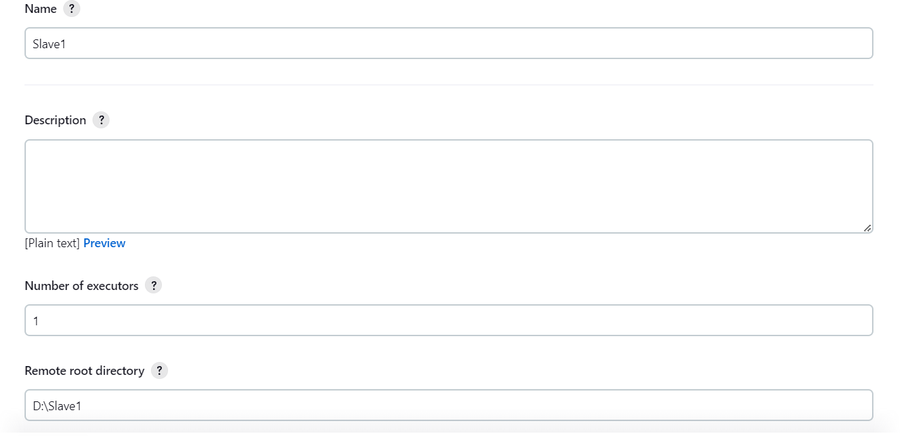

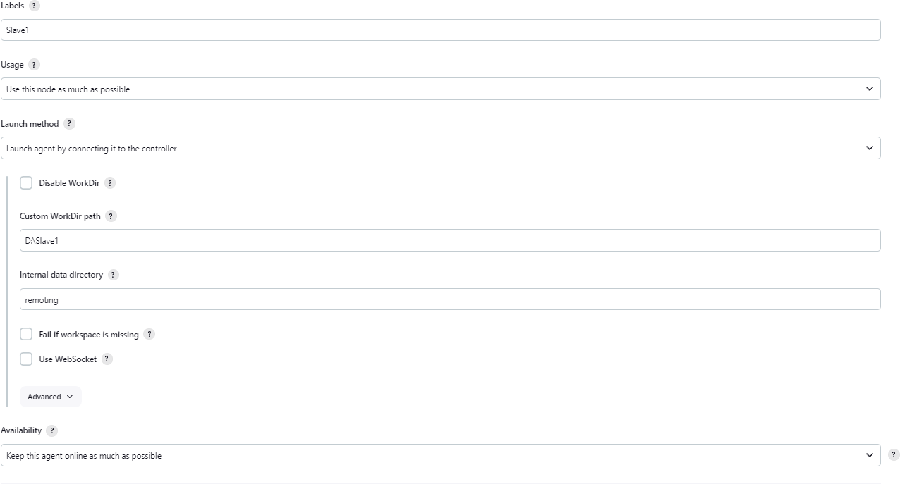

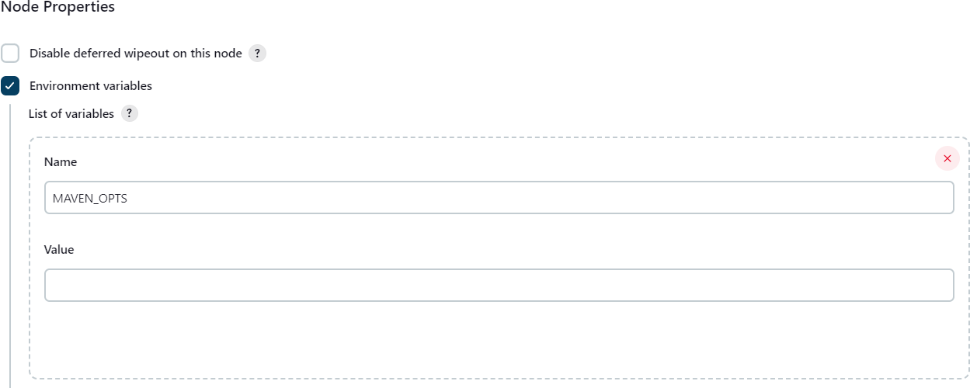

1. Make a build and check the output and Node.

