

CONTINUOUS INTEGRATION AND CONTINUOUS DEPLOYMENT LAB

**Lab File (2023-2024)**

**for**

**5th Semester**

**Submitted By:**

Dhruv Srivastava

B.Tech CSE DevOps B2-NH

500092009

R2142210276

**Submitted To:**

Dr. Hitesh Kumar Sharma

CI/CD Professor, Cluster Head (Cybernetics)

School of Computer Science

Experiment 1

**Setting Up a Jenkins Job for Maven Build**

# Aim

Create a Jenkins job that builds a Maven project using Jenkins and triggers the build on changes in the version control repository.

# Steps

1. Create a maven project
   1. Create the project

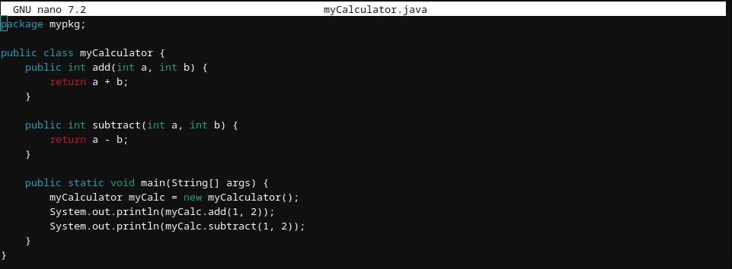

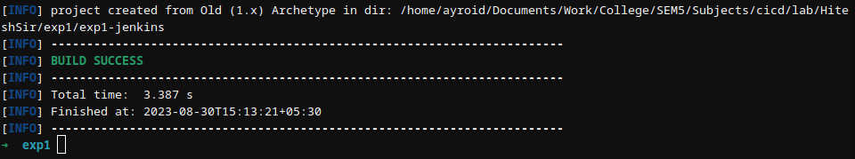

* 1. Create a package mypkg inside src/main/java/ and add myCalculator.java file

1. Push the project on GitHub

a. Create a repository on GitHub

1. In the project run git init command



1. Link the local repository and the remote repository



1. Add, Commit and Push the project

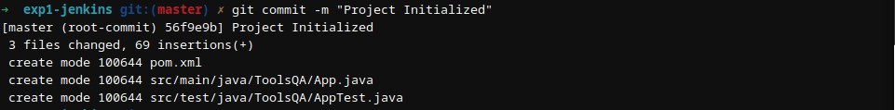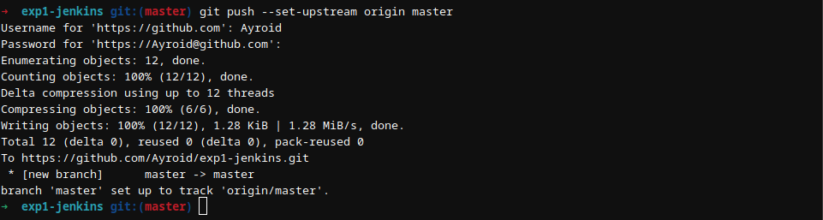

1. Install and start Jenkins



1. Create Jenkins job to clone GitHub project and make a build
   1. Creating a maven project pipeline named CICDLAB-1



* 1. Installing maven integration plugin - Dashboard > Manage Jenkins > Plugins > Available plugins > Maven Integration plugin

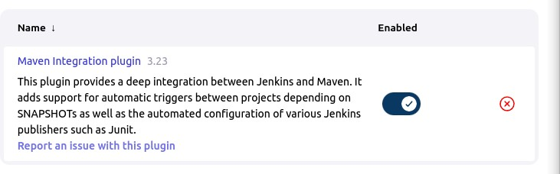

* 1. Configuring the pipeline
     1. Provide GitHub repository url in Dashboard > CICDLAB-1 > Configuration > Source Code Management > Git > Repositories > Repository URL

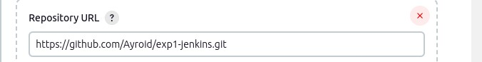

* + 1. Specify the branch in Dashboard > CICDLAB-1 > Configuration > Source Code Management > Git > Branches to build > Branch Specifier

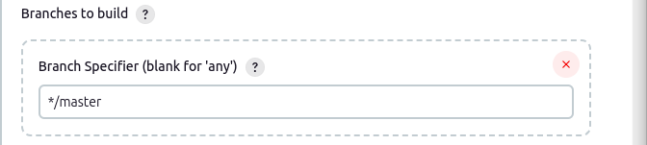

* + 1. Specify Build Goal in Dashboard > CICDLAB-1 > Configuration > Build > Goals and options



* + 1. Save the changes

1. 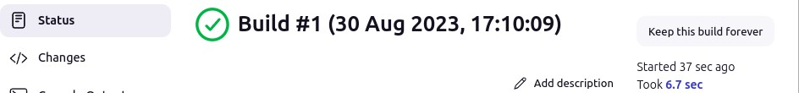Execute the build
2. Add Build Trigger for automated builds by scheduling them in Dashboard > CICDLAB-1 > Configuration > Build Triggers > Poll SCM > Schedule

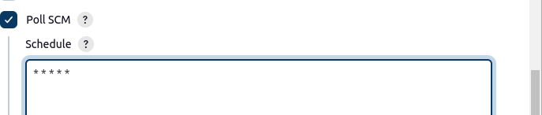

1. Make changes to the project

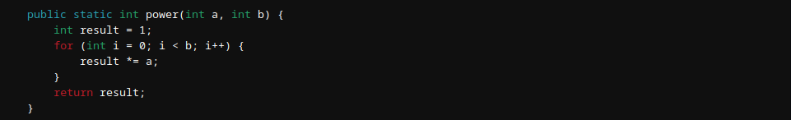

1. Commit and Push the changes

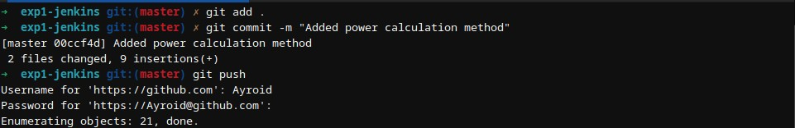

1. An automated build is triggered

