

CONTINUOUS INTEGRATION AND CONTINUOUS DEPLOYMENT LAB

**Lab File (2023-2024)**

**for**

**5th Semester**

**Submitted By:**

Dhruv Srivastava

B.Tech CSE DevOps B2-NH

500092009

R2142210276

**Submitted To:**

Dr. Hitesh Kumar Sharma

CI/CD Professor, Cluster Head (Cybernetics)

School of Computer Science

Experiment 2

**Creating a Jenkins Pipeline with a Jenkinsfile**

# Aim

Create a Jenkins pipeline using a Jenkinsfile that builds a simple project, runs tests, and deploys the project to a designated environment

# Steps

1. Create a maven project
   1. Create the project

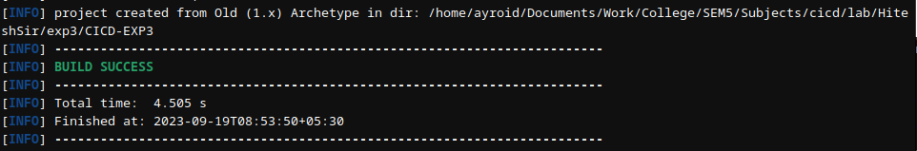

* 1. Create a package DevOps inside src/main/java/ and add App.java file

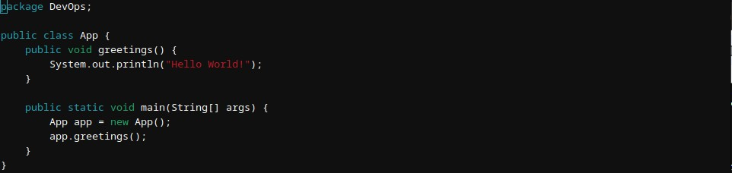

1. Create a Jenkinsfile and write the steps to be executed in it

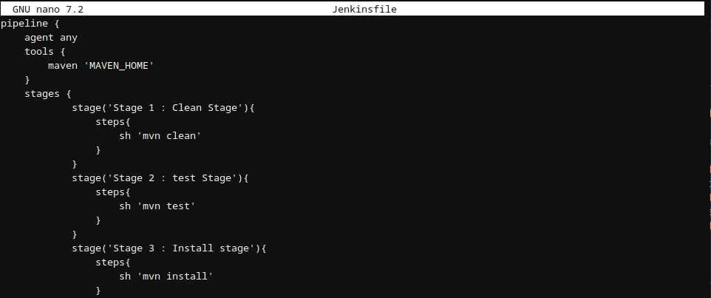

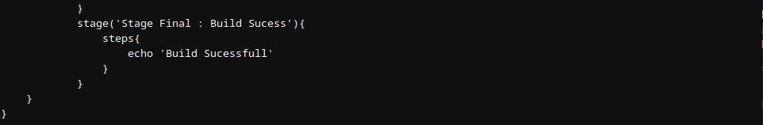

1. Create a GitHub Repository



1. Create a Jenkins Pipeline
   1. Create a pipeline

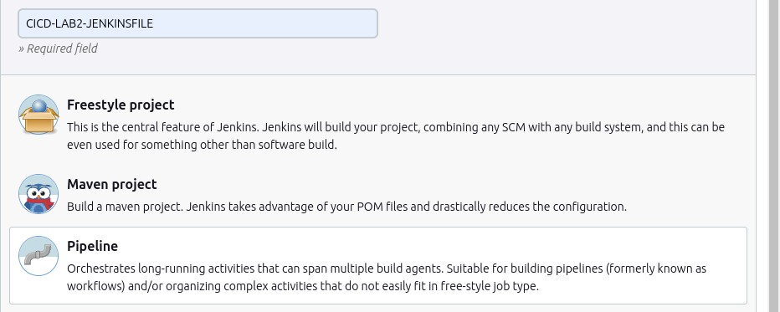

* 1. Add the project url

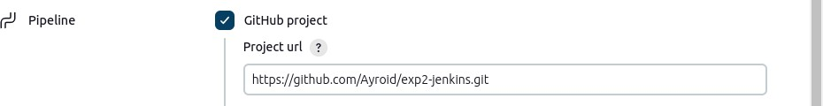

* 1. Configure the build trigger to poll scm and set it to perform build every minute



* 1. Specify the path to Jenkinsfile in the project

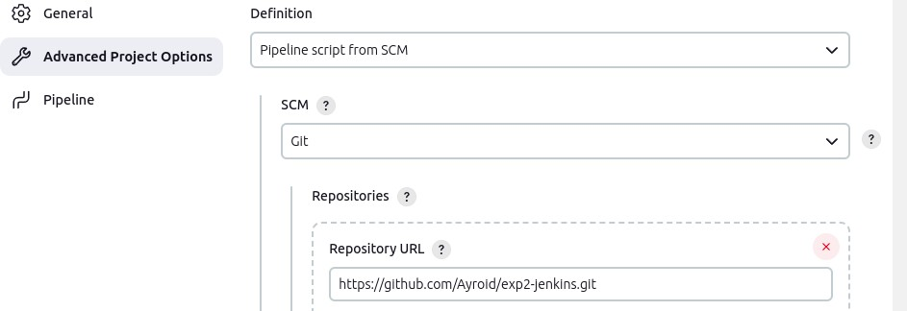



* 1. Save the pipeline

1. Commit and push the changes of the project on GitHub

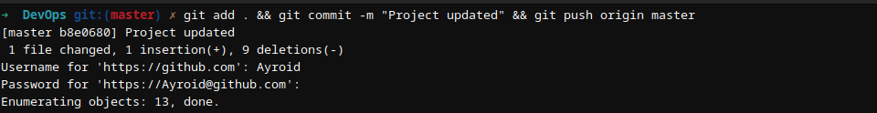

1. An automatic build is triggered

