

CONTINUOUS INTEGRATION AND CONTINUOUS DEPLOYMENT LAB

**Lab File (2023-2024)**

**for**

**5th Semester**

**Submitted By:**

Dhruv Srivastava

B.Tech CSE DevOps B2-NH

500092009

R2142210276

**Submitted To:**

Dr. Hitesh Kumar Sharma

CI/CD Professor, Cluster Head (Cybernetics)

School of Computer Science

Experiment 3

**Maven Build using GitHub Actions**

# Aim

Set up a GitHub Actions workflow to automatically build a Maven project whenever changes are pushed to a GitHub repository.

# Steps

1. Create a maven project
   1. Create the project

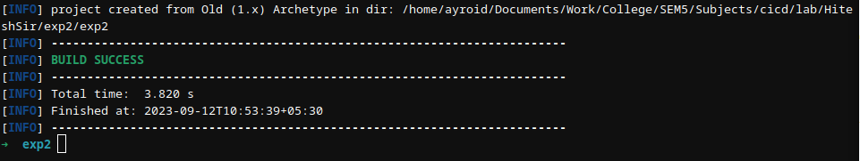

* 1. Create a package DevOps inside src/main/java/ and add App.java file

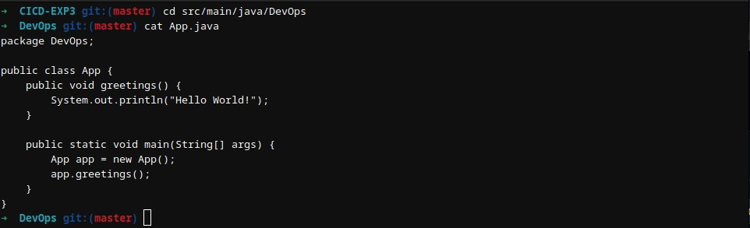

* 1. Configure the pom.xml



1. Create a Git Repository



1. Commit and Push the changes on GitHub

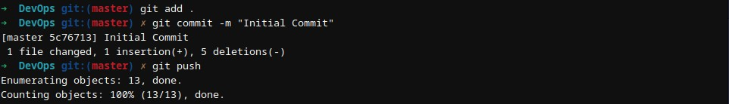

1. Setup GitHub workflow for the project
   1. On GitHub repository, Go to Actions tab

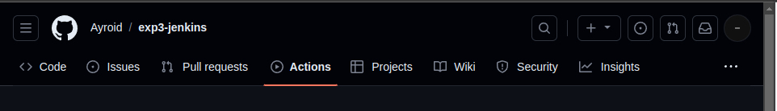

* 1. Select Java with Maven and click on Configure

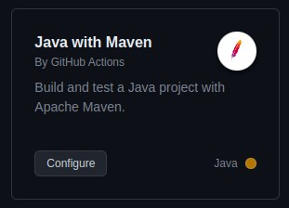

* 1. Configure the maven.yml file & commit the changes

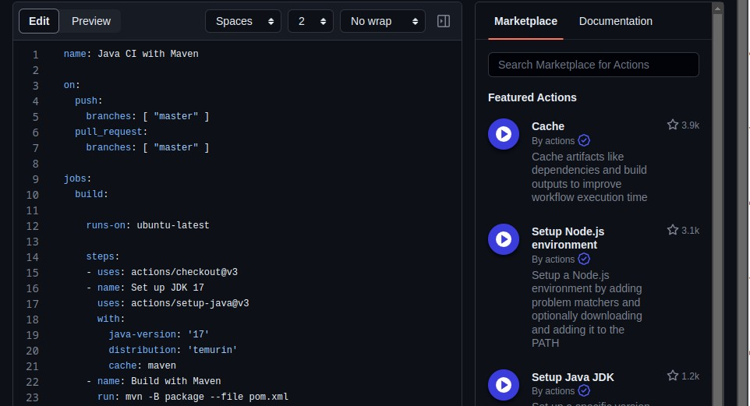

* 1. An automatic build will be triggered

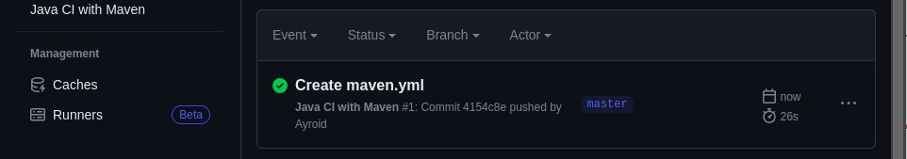

1. Pull the updated code on local machine

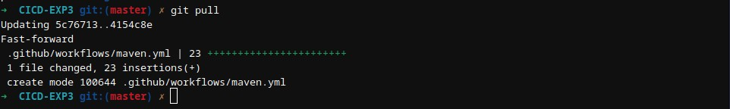

1. Update the source code and push it on GitHub

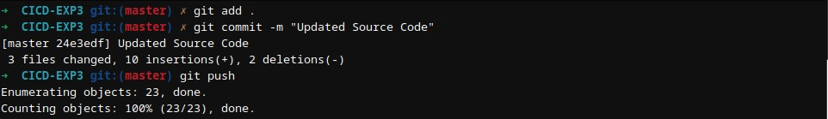

1. Another automatic build will be triggered

