

CONTINUOUS INTEGRATION AND CONTINUOUS DEPLOYMENT LAB

**Lab File (2023-2024)**

**for**

**5th Semester**

**Submitted By:**

Dhruv Srivastava

B.Tech CSE DevOps B2-NH

500092009

R2142210276

**Submitted To:**

Dr. Hitesh Kumar Sharma

CI/CD Professor, Cluster Head (Cybernetics)

School of Computer Science

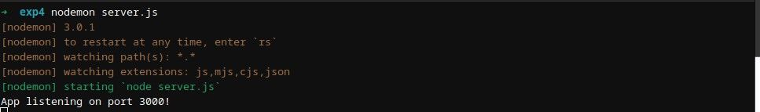Experiment 4

**Docker Build and Push using GitHub Actions**

# Aim

Set up a GitHub Actions workflow to automatically build a Docker image from a Dockerfile in your GitHub repository and push it to a container registry (e.g., Docker Hub).

# Steps

1. Create a project, Add Dockerfile and Push it on GitHub
   1. Create the project

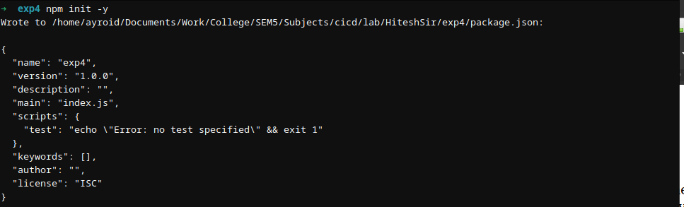

* 1. Install the packages

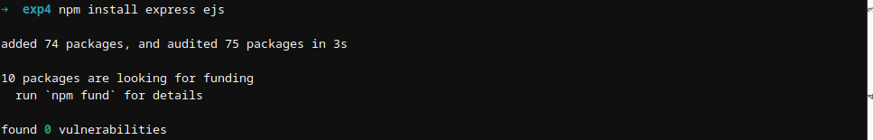

* 1. Add the server.js file that runs a basic server that renders index.ejs file present inside views folder



* 1. Run & test the server

2. Create a Git Repository

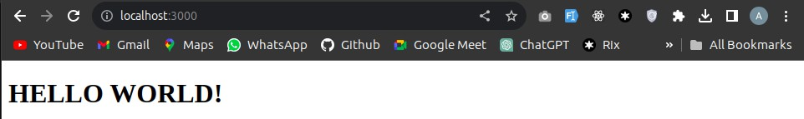

* 1. Add a Dockerfile & write the configuration to run the project

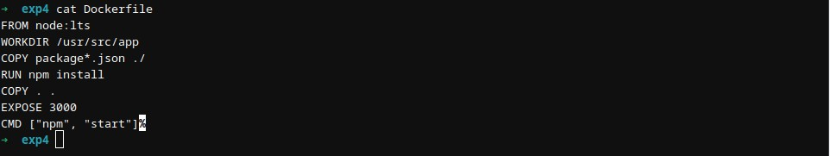

* 1. Build & run the image using Dockerfile to test the application

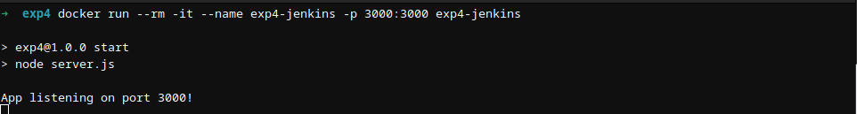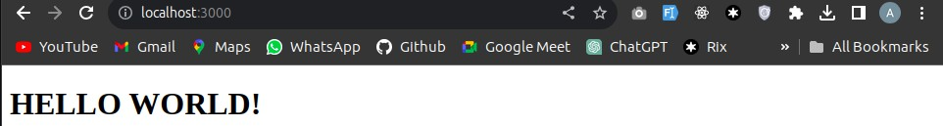

* 1. Create a GitHub repository and push the code to it

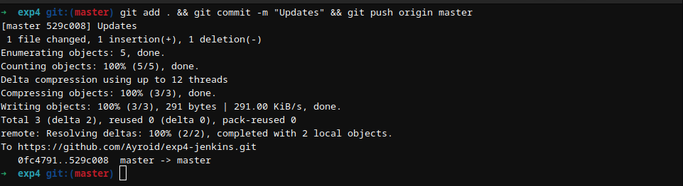

1. Create Docker Hub Access Token
   1. Log in to your Docker Hub account.
   2. Go to your account settings and click on the "Security" tab.
   3. Under "Access Tokens," click "New Access Token." Give it a name, select the required permissions (e.g., "Write" for pushing Docker images), and click "Create."
   4. Copy the generated access token. You will need it to authenticate with Docker Hub in your GitHub Actions workflow.

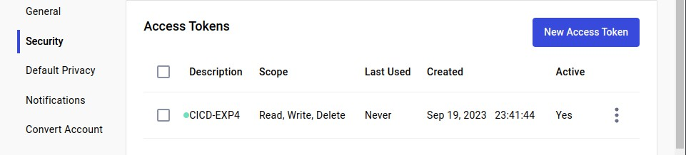

1. Create a GitHub Actions Workflow
   1. Create a directory named .github/workflows



* 1. Create a YAML file inside this directory



* 1. Write the necessary configuration in it

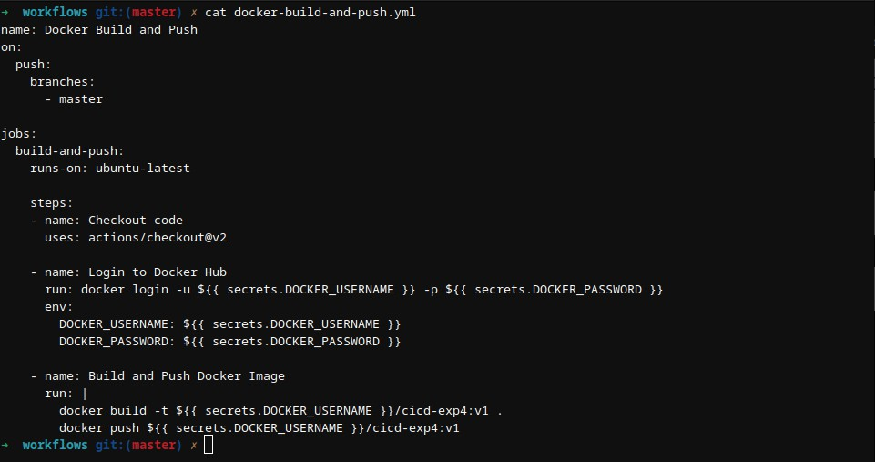

1. In the GitHub repository setup the Docker Username and Password as secrets

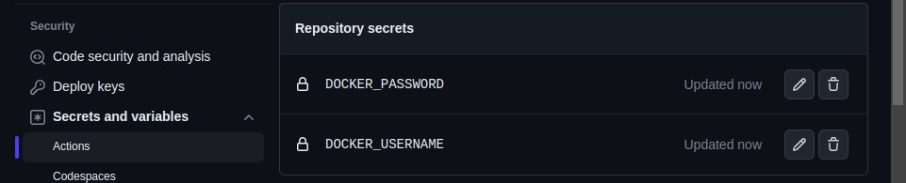

1. Commit and Push Changes

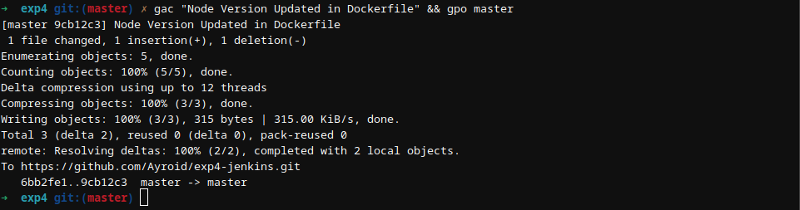

1. Check the Workflow Status

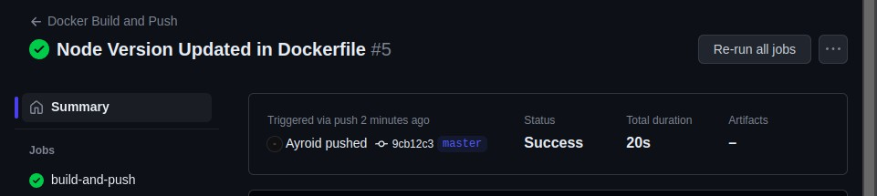

1. Verify the Docker Image on Docker Hub

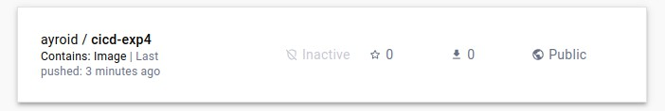

1. Triggering another build to verify

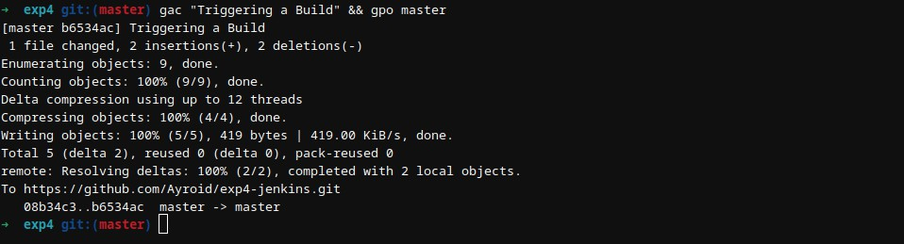

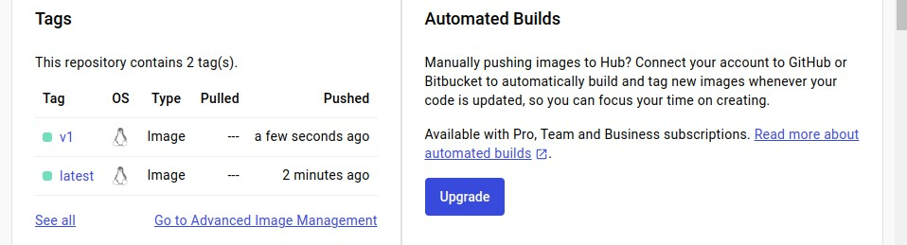

An image with v1 tag is created on DockerHub.