

CONTINUOUS INTEGRATION AND CONTINUOUS DEPLOYMENT LAB

**Lab File (2023-2024)**

**for**

**5th Semester**

**Submitted By:**

Dhruv Srivastava

B.Tech CSE DevOps B2-NH

500092009

R2142210276

**Submitted To:**

Dr. Hitesh Kumar Sharma

CI/CD Professor, Cluster Head (Cybernetics)

School of Computer Science

Experiment 5

**Jenkins Master-Slave**

# Aim

To understand the Master-Slave methodology of Jenkins

# Steps

1. Create a Slave Node on Jenkins
   1. Go to Dashboard > Manage Jenkins > Nodes > New Node
   2. Give a name to the node, select Permanent Agent & click Create

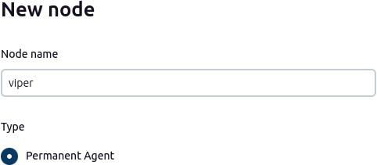

* 1. Provide the root directory path & label

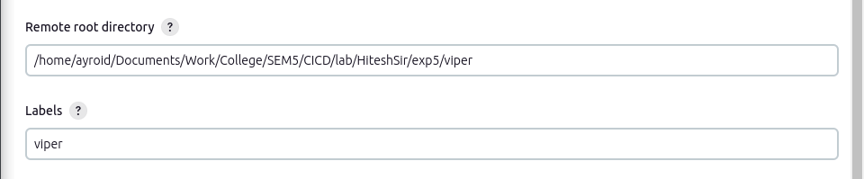

* 1. Provide Custom WorkDir path

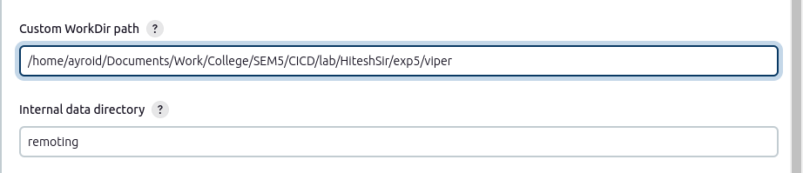

* 1. Run the following commands at the location of root directory





* 1. Your agent should be up and running

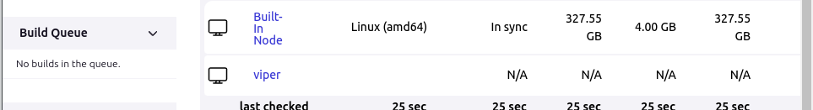

1. Create another agent following the above steps

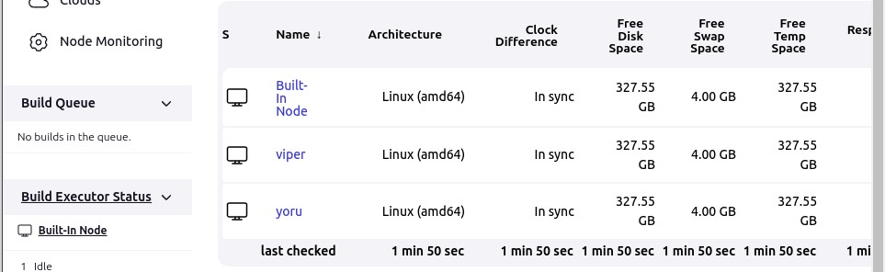

1. Create a Maven Project Pipeline and restrict it to run on one of the agents

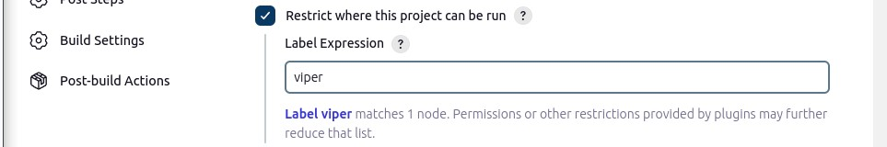

1. Run a build to verify the pipeline



1. Create another Maven Project Pipeline on the 2nd agent



1. Run a build to verify both the agents

