

CONTINUOUS INTEGRATION AND CONTINUOUS DEPLOYMENT LAB

**Lab File (2023-2024)**

**for**

**5th Semester**

**Submitted By:**

Dhruv Srivastava

B.Tech CSE DevOps B2-NH

500092009

R2142210276

**Submitted To:**

Dr. Hitesh Kumar Sharma

CI/CD Professor, Cluster Head (Cybernetics)

School of Computer Science

Experiment 6

**Job Chaining in Jenkins**

# Aim

To understand and practice job chaining in Jenkins.

# Steps

1. Create a Maven Project pipeline E6J1

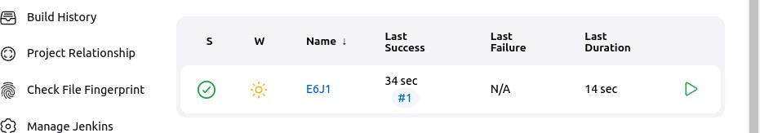

1. Create another pipeline E6J2
   1. Choose Build Triggers > Build after other projects are built

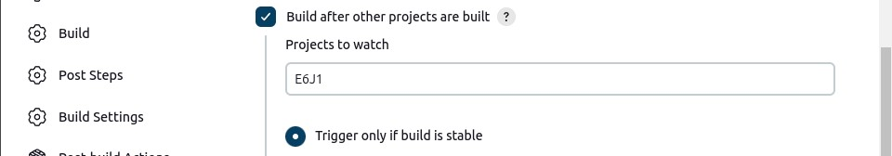

* 1. Previous job is now showing as Upstream Project in the new job

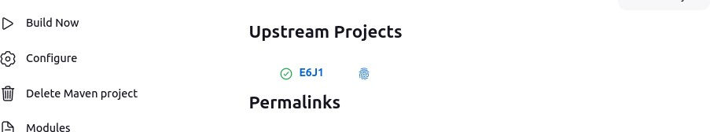

1. Test the chain by building the first pipeline

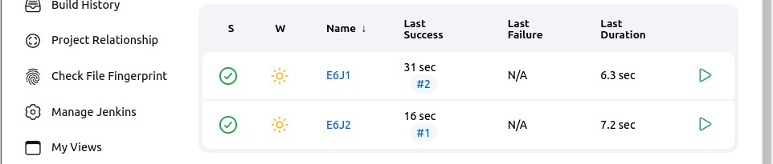

1. Create 2 more pipelines E6J3 and E6J4, creating a longer and branched chain
   1. Add E6J2 as upstream in E6J3

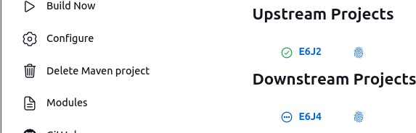

* 1. Add E6J2 and E6J3 as upstream in E6J4

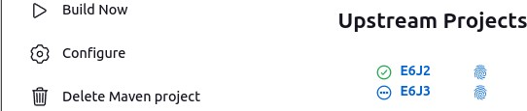

1. Test the complete pipeline chain by running E6J1

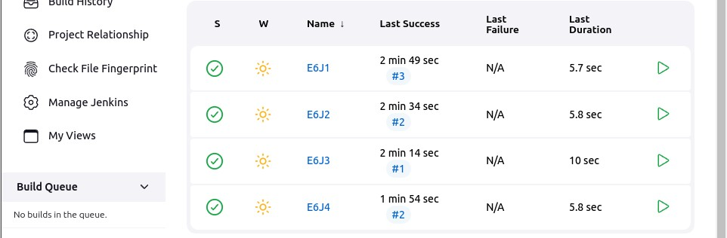

1. Checking logs
   1. E6J1 triggered E6J2 once it succeeded



* 1. Similarly others were also triggered
     1. E6J2 logs



* + 1. E6J3 logs

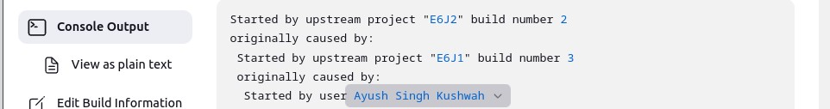

* + 1. E6J4 logs

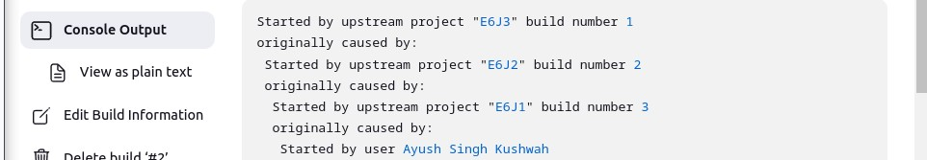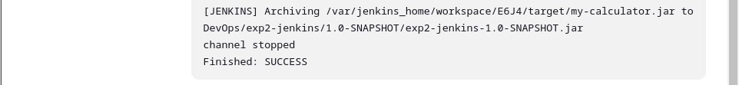

1. Cleaning up the jobs

