

CONTINUOUS INTEGRATION AND CONTINUOUS DEPLOYMENT LAB

**Lab File (2023-2024)**

**for**

**5th Semester**

**Submitted By:**

Dhruv Srivastava

B.Tech CSE DevOps B2-NH

500092009

R2142210276

**Submitted To:**

Dr. Hitesh Kumar Sharma

CI/CD Professor, Cluster Head (Cybernetics)

School of Computer Science

# Aim

Experiment 7

**Email Notifications in Jenkins**

To understand and practice setting up email.

# Steps

1. Install Email Extension & Email Extension Template Plugin

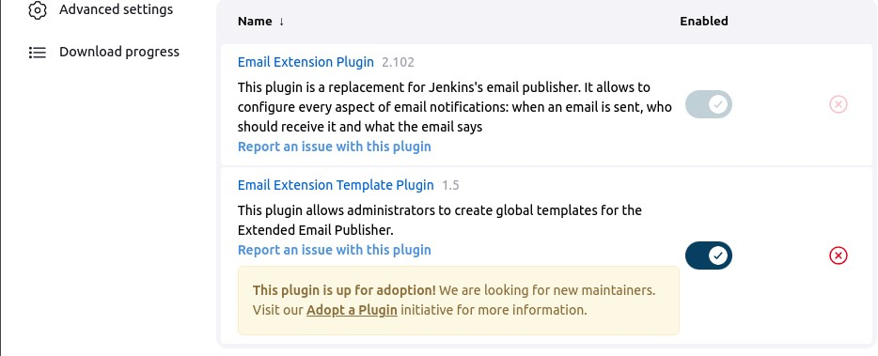

1. Configure the SMTP Server by going to Dashboard > Manage Jenkins > System > Email Notification

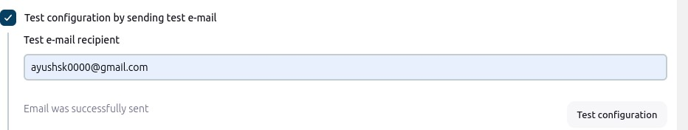

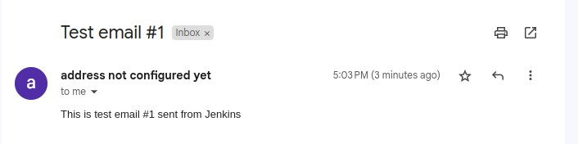

1. Create a job and add email in Build Settings

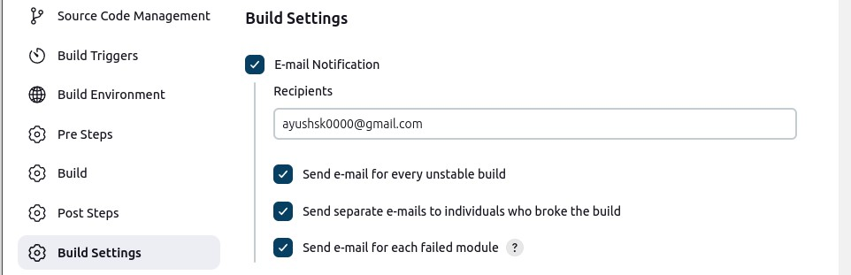

1. Add a Post Build Step for sending Editable Email Notification & add email

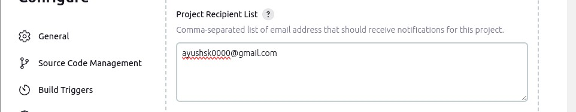

1. Test the mail by intentionally failing a build

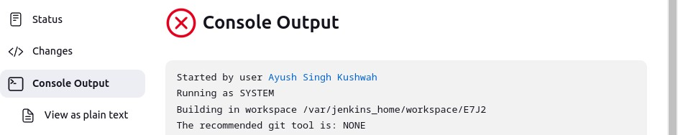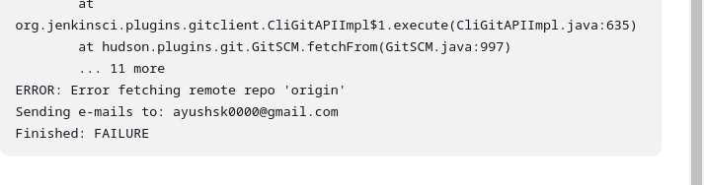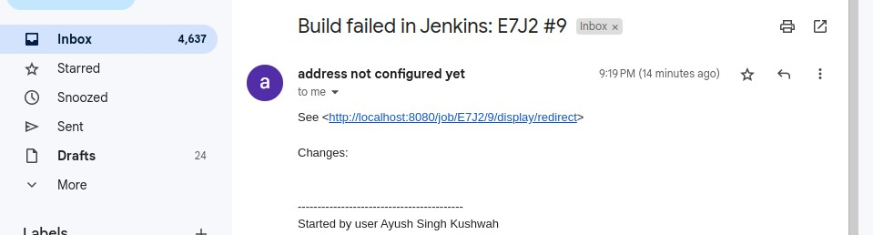

Build log is also attached to the mail

