**Lab Experiment 1**

**Setting Up a Jenkins Job for Maven Build**

**Objective: Create a Jenkins job that builds a Maven project using Jenkins and triggers the build on changes in the version control repository.**

**STEP 1: Create and compile a maven project.**

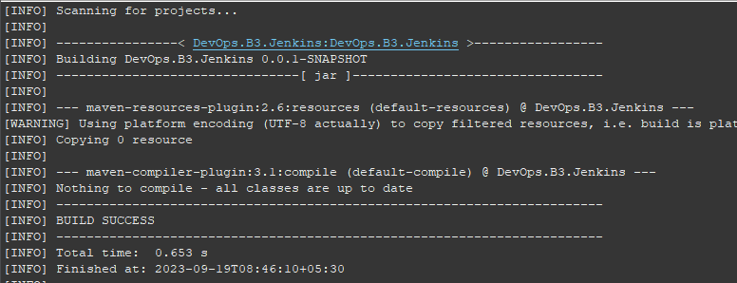

**STEP 2: Create a GitHub repository and push the project in it.**

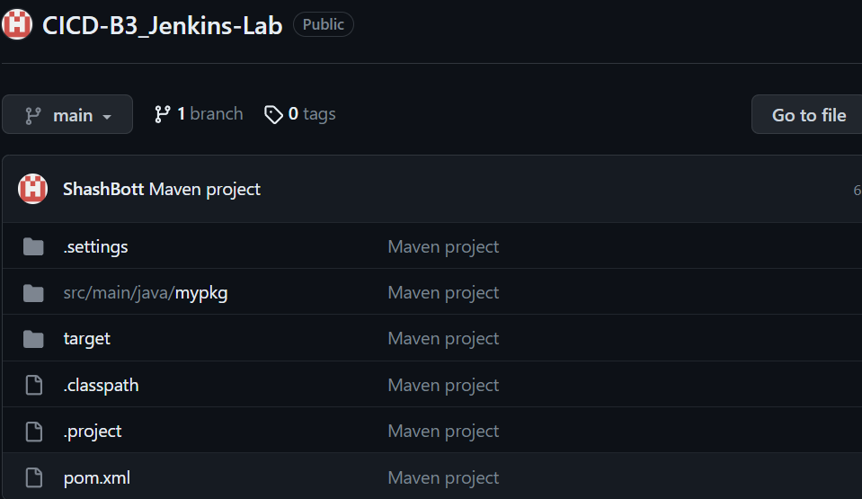

**STEP 3: Create a Jenkins pipeline. (for this part we select Maven Project)**

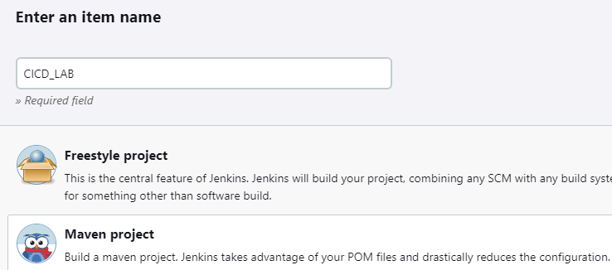



**STEP 4: Check the GitHub project option and add the repository link for GitHub.**

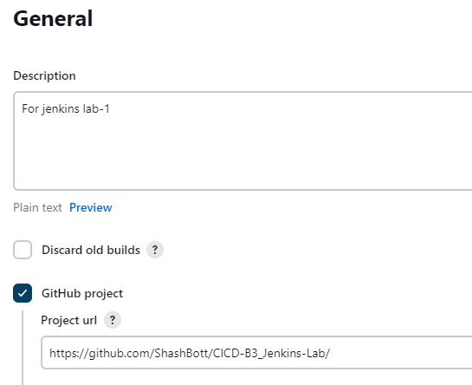

**STEP 5: Check the Git option and provide the URL.**

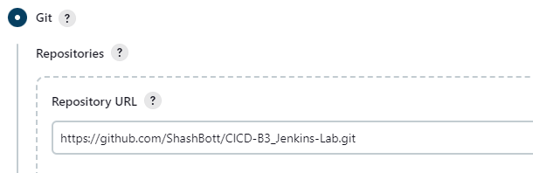

**STEP 6: Setup the build trigger.**

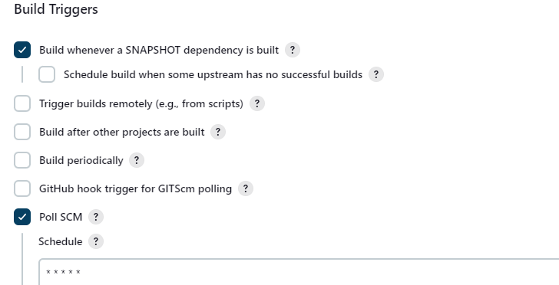

**STEP 7: Add path for POM file and maven command according to the requirement.**

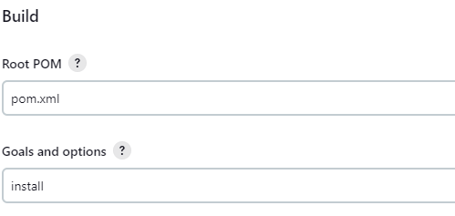

**STEP 8: Click on build now from the pipeline**

