**Lab Experiment 2**

**Creating a Jenkins Pipeline with a Jenkinsfile**

**Objective: Create a Jenkins pipeline using a Jenkinsfile that builds a simple project, runs tests, and deploys the project to a designated environment.**

**STEP 1: Create and compile a maven project.**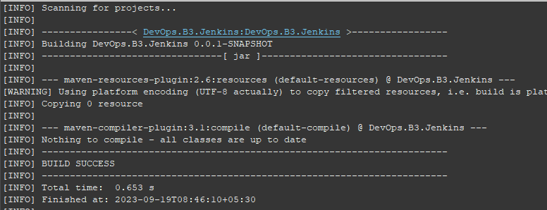

**STEP 2: Create a Jenkinsfile and write the following commands in it to create a pipeline.**

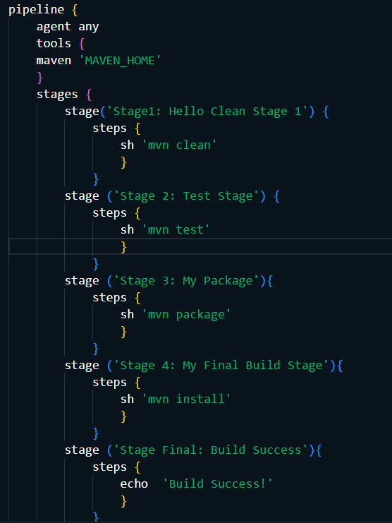

**STEP 3: Create a GitHub repository to push the project.**



**STEP 4: Create a Jenkins pipeline.**

1. **Create a pipeline.**

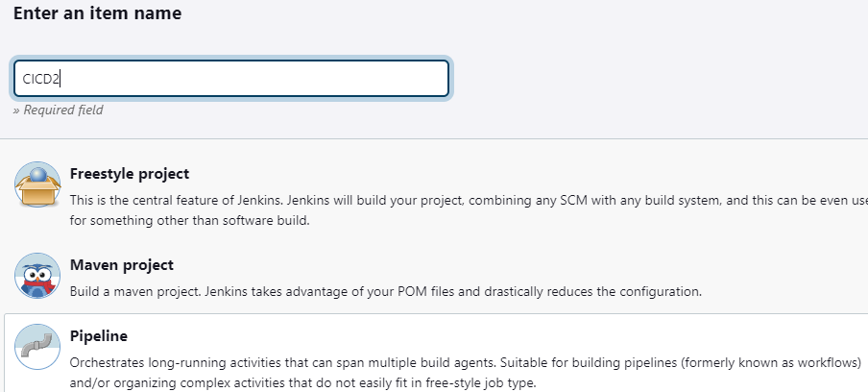

1. **Add the project URL.**

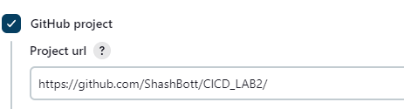

1. **Configure the build trigger to poll scm to make it to perform build every minute.**

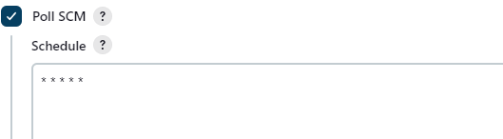

1. **Specify the path to Jenkinsfile which is in your GitHub project.**

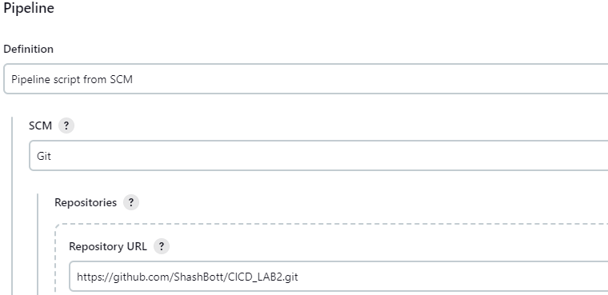

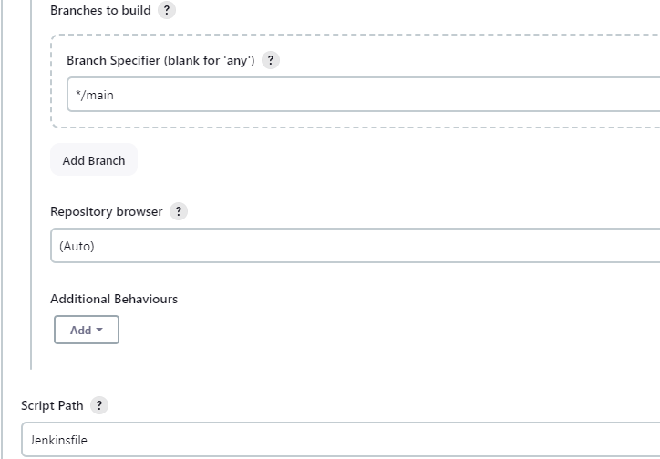

1. **Save the pipeline.**

**STEP 5: Commit and push the changes on GitHub repository that you created.**

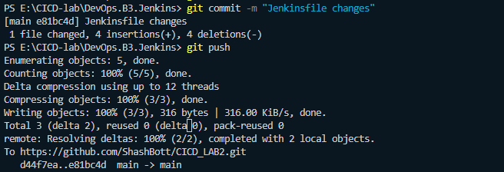

**STEP 6: An automatic build is triggered.**

