**Lab Experiment 3**

**Maven Build using GitHub Actions**

**Objective: Set up a GitHub Actions workflow to automatically build a Maven project whenever changes are pushed to a GitHub repository.**

**STEP 1: Create and build a maven project.**

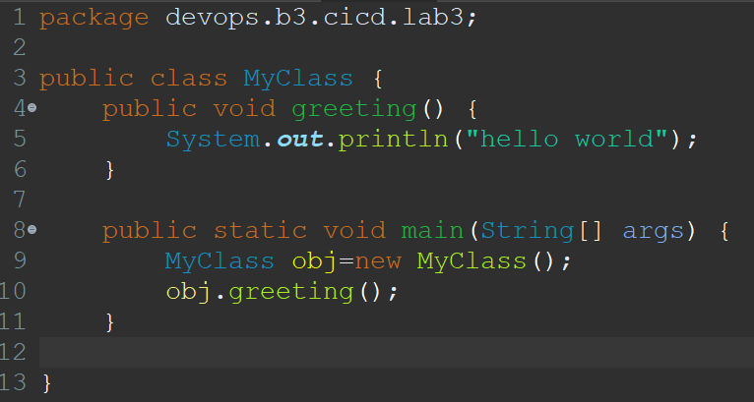

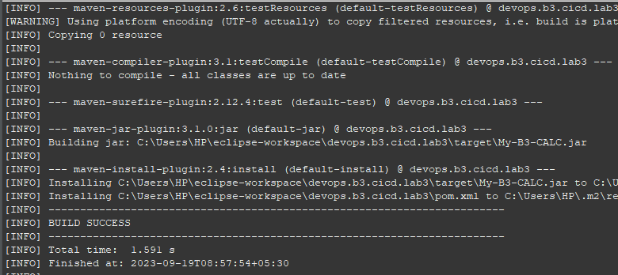

**STEP 2: Create a GitHub repository to deploy your maven project.**



**STEP 3: Push the project to your GitHub repository.**

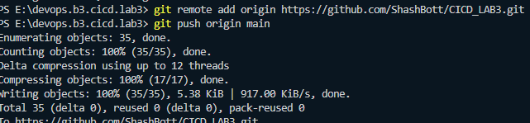

**STEP 4: Go to GitHub Actions and configure Java with Maven i.e create a GitHub Actions Workflow.**



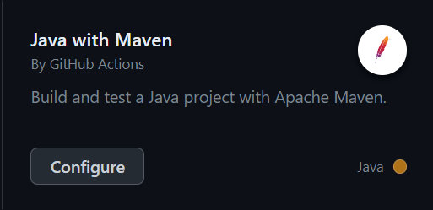

**STEP 5: Edit and make changes to the maven.yml like changing the name of the branch mentioned to the one you are using.**

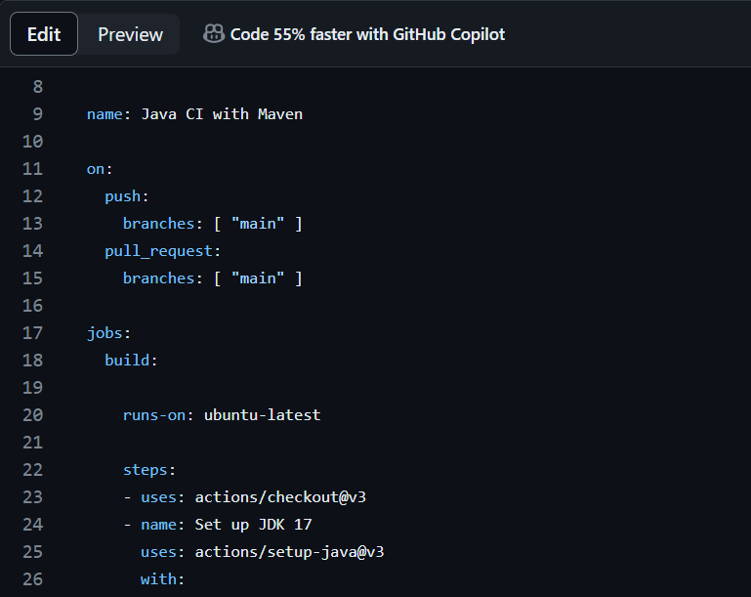

**STEP 6: Commit the changes made to maven.yml, a new directory named workflows will be established.**



**STEP 7: Check the workflow status and verify the build artifacts.**

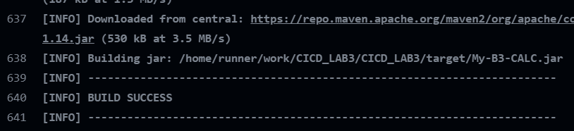

**STEP 8: Trigger a build to test the workflow.**