**Lab Experiment 4**

**Docker Build and Push using GitHub Actions**

**Objective: Set up a GitHub Actions workflow to automatically build a Docker image from a Dockerfile in your GitHub repository and push it to a container registry (e.g., Docker Hub).**

**STEP 1: Create a GitHub repository and one in docker.**

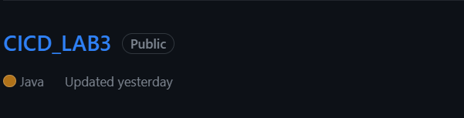

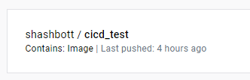

**STEP 2: Create dockerhub access token.**

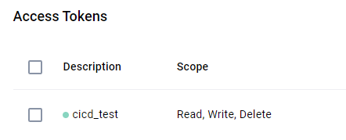

**STEP 3: Create a Dockerfile which will build an image.**

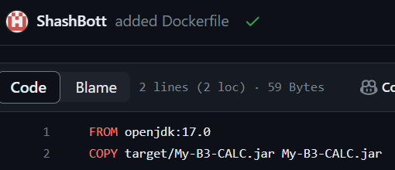

**STEP 4: Create/configure a YAML file inside .github/workflows directory.**

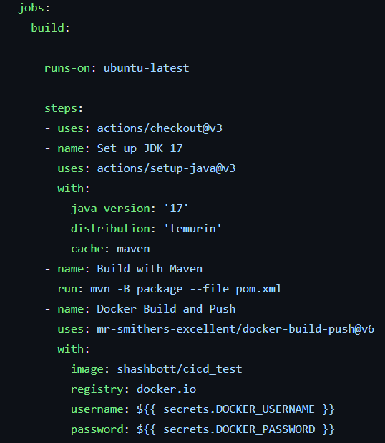

**STEP 5: Add dockerhub credentials to GitHub secrets.**

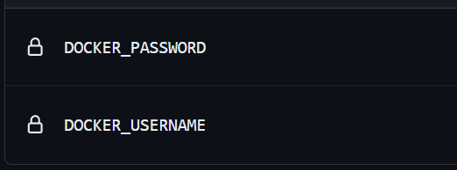

**STEP 6: Check the workflow status.**

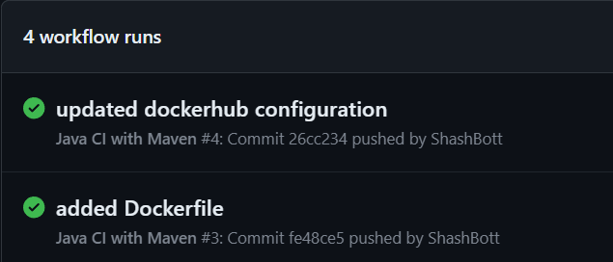

**STEP 7: Verify the Docker Image on Docker Hub.**

