**Lab Experiment 5**

**Creating Master Slave nodes in Jenkins**

**STEP 1: Create a slave node in jenkins.**

1. **Go to dashboard > manage Jenkins > Nodes > New Node.**
2. **Give it a name and select permanent agent and click create**

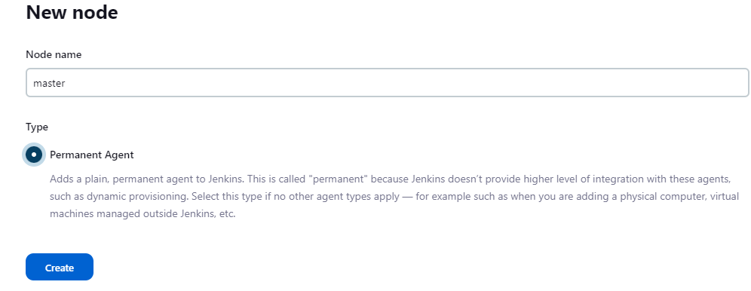

**STEP 2: Provide its root directory and label.**

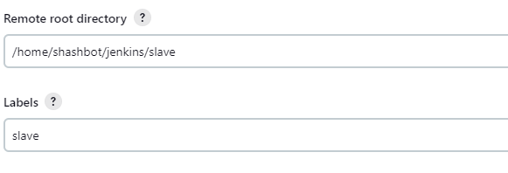

**STEP 3: Provide Custom WorkDir path.**

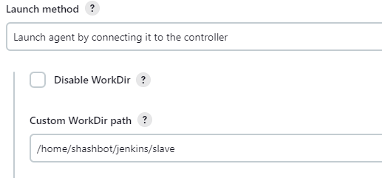

**STEP 4: Run the commands provided by Jenkins after creating slave node and your agent should be up and running.**

**STEP 5: Create another node (master) repeating the same steps as above.**

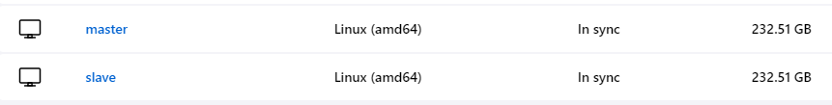

**STEP 6: Create and build a maven project pipeline and restrict it to run on one of the agents.**

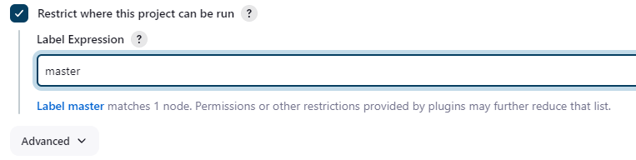

**STEP 7: Run it to verify the pipeline.**



**STEP 8: Create another project pipeline on the 2nd agent.**

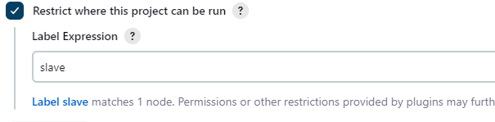

**STEP 9: Run a build to verify both the agents.**

