**Lab Experiment 6**

**Job Chaining in Jenkins**

**STEP 1: Install Jenkins and create multiple jobs for chaining.**

**STEP 2: Configure Job Dependencies and set up build triggers.**

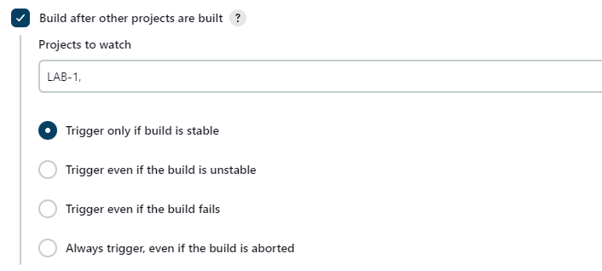

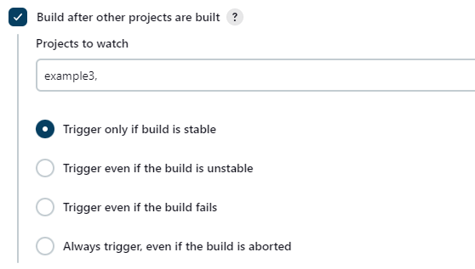

**STEP 3: Run the jobs.**

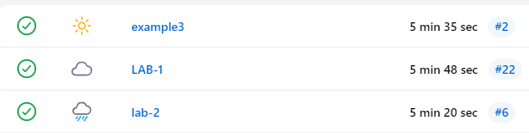

As visible the jobs ran as scheduled and configured, in the below images we can see downstream and upstream projects i.e the projects which are triggered and the projects which trigger the project in context respectively.

