**Lab Experiment 7**

**Email Notification in Jenkins**

**STEP 1: First install the email extension plugin in jenkins.**

1. **Go to Manage Jenkins.**



1. **Search the extension and install it.**

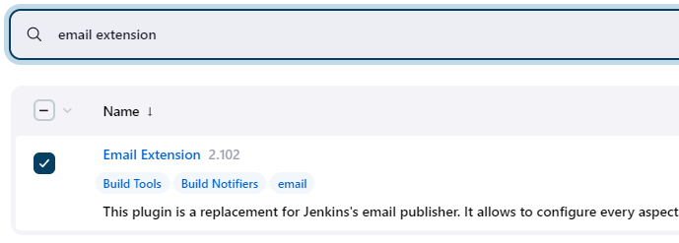

**STEP 2: Enable 2FA in gmail account and generate a token for Jenkins next.**

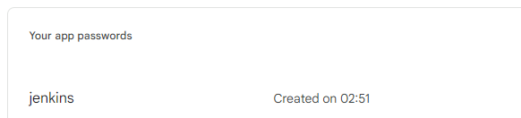

**STEP 3: Go to System and configure the email notification.**

1. **Put in SMTP server, use SMTP authentication**
2. **Check SSL option.**
3. **Put in 465 as SMTP port and reply-to-address.**

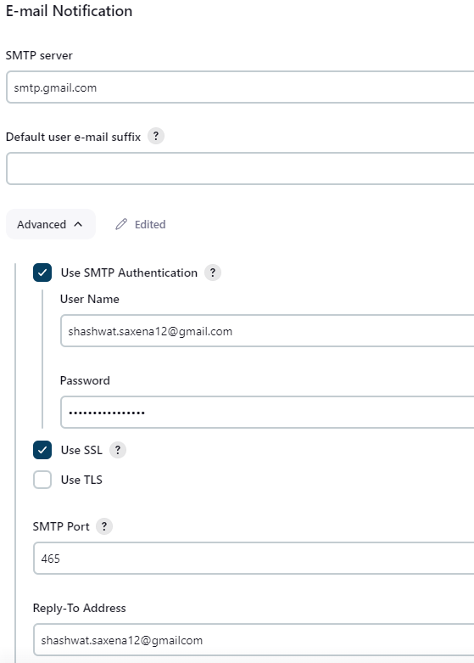

1. **Test configuration by sending an email on your mail address**

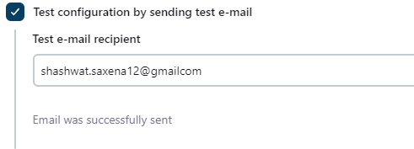

**STEP 4: Scroll up and configure the extended email server.**

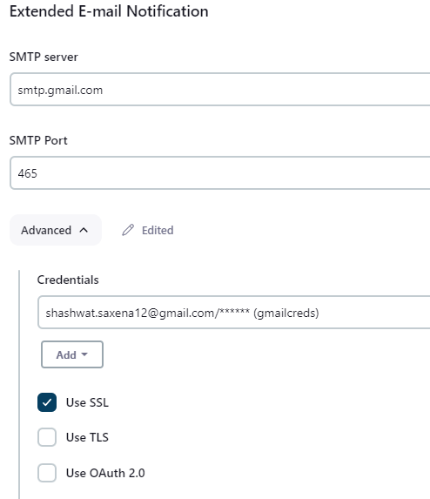

**STEP 5: Setup gmail credentials in the advanced option.**

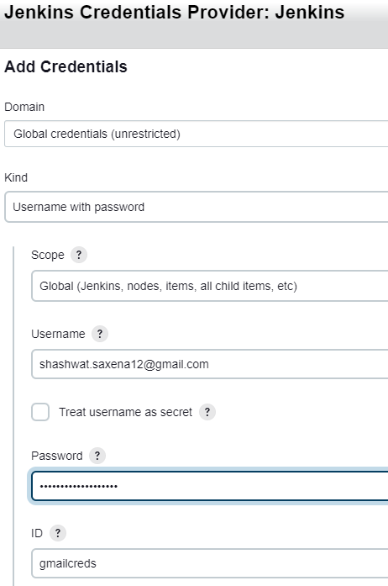

**STEP 6: Test this exercise, put in a bug and check your mail.**

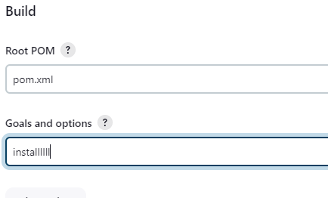

**STEP 7: In the build settings of that project configure email notification.**

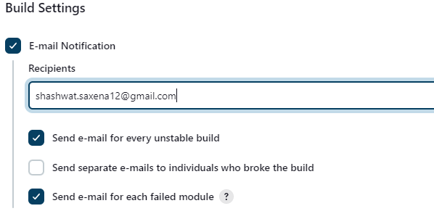

**STEP 8: Run the build.**

**STEP 9: Check your mail address.**

