Lesson 03 Demo 02

Executing Ansible Modules

Objective: To demonstrate the use of the Ansible module for server configuration and management

Tools required: Linux terminal

Prerequisites: None

Steps to be followed:
- Use Ansible modules for server configuration

Step 1: Use Ansible modules for server configuration

- Run the following command using the setup module to collect and display detailed system information about the servers:
ansible -m setup dbservers
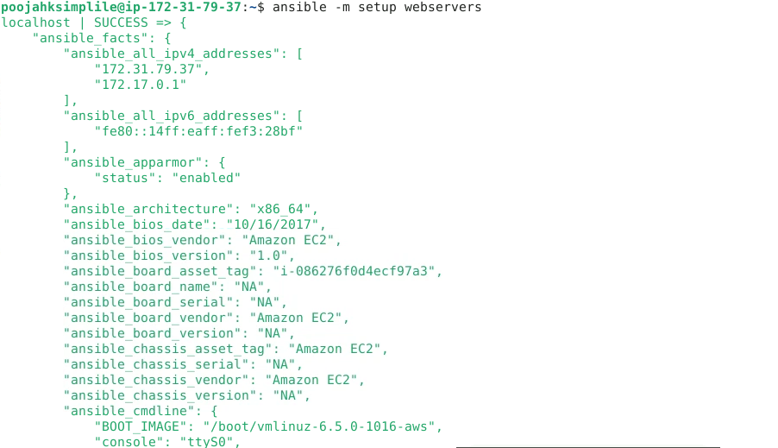
- Run the following command using the shell module to retrieve server hostnames:
ansible dbservers -m shell -a ‘hostname’
- Run the following command using the apt module to install Git on servers:
ansible dbservers -m apt -a 'name=git state=present' - - become
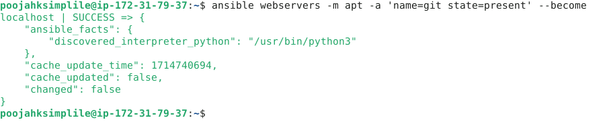
- Run the following command using the file module to create a secured root file:
ansible dbservers -m file -a 'dest=/root/sample.txt state=touch mode=600 owner=root group=root' --become
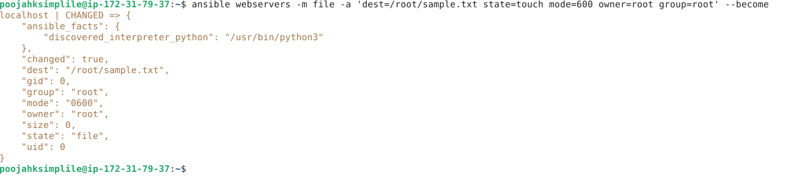
By following these steps, you have successfully managed server configurations using Ansible modules.

