Lesson 05 Demo 05

Configuring Docker to Use External DNS

Objective: To configure Docker Daemon to utilize External DNS for enhanced DNS resolution and network connectivity within containers

Tools required: Ubuntu OS and Docker

Prerequisites: None

Steps to be followed:
- Configure the Docker Daemon config file to use external DNS

Step 1: Configure the Docker Daemon config file to use external DNS

- Use the following command to create a file named daemon.json:
sudo nano /etc/docker/daemon.json

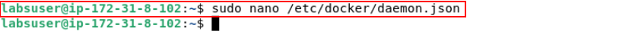

- Add the following DNS key code to the daemon.json file:
{
"data-root": "/mnt/docker-data",
"storage-driver": "overlay2",
"dns": ["8.8.8.8", "8.8.4.4"]
}
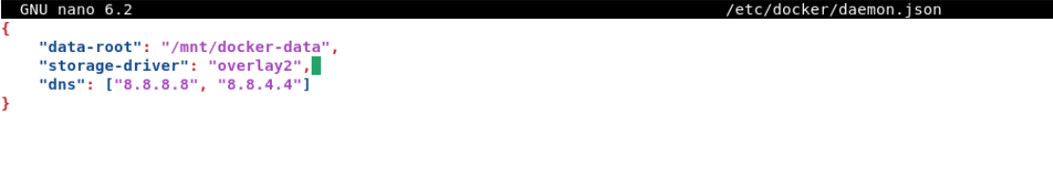

- Use the following command to restart the Docker Daemon:
sudo service docker restart
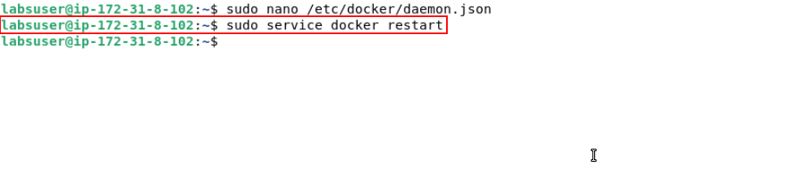

- Use the following command to test the DNS by looking up an external domain:
sudo docker run nicolaka/netshoot nslookup google.com
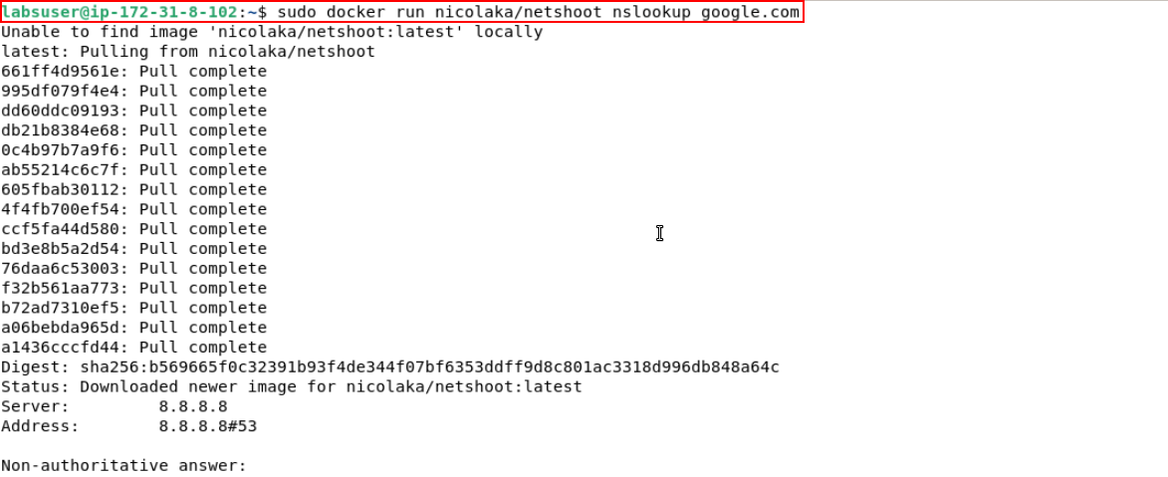

- Use the following command to run and test a container with a custom DNS:
sudo docker run --dns 8.8.4.4 nicolaka/netshoot nslookup facebook.com
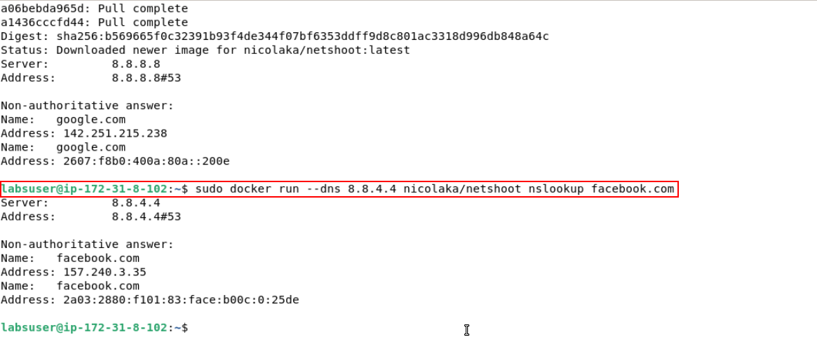
By following these steps, you have successfully configured Docker Daemon to utilize External DNS for improved DNS resolution and network connectivity within containers.

