**Lesson 01 Demo 02**

**Launching an S3 Bucket Using CloudFormation**

**Objective:** To create an S3 bucket on AWS using CloudFormation, with a focus on defining bucket properties, securing access, and ensuring proper configuration

**Tools required:** AWS Management Console

**Prerequisites:** None

Steps to be followed:

1. Create a CloudFormation template

**Step 1:** **Create a CloudFormation template**

* 1. Navigate to the AWS console and search for and select **CloudFormation**

* 1. Click on **Create stack** and choose **With new resources (standard)**

* 1. Select **Create template in Designer** to enter the template design interface

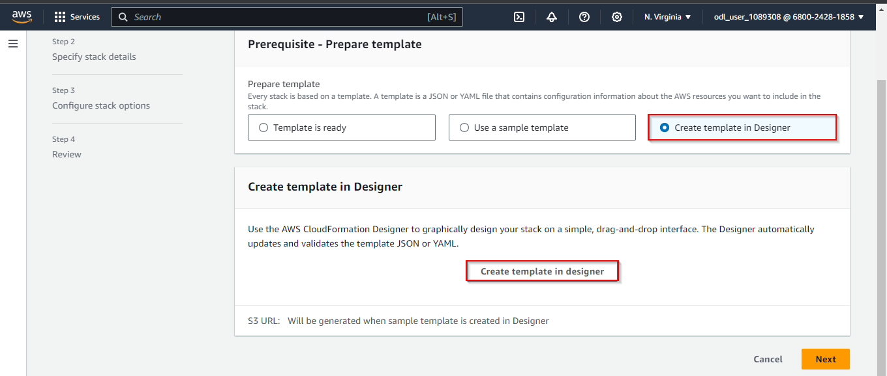

**AWSTemplateFormatVersion: '2010-09-09'**

**Description: CloudFormation template to create an S3 bucket**

**Resources:**

**MyS3Bucket:**

**Type: AWS::S3::Bucket**

**Properties:**

**BucketName: my-unique-s3-bucket-name-123456**

**AccessControl: Private**

1. Click the **Validate template** icon to ensure the template is correct

1. Click on the **Create stack** icon

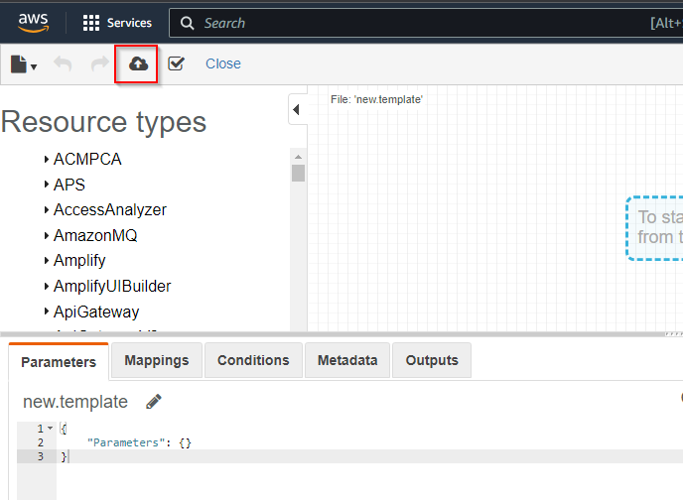

This will automatically open the **Create stack** window. Now, click on the **Next** button.

1. In the **Create stack** window, enter the Stack name as **CreateS3Bucket** and click **Next**

1. Click **Submit**

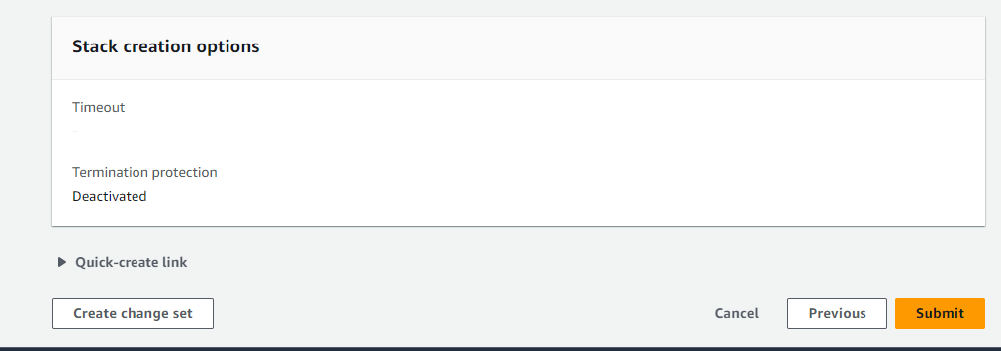

The S3Bucket has been created successfully.

After successfully completing it, navigate to the S3 service and click on **Buckets** to view the newly created bucket.

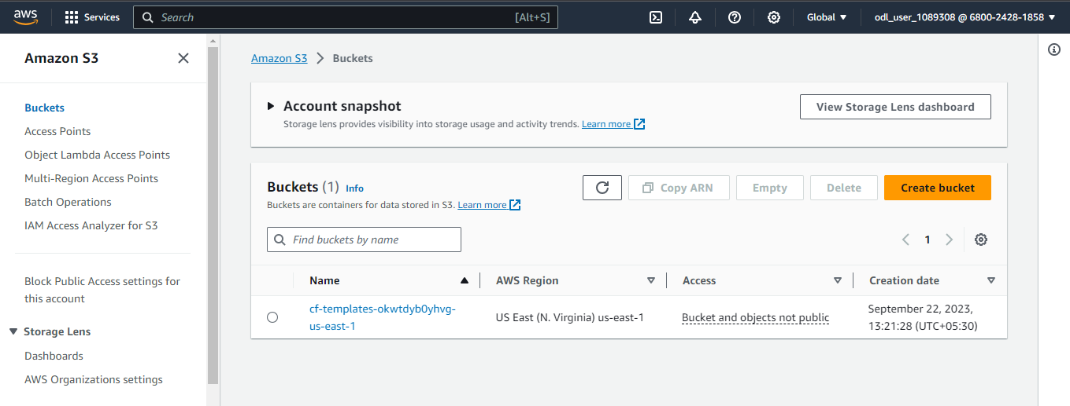

By following these steps, you have successfully created an S3 bucket with the specified configuration and access controls.