Lesson 06 Demo 06

Configuring Pod Using NFS-Based PV and PVC

Objective: To configure a pod using NFS-based PersistentVolume (PV) and PersistentVolumeClaim (PVC) for more efficient storage management

Tools required: kubeadm, kubectl, kubelet, and containerd

Prerequisites: A Kubernetes cluster should already be set up (refer to the steps provided in Lesson 02, Demo 01 for guidance)

Steps to be followed:
- Configure the NFS kernel server
- Set the permissions
- Configure the NFS common on client machines
- Create PersistentVolume
- Create PersistentVolumeClaim
- Create the deployment for MySQL

Step 1: Configure the NFS kernel server

- Create a directory on the worker-node-1 using the following command:
sudo mkdir /mydbdata

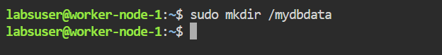

- Install the NFS kernel server on the machine:
sudo apt install nfs-kernel-server

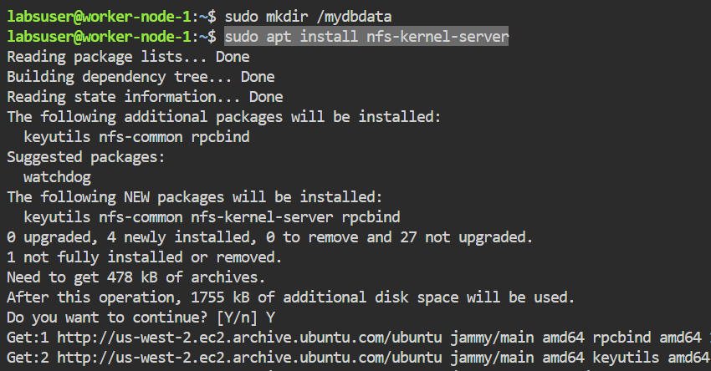

Step 2: Set the permissions

- On the worker-node-1, open the exports file in the /etc directory using the following command:
sudo nano /etc/exports

- Inside the file, append the following code:
/mydbdata *(rw,sync,no_root_squash)

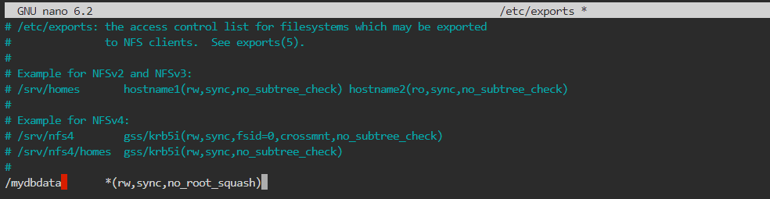

- Use the cat command to view the file:

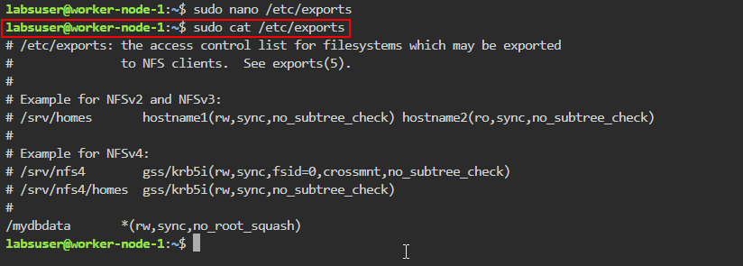

- Export all shared directories defined in the /etc/exports file using the following command:
sudo exportfs -rv

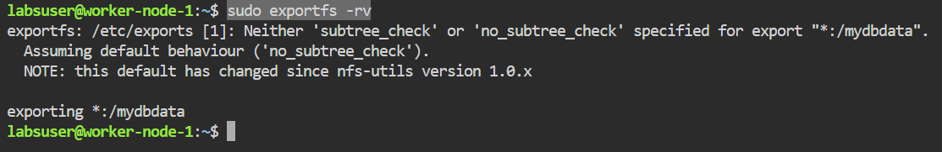

- Make the folder publicly accessible by changing its owner user and group using the following command:
sudo chown nobody:nogroup /mydbdata/

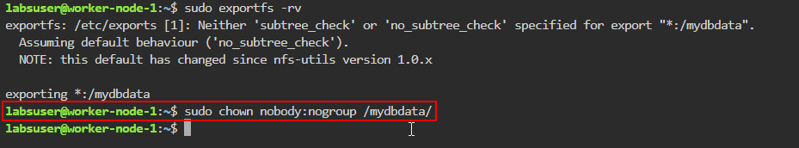

- Assign full permissions to read, write, and execute files in this directory using the following command:
sudo chmod 777 /mydbdata/

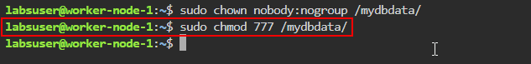

- Restart the NFS kernel server to apply the changes using the following command:
sudo systemctl restart nfs-kernel-server
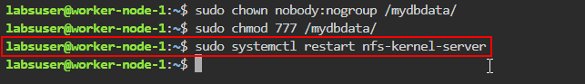
- Retrieve the internal IP of the node where the NFS server is installed using the following command:
ip a
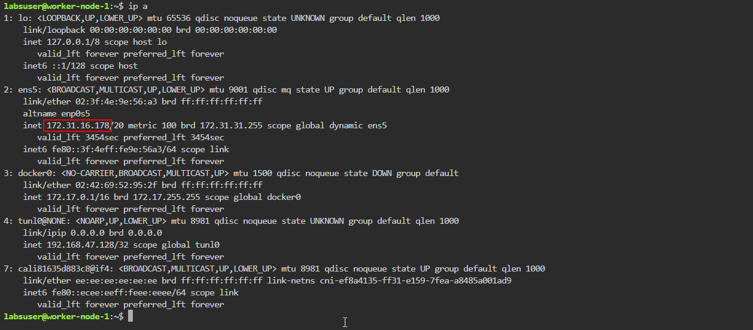
After running this command, look for the relevant IP address in the output. This IP will be used to associate the PV with the NFS server.
Note: Save the IP address to use in the next steps

Step 3: Configure the NFS common on client machines

Note: Perform the below steps on each worker node intended for sharing

- Run the following command to install the NFS common package:
sudo apt install nfs-common

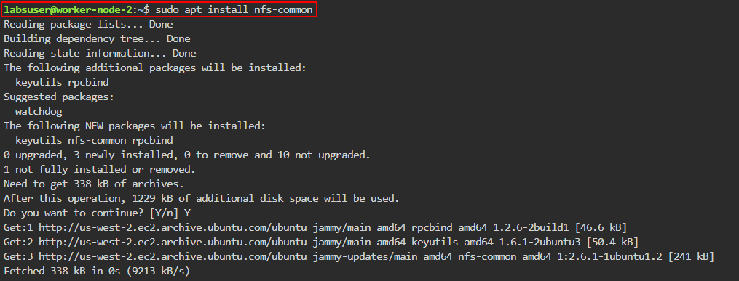

- Execute the following commands to refresh the NFS common service and verify its status:
sudo rm /lib/systemd/system/nfs-common.service
sudo systemctl daemon-reload
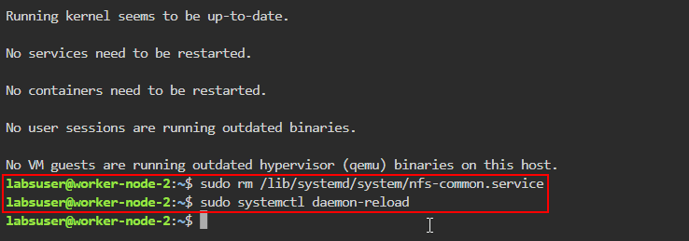

- Restart the NFS client service and check its status using the following commands:
sudo systemctl restart nfs-common
sudo systemctl status nfs-common

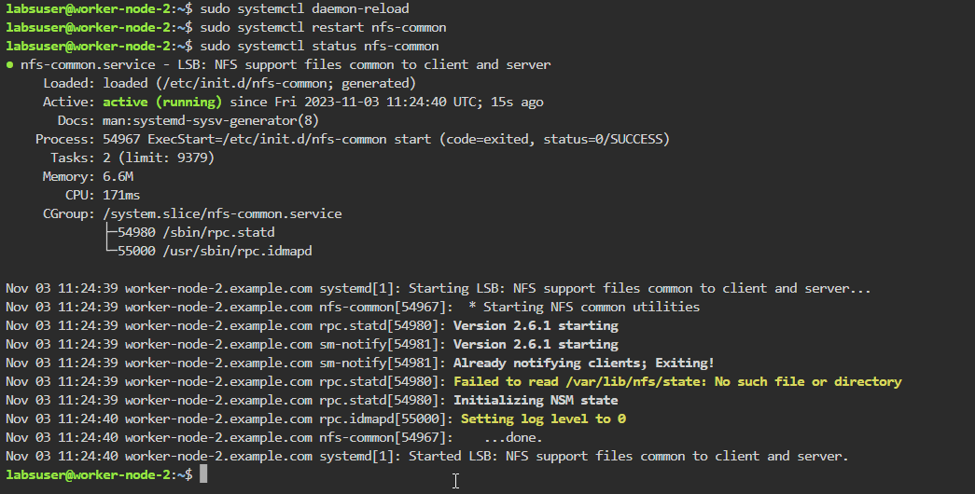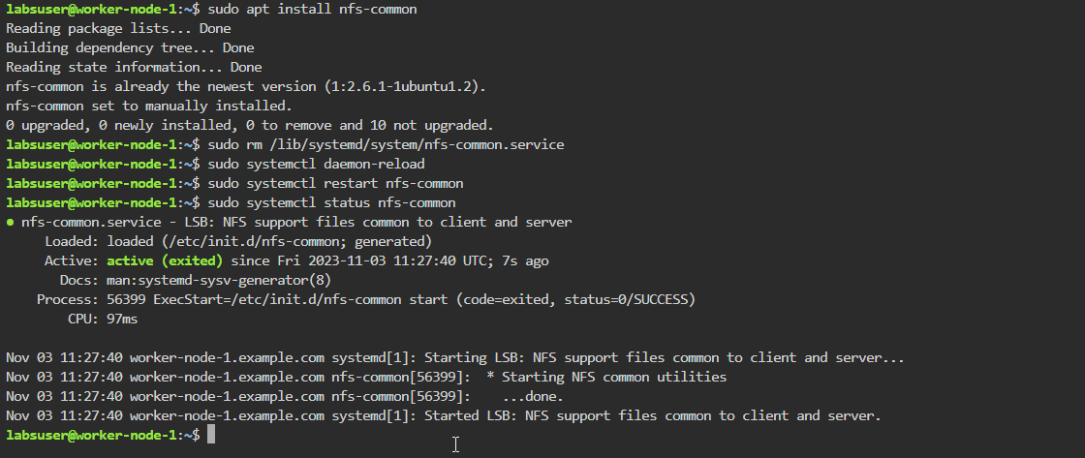

Note: These steps are to be performed on both worker nodes as shown in the screenshots above.

Step 4: Create PersistentVolume

- On the master node, create the YAML file using the following command:
nano pv.yaml
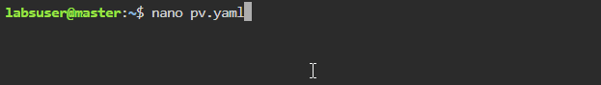
- Add the following code to the pv.yaml file:
apiVersion: v1
kind: PersistentVolume
metadata:
name: test
labels:
app: wordpress
spec:
capacity:
storage: 10Gi
accessModes:
- ReadWriteMany
nfs:
server: YOUR_NFS_SERVER_IP_HERE
path: "/mydbdata"
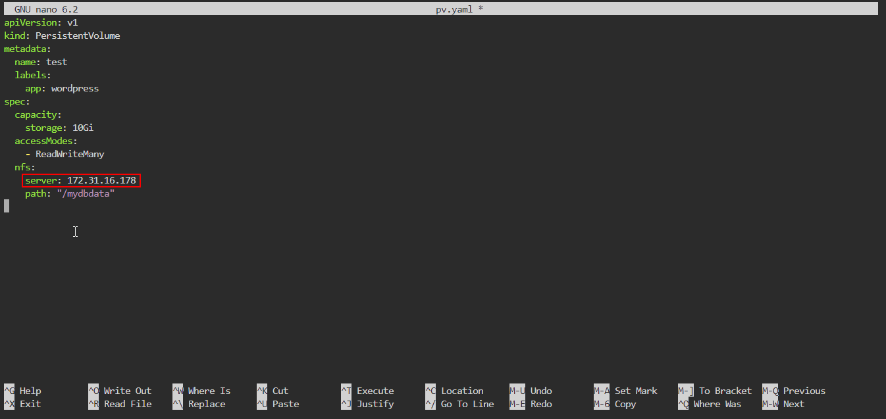

Note: Replace YOUR_NFS_SERVER_IP_HERE with the internal IP of the NFS server from step 2.8 as shown in the screenshot above

- Apply the configuration defined in pv.yaml using the following command:
kubectl apply -f pv.yaml
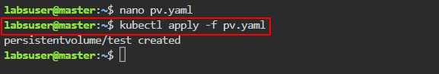
- List all the PVs in the cluster using the following command:
kubectl get pv

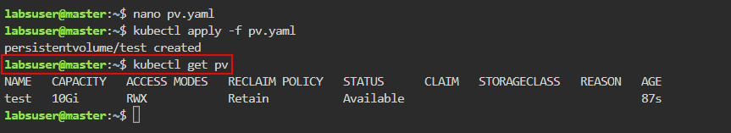

Step 5: Create PersistentVolumeClaim

- Create the YAML file using the following command:
nano pvc.yaml
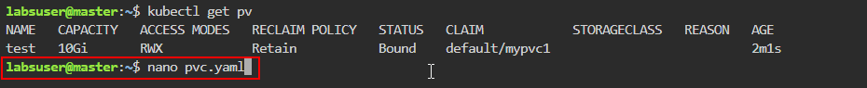
- Add the following code to the pvc.yaml file:
apiVersion: v1
kind: PersistentVolumeClaim
metadata:
name: mypvc1
labels:
app: wordpress
spec:
accessModes:
- ReadWriteMany
resources:
requests:
storage: 6Gi

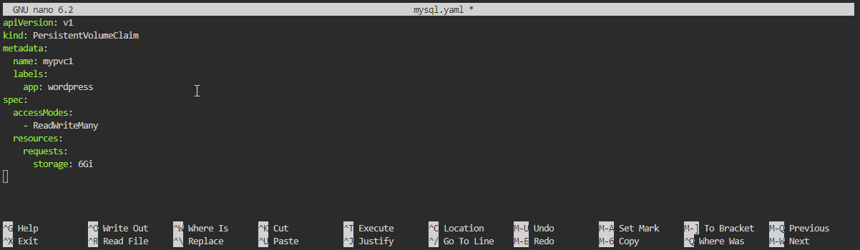

- Apply the configuration defined in pvc.yaml using the following command:
kubectl apply -f pvc.yaml
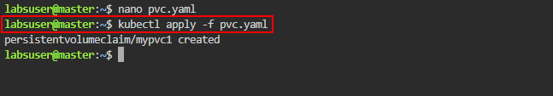
- List all the PVs and PVCs in the cluster using the following commands:
kubectl get pv
kubectl get pvc
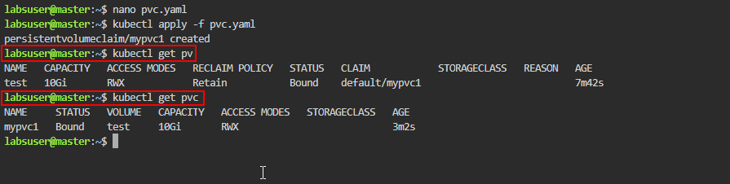

Step 6: Create the deployment for MySQL

- Create the YAML file using the following command:
nano mysql.yaml
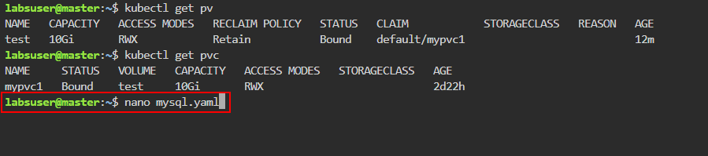
- Add the following code to the mysql.yaml file:
apiVersion: apps/v1
kind: Deployment
metadata:
name: test-mysql
labels:
app: wordpress
spec:
selector:
matchLabels:
app: wordpress
tier: mysql
strategy:
type: Recreate
template:
metadata:
labels:
app: wordpress
tier: mysql
spec:
containers:
- image: mysql:5.6
name: mysql
env:
- name: MYSQL_ROOT_PASSWORD
value: password
ports:
- containerPort: 3306
name: mysql
volumeMounts:
- name: myvol1
mountPath: /var/lib/mysql
volumes:
- name: myvol1
persistentVolumeClaim:
claimName: mypvc1

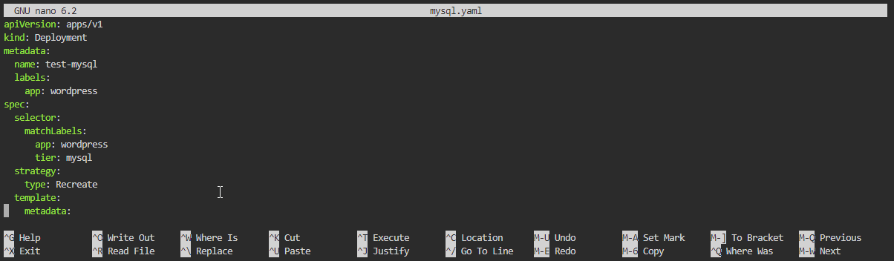

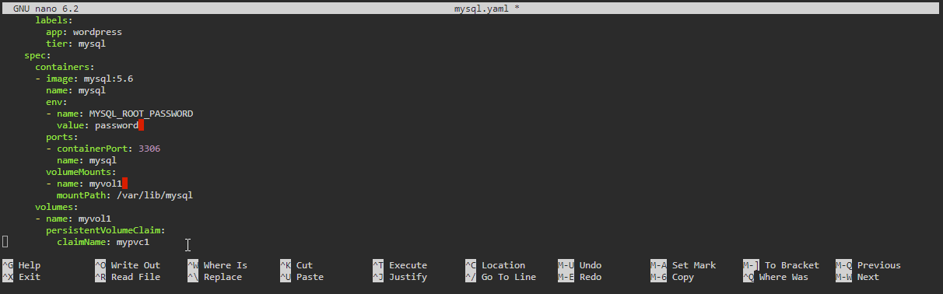

- Apply the configuration defined in mysql.yaml using the following command:
kubectl apply -f mysql.yaml
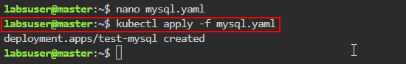

- Check the status of deployment using the following command:
kubectl get deploy test-mysql
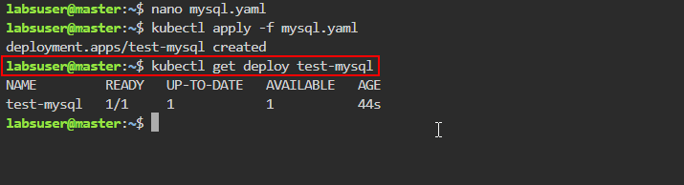
- Check the status of the pod using the following command:
kubectl get pod -l app=wordpress
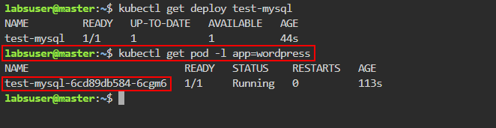
Note: Save the name of the pod for the next step

- View detailed information about the pod using the following command:
kubectl describe pod <pod-name>
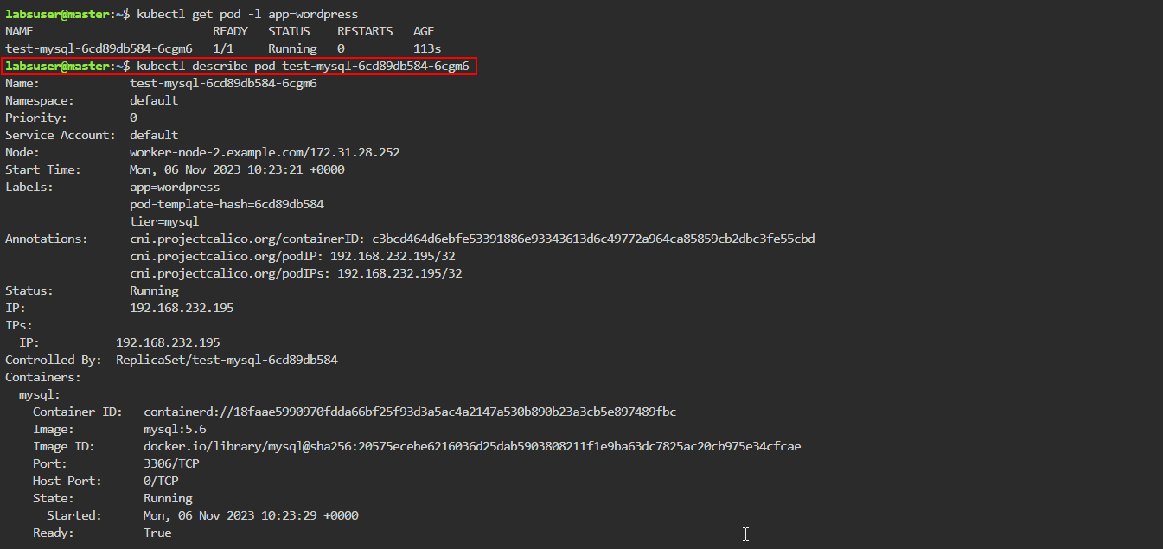

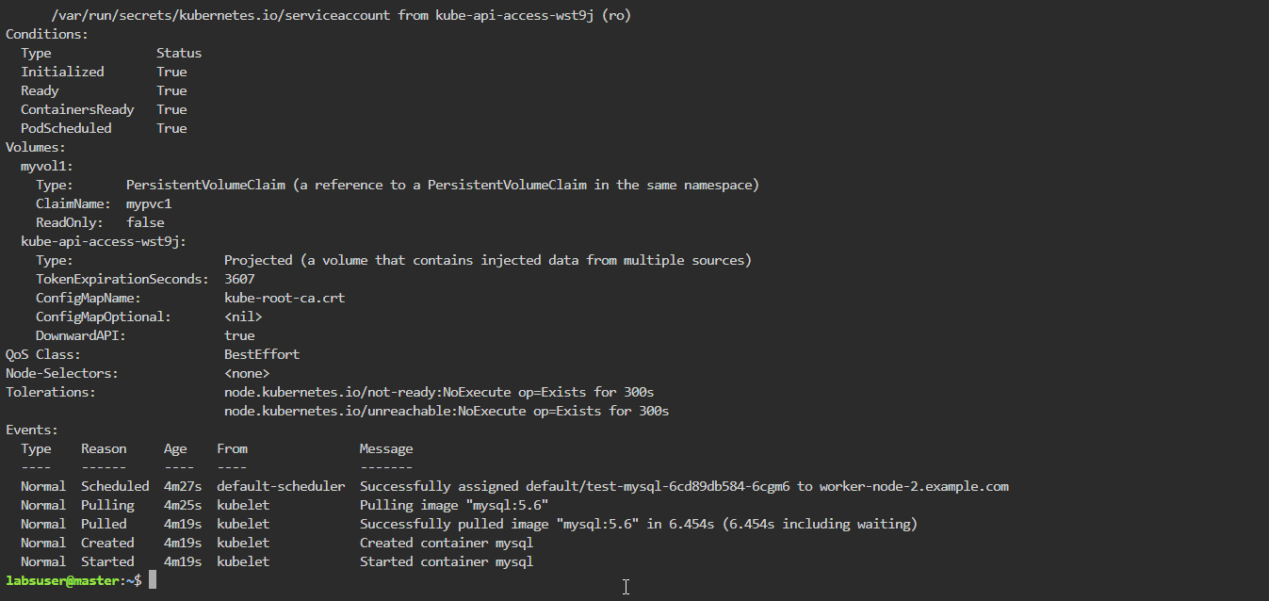

Note: Replace the <pod-name> with the name of your pod, as shown in the screenshots above

By following these steps, you have successfully configured a Kubernetes pod using
NFS-based PV and PVC for efficient storage management.

