Lesson 01 Demo 01

Creating and Configuring a Kubernetes Cluster

Objective: To set up a Kubernetes cluster by configuring hostnames, initializing the master node, joining worker nodes, and verifying the cluster's status

Tools required: kubeadm, kubectl, kubelet, and containerd

Prerequisites: Ensure you have executed sudo kubeadm reset on all machines. This action will clear any past configurations and prepare the machines for a new cluster setup.

Steps to be followed:
- Change the hostnames of all machines
- Set up the master node
- Join the worker nodes in the cluster

Step 1: Change the hostnames of all machines

- Execute the following commands on the master node:
sudo hostnamectl set-hostname master.example.com
exec bash

- Execute the following commands on the worker1 node:
sudo hostnamectl set-hostname worker-node-1.example.com
exec bash

- Execute the following commands on the worker2 node:
sudo hostnamectl set-hostname worker-node-2.example.com
exec bash

Step 2: Set up the master node

- Initiate kubeadm by executing the following command:
sudo kubeadm init --ignore-preflight-errors=all

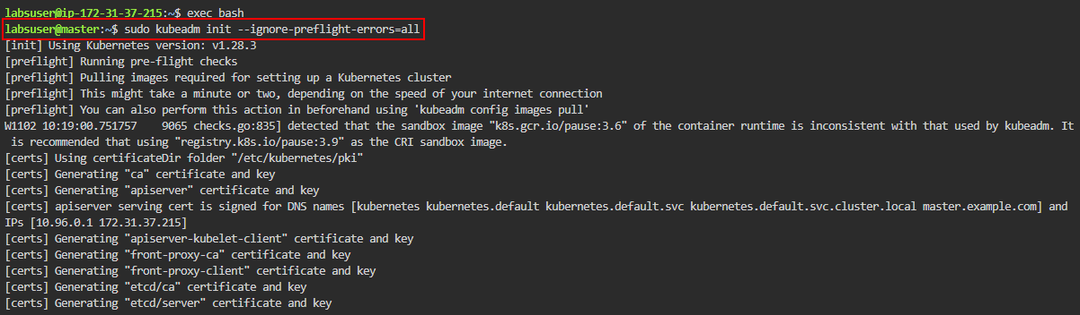

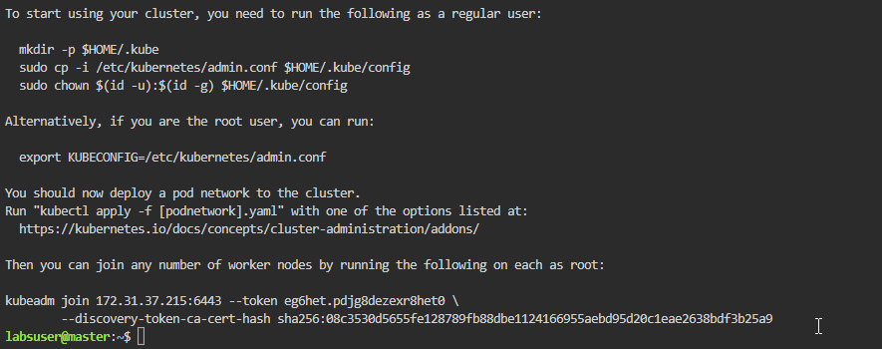

- Run the following commands to allow non-root users to access kubeadm:
mkdir -p $HOME/.kube
sudo cp -i /etc/kubernetes/admin.conf $HOME/.kube/config
sudo chown $(id -u):$(id -g) $HOME/.kube/config

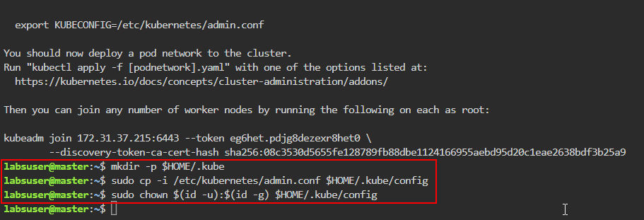

- Run the following command to deploy the weave network:
kubectl apply -f https://docs.projectcalico.org/manifests/calico.yaml

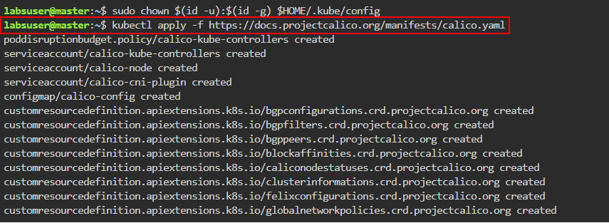

- To verify the master node's status, execute the following command:
kubectl get nodes

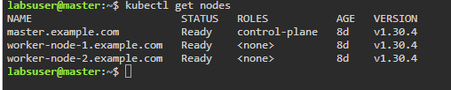

You can see the master node is now ready and operational.

- Run the following command to generate a command with a token for joining the worker nodes:
sudo kubeadm token create --print-join-command
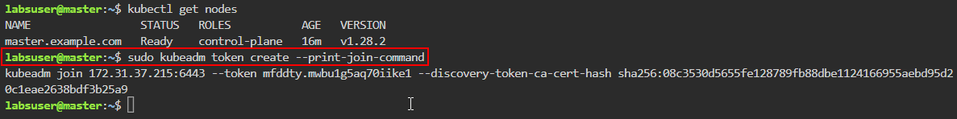

Note: Save the displayed kubeadm join command and token for later; you will need them to connect the worker nodes.

Step 3: Join the worker nodes in the cluster

- Use the kubeadm join command (from step 2.5) on both worker nodes

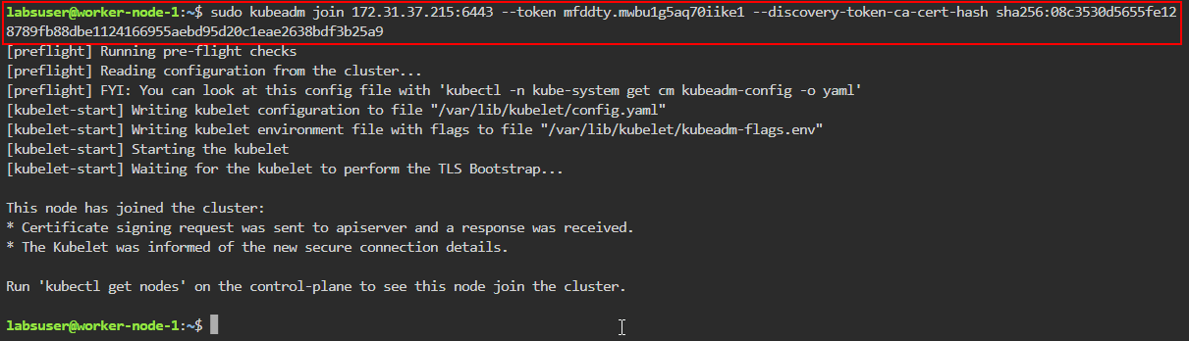

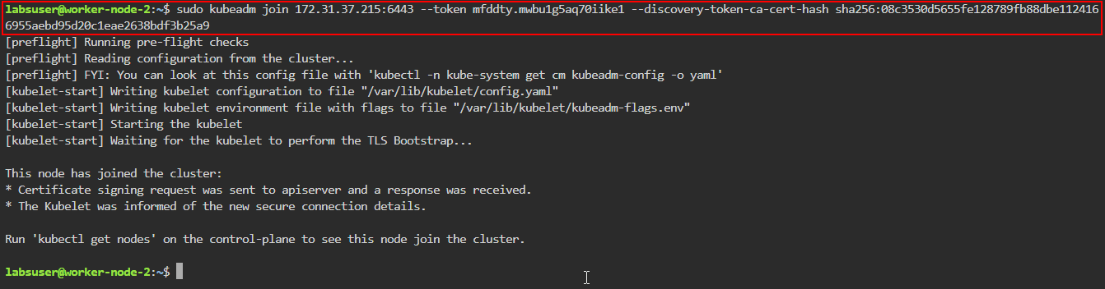

Note: Ensure you use sudo before executing the command

- Return to the master node and check if the worker nodes have joined by executing the following command:
kubectl get nodes

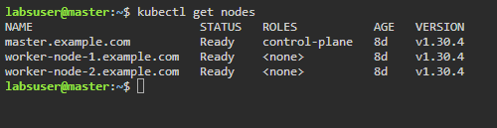

Both worker nodes have been integrated into the cluster.

By following these steps, you have successfully set up a Kubernetes cluster by configuring hostnames, initializing the master node, joining worker nodes, and verifying the cluster's status.

