Lesson 05 Demo 02

Creating User-Defined Bridge Network

Objective: To create a user-defined bridge network for better control, isolation, and communication between containers within a customized network environment

Tools required: Docker

Prerequisites: None

Steps to be followed:
- Create and delete user-defined network
- Connect a ngnix container to the my-net network
- Connect the running my-nginx container to the my-net network
- Inspect the container and disconnect it from the network

Step 1: Create and delete user-defined network

- Use the following commands to create a user network:
sudo docker network create my-net1
sudo docker network rm my-net1

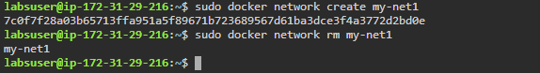

Step 2: Connect a nginx container to the my-net network

- Use the following commands to create a new Docker container named my-nginx, attach it to the my-net network, and map port 8080 on the host to port 80 in the container:
sudo docker create --name my-nginx \
--network my-net \
--publish 8080:80 \
nginx:latest

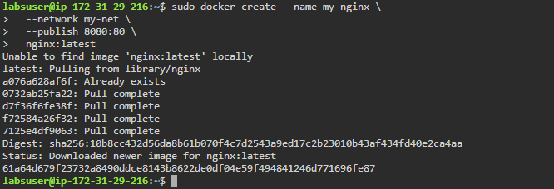

Step 3: Connect the running my-nginx container to the my-net network

- Use the following command to connect the running my-nginx container to the existing
my-net network:
sudo docker network connect my-net my-nginx

Step 4: Inspect the my-nginx container and check the networks

- Use the following command to inspect and check the network:
sudo docker container inspect my-nginx

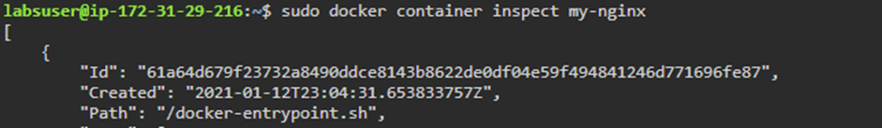

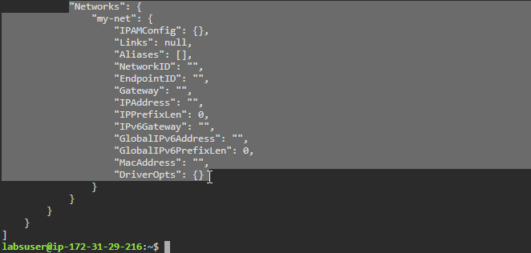

- Use the following command to disconnect the container from the network:
sudo docker network disconnect my-net my-nginx

- Use the following command to inspect the container and check the network:
sudo docker container inspect my-nginx

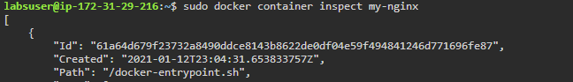

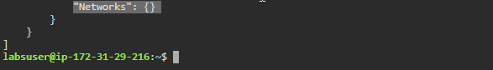

By following these steps, you can successfully create a user-defined bridge network for better control, isolation, and communication between containers within a customized network environment.

