Lesson 03 Demo 03

Developing a Backup and Restore Plan for Docker Volumes

Objective: To develop a backup and restore plan for Docker volumes for enhanced data management and disaster recovery

Tools required: Ubuntu

Prerequisites: None

Steps to be followed:
- Create, backup, and restore a Docker volume

Step 1: Create, backup, and restore a Docker volume

- Create a new container named dbstore using the following command:
sudo docker run -v /dbdata --name dbstore ubuntu /bin/bash

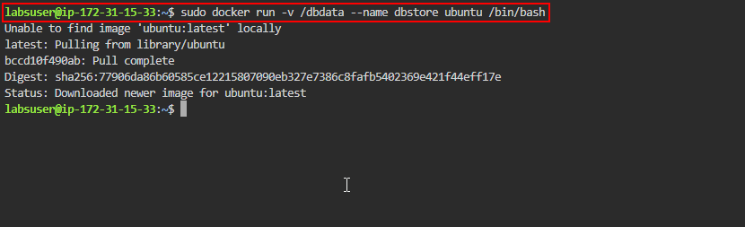

- Run the following command to list all containers:
sudo docker ps -a
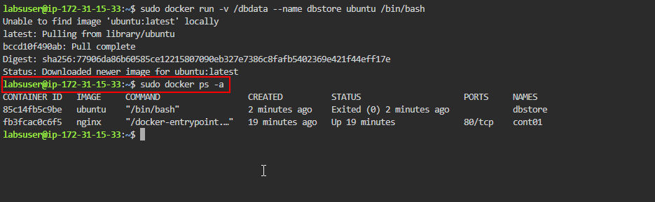
- Mount a local host directory as /backup and pass a command to tar the contents of the dbdata volume into a backup.tar file using the following command:
sudo docker run --rm --volumes-from dbstore -v $(pwd):/backup ubuntu tar cvf /backup/backup.tar /dbdata
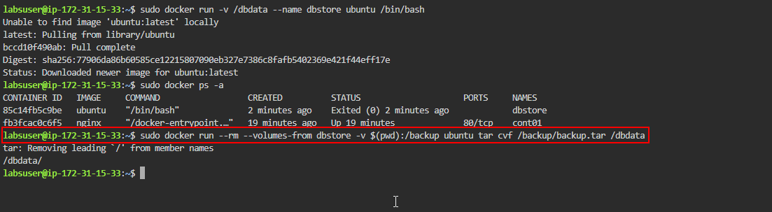
- Run the following command to list the files and directories:
sudo ls
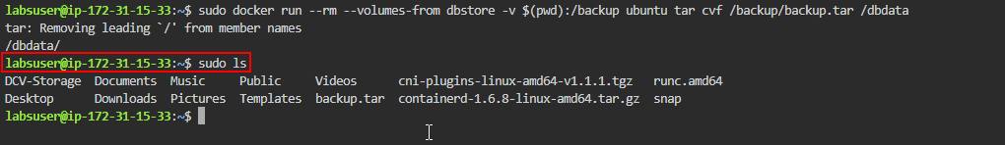

- Create a new container named dbstore2 using the following command:
sudo docker run -v /dbdata --name dbstore2 ubuntu /bin/bash
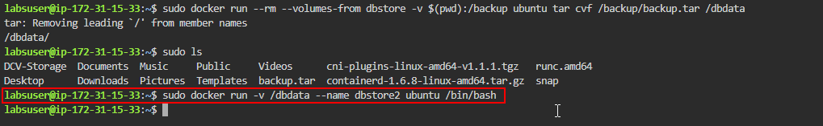
- Execute the following command to un-tar the backup file in the new container's data volume:
sudo docker run --rm --volumes-from dbstore2 -v $(pwd):/backup ubuntu bash -c "cd /dbdata && tar xvf /backup/backup.tar --strip 1"
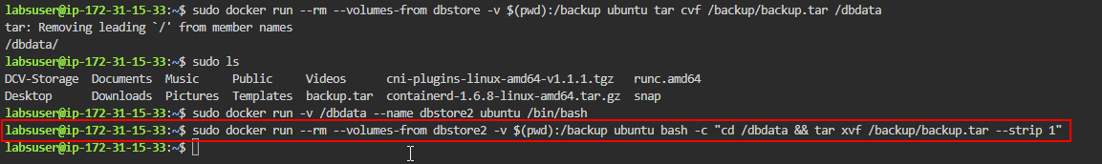
- Run the following command to list all containers:
sudo docker ps -a
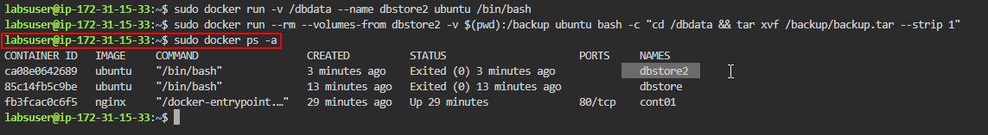
By following these steps, you have successfully developed a backup and restore plan for Docker volumes to ensure data resilience and facilitate efficient disaster recovery strategies.

