Lesson 05 Demo 01

Creating a Docker Bridge Network

Objective: To create a bridge network to enable communication between Docker containers running on different networks

Tools required: Docker

Prerequisites: None

Steps to be followed:
- Create a default network in Docker
- Inspect the network for the network driver

Step 1: Create a default network in Docker

- Use the following command to create a network:
sudo docker network create mynetwork1

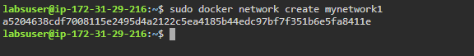

- Use the following command to list the current networks:
sudo docker network ls

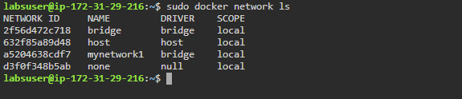

Step 2: Inspect the network for the network driver

- Use the following command to inspect the network:
sudo docker network inspect mynetwork1

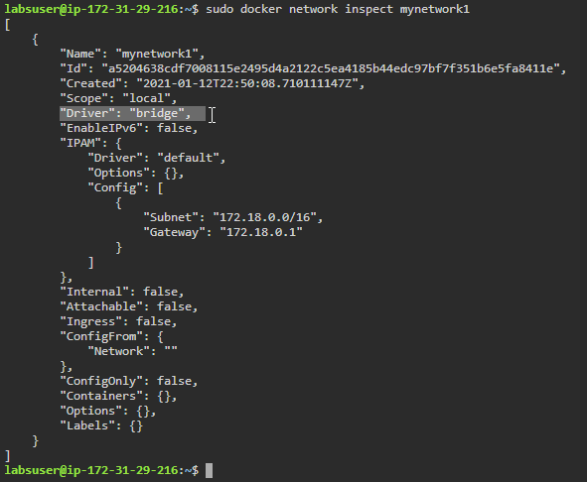
Note: A bridge driver is the default driver that automatically gets installed and configured while creating a network.

By following these steps, you have successfully created a bridge network that will allow you to communicate between Docker containers running on different networks.

