Lesson 02 Demo 04

Displaying Layers of a Docker Image

Objective: To display the layered structure of Docker images for providing insight into the hierarchical arrangement of image layers within Docker's architecture

Tools required: Ubuntu

Prerequisites: None

Steps to be followed:
- Create and display the layers of a Docker image

Step 1: Create and display the layers of a Docker image

- Create a Docker file with multiple instructions using the following command:
nano Dockerfile

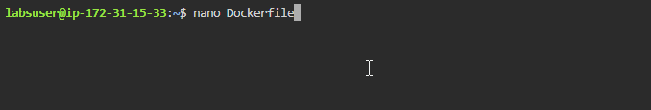
- Add the following configurations in the Dockerfile as shown in the screenshot below:
# Dockerfile
FROM ubuntu:latest

# Layer 1: Update package lists
RUN apt-get update

# Layer 2: Install curl
RUN apt-get install -y curl

# Layer 3: Install wget
RUN apt-get install -y wget

# Layer 4: Create a directory
RUN mkdir /my_directory

# Layer 5: Copy a file
COPY myfile.txt /my_directory/myfile.txt

# Layer 6: Set environment variable
ENV MY_VAR="Hello Docker!"
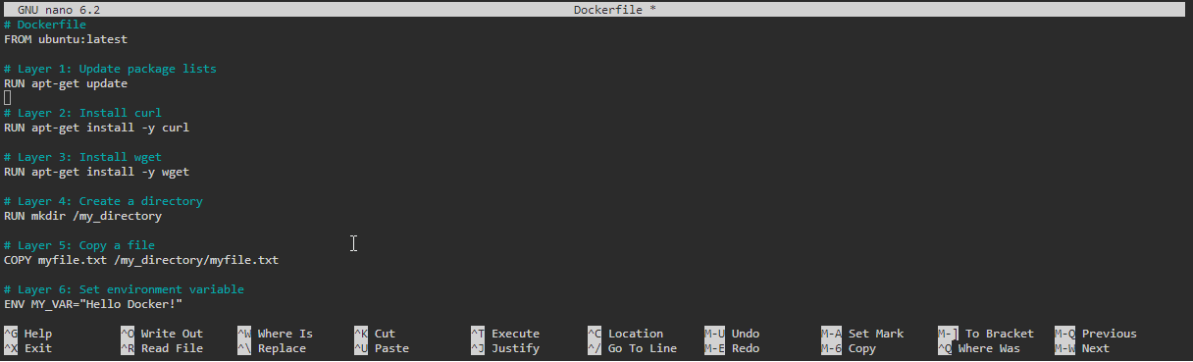
- Create a text file using the following command:
nano myfile.txt
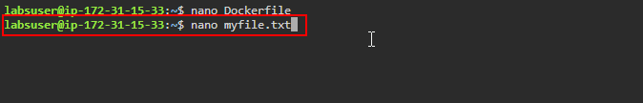
- Add the following sentence in the myfile.txt:
This is a sample text file.
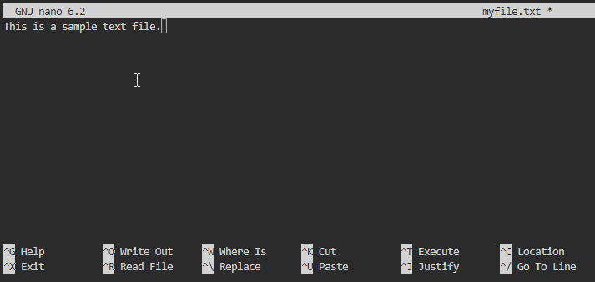

- Execute the following command to build the Docker image using the Dockerfile:
sudo docker build -t my_custom_image .
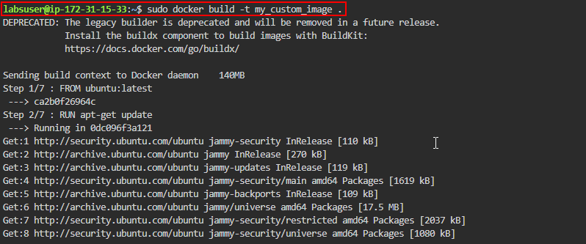
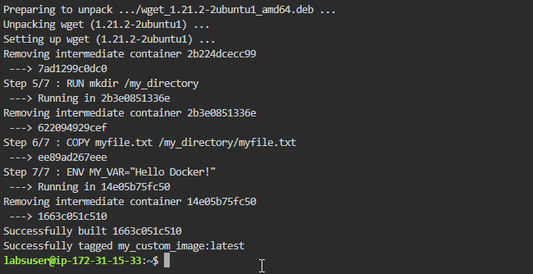

- Execute the following command to view the history of the image, including all the layers:
sudo docker history my_custom_image
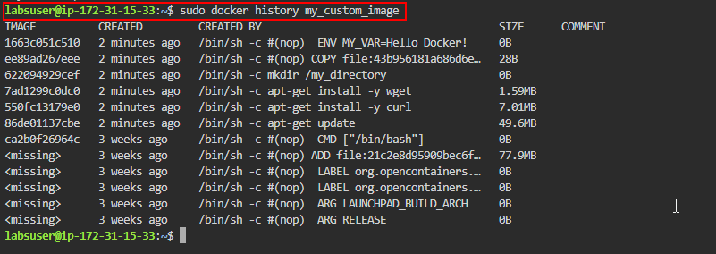
- Run the following command to inspect individual layers of the image using their respective layer IDs:
sudo docker history --no-trunc my_custom_image
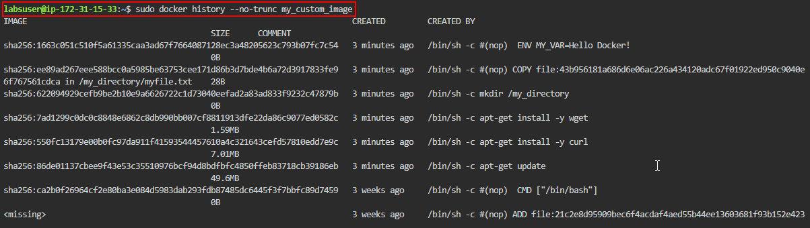
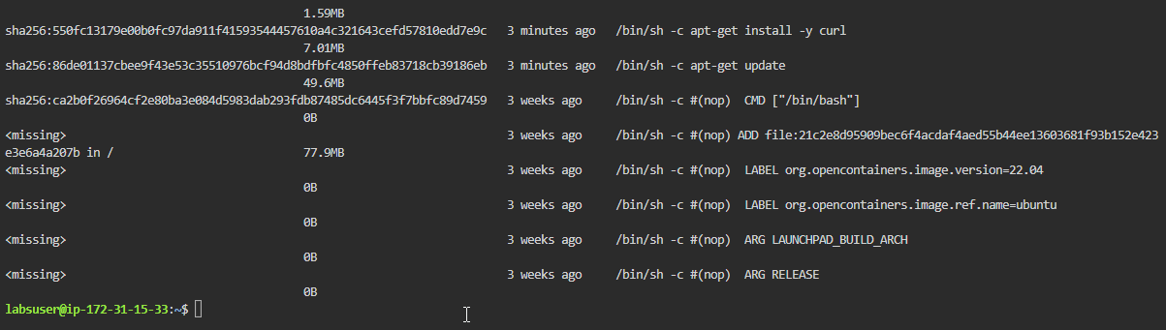
By following these steps, you have successfully displayed the layered structure of Docker images to provide insight into the hierarchical arrangement of image layers within Docker's architecture.

