Lesson 02 Demo 01

Demonstrating Lifecycle of Containers

Objective: To demonstrate the lifecycle of containers for efficient management and optimization of Docker container orchestration

Tools required: Ubuntu

Prerequisites: None

Steps to be followed:
- Demonstrate Docker container lifecycle management

Step 1: Demonstrate Docker container lifecycle management

- Pull a Docker image from Docker hub using the following command:
docker pull nginx

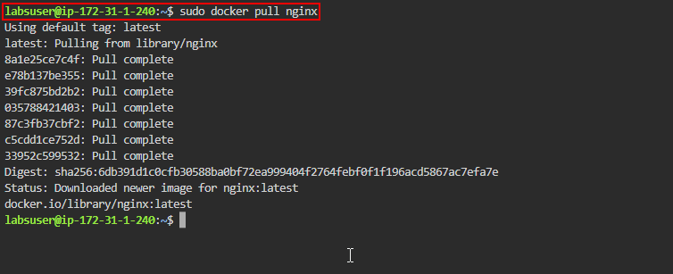

- Execute the following command to run a container from the Nginx image:
docker run -d --name my-nginx -p 8006:80 nginx
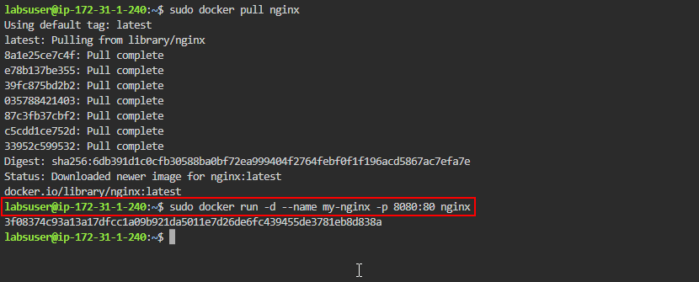
- Run the following command to list the running containers:
docker ps
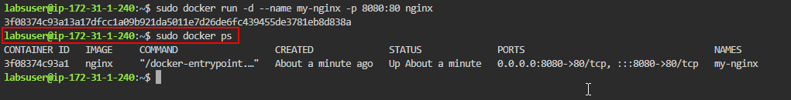
- Click on the master dropdown and select the desktop option as shown in the screenshot below:
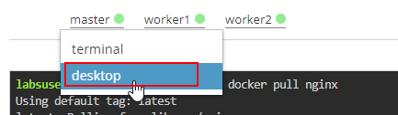

- Open a web browser and navigate to http://localhost:8080 to view the default Nginx welcome page
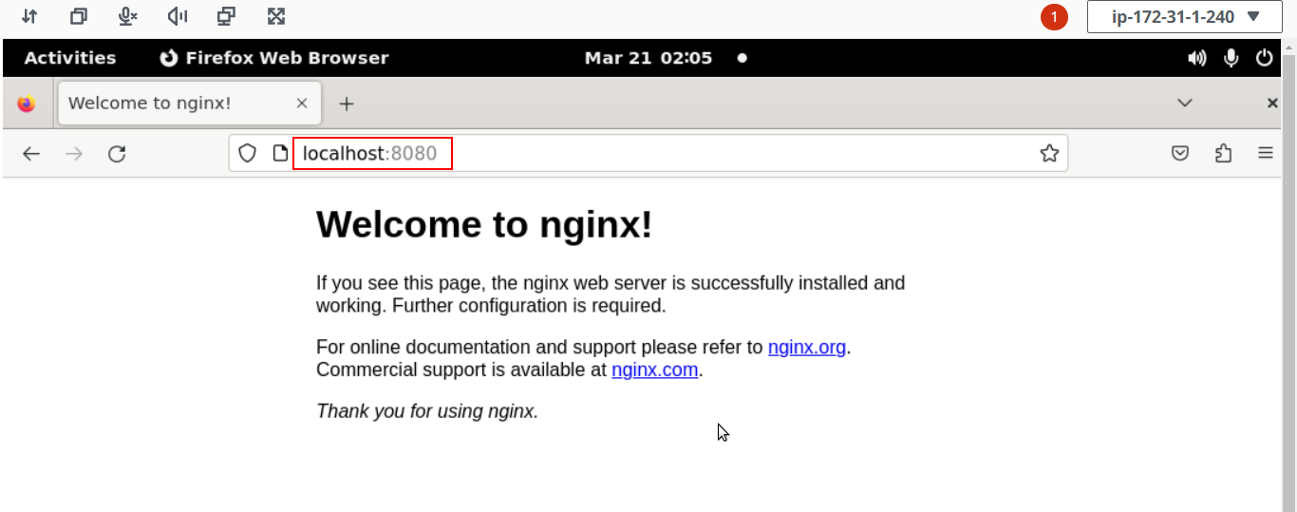
- Execute the following command to inspect the details of the running container, including its configuration and networking information as shown in the screenshots below:
docker inspect my-nginx
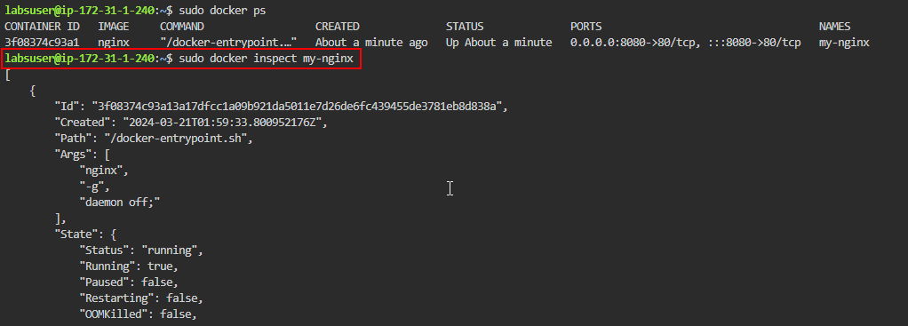
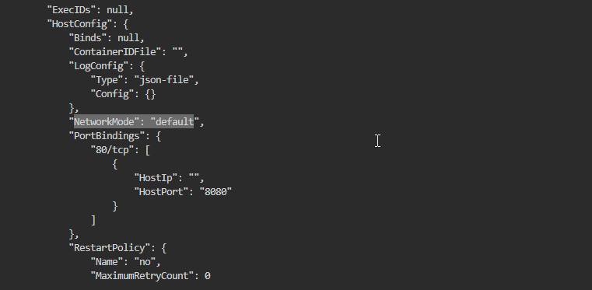
- Run the following command to stop the running container:
docker stop my-nginx
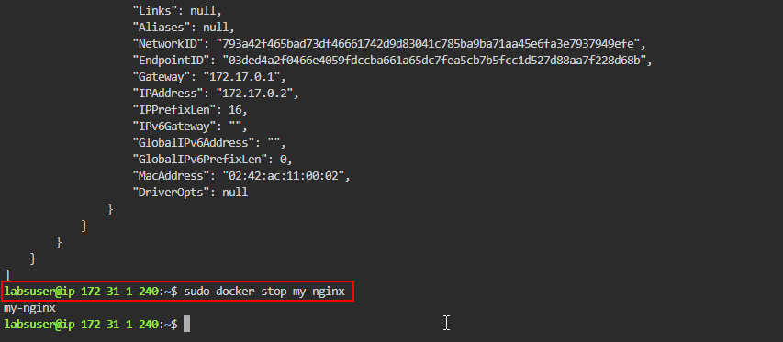
- Run the following command to list the running containers:
docker ps
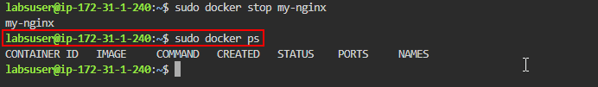
- Use the following command to start the container as shown in the screenshot below:
docker start my-nginx
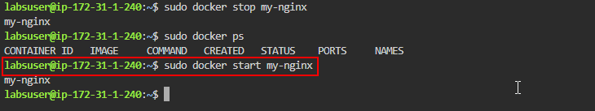
- Run the following command to list the running containers:
docker ps
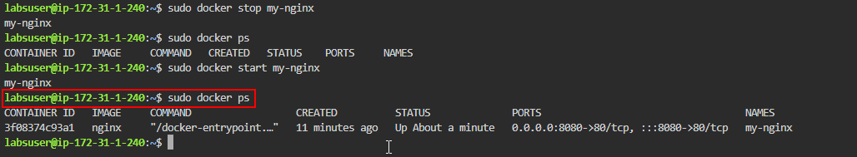
- Run the following command to remove the running container:
docker rm my-nginx
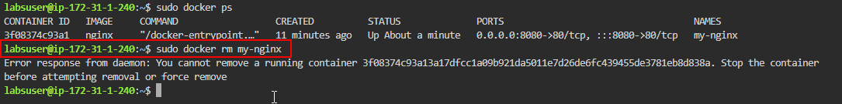
Note: You need to first stop the running container and then remove it as shown in the next steps.

- Run the following command to stop the running container:
docker stop my-nginx
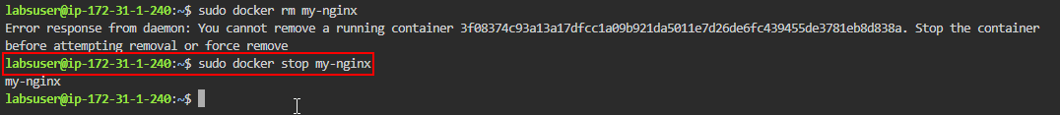
- Use the following command to remove the running container:
docker rm my-nginx
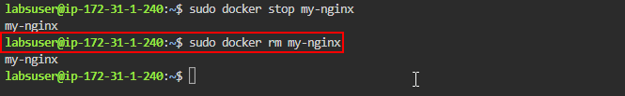
- Check the list of running and stopped containers to ensure that the running container has been removed using the following command:
docker ps -a
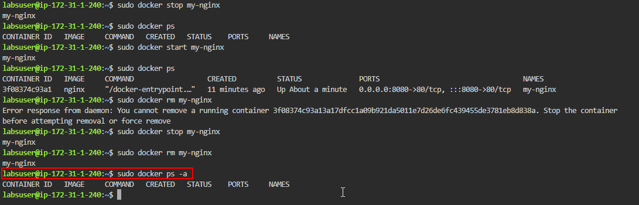
By following these steps, you have successfully demonstrated the lifecycle of containers for efficient management and optimization of Docker container orchestration.

