Lesson 05 Demo 03

Creating a Host Network

Objective: To create a host network for a standalone container and enable direct binding to the Docker host's network interface for seamless integration and optimal network performance

Tools required: Ubuntu OS and Docker

Prerequisites: None

Steps to be followed:
- Initialize Docker swarm and create a standalone container
- Inspect and verify container networking

Step 1: Initialize Docker swarm and create a standalone container

- Run the following command to create and start a container as a detached process using the host networking driver:
sudo docker run --rm -d --network host --name nginx_container1 nginx

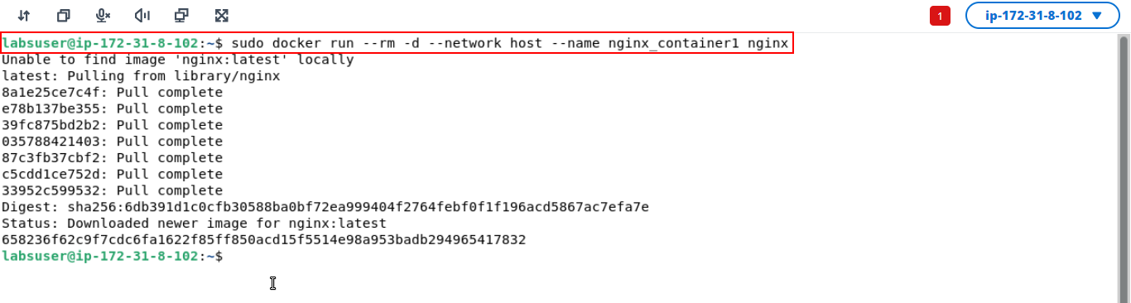
Note: The host networking driver works only on Linux hosts and is not supported on Docker Desktop for Mac or Windows Server.

- Open the browser and navigate to http://localhost:80/
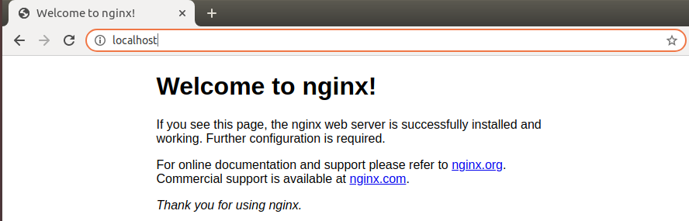

Step 2: Inspect and verify container networking
- Inspect the container to check the NetworkMode under the HostConfig using the following command:
sudo docker container inspect nginx_container1
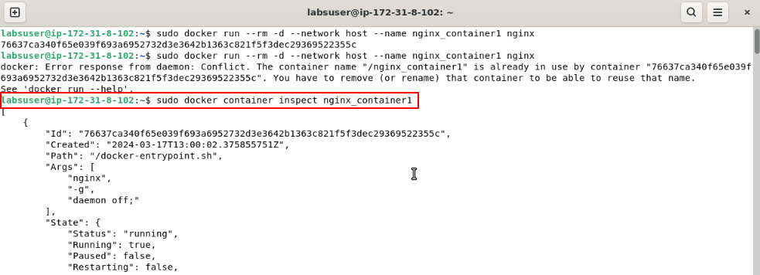
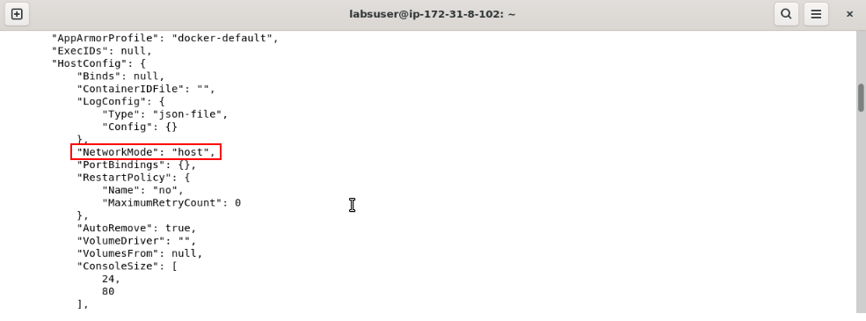

- Verify the process that is bound to port 80 using the following netstat command:
sudo netstat -tulpn | grep :80
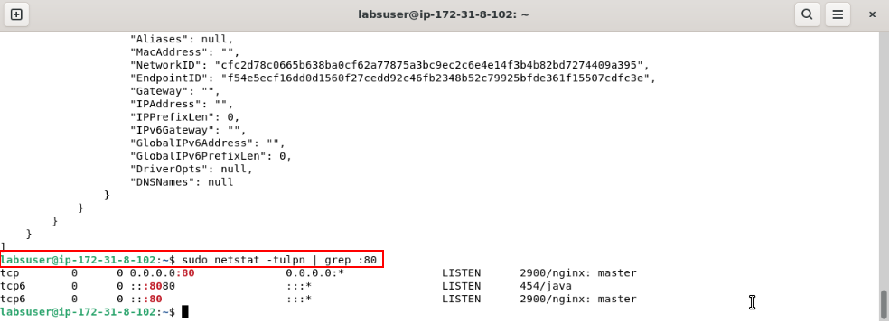

- Examine all the network interfaces using the following command:
ip addr show
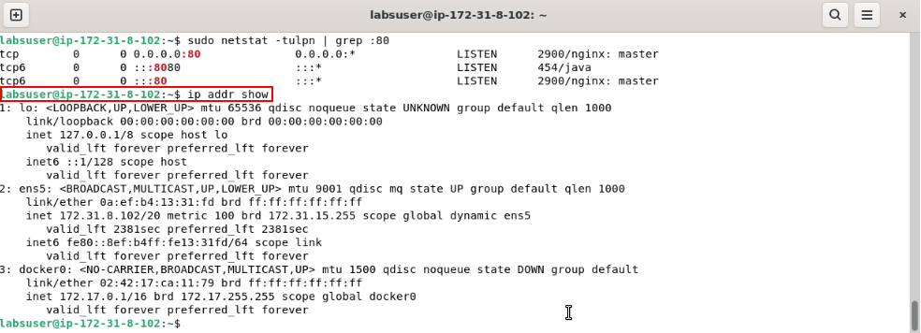
- Stop the container using the following command:
sudo docker container stop nginx_container1
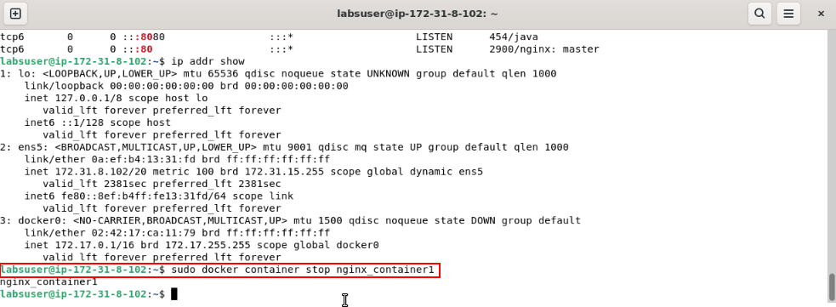
By following these steps, you have successfully created a host network for a standalone container to facilitate direct binding to the Docker host's network interface and ensure seamless integration and optimal network performance.

