Lesson 02 Demo 02

Creating a Docker Image

Objective: To create a Docker image using a Docker file, which installs and configures a Nginx web server with a custom welcome message

Tools required: Docker

Prerequisites: None

Steps to be followed:
- Create a Docker image using the Docker file

Step 1: Create a Docker image using the Docker file

- Use the following command to create a directory:
mkdir demo
cd demo

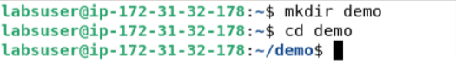

- Use the following command to create the Docker file:
- Use VS Code and make
Dockerfile

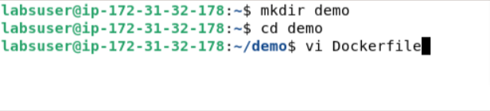

- Add the following code to the Dockerfile:

FROM ubuntu
RUN apt-get update
RUN apt-get install -y nginx
COPY index.nginx-debian.html /var/www/html
CMD nginx -g 'daemon off;'

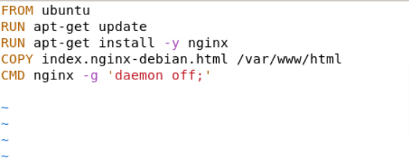

- Use the following command to create another file in the same directory:

index.nginx-debian.html

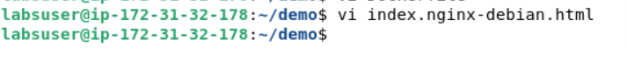

- Add the following welcome message to the index file:
WELCOME TO NGINX.

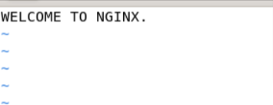

- Use the following command to execute the Docker file:
sudo docker build .

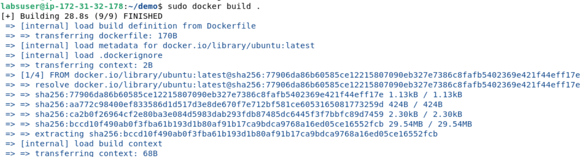

- Execute the given command to display the images. This will confirm that the image has been created.
sudo docker images

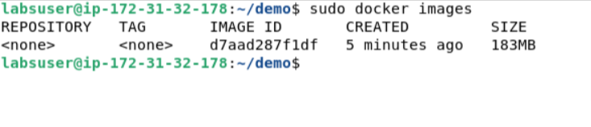

By following these steps, you have successfully created a Docker image containing a Nginx web server with a custom welcome message using a Docker file. This image can then be used to spin up containers with the configured web server environment.

