Lesson 02 Demo 05

Deploying and Configuring a Registry

Objective: To configure a local Docker registry for efficient storage and transfer of container images, facilitating streamlined image management within the development environment

Tools required: Docker

Prerequisites: None

Steps to be followed:
- Run a local registry

Step 1: Run a local registry

- Run the following command to start the registry container:
sudo docker run -d -p 5000:5000 --restart=always --name registry registry:2

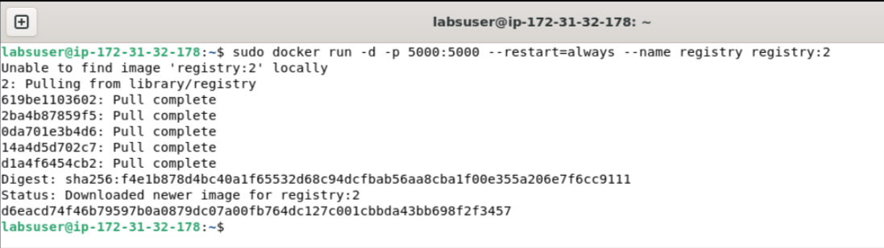

- Run the following command to list the running containers to check the newly created container:
sudo docker ps

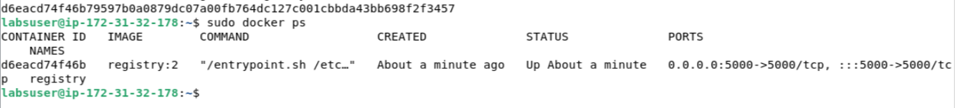

- Pull the Ubuntu image using the following command:
sudo docker pull ubuntu:16.04

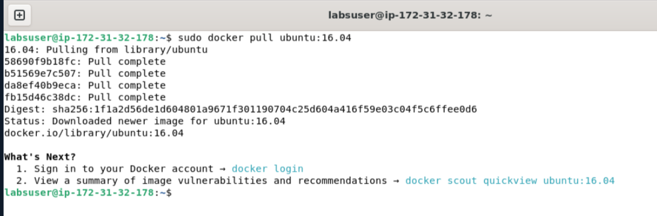

- Use the following commands to tag the Ubuntu image and check the running images:
sudo docker tag ubuntu:16.04 localhost:5000/my-ubuntu
sudo docker images

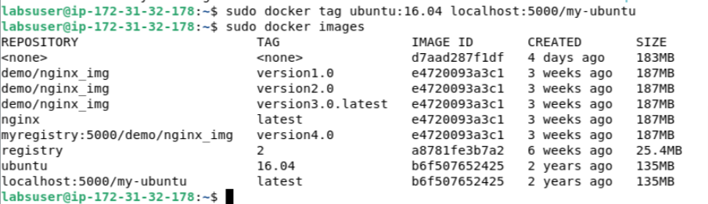

- Push the image to the local registry using the following command:
sudo docker push localhost:5000/my-ubuntu

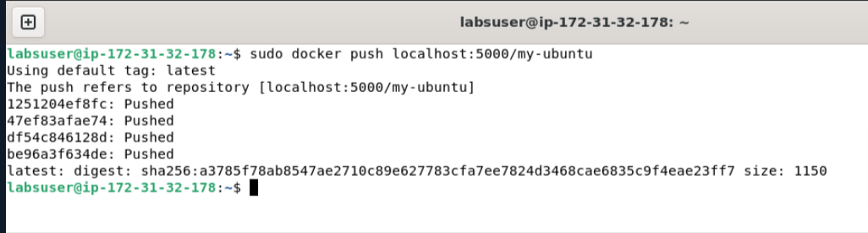

- Remove the locally cached images using the following commands:
sudo docker image remove ubuntu:16.04
sudo docker image remove localhost:5000/my-ubuntu

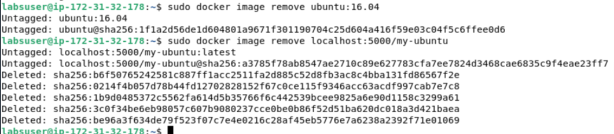

- Pull the localhost:5000/my-ubuntu image from the local registry
sudo docker pull localhost:5000/my-ubuntu

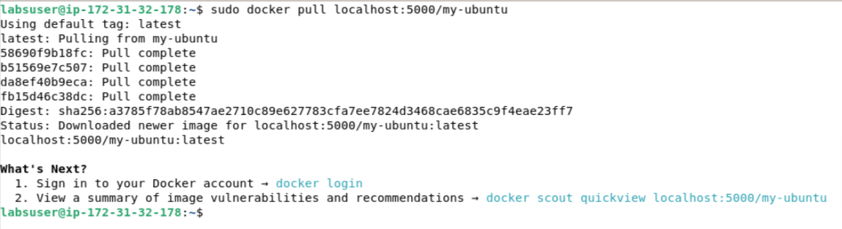

- Use the following command to stop the running registry container:
sudo docker container stop registry

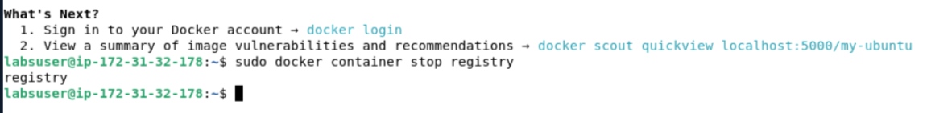

By following these steps, you have successfully configured a local registry, transferred an Ubuntu image to it, and demonstrated the ability to push and pull images to and from the registry.

