Lesson 02 Demo 01

Creating a Pipeline from the GitHub Repository

Objective: To create an AWS CodePipeline for continuous integration and delivery (CI/CD) using a GitHub repository

Tools required: GitHub and CodePipeline

Prerequisites: A GitHub Git repository with the master branch should be set up and integrated with AWS CodePipeline for continuous integration and delivery (CI/CD)

Steps to be followed:
- Create a new pipeline using the GitHub repository

Step 1: Create a new pipeline using the GitHub repository

- Sign in to the AWS Console

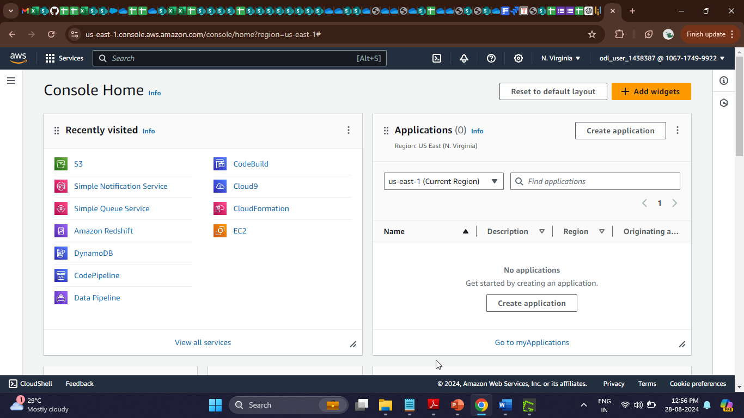

- Search for and click on CodePipeline

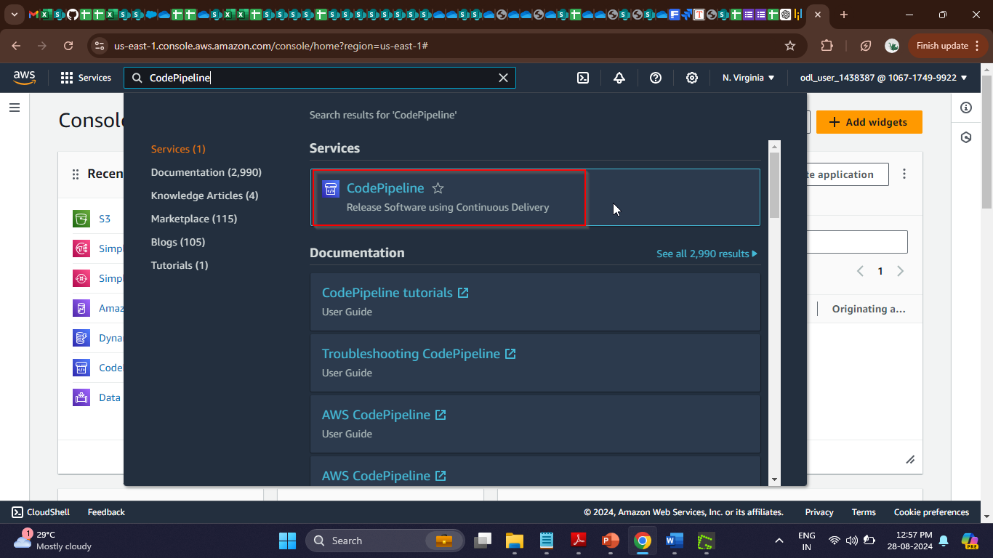

After clicking on the CodePipeline service, you will see the following interface:

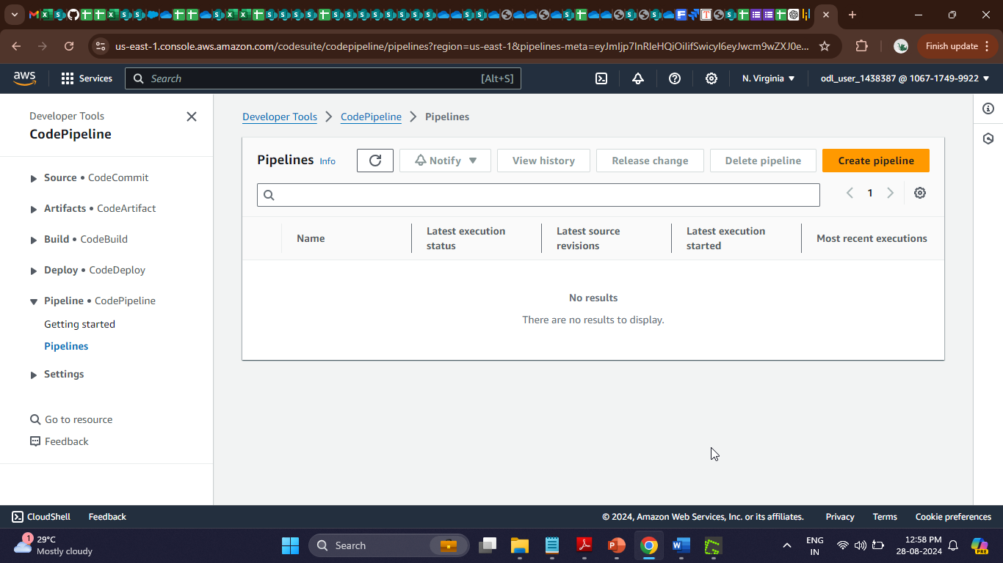

- Click on the Create pipeline button
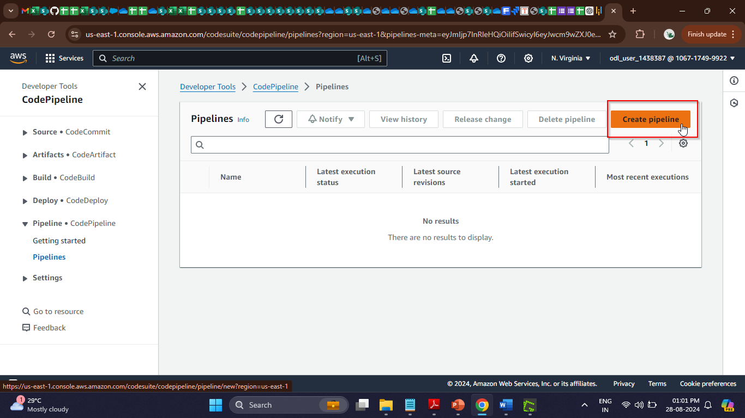

- Enter a name for the pipeline and click the Next button

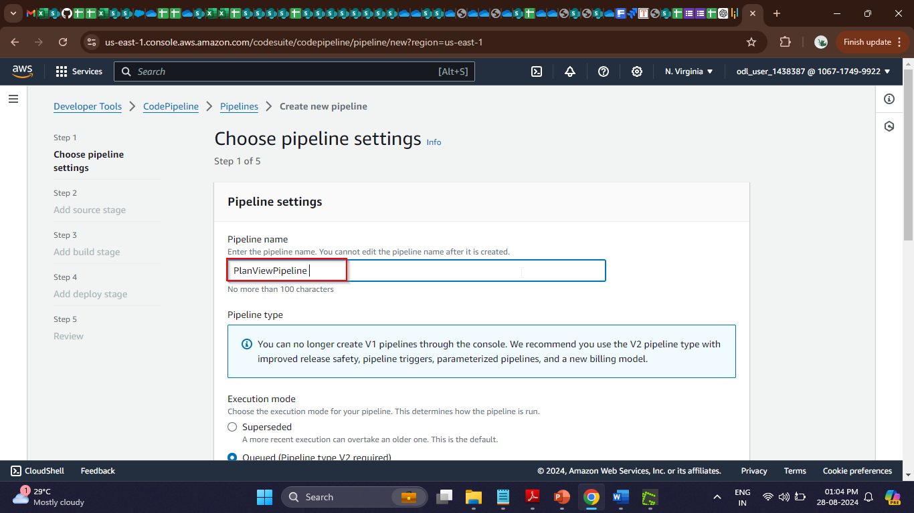

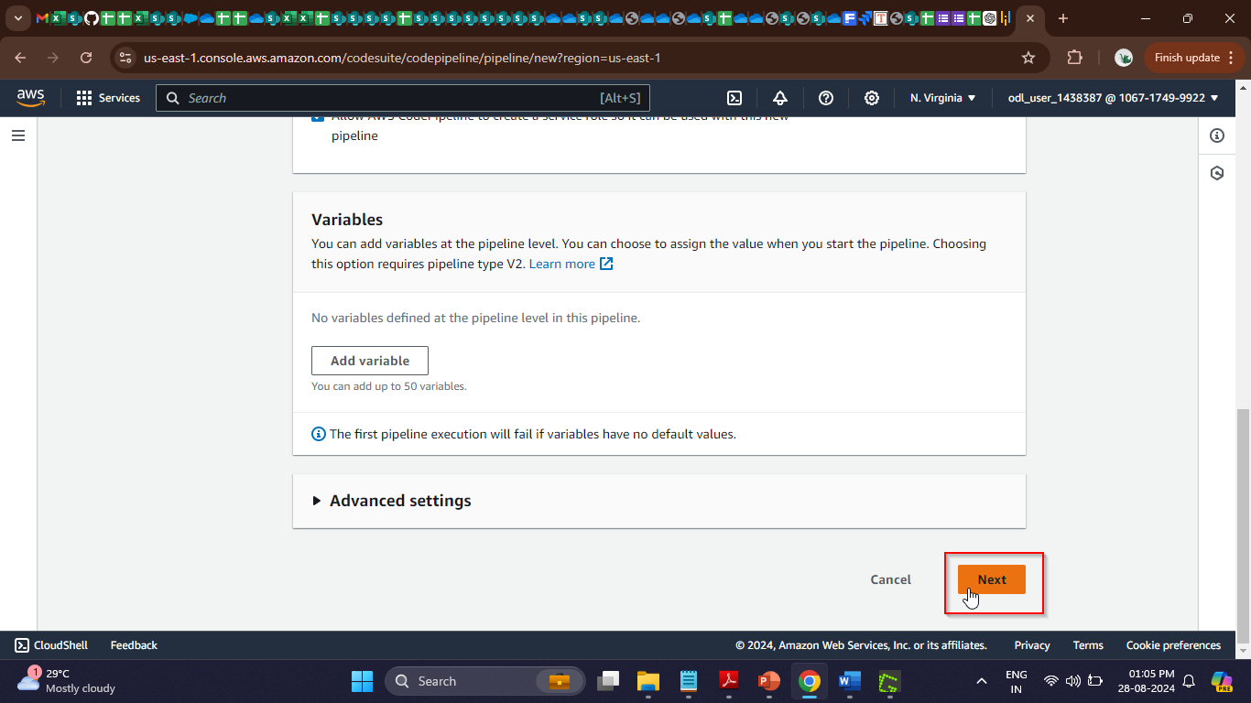

- Select the desired Source provider as GitHub (Version 1)
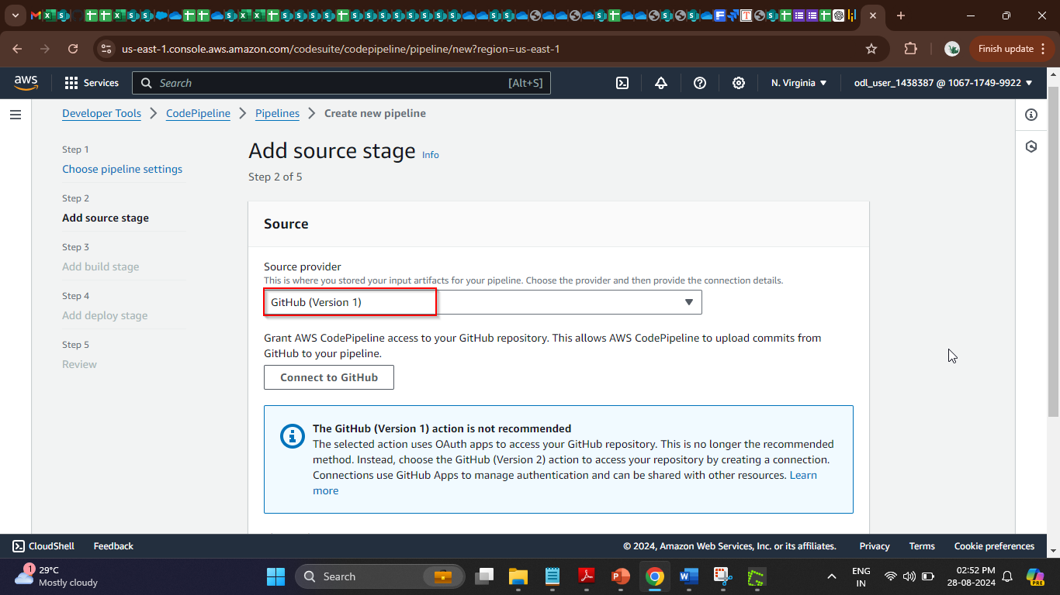

- Click on Connect to GitHub

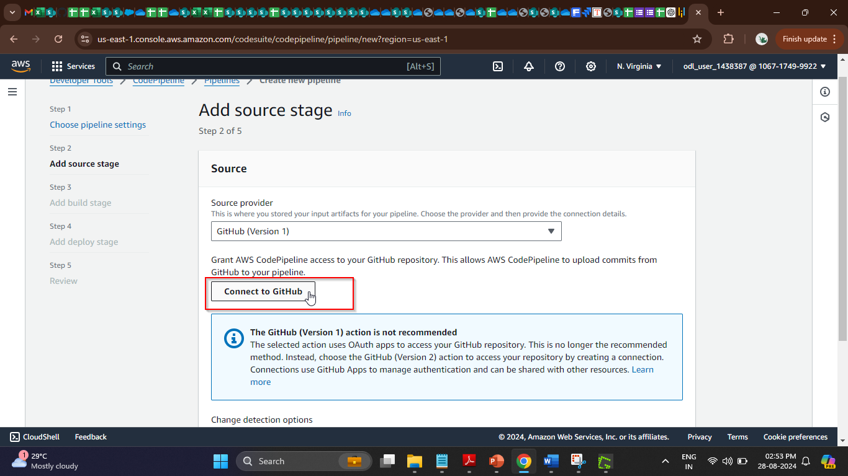

- Click on Confirm

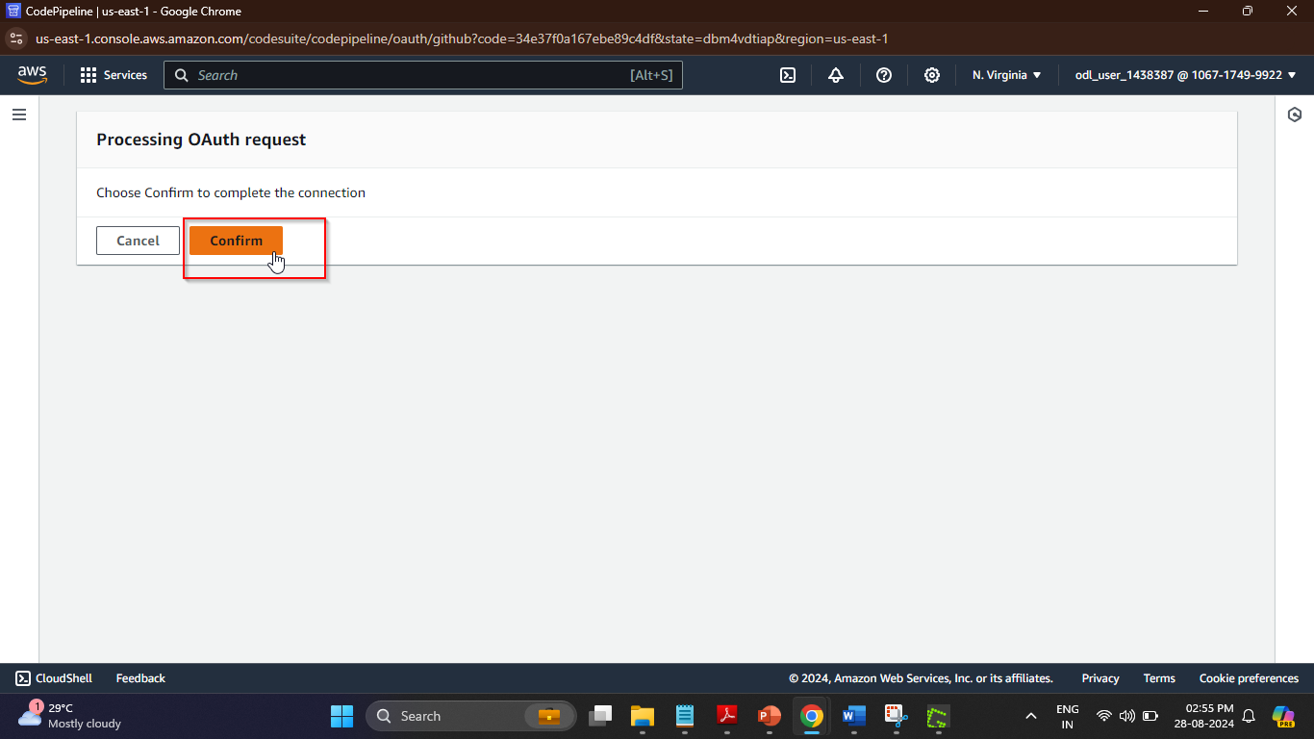

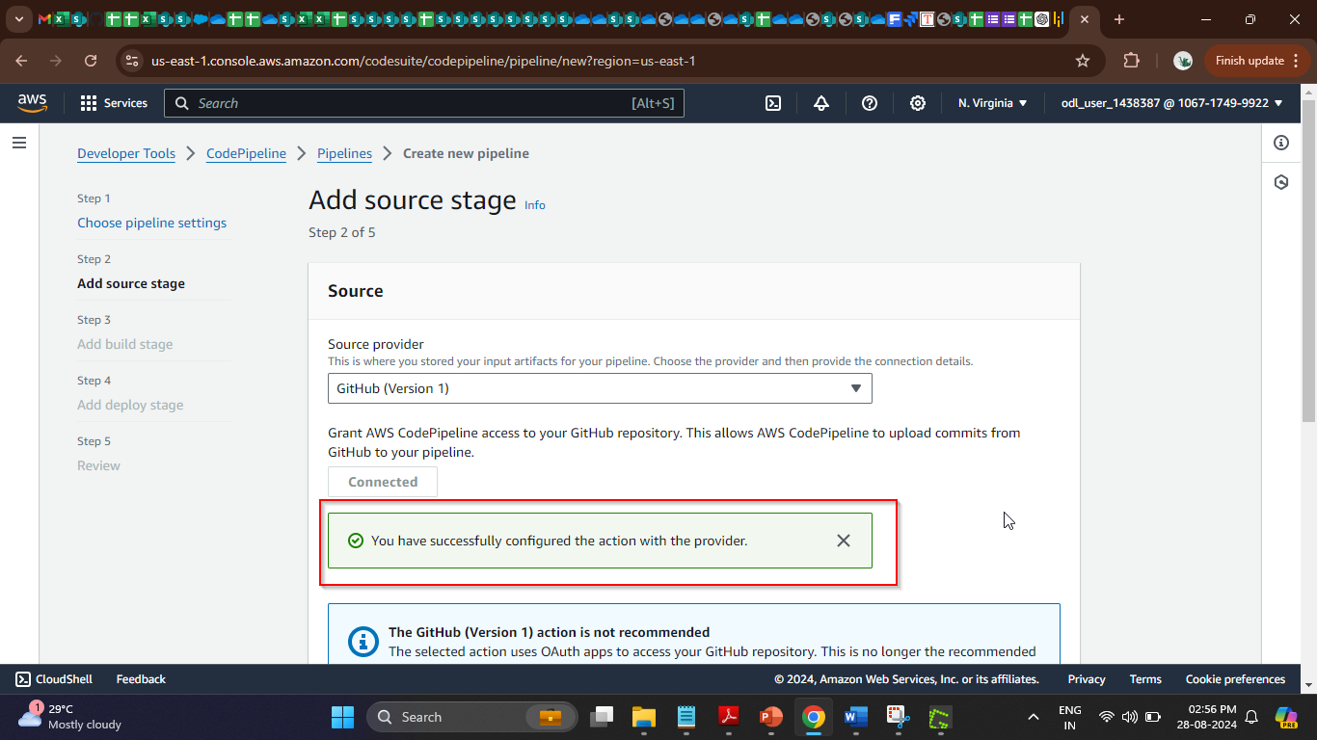

The GitHub connection is now ready for use.

- Select the GithubWorkstation/PlanView option under Repository
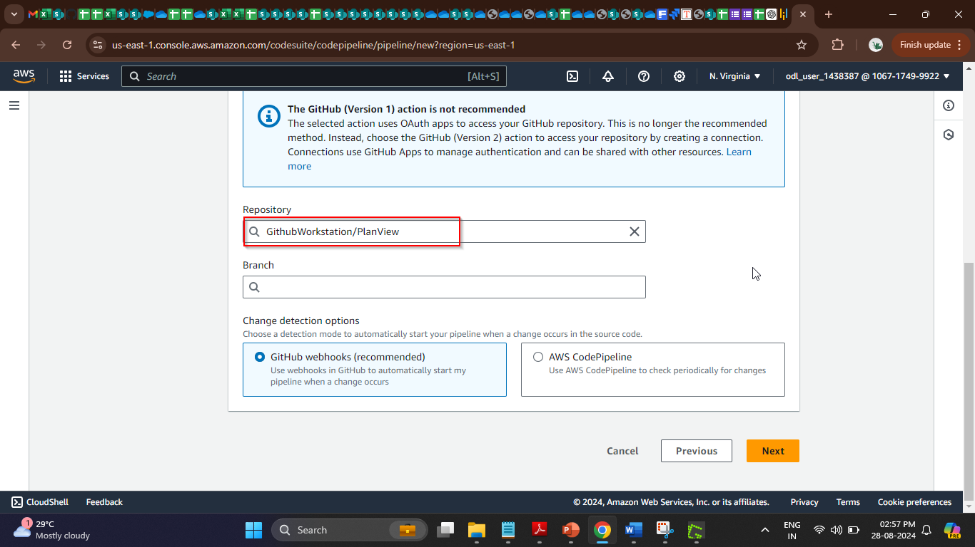
Note: Name the previously created repository as PlanView or specify any desired name of the repository you created

- Select the master option under Branch

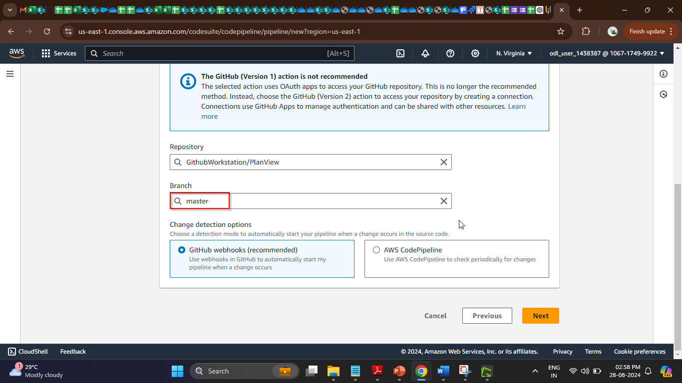

- Click the Next button
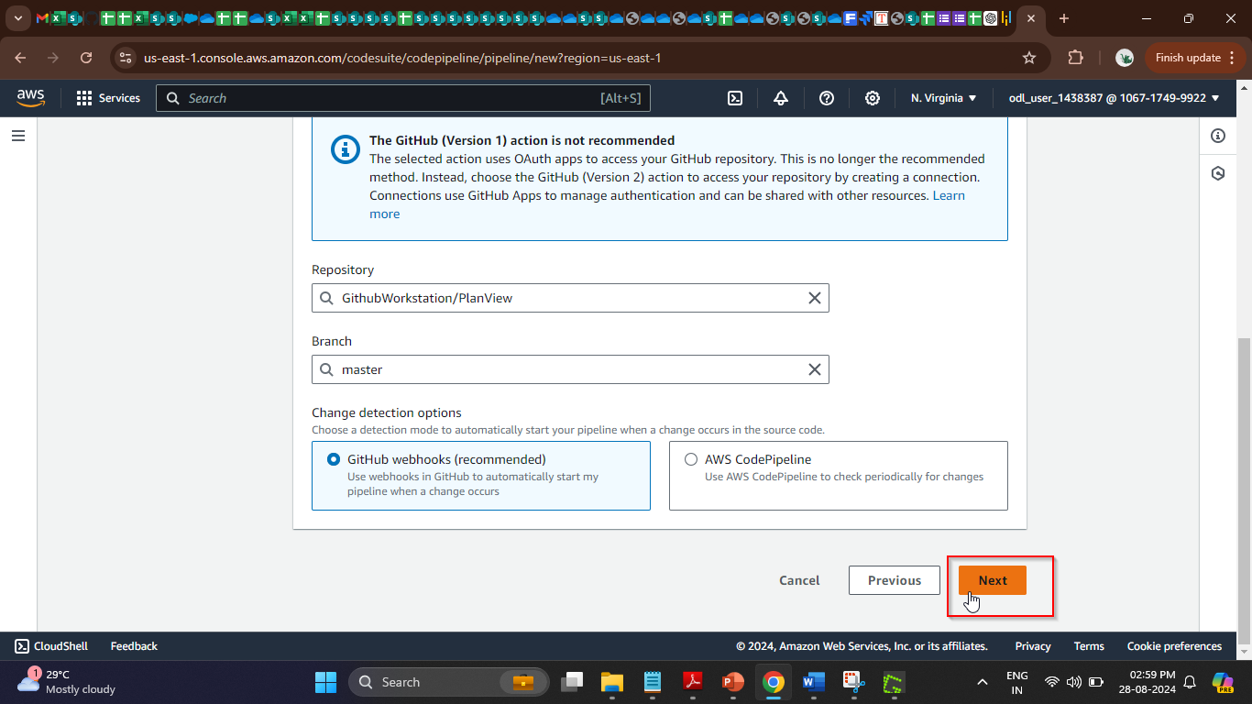
- Select AWS CodeBuild under Build provider for building and automating tests
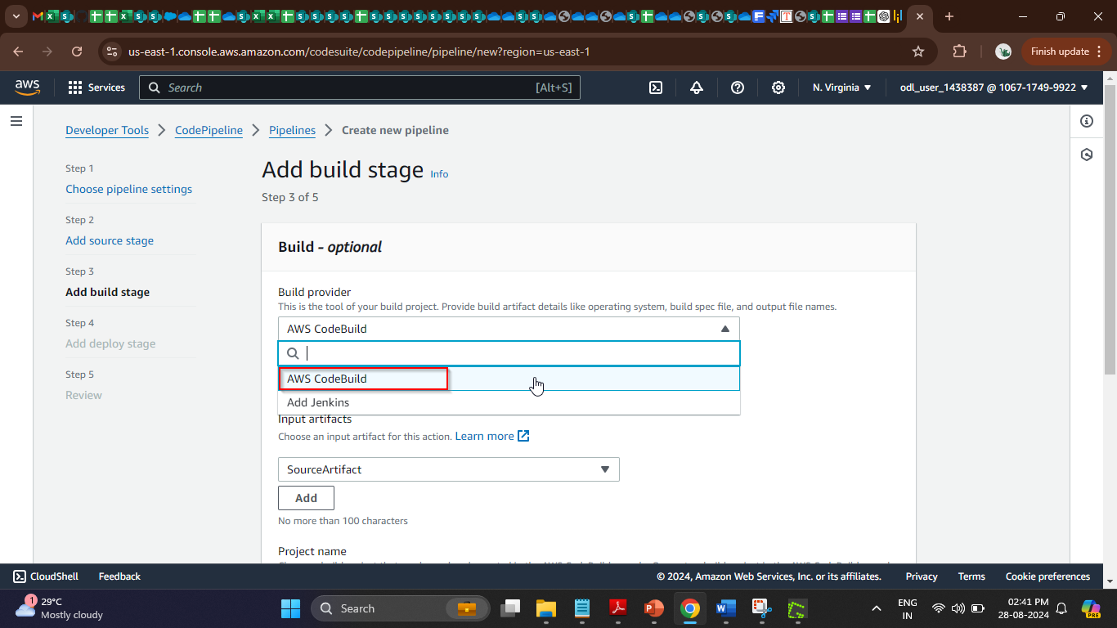

- Click on the Create project button; a pop-up window will appear
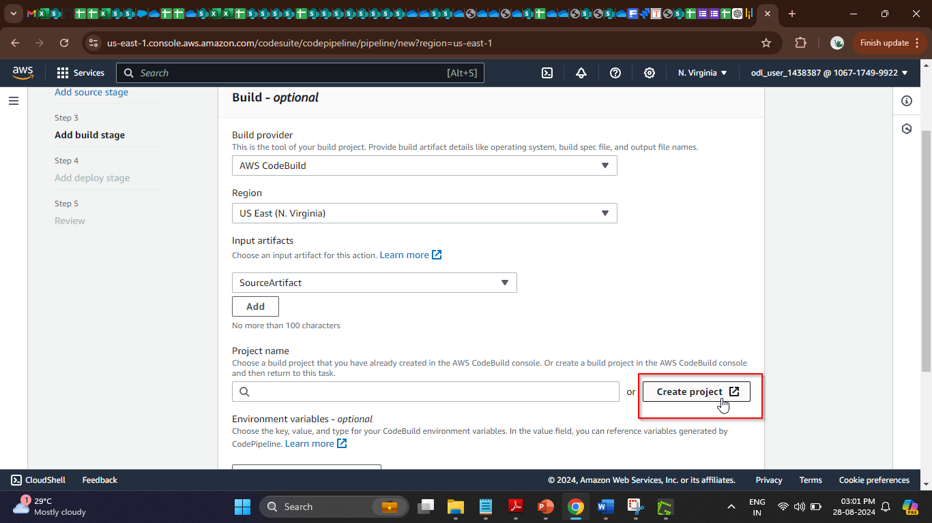

- In the new window, add the name of the project
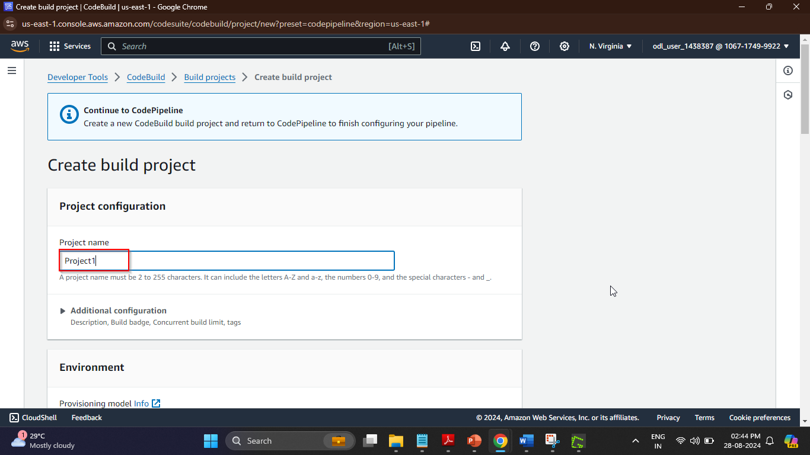
- In the Environment section, add the details as shown in the screenshot below:
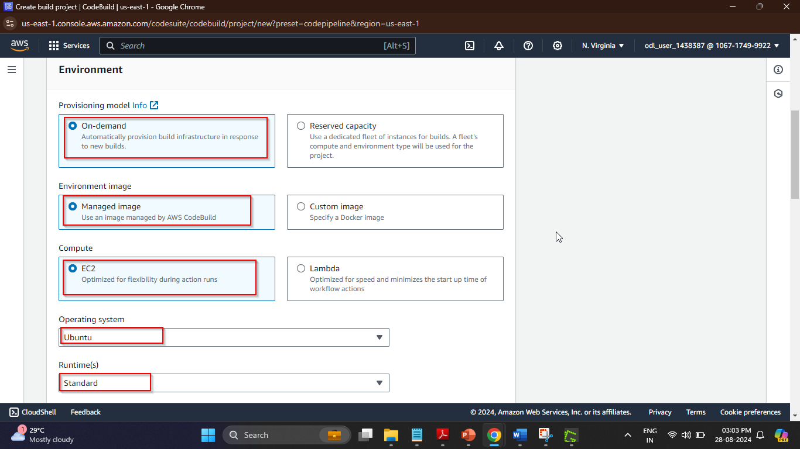
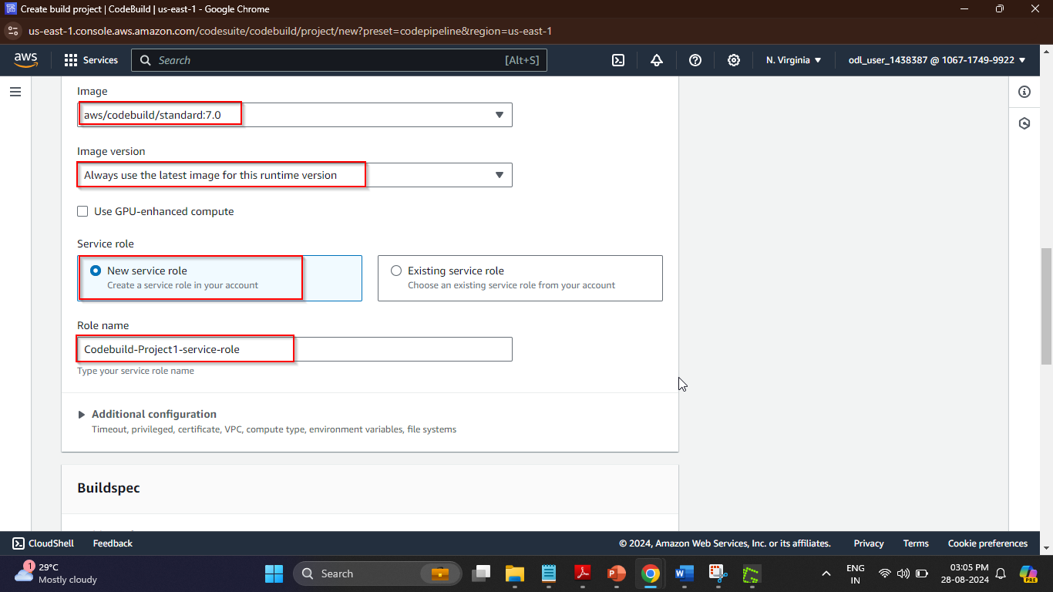
- Under Buildspec, select the Insert build commands option and click on the Switch to editor button
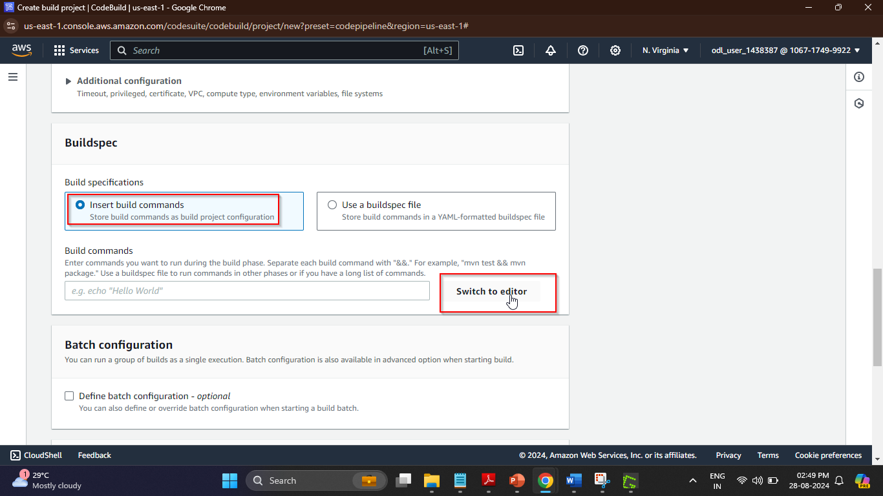

- Remove the existing build commands from the editor and enter the following YAML code:
version: 0.2
phases:
build:
commands:
- "ls -alrt"
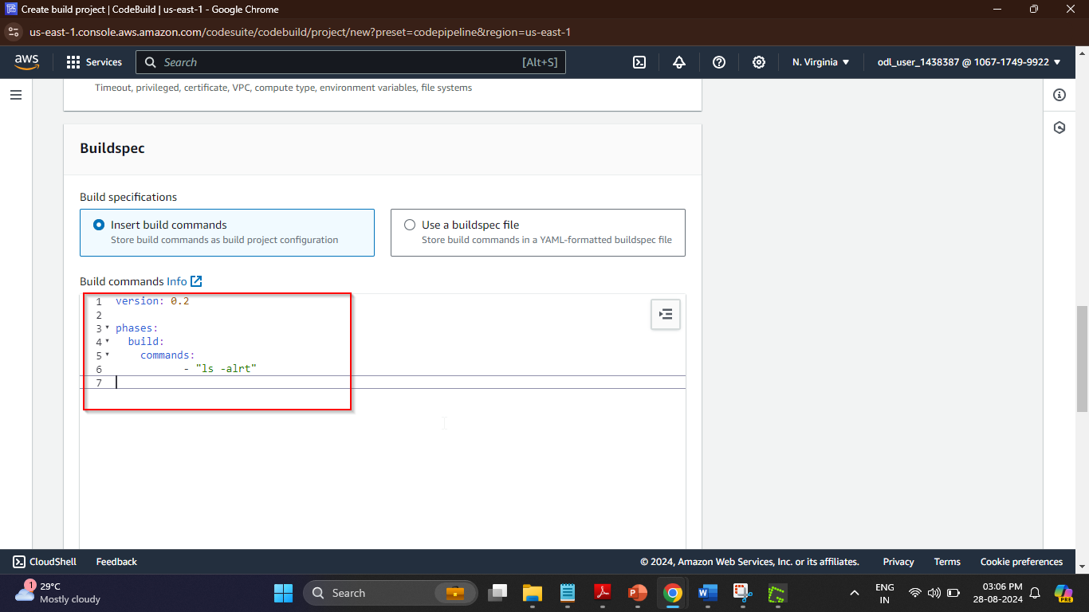
- Scroll to the bottom of the page and click on the Continue to CodePipeline button
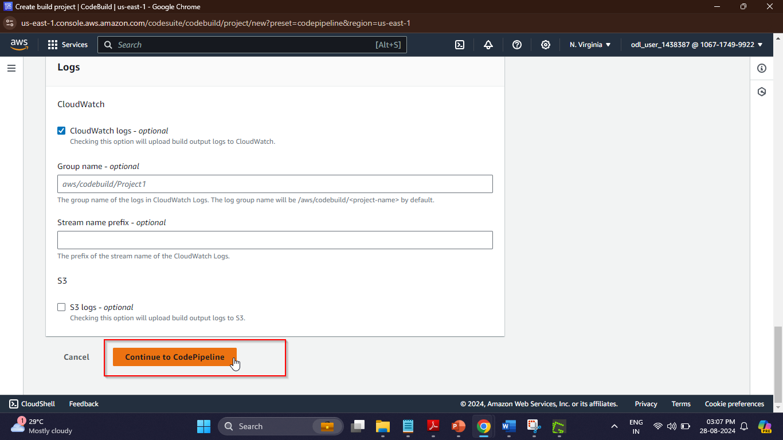

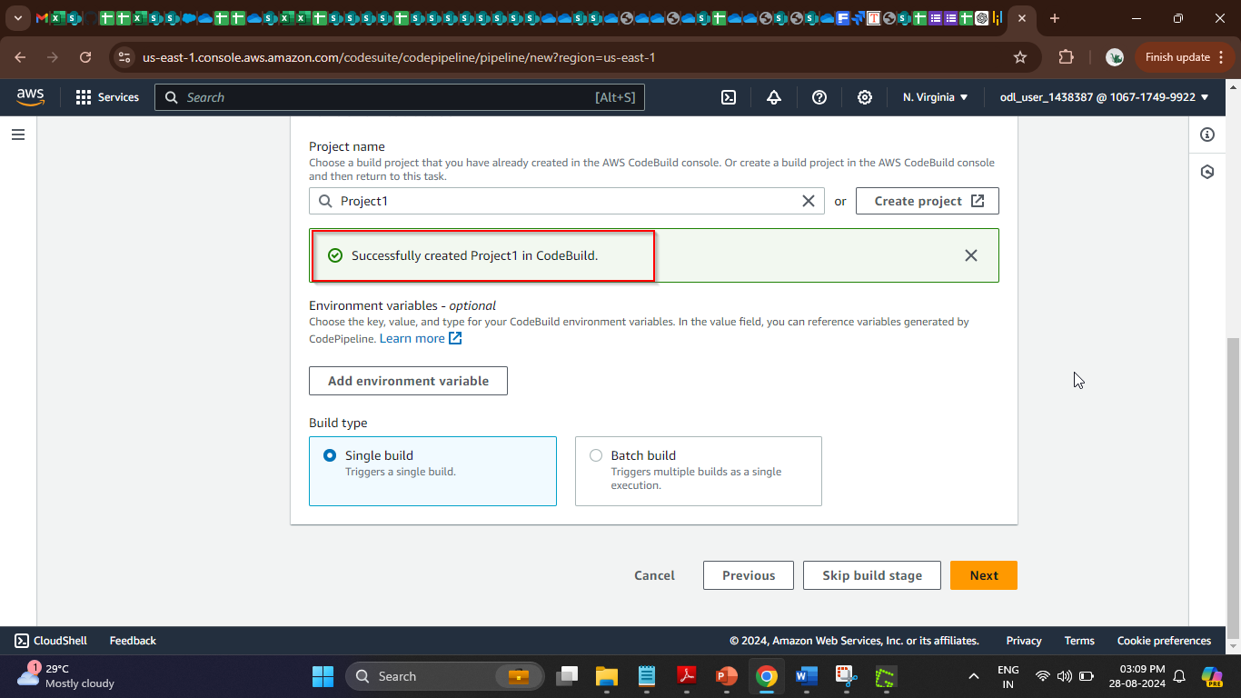
The project has been successfully created.

- Now, click on the Next button
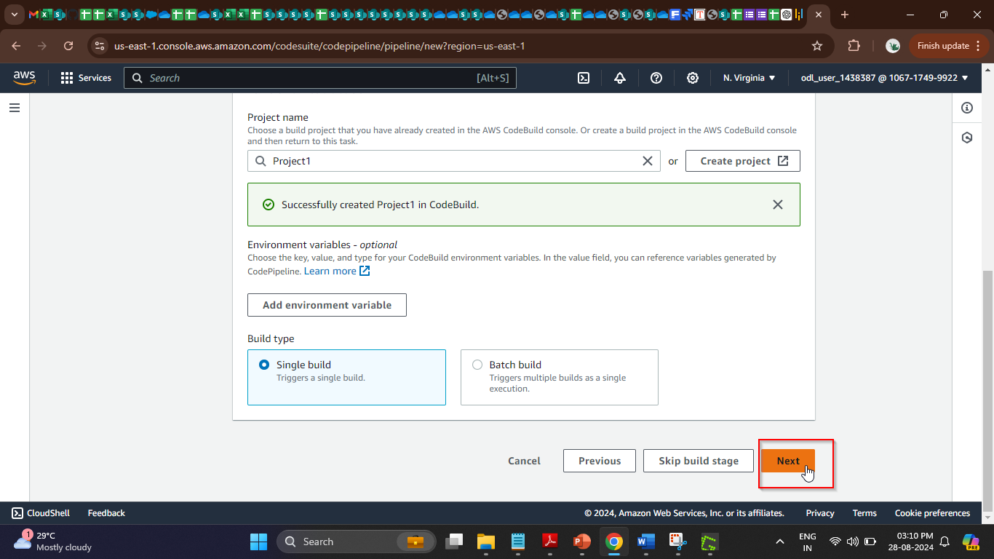

- Click on the Skip deploy stage button and then on the Skip button to finalize the
pipeline
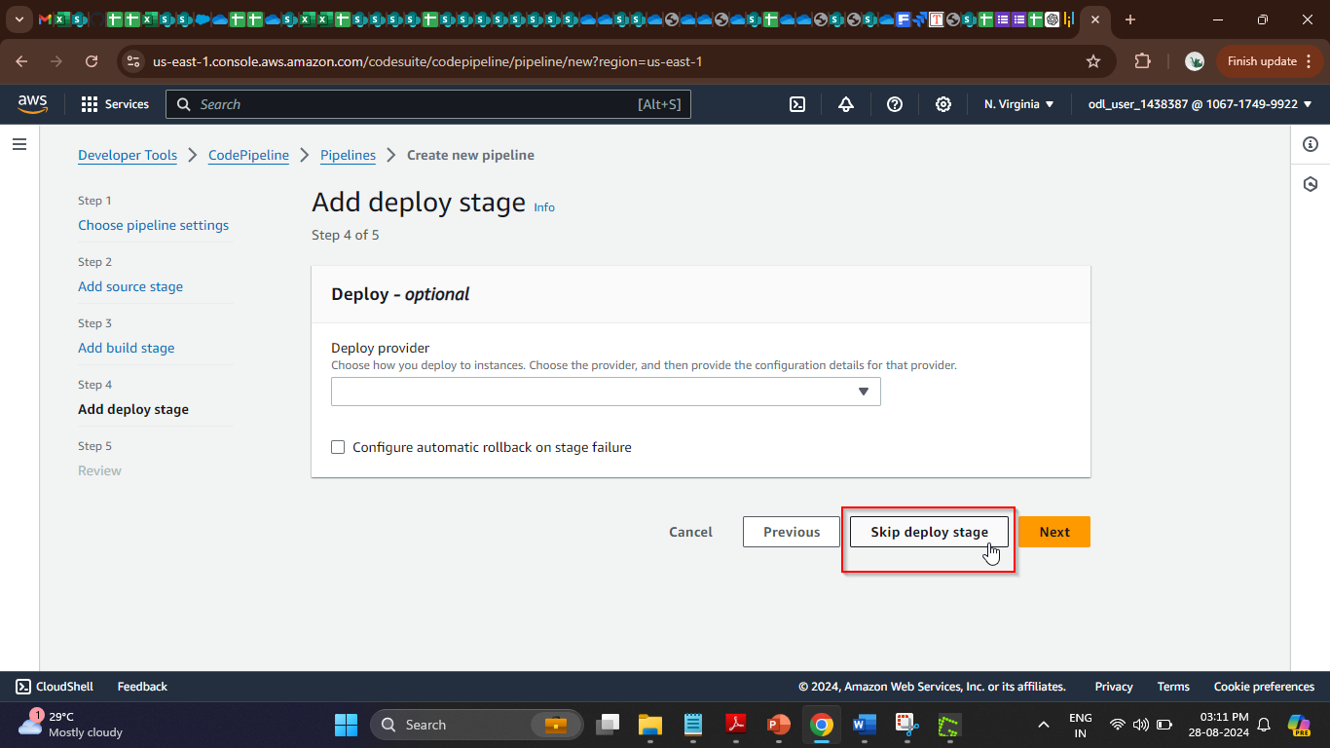
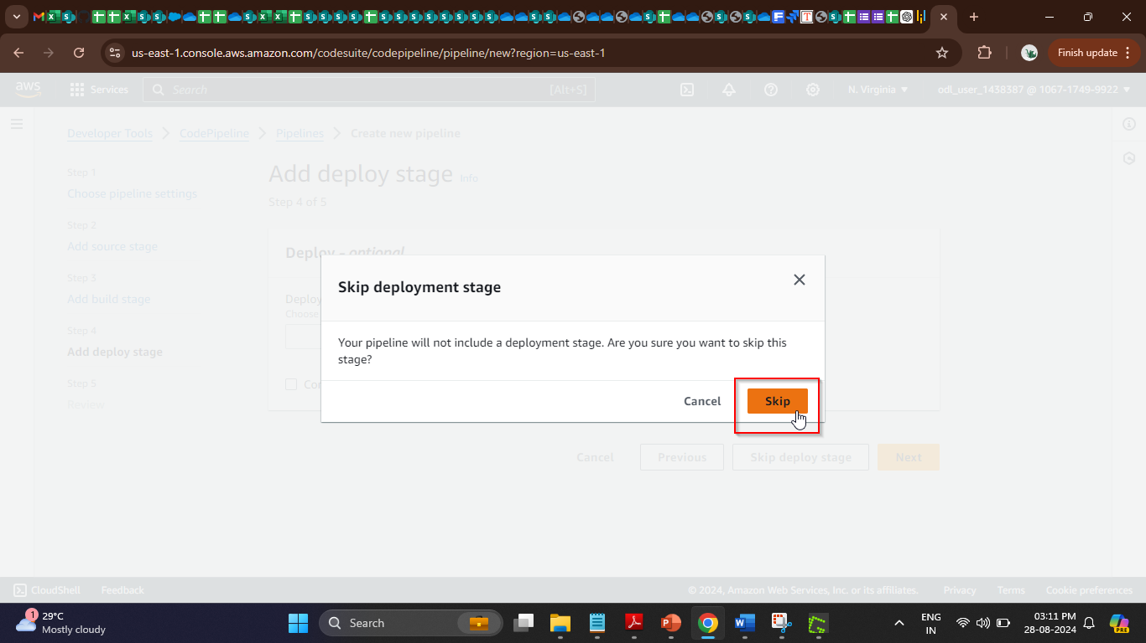

- Scroll to the bottom of the page and click on the Create pipeline button
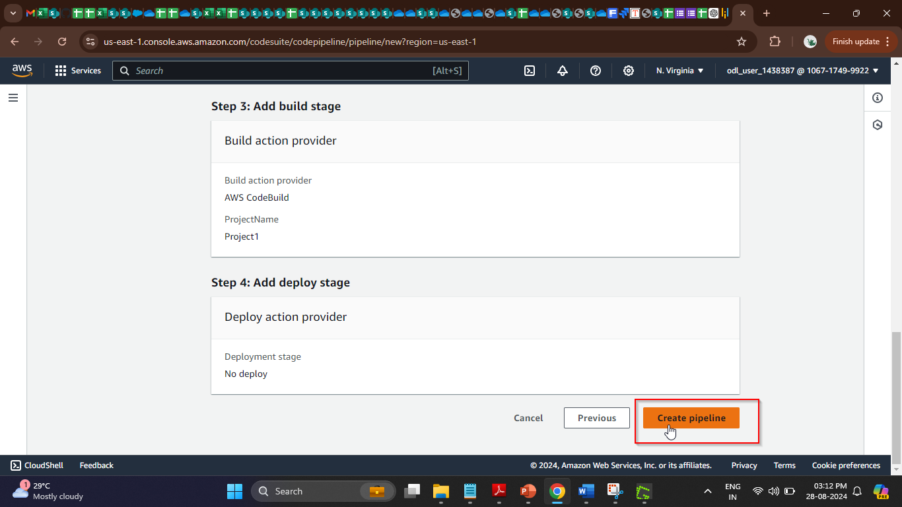
After creating the pipeline, the execution starts.
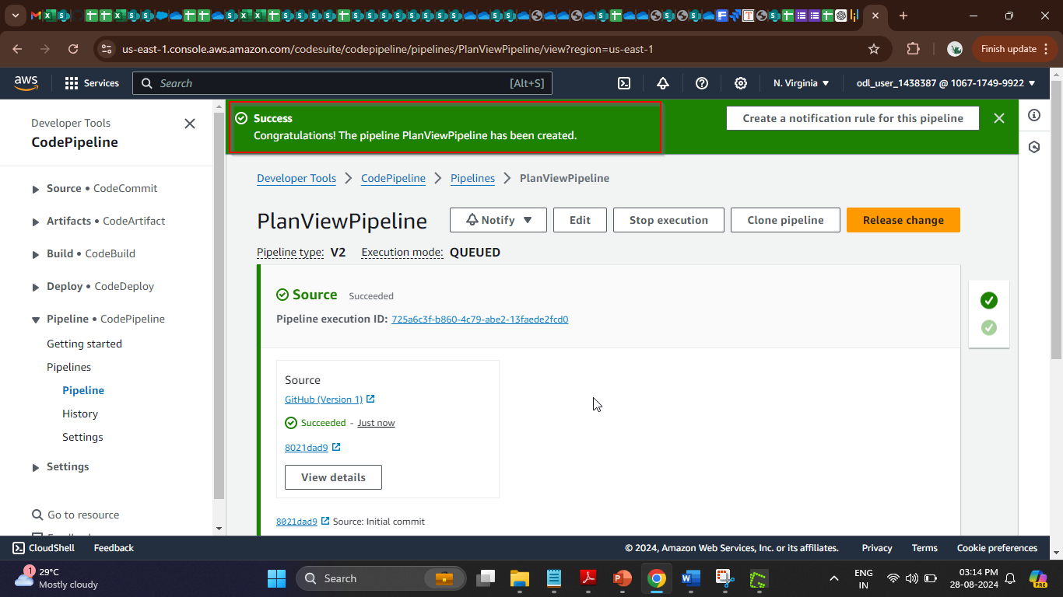

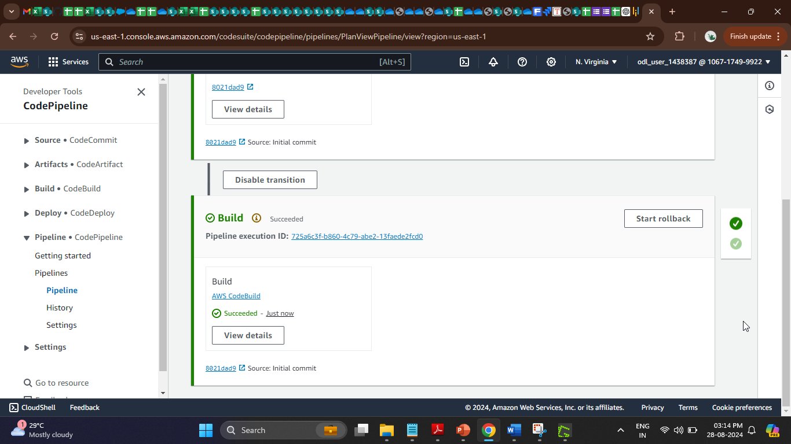
- Once the build stage is completed, click on the View details button in the Build section for validation
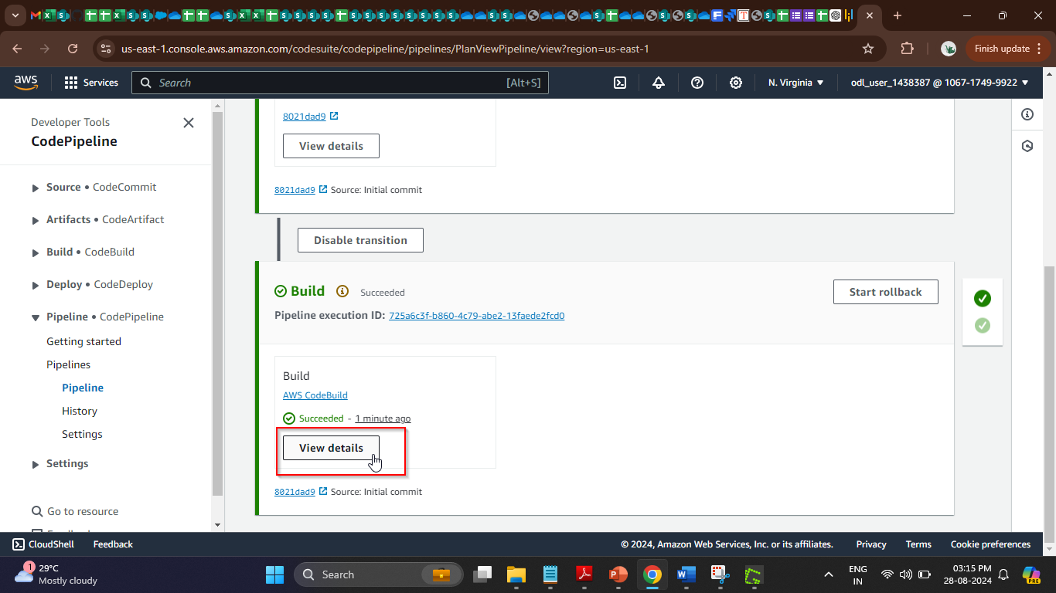
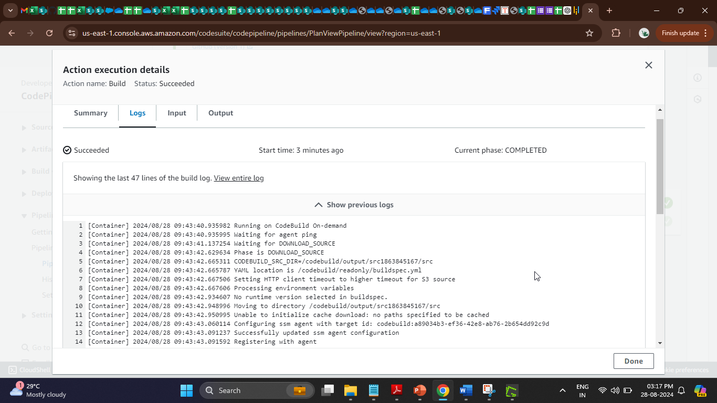
By following these steps, you have successfully created an AWS CodePipeline for continuous integration and delivery (CI/CD) using a GitHub repository.

