Lesson 03 Demo 03

Creating an IAM User and Attaching Permissions
Objective: To create an IAM user in AWS and assign necessary permissions using the AWS Management Console

Tools required: AWS Console

Prerequisites: None

Steps to be followed:
- Create an IAM user and attach a policy

Step 1: Create an IAM user and attach a policy

- Open the AWS Management Console in your practice environment

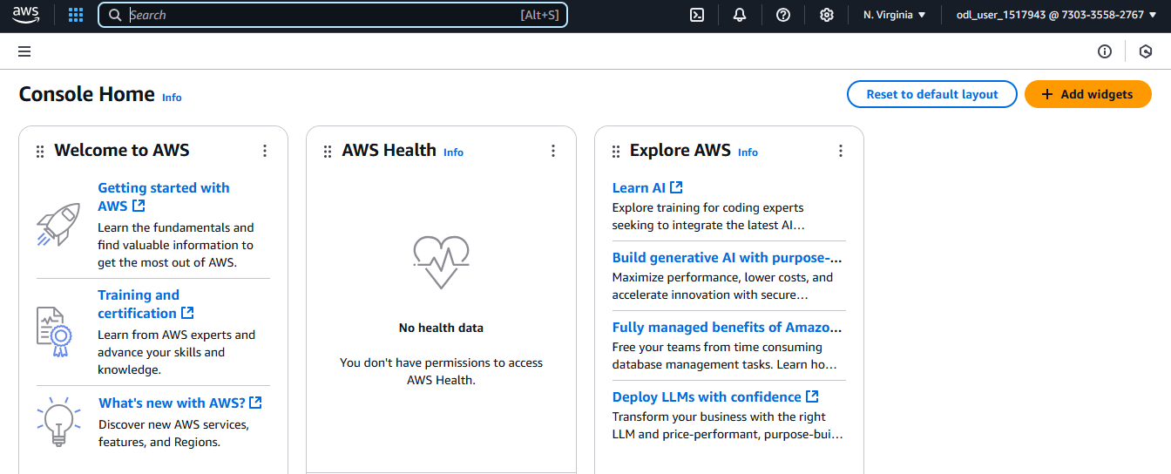

- In the search bar, type IAM and select the IAM service
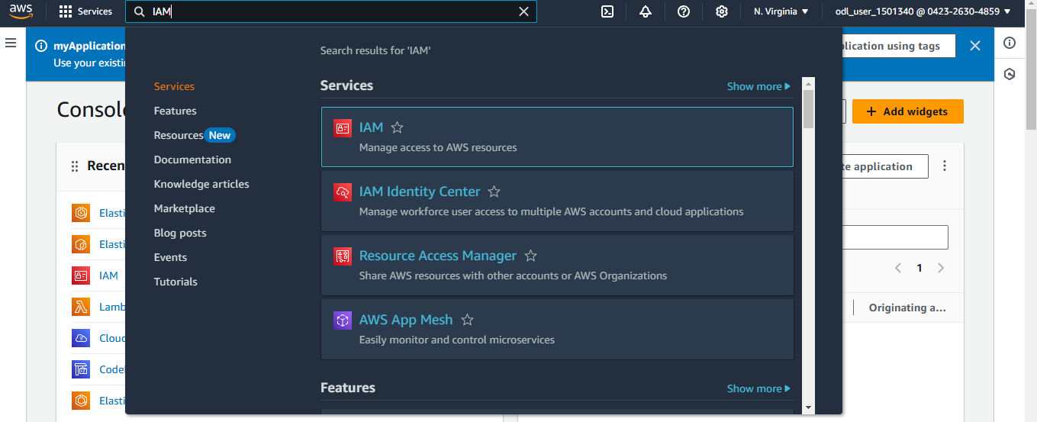
- Click on Users in the left navigation panel
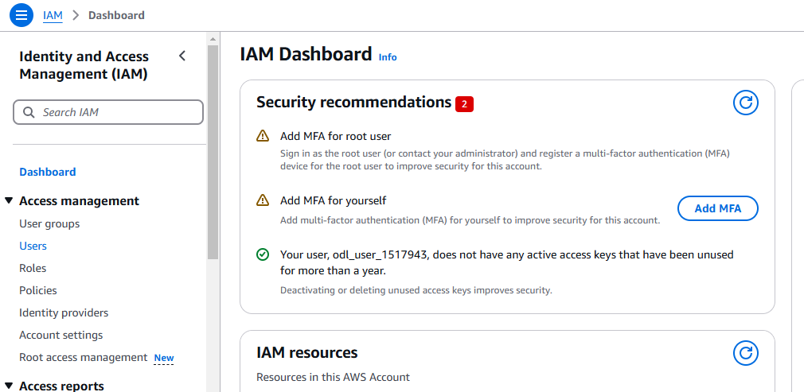
- Provide a name for the user and check the box labeled AWS Management Console Access to enable console access
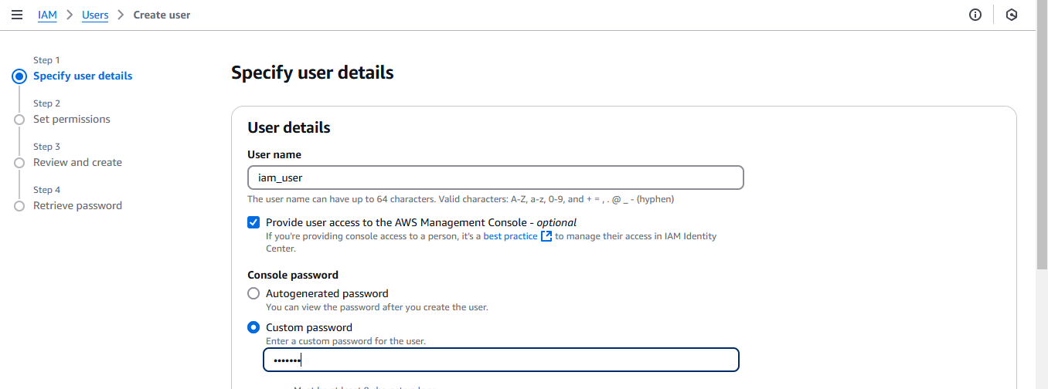
- Set a Custom password for the user in the corresponding field

- Scroll down and click on Next to proceed
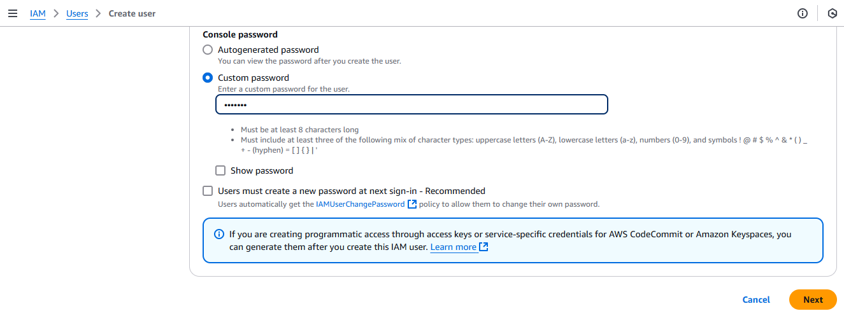
- On the Permissions page, select Add user to group and then click on Create group
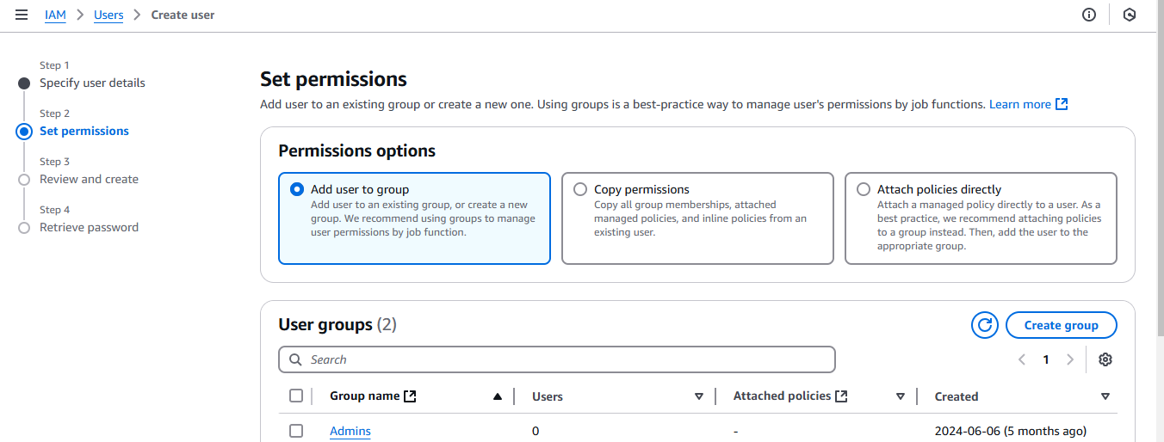
- Enter a name for the user group in the Group Name field and click Create user group to
save it
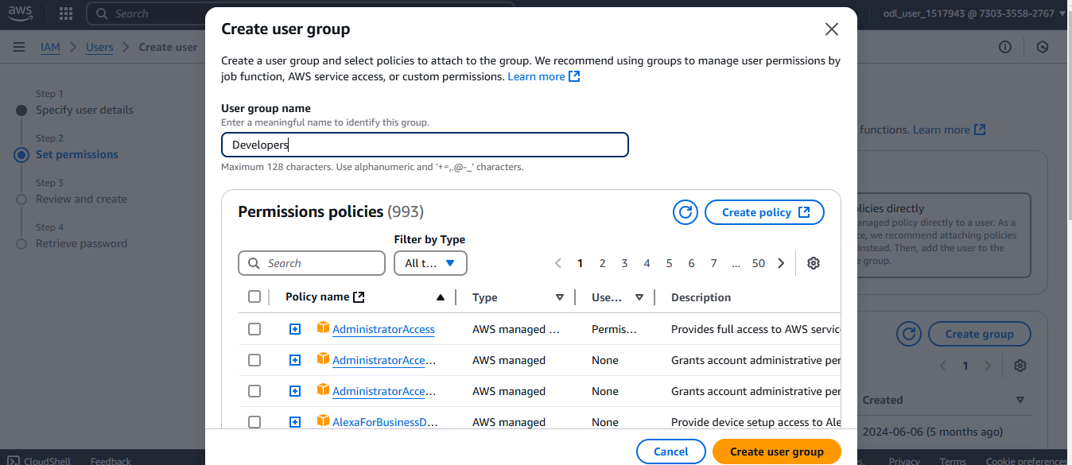
- Select Attach policies directly from the available options
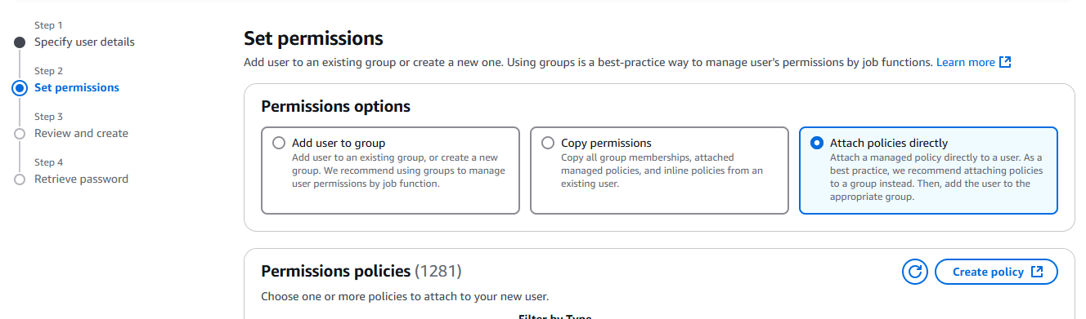
- In the Permission policies search bar, type EC2, and select AmazonEC2FullAccess from the list of policies
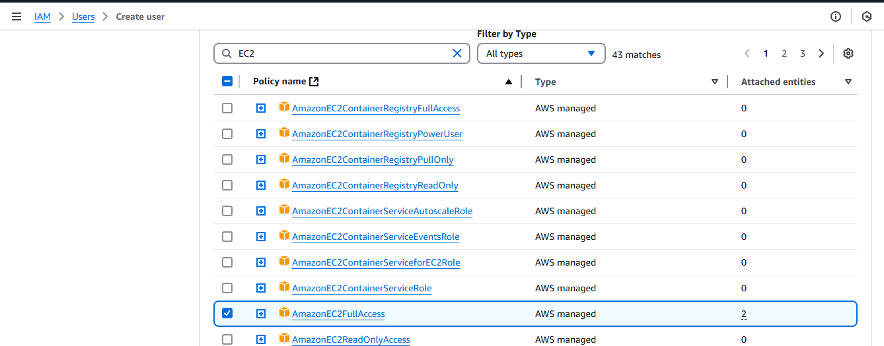
- Scroll down and click Next to review the settings
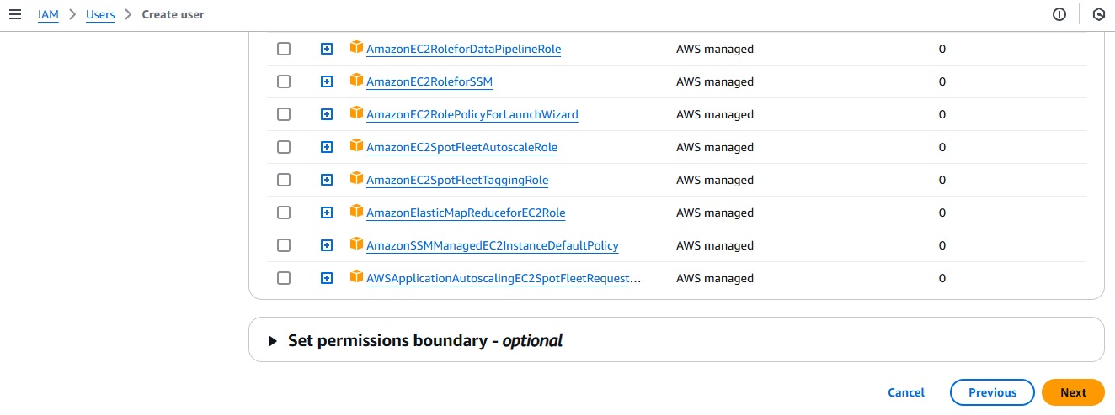
- On the final review page, click on Create user to complete the process
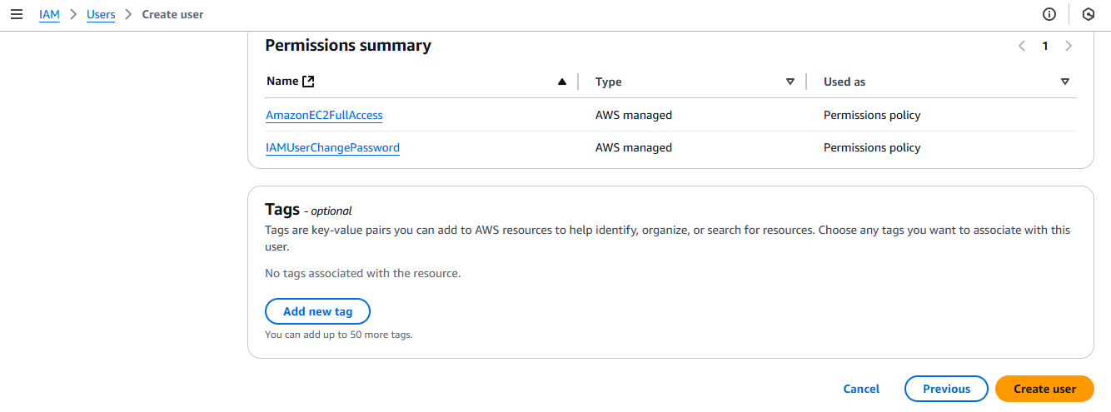
The user and user group are created, and the necessary permissions are assigned.
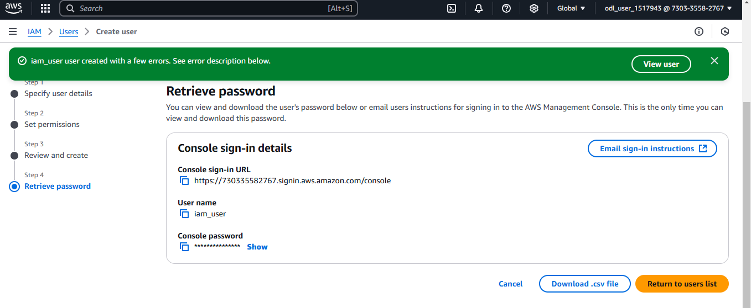
By following these steps, you have successfully created an IAM user, added the user to a group, and attached the AmazonEC2FullAccess policy, ensuring the user has the required permissions to manage EC2 resources.

