Lesson End Project
Integrating Penetration Testing and SQL Injection in DevSecOps with GitHub Actions

Project agenda: To implement penetration testing and SQL injection detection in a DevSecOps pipeline using GitHub Actions, enhancing the security of a Java application by automating security scans and generating vulnerability reports

Description: As a DevOps engineer, your task is to enhance the security of a deliberately vulnerable application by incorporating penetration testing and SQL injection detection into a GitHub Actions workflow. This involves setting up workflows to automatically perform penetration scans using OWASP ZAP, detect vulnerabilities, and log results as GitHub issues, ensuring early identification of potential threats.

Tools required: GitHub Actions and OWASP ZAP

Prerequisites: A GitHub account, an AWS account to launch an EC2 instance, basic knowledge of Docker, OWASP ZAP, SQL injection techniques, and YAML syntax for GitHub Actions workflows

Expected deliverables: A GitHub Actions workflow for automated penetration testing using OWASP ZAP, a deployed WebGoat application on the EC2 instance, a baseline scan report identifying vulnerabilities like SQL injection, GitHub issues logged for detected vulnerabilities, and a consolidated security report in the repository

Steps to be followed:
- Set up EC2 Instance
- Deploy the vulnerable application
- Test SQL Injection
- Create GitHub repository and set up Actions Workflow
- Run Workflow and review results

Step 1: Set up EC2 Instance

- Open the Amazon console at https://console.aws.amazon.com/

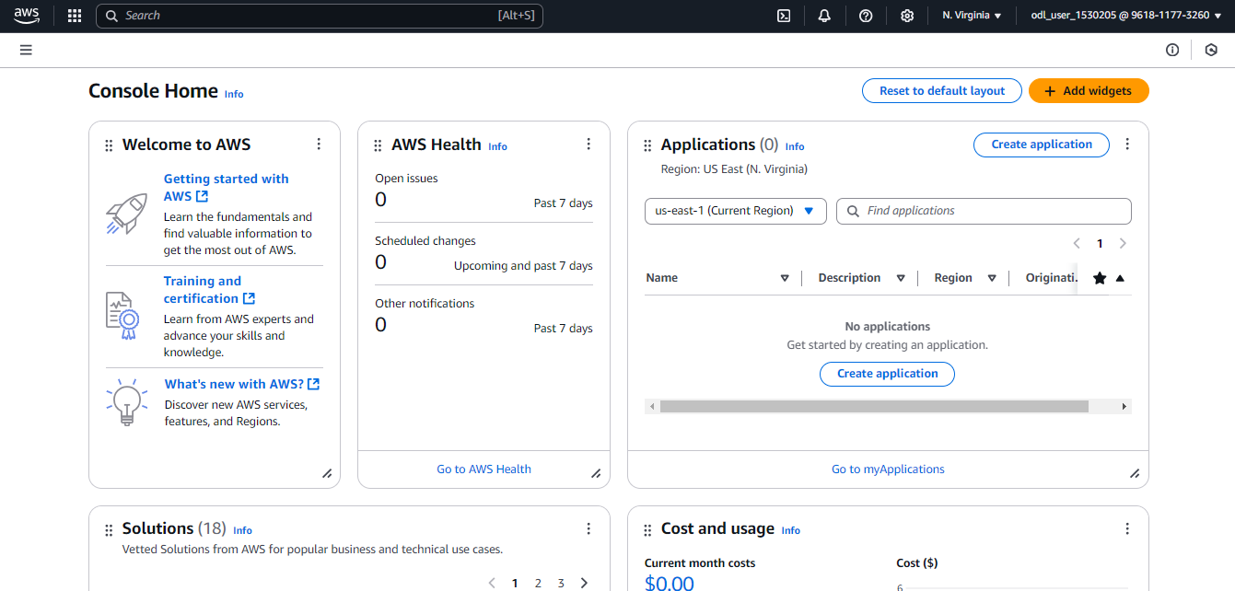

- Type EC2 in the search bar and press enter to navigate to EC2 Dashboard

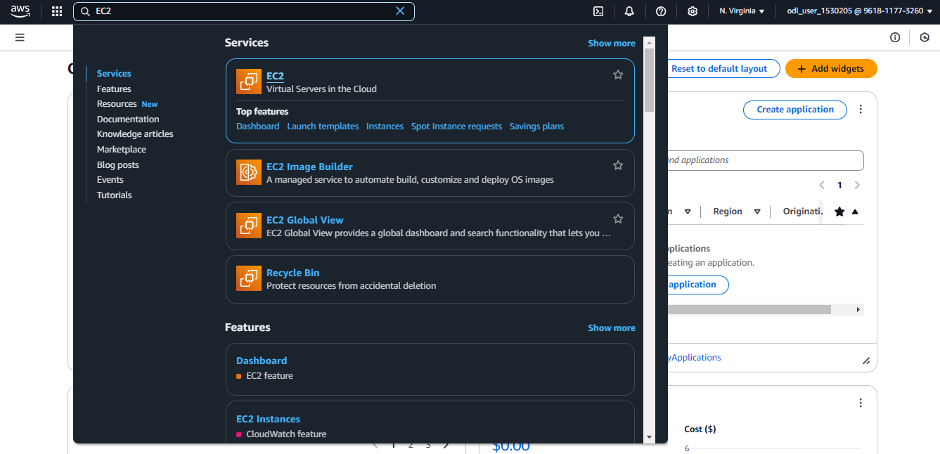

You will be redirected to the EC2 Dashboard.

- Click on Launch instance

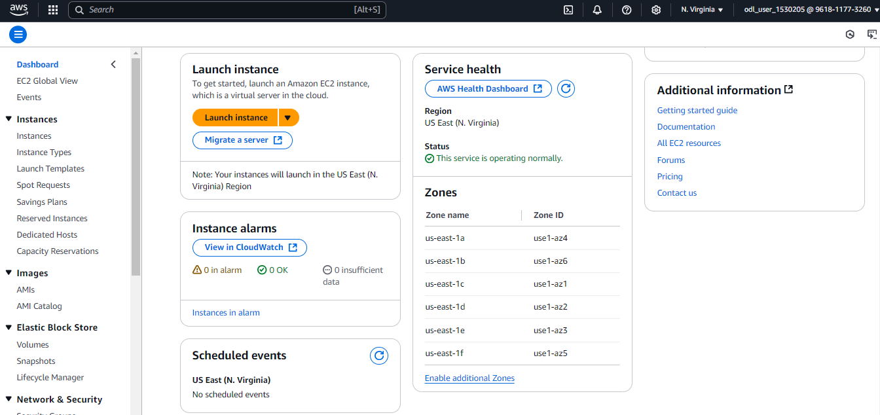

- Add a desired name for the Instance (demo_lep)

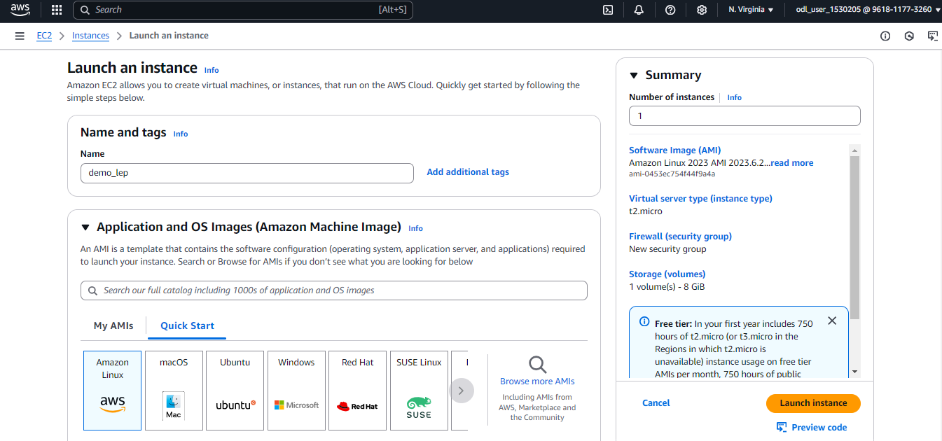

- Select Amazon Linux

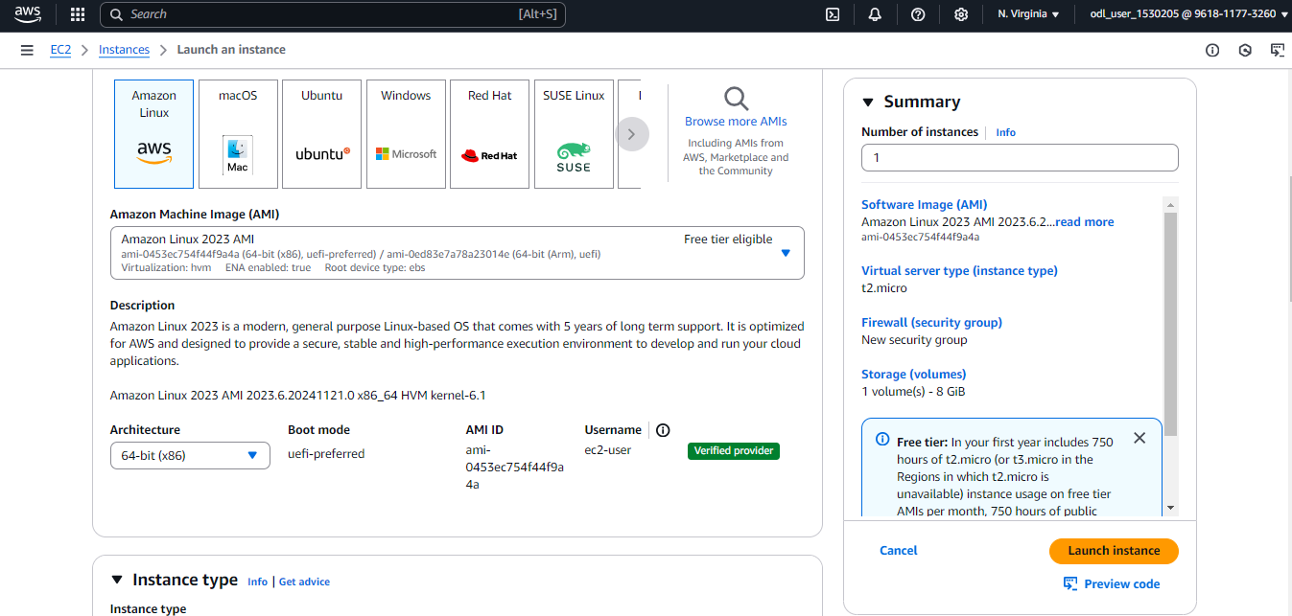

- Scroll down and click on Create new key pair

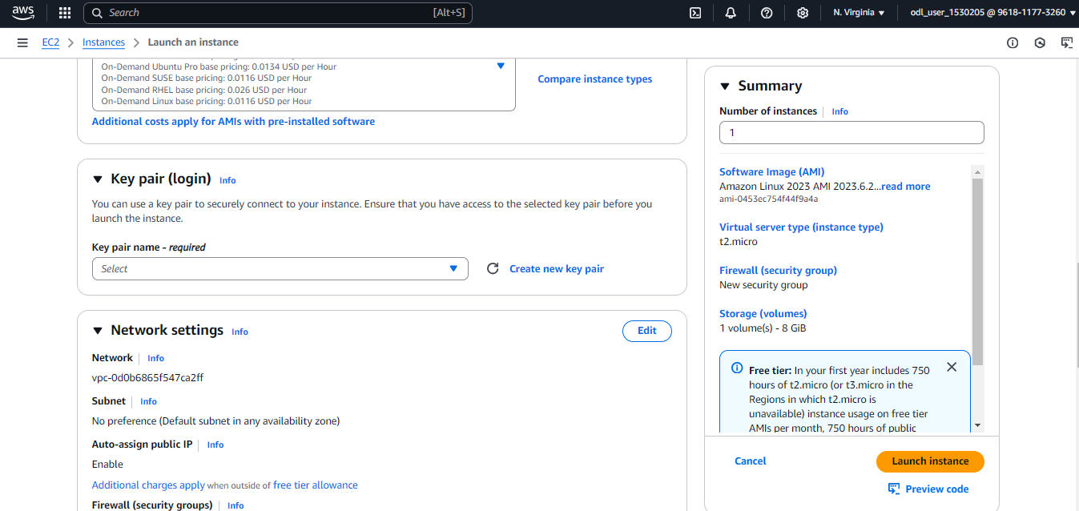

- Add a desired name for the key pair and click on Create key pair

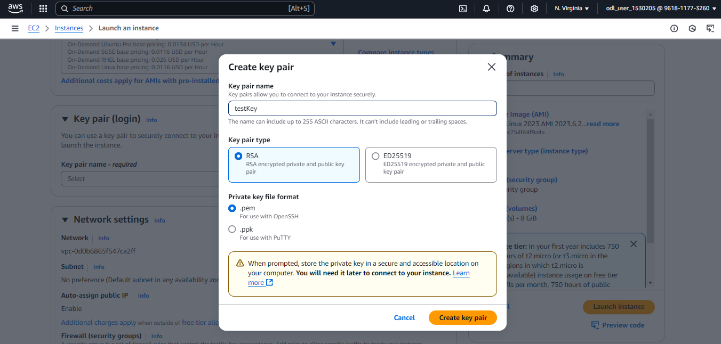

- Scroll down and click on Edit in the Network settings section

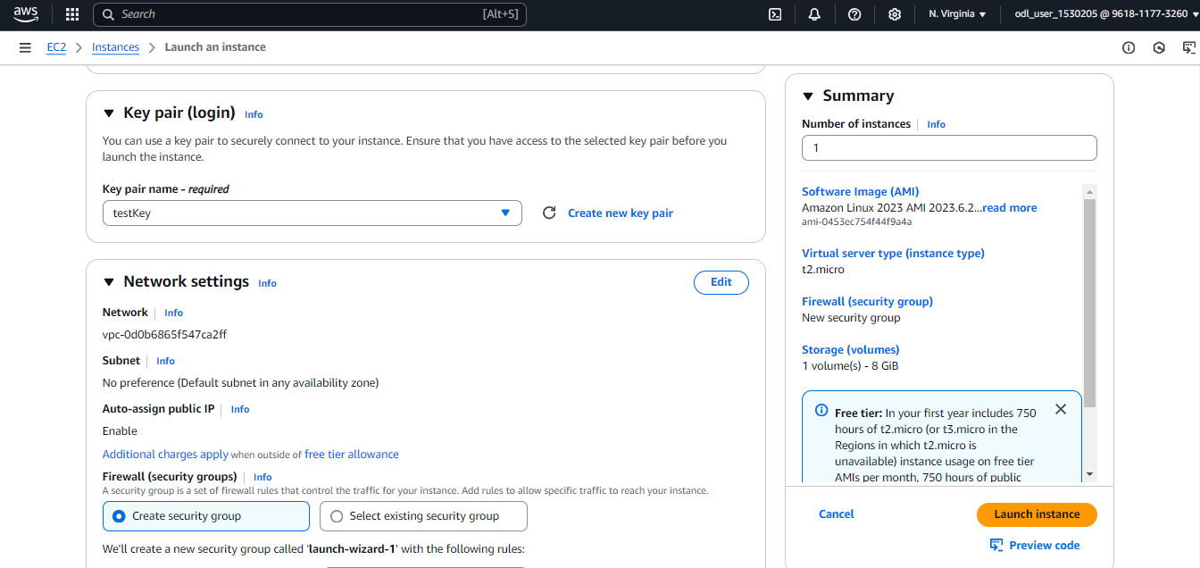

- Scroll down and click Add security group rule

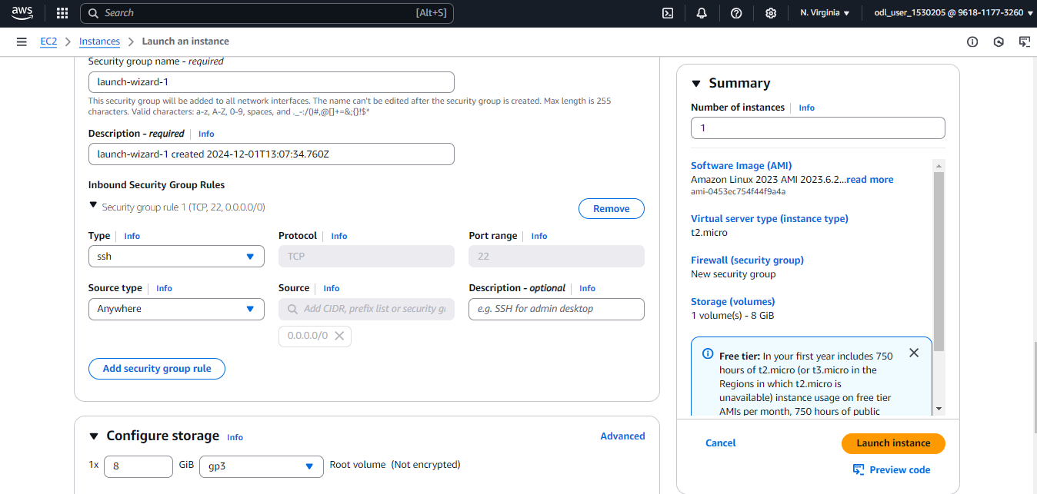

- Select All traffic under the Type selector and Anywhere under the Source type selector

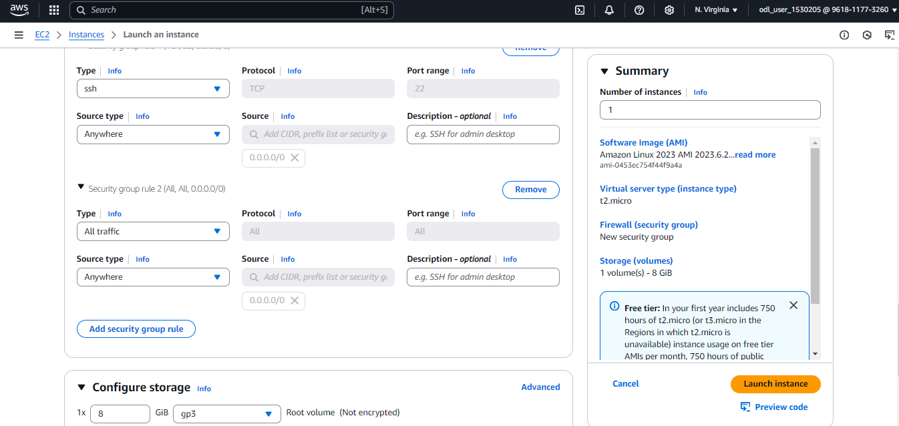

- Click on Launch instance



- Select the instance created from the message box

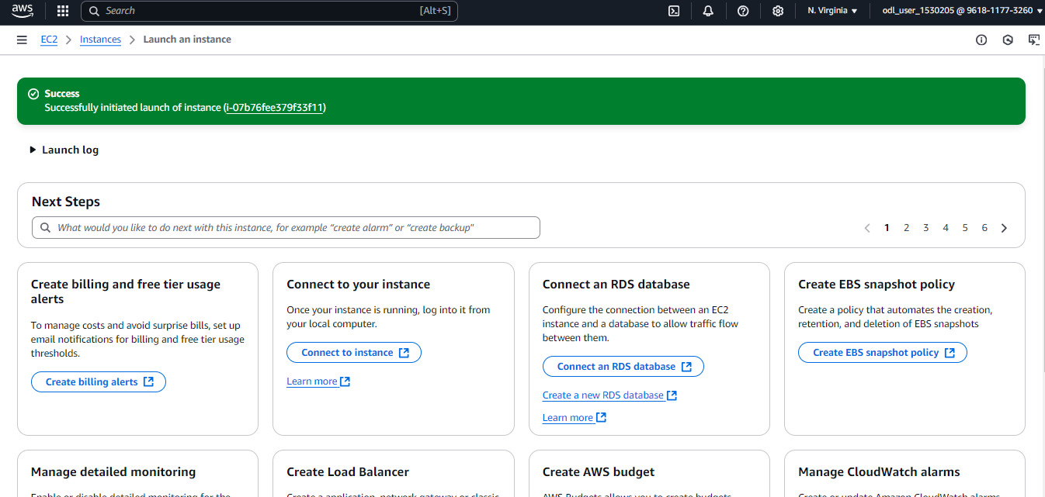

- Select the instance created and click on Connect

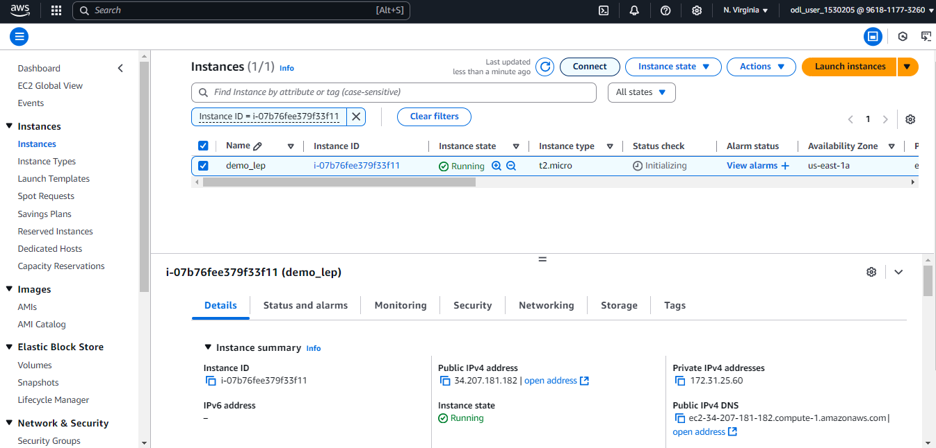

- Select EC2 Instance Connect. Then, scroll down and click on Connect.

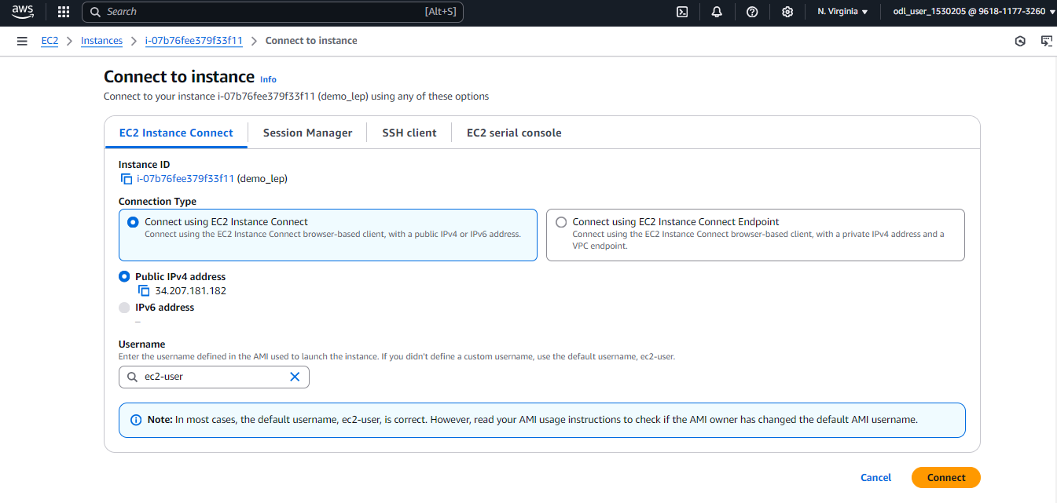

Now, you will be redirected to the EC2 terminal.

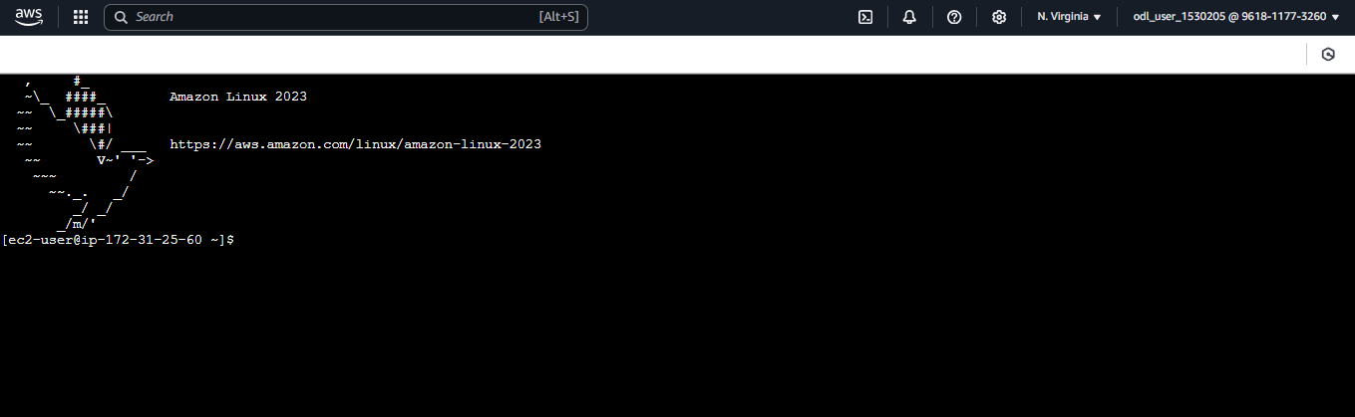
Step 2: Deploy the vulnerable application

- Run the following command to switch to the root user:
sudo su

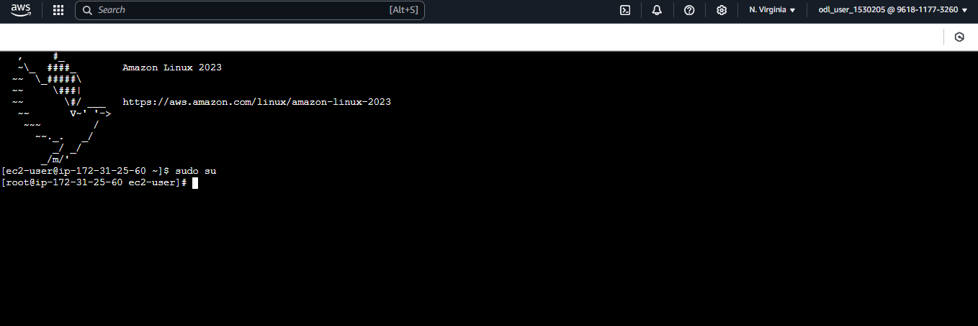

- Run the following command to install docker:
yum install docker -y

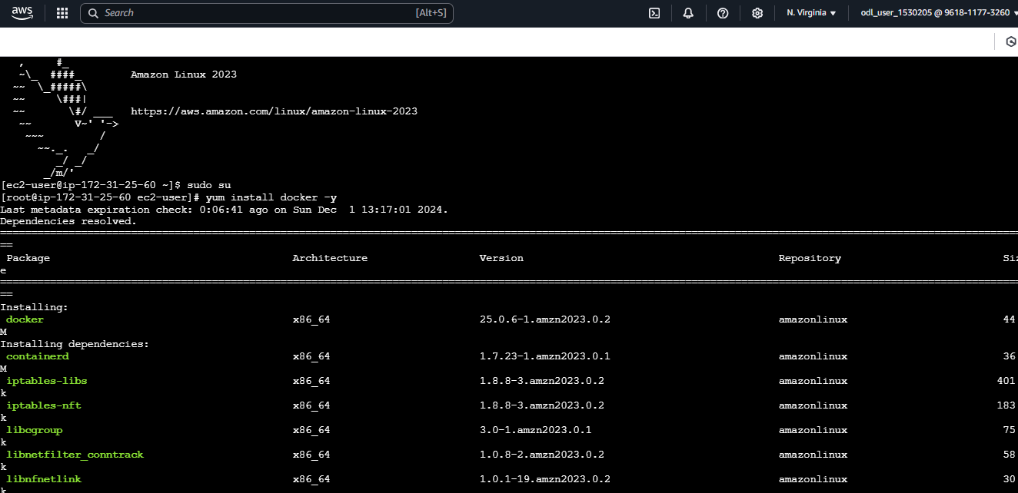

- Run the following command:
systemctl start docker

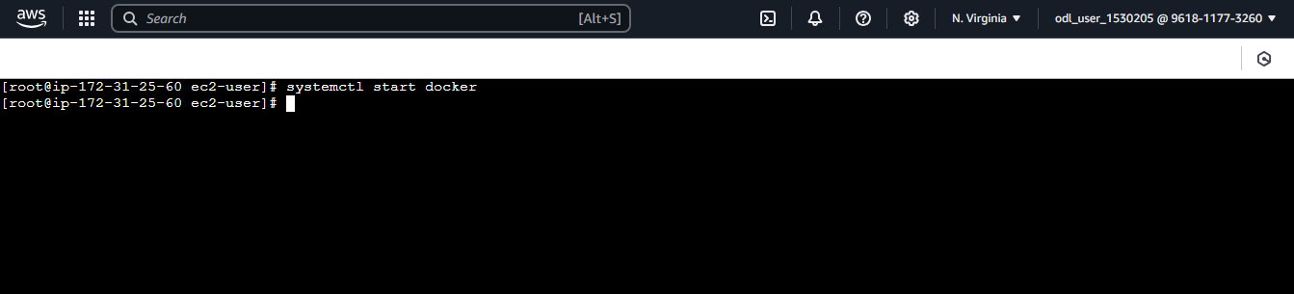

- Run the following command to deploy the webgoat application:
docker run -d -p 8989:8080 -p 9090:9090 -p 8081:8888 -e TZ=Europe/Amsterdam webgoat/goatandwolf:latest

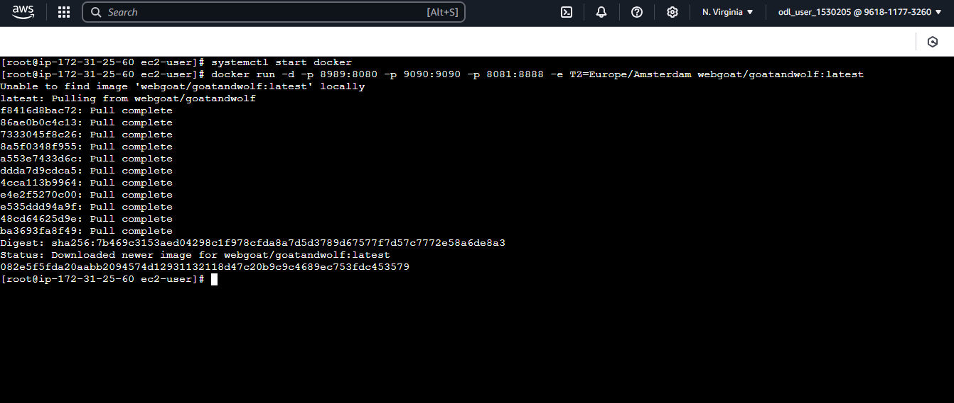

- Navigate to the EC2 instance and copy the Public IPv4 address

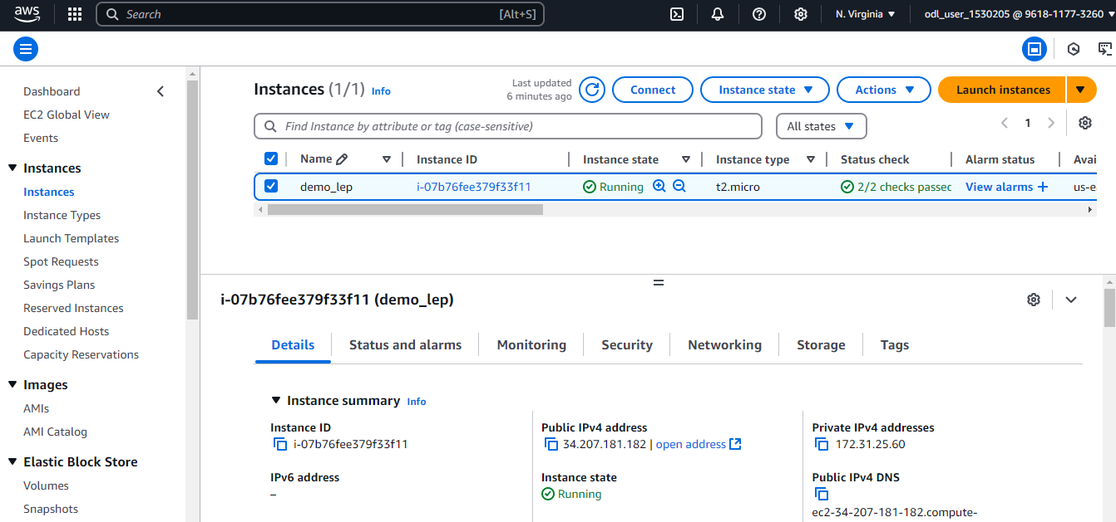

Step 3: Test SQL Injection

- Navigate to the browser and paste the following link:
http://<publicIPServer>:8081

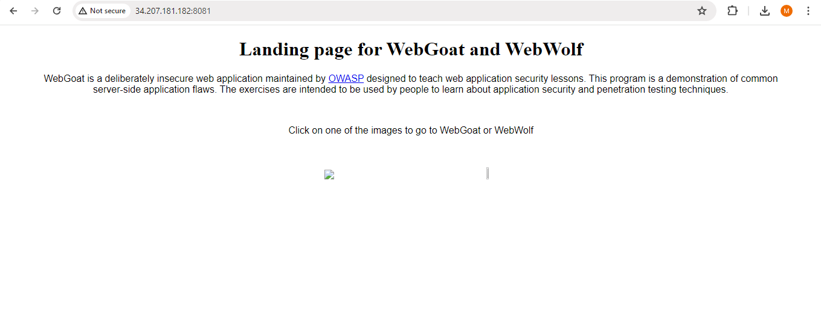

Note: Replace the <publicIPServer> with the Public IPv4 address copied

- Paste the link given below in a new tab and click on Register new user
http://<PublicIPServer>:8989/WebGoat/login

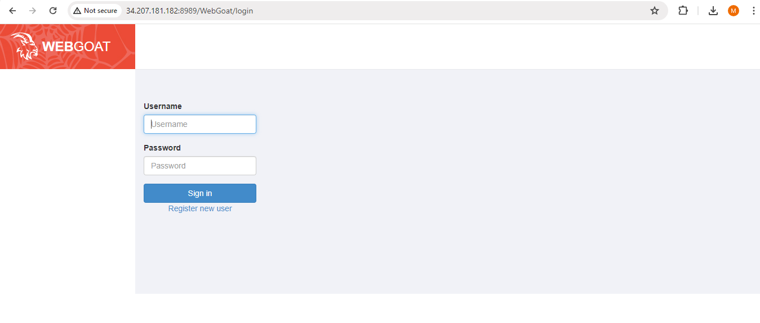

Note: Replace the <publicIPServer> with the Public IPv4 address copied

- Enter the Username, Password, and Confirm password as desired

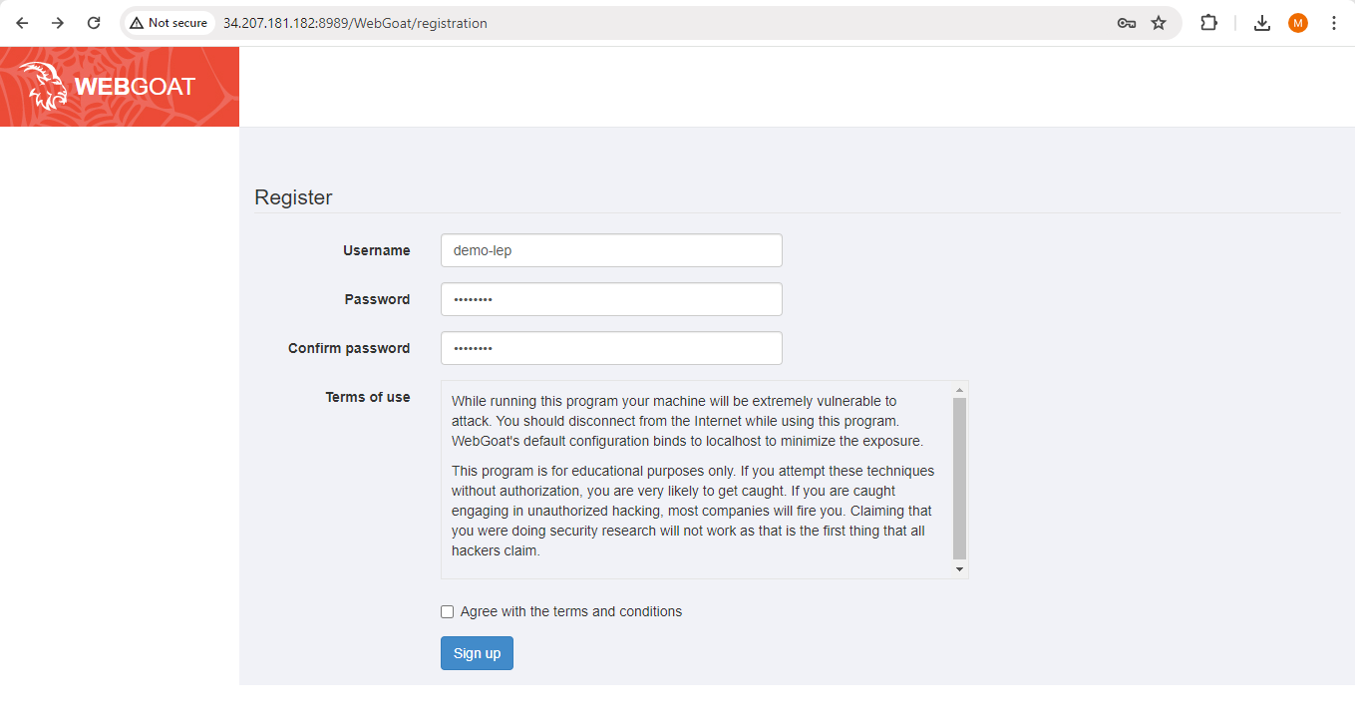

- Select the checkbox and click on Sign up

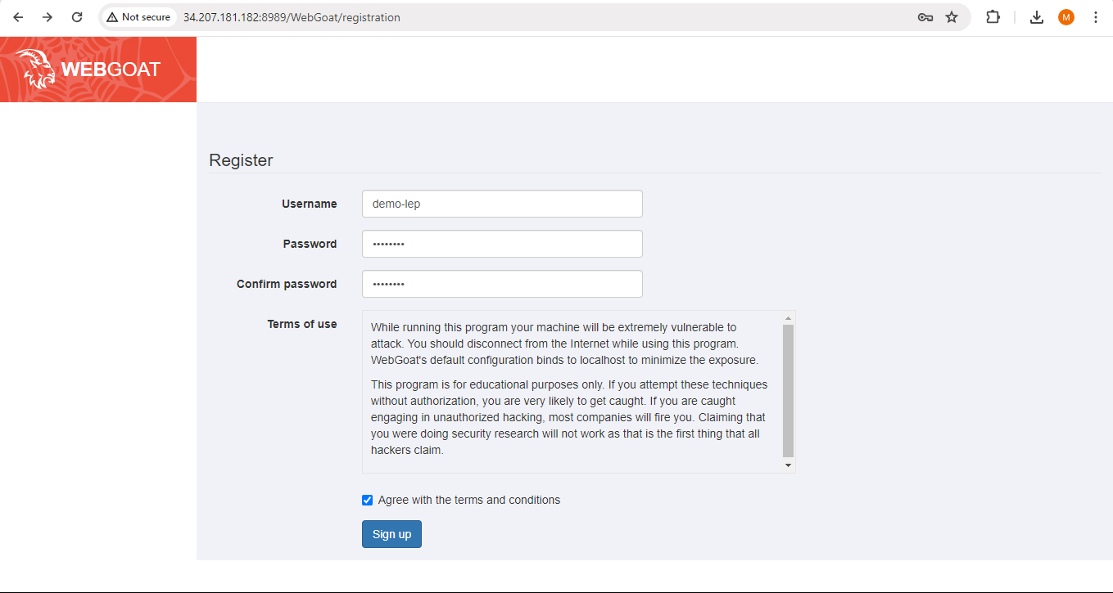

- Click on (A1) Injection

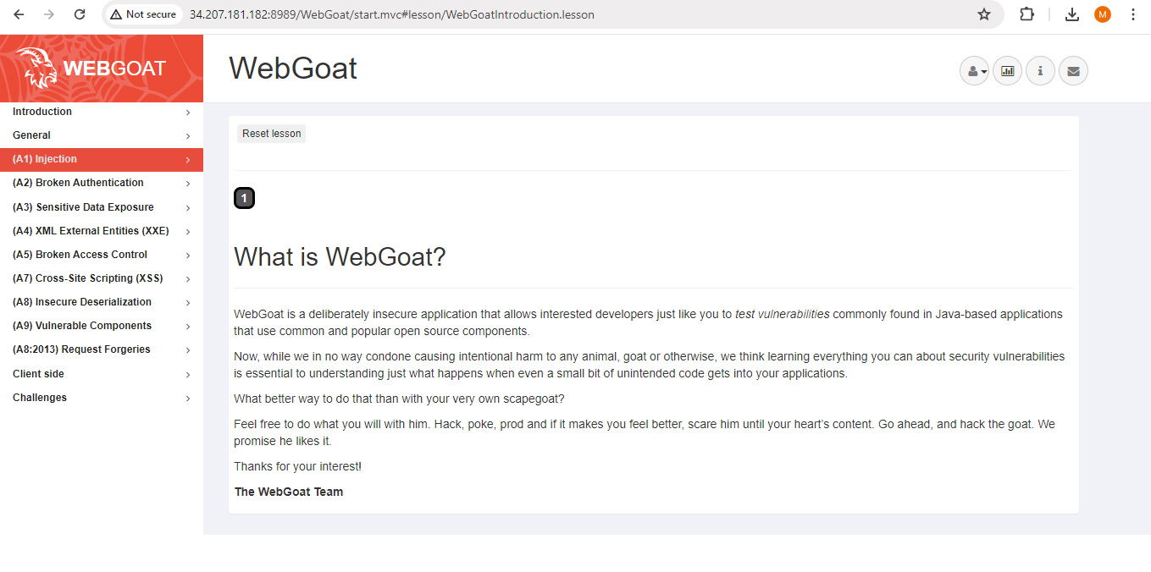

- Click on SQL Injection (intro)

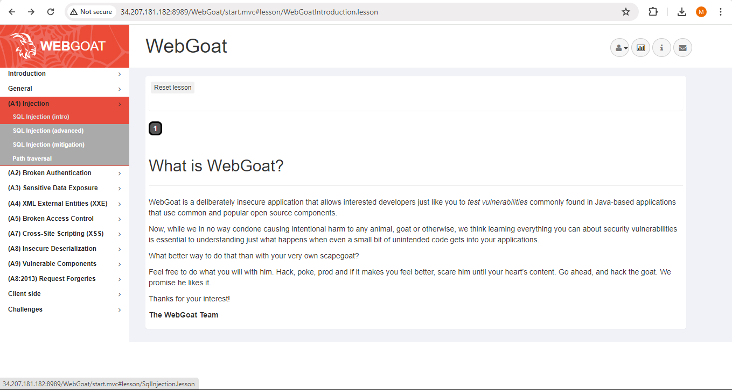

- Select lesson 11 in the SQL Injection

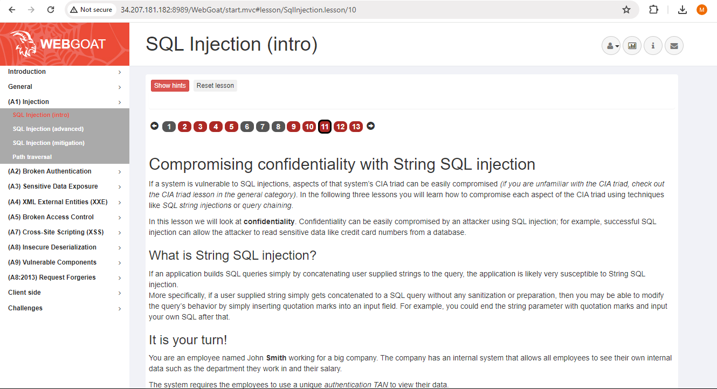

- Scroll down, enter the following text in the Employee Name, and click on the
Get department button
' OR 1=1; --

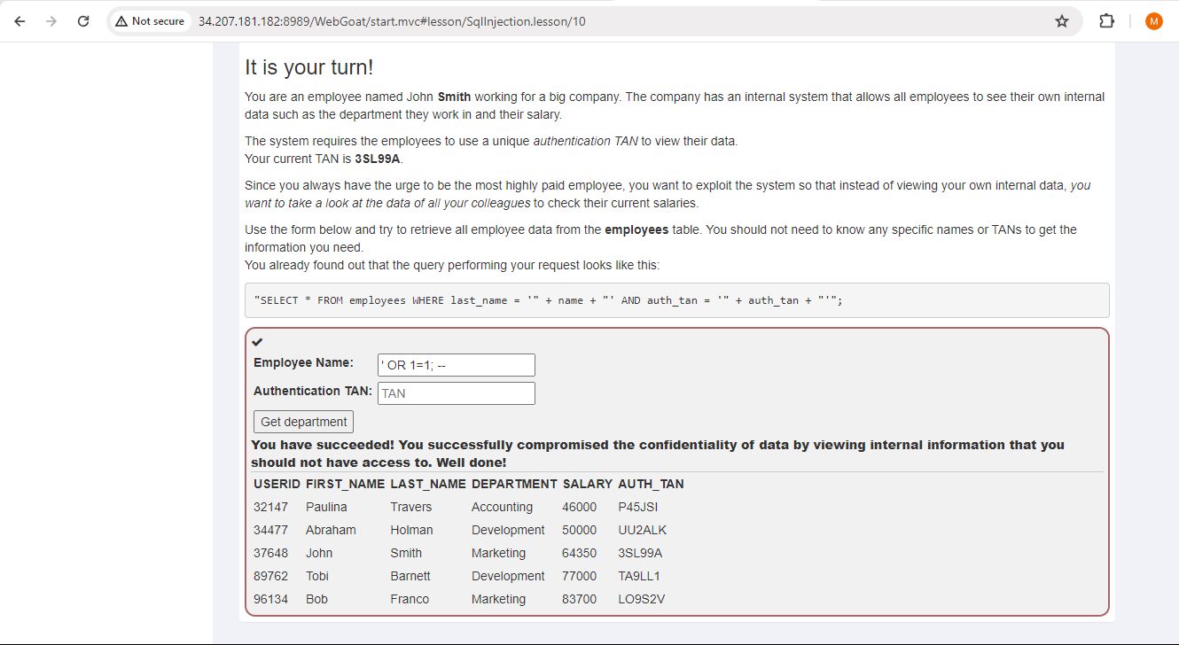

Now, you can see the table data instead of an error indicating the site is vulnerable.

Step 4: Create GitHub repository and set up Actions Workflow

- Sign in to your GitHub account using the following URL:
https://github.com/login

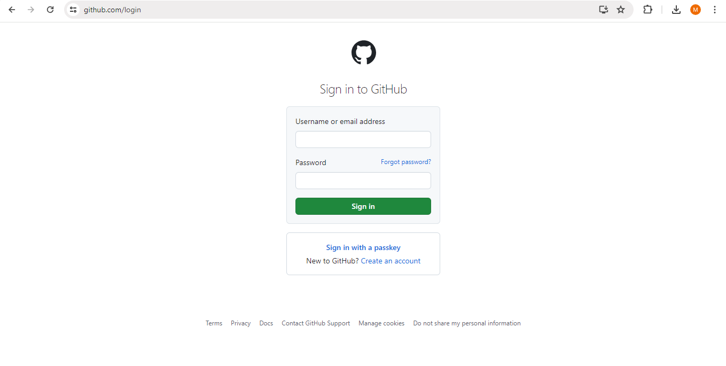

- Click on New repository

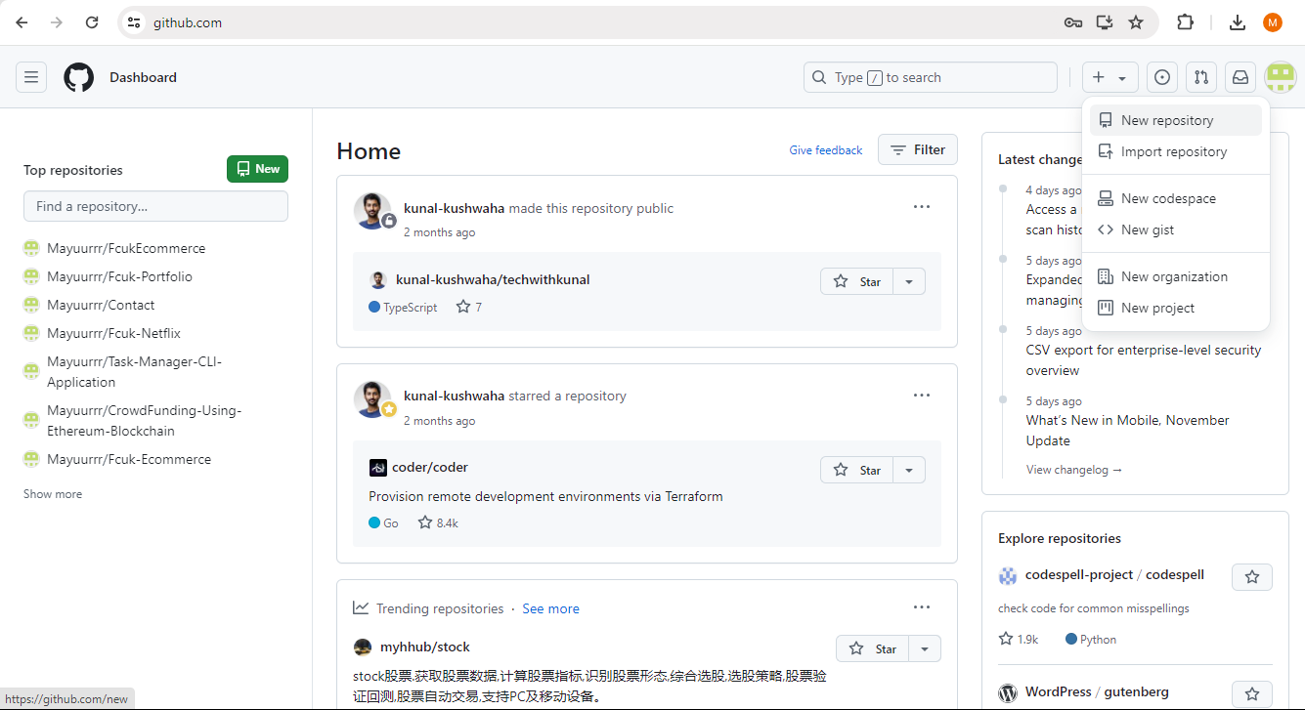

- Enter the repository name as desired

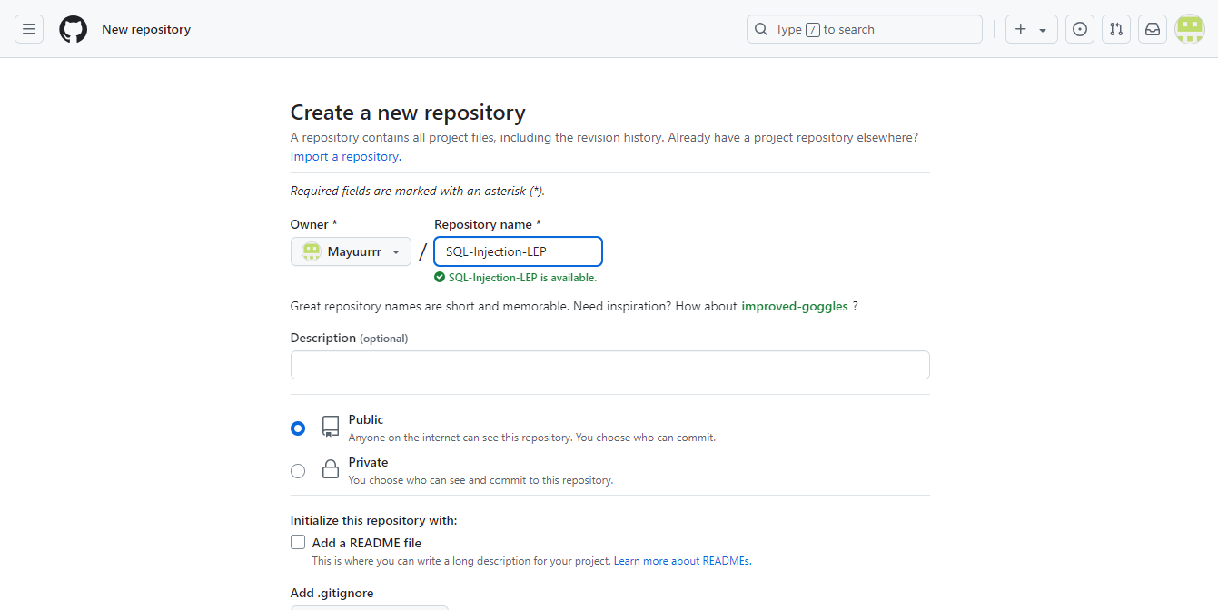

- Scroll down and click on Create repository

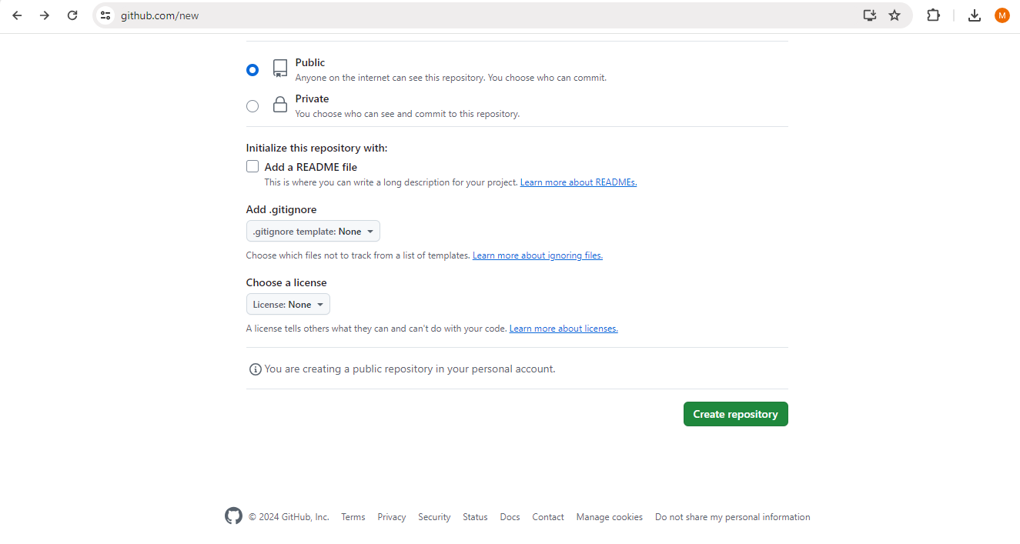

- Navigate to Actions tab

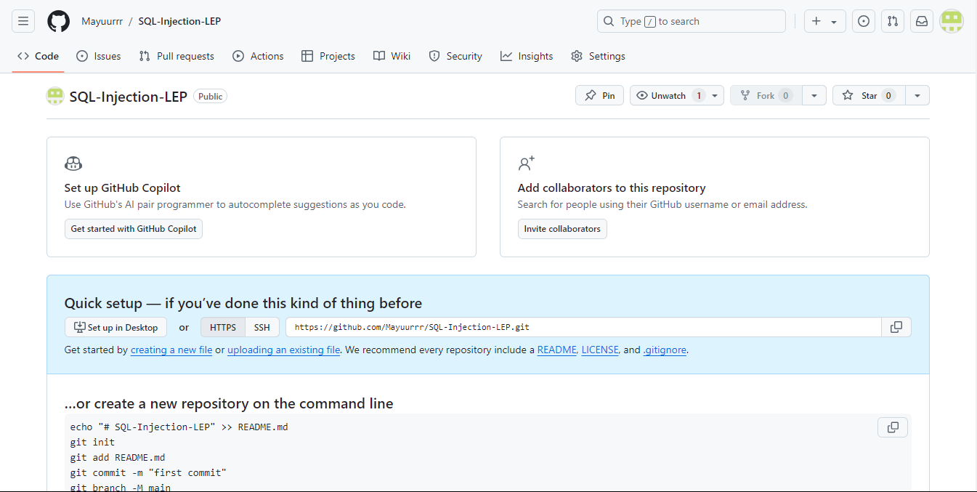

- Click on set up a workflow yourself

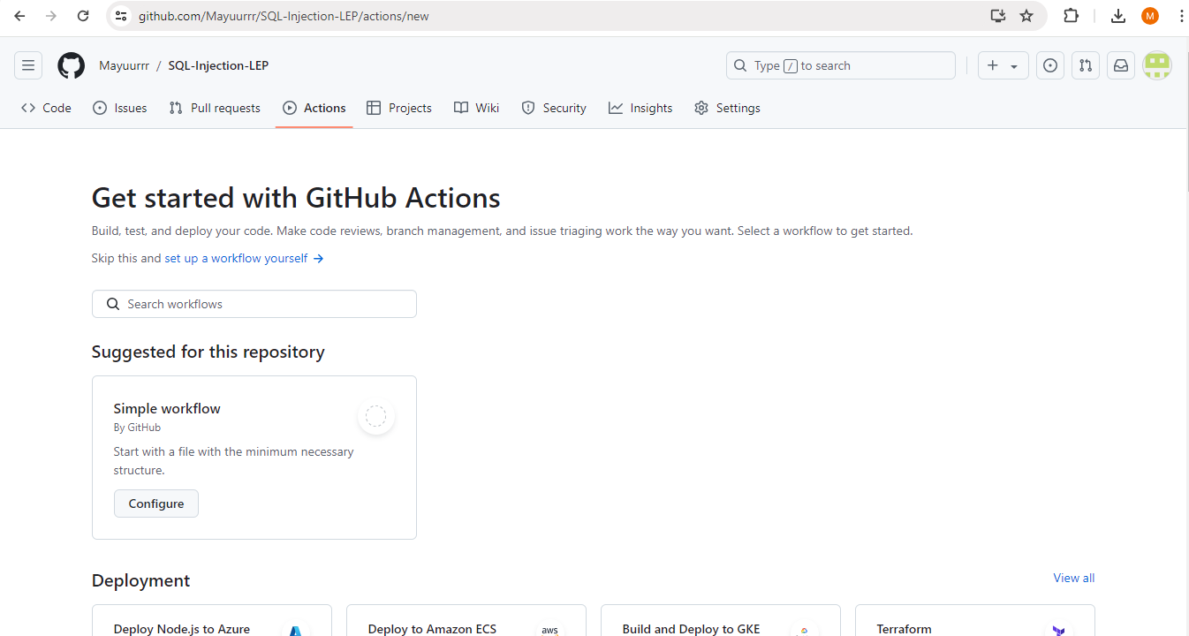

- Paste the code given below in main.yml file and click on Commit changes

name: penetration security scans for sql injection
on: push
jobs:
pen_scan:
runs-on: ubuntu-latest
permissions: write-all
name: Run pen scan on the web application
steps:
- name: ZAP Scan
uses: zaproxy/action-baseline@v0.13.0
continue-on-error: true
with:
token: ${{ secrets.GITHUB_TOKEN }}
docker_name: 'ghcr.io/zaproxy/zaproxy:stable'
target: 'http:// 34.207.181.182/:8989/WebGoat'
rules_file_name: '.zap/rules.tsv'
cmd_options: '-a'

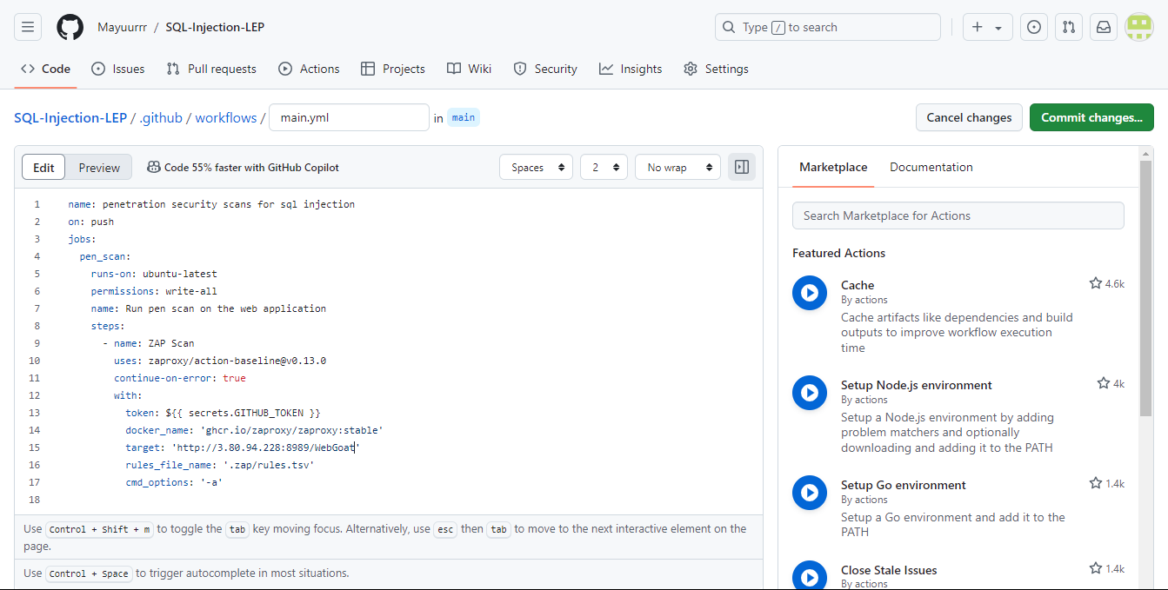

- Click on Commit changes to save the file

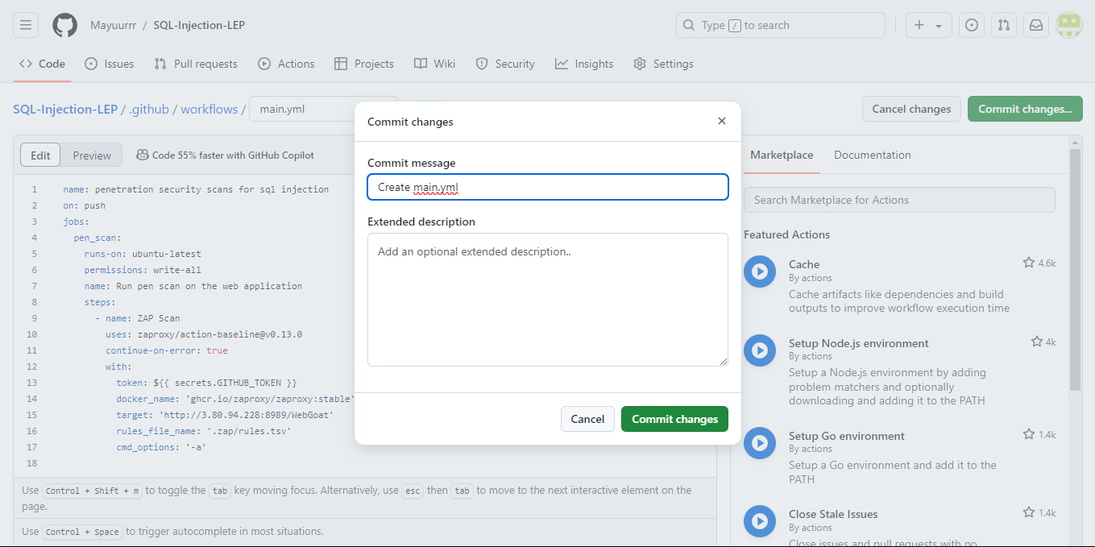

Step 5: Run Workflow and review results

- Navigate to the Actions tab and click on the workflow run created

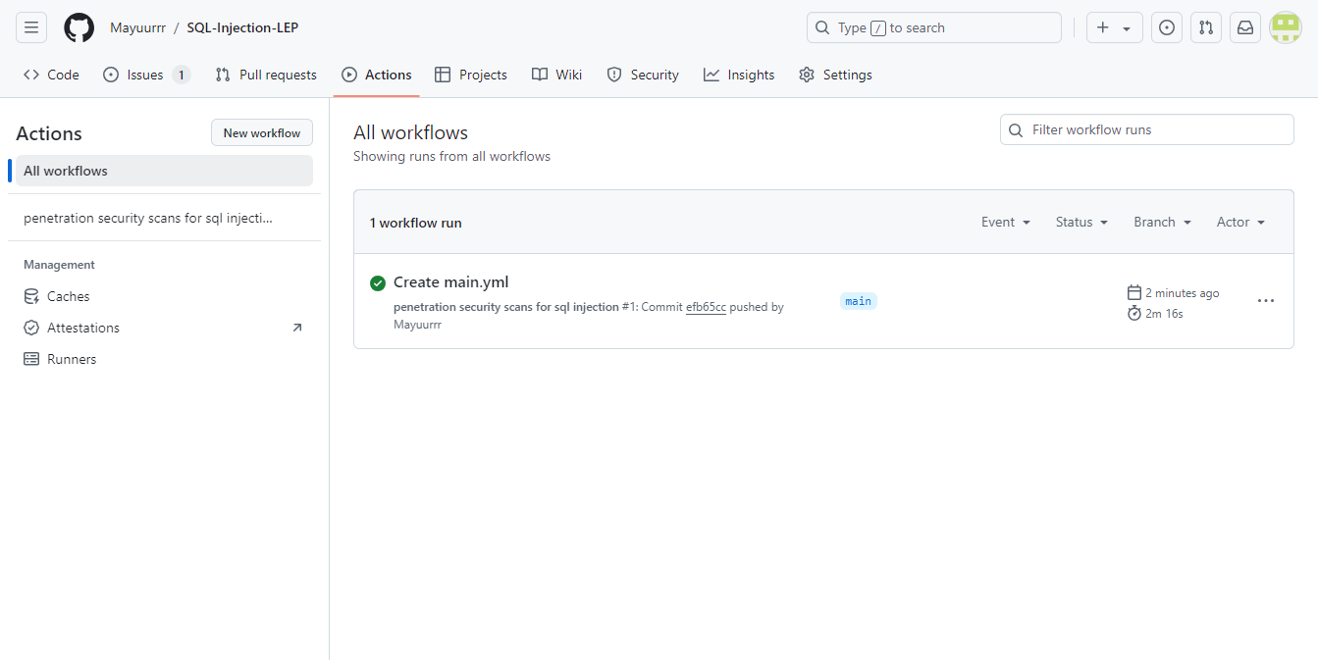

- Click on Run pen scan on the webgoat to view the details of the scan

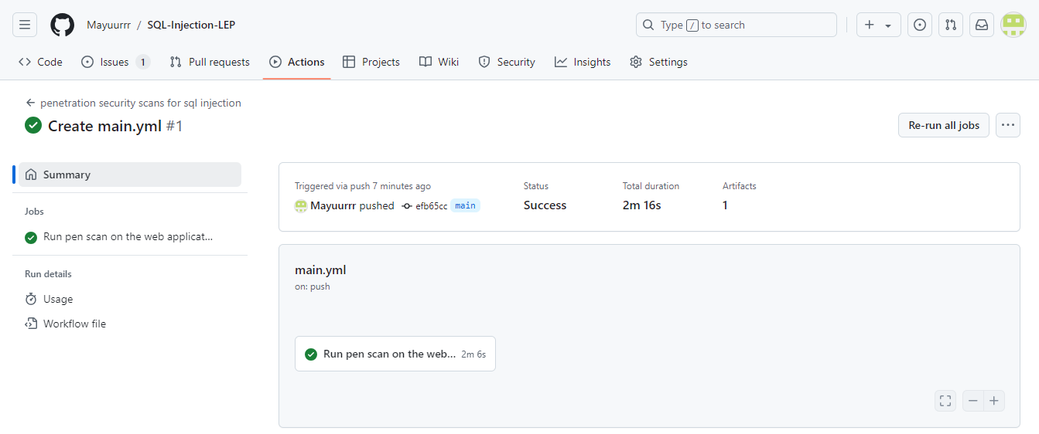

- Click on Set up job to view the run details

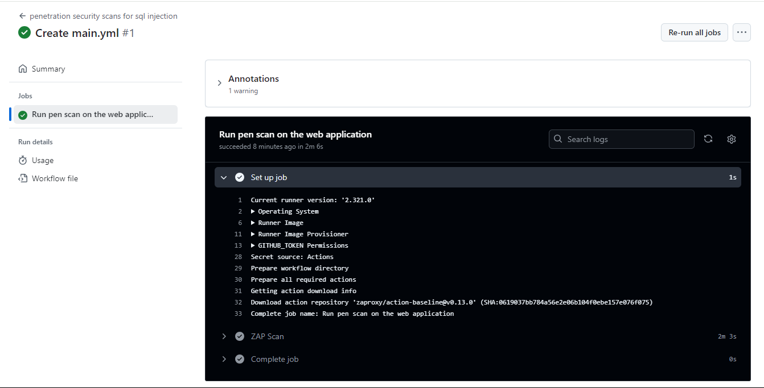

- Click on ZAP Scan to view its complete report

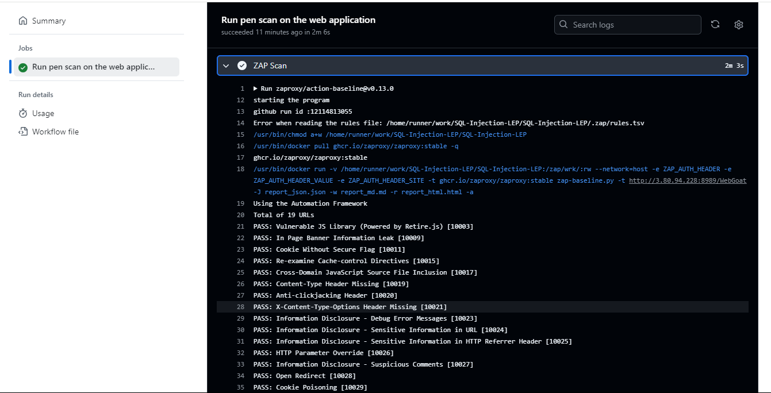

By following these steps, you have successfully set up an EC2 instance, deployed a vulnerable application, tested SQL Injection vulnerabilities, and integrated automated penetration testing using GitHub Actions. This process demonstrates how to identify and address security risks in a DevSecOps pipeline, enhancing application security through continuous monitoring and automation.

