Lesson 03 Demo 02

Configuring AWS Security Hub
Objective: To configure AWS security hub for continuous security monitoring and compliance assessment across AWS accounts and resources

Tools required: AWS Console

Prerequisites: None

Steps to be followed:
- Enable security hub

Step 1: Enable security hub

- Open the AWS Management Console in your practice environment

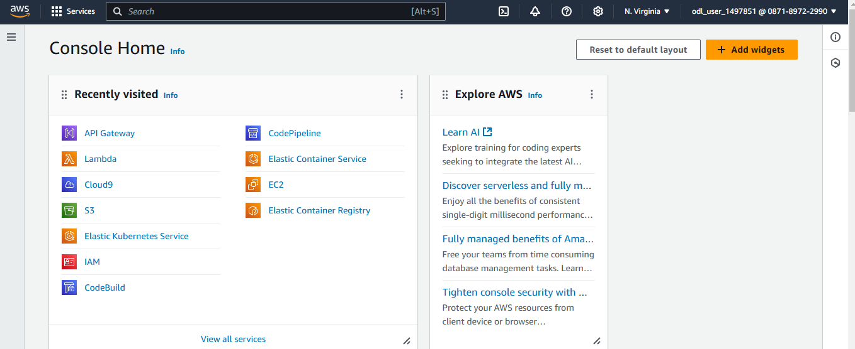

- In the search bar, type Security Hub and select the Security Hub service
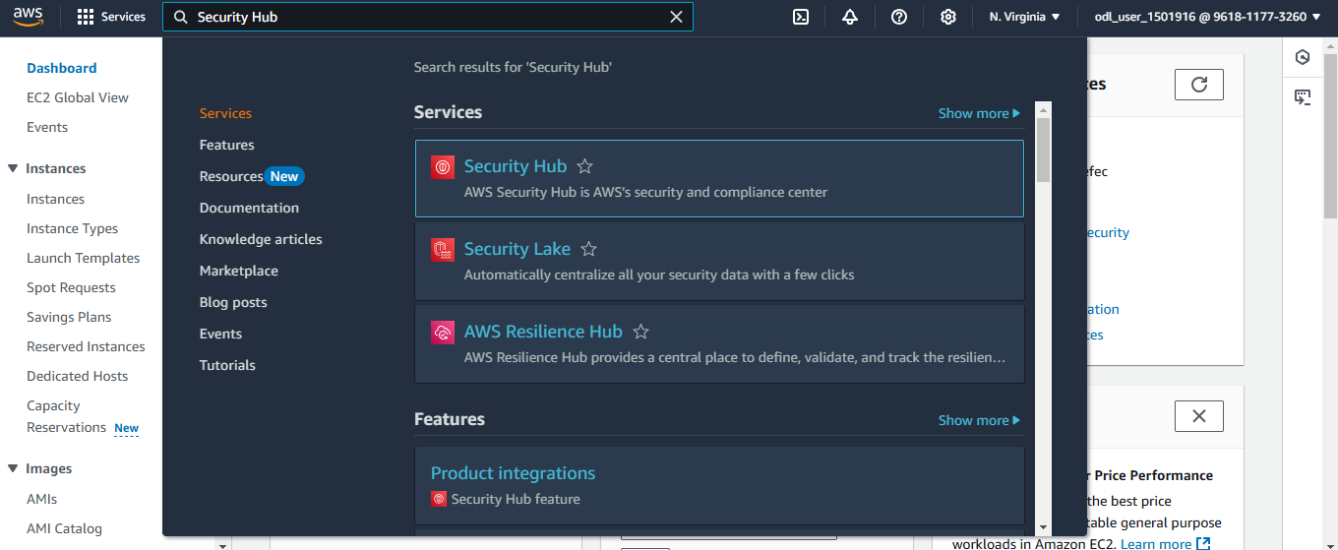
- Click on Go to Security Hub
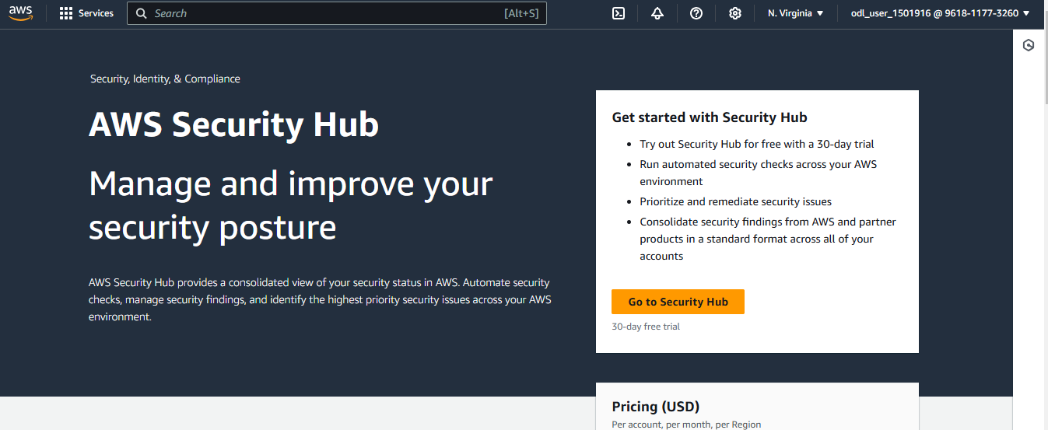
- Enable the required Security standards
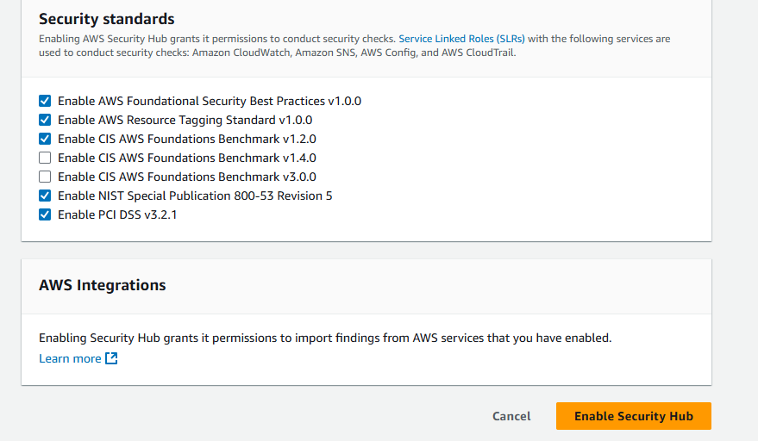
- Click Enable Security Hub to activate the service

- Scroll down and click Next to proceed
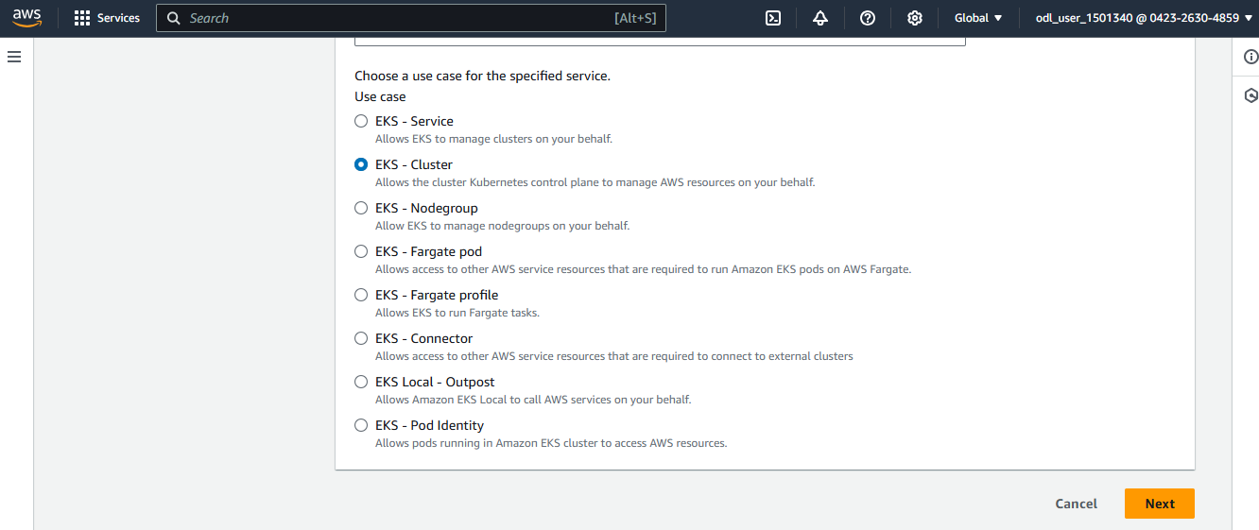
- Select Findings from the Security Hub left panel to review findings management
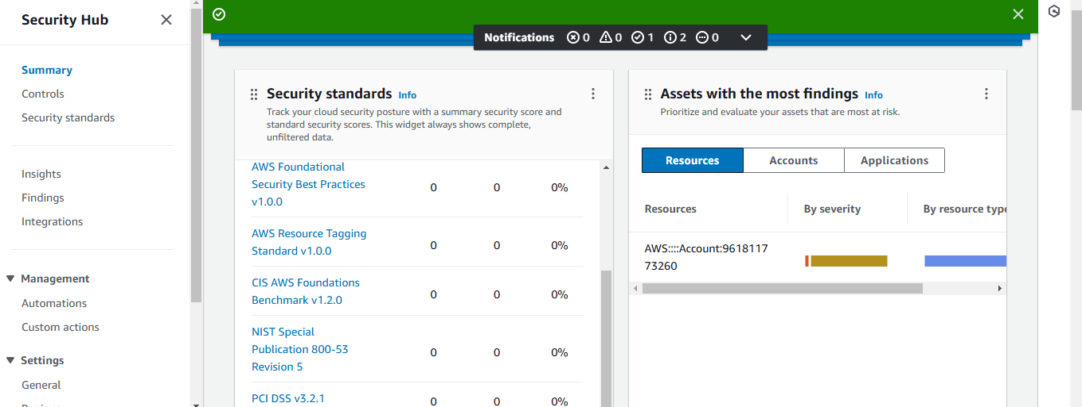
You can see a list of security findings in AWS Security Hub with details such as Finding, Severity, Workflow status, Region, Account ID, and Product.
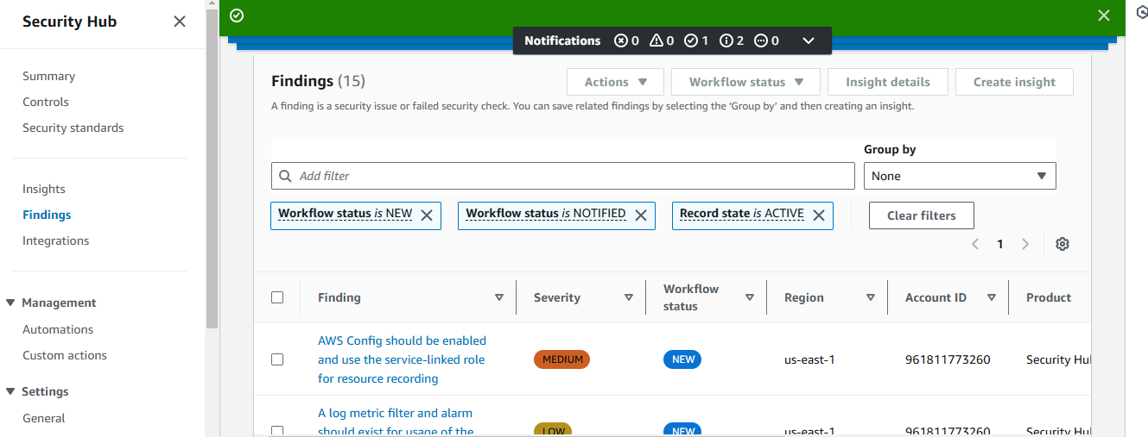
By following these steps, you have successfully configured the AWS security hub, which enables continuous security monitoring and compliance checks to help detect and manage security findings across the AWS environment.

