Lesson 01 Demo 04
Performing DAST Scan on a Running Web Application with
OWASP ZAP

Objective: To configure and execute a DAST scan on a running web application using OWASP ZAP integrated with GitHub Actions for identifying vulnerabilities and ensuring application security

Tools required: GitHub Actions and OWASP ZAP DAST tool

Prerequisites: None

Steps to be followed:
- Configure DAST tool with GitHub Actions

Step 1: Configure DAST tool with GitHub Actions

  - Sign in to your GitHub account using the following URL:
https://github.com/login

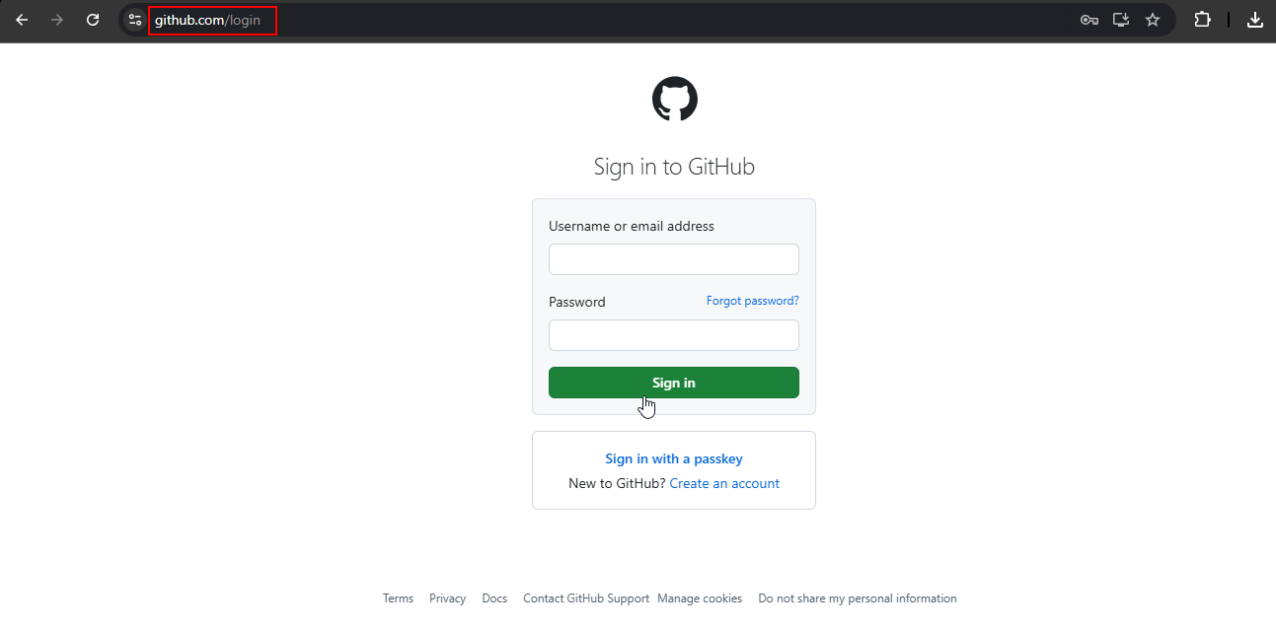

  - Create a repository, add a desired name, and click on the check box to add a README file
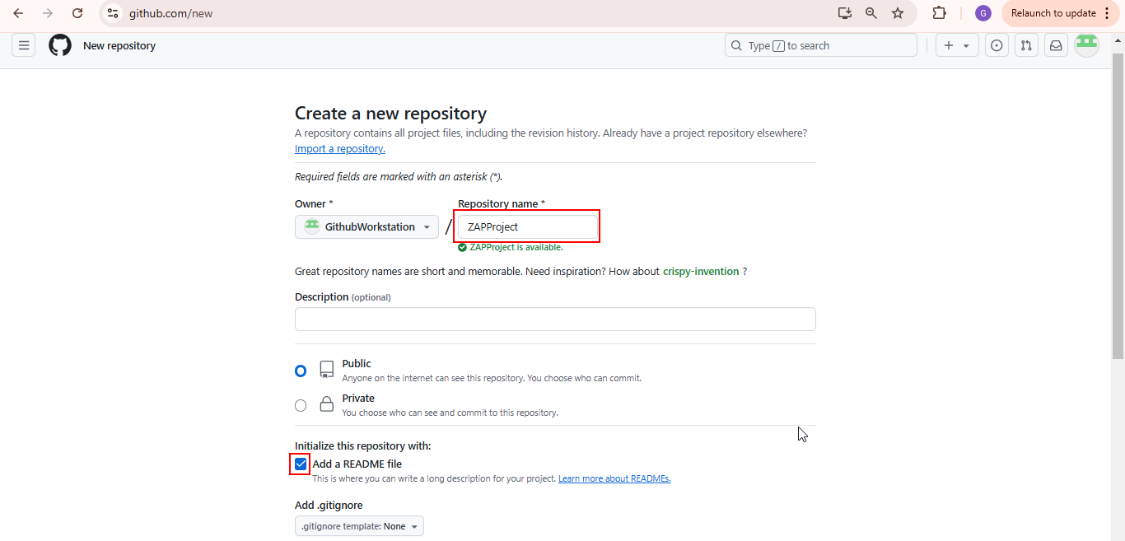
The repository is created successfully as shown below:
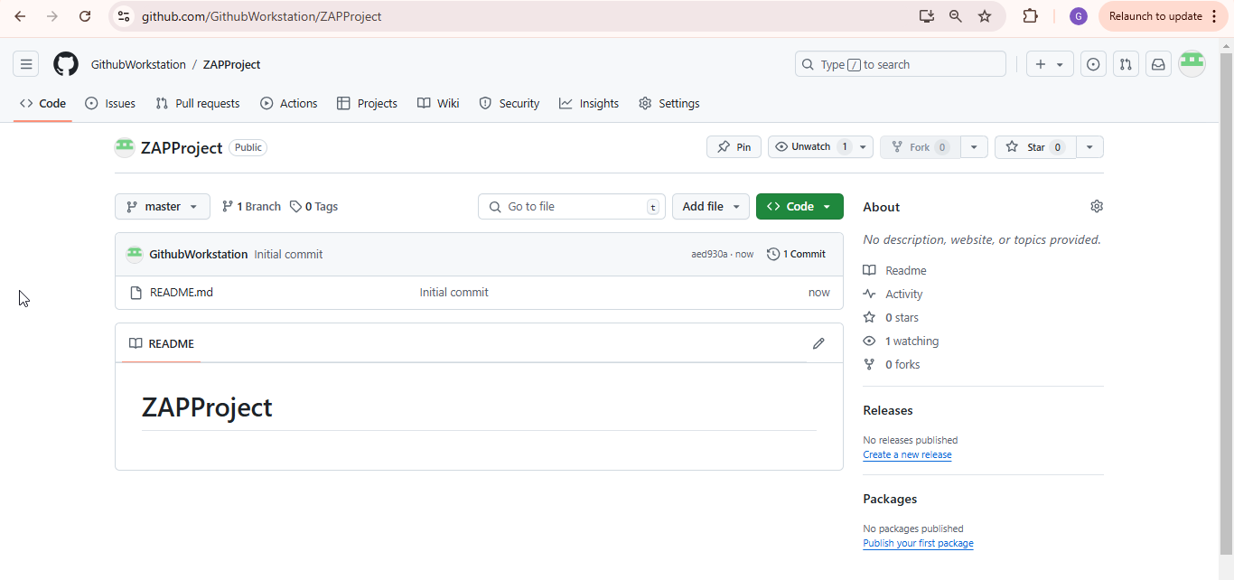

  - Click on the Actions tab
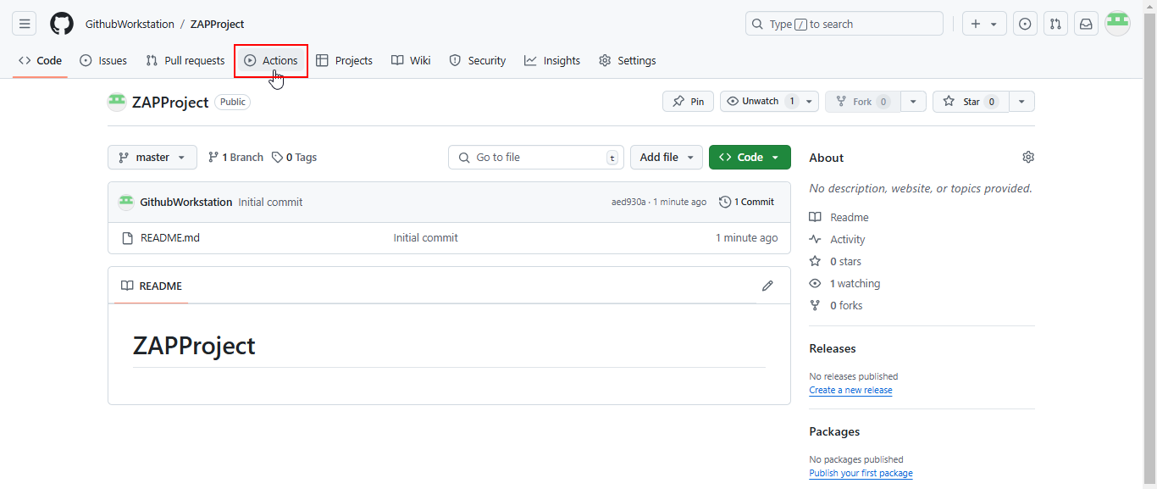
  - Click on Configure in the Simple workflow section
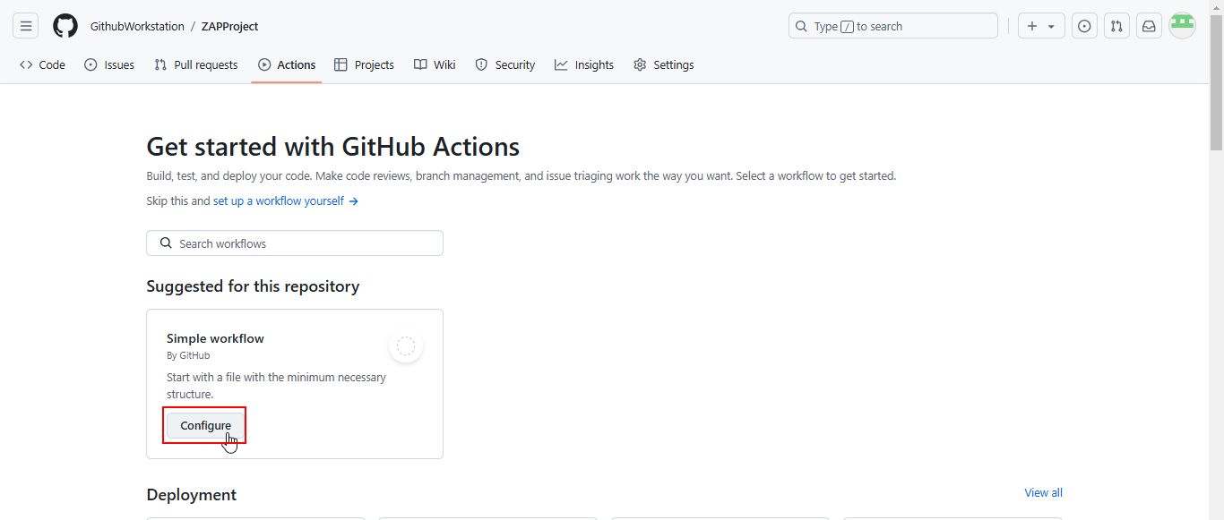
  - Add the following code to the .yml file as shown below:
name: OWASP ZAP Scan

on:
pull_request:
branches:
- main # Trigger ZAP scan on PRs targeting the `main` branch
push:
branches:
- main # Or trigger on push to the `main` branch
workflow_dispatch: # Allow manual triggering of the workflow

permissions:
issues: write

jobs:
zap_scan:
runs-on: ubuntu-latest

steps:
# Checkout the repository
- name: Checkout Repository
uses: actions/checkout@v2

# Set up Python (optional, if your application is Python-based)
- name: Set up Python
uses: actions/setup-python@v2
with:
python-version: '3.8'

# Run ZAP Scan
- name: ZAP Scan
uses: zaproxy/action-baseline@v0.14.0
with:
target: 'https://www.medium.com/'
token: ${{ secrets.GITHUB_TOKEN }}
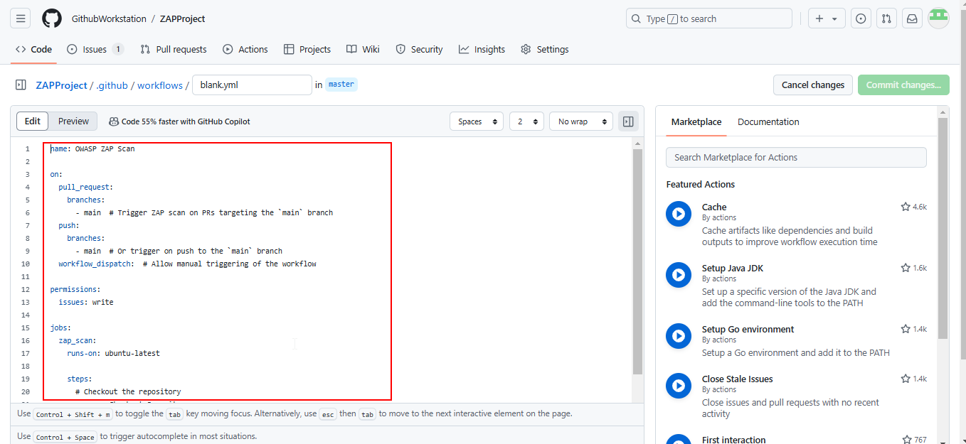
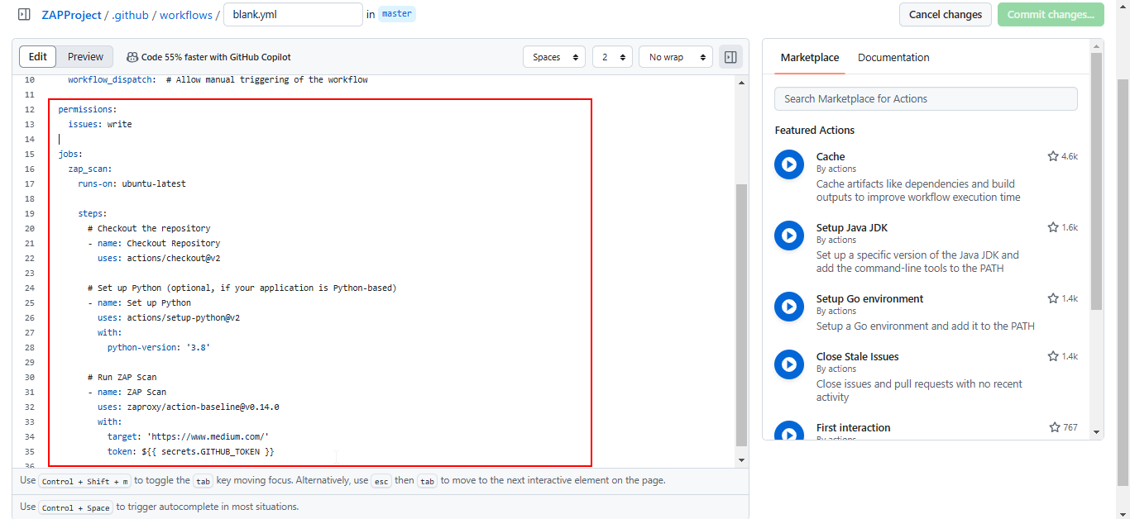
Note: The ZAP Baseline Python script spiders the target URL for one minute and provides scan results for the specified website.

  - Click on the Commit changes… button, add a commit message, and then click Commit changes
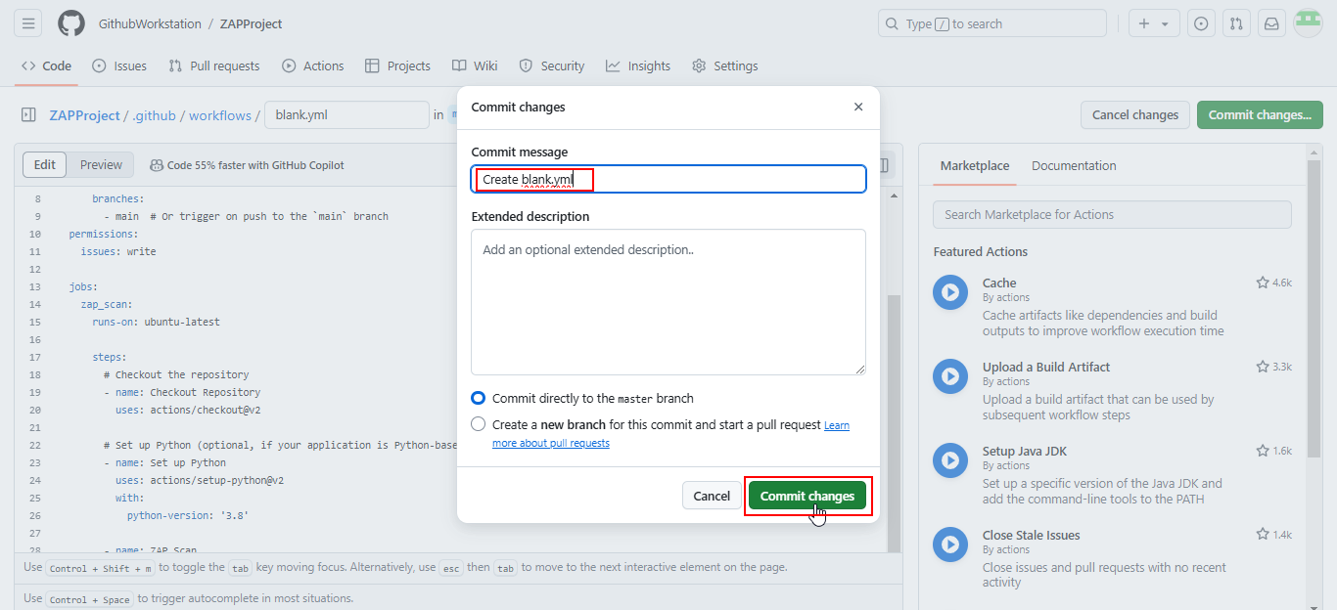

  - Navigate to the Actions tab to view the workflow
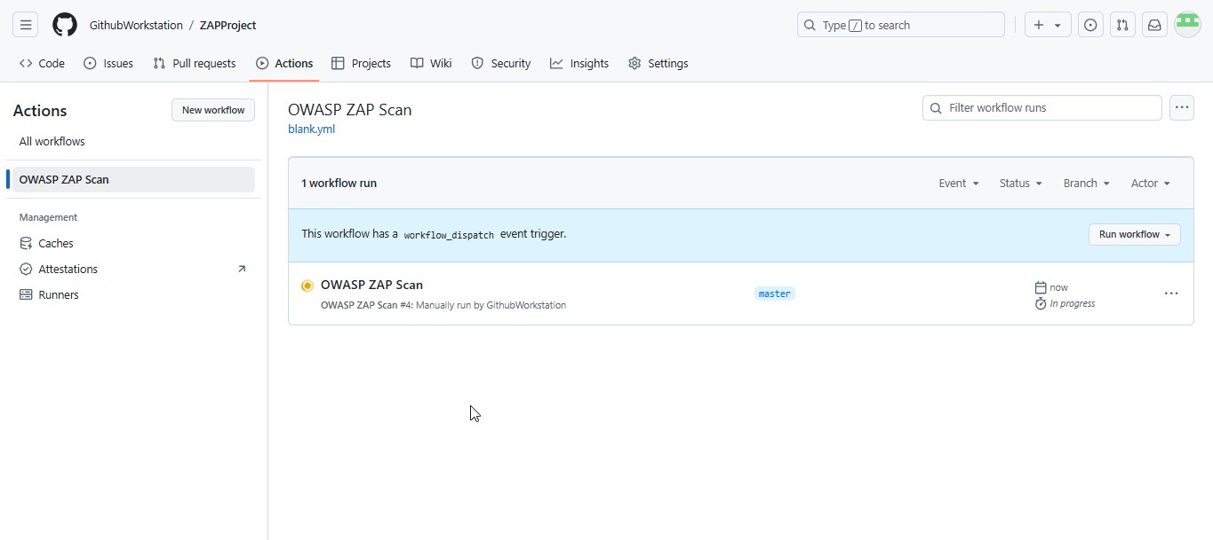
  - Click on OWASP ZAP Scan as shown below:
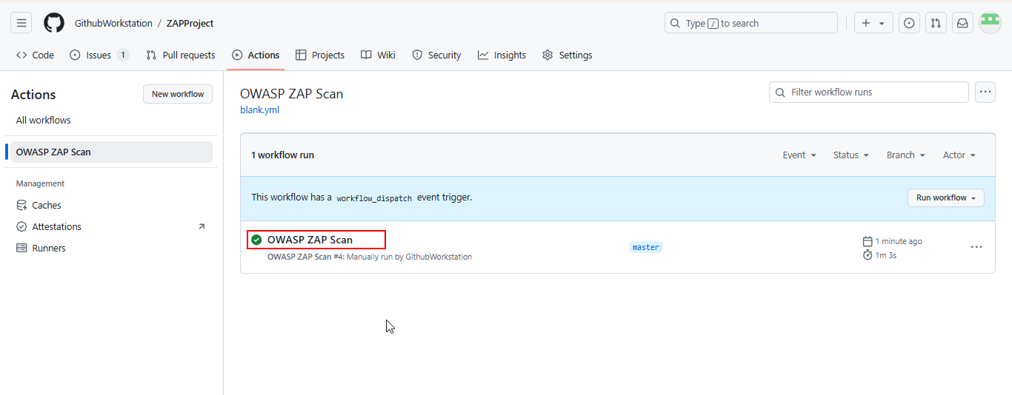
  - Navigate to zap_scan in the Jobs section and view the detailed steps as shown below:
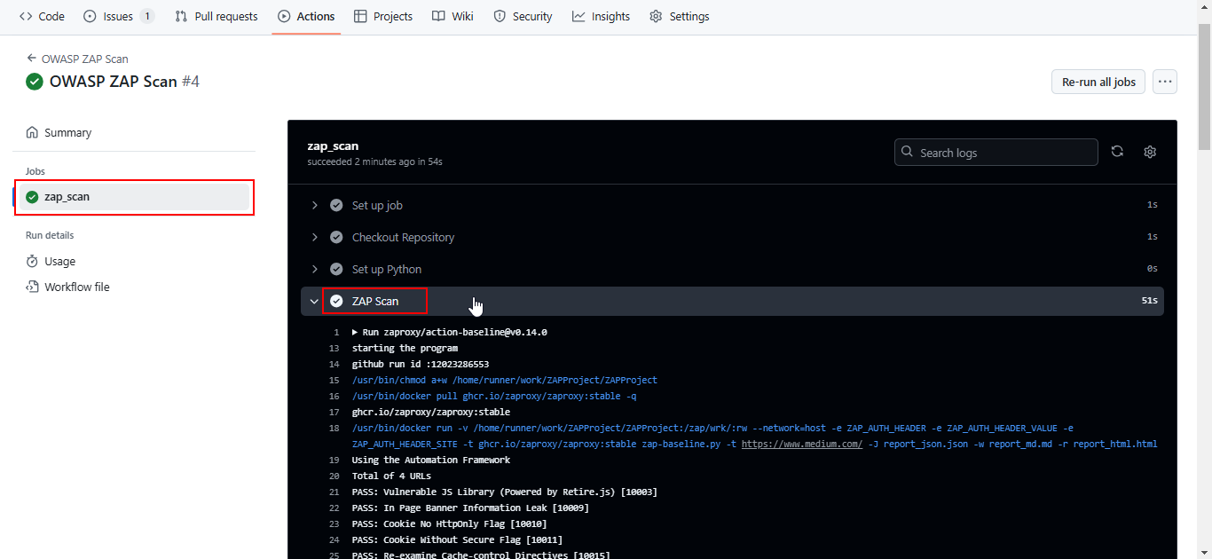
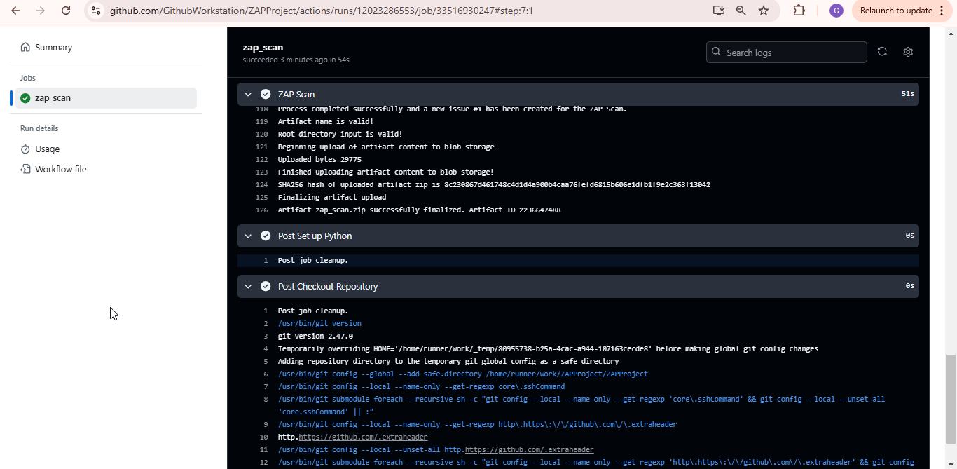
  - Click on Summary
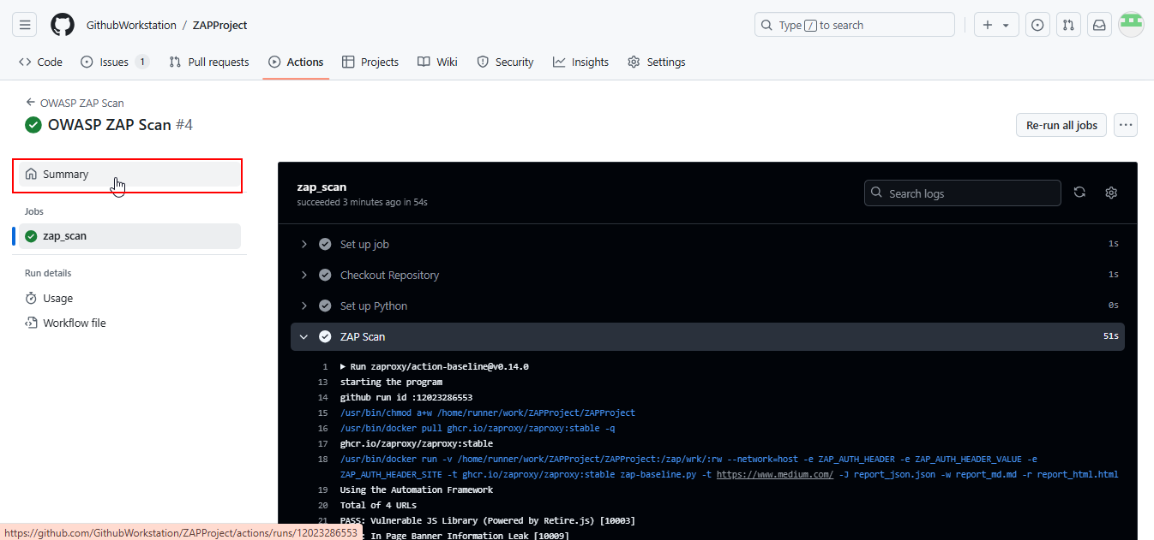
  - Click on the download icon in the Artifacts section as shown below:
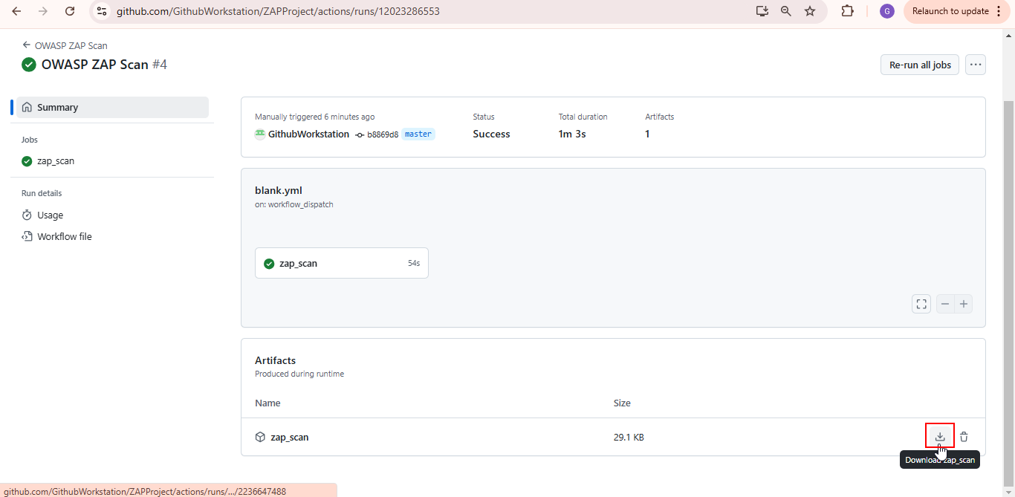
  - Open the downloaded report_html.html file to view the ZAP report as shown below:
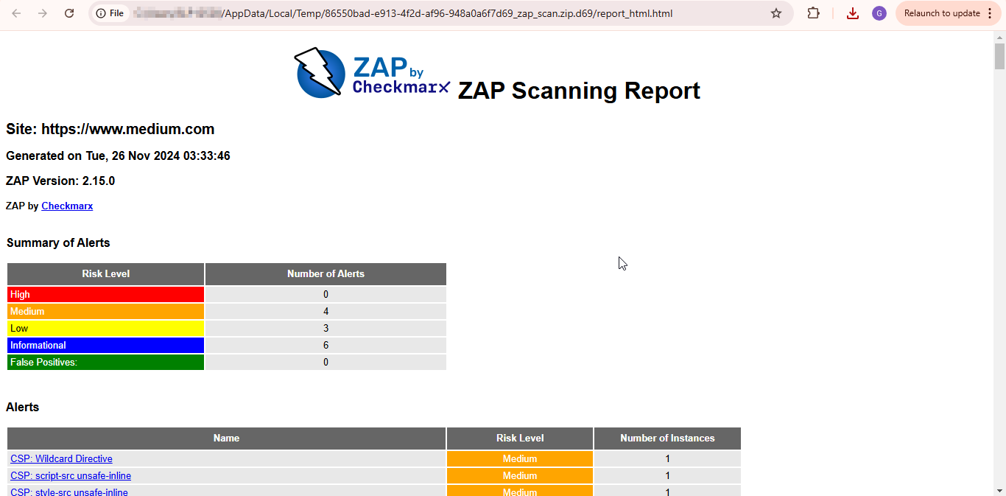
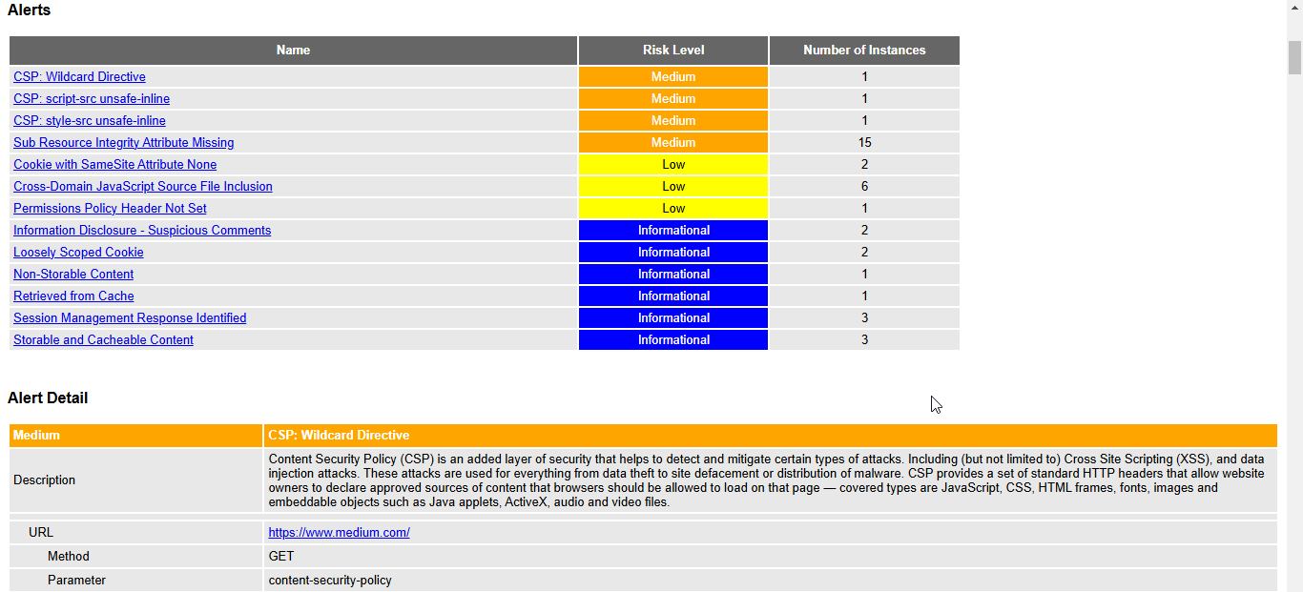

By following these steps, you have successfully configured and executed a DAST scan on a running web application using OWASP ZAP to identify vulnerabilities and enhance security.

