Lesson 01 Demo 01

Implementing DREAD Model
Objective: To implement a DREAD (Damage, Reproducibility, Exploitability, Affected users, and Discoverability) model for assessing and prioritizing security risks, enabling systematic evaluation of vulnerabilities in web applications

Tools required: Python

Prerequisites: None

Steps to be followed:
- Implement the DREAD model using a Python script

Step 1: Implement the DREAD model using a Python script

- Open the AWS Management Console in your practice environment

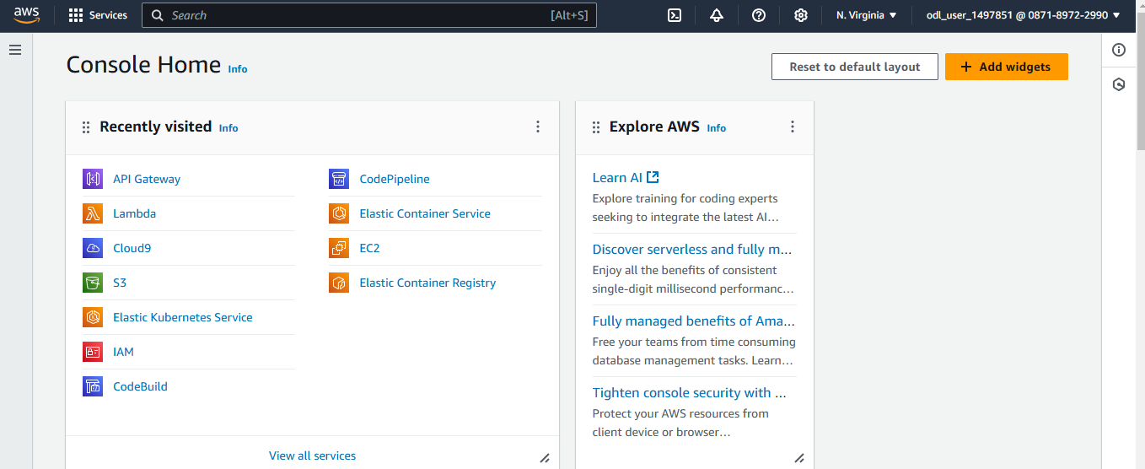

- Click on the cloud shell icon for the terminal
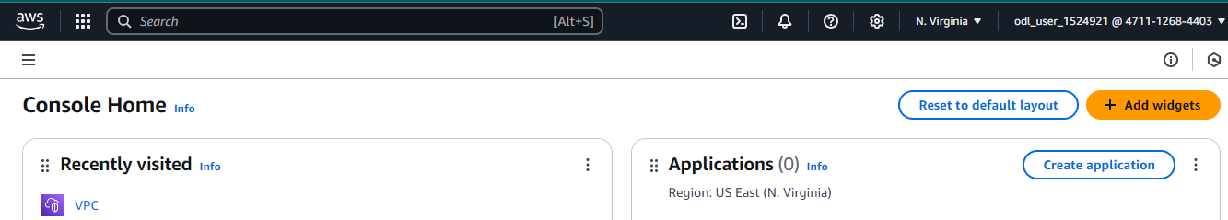
- Run the following command to verify if Python is installed:
python3 --version

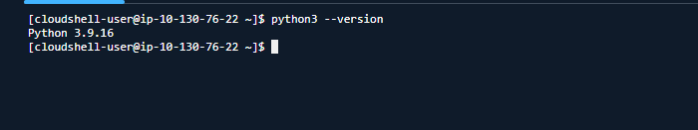
- Execute the following command to create and navigate to the directory:
mkdir python
cd python
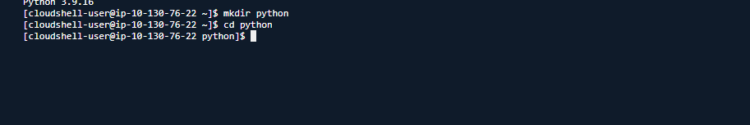

- Run the following command to create a file:
nano dread_model.py
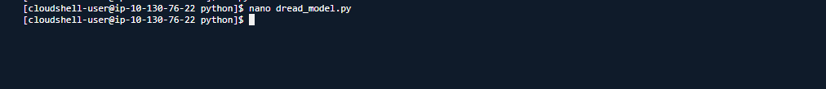

  - Once the file opens, add the code given below, save it, and then exit:
class DREADRiskModel:
def __init__(self, damage_potential, reproducibility, exploitability, affected_users, discoverability):
self.damage_potential = damage_potential
self.reproducibility = reproducibility
self.exploitability = exploitability
self.affected_users = affected_users
self.discoverability = discoverability

def calculate_risk(self):
risk_score = (self.damage_potential + self.reproducibility +
self.exploitability + self.affected_users +
self.discoverability)
return risk_score

def print_risk_assessment(self):
print("DREAD Risk Model Assessment:")
print(f"Damage Potential: {self.damage_potential}")
print(f"Reproducibility: {self.reproducibility}")
print(f"Exploitability: {self.exploitability}")
print(f"Affected Users: {self.affected_users}")
print(f"Discoverability: {self.discoverability}")
print(f"Total Risk Score: {self.calculate_risk()}")

def get_input():
print("Please rate each parameter from 1 (low risk) to 10 (high risk):\n")
damage_potential = int(input("Damage Potential: "))
reproducibility = int(input("Reproducibility: "))
exploitability = int(input("Exploitability: "))
affected_users = int(input("Affected Users: "))
discoverability = int(input("Discoverability: "))
return damage_potential, reproducibility, exploitability, affected_users, discoverability

def main():
print("Welcome to the DREAD Risk Assessment Model.\n")
damage_potential, reproducibility, exploitability, affected_users, discoverability = get_input()
dread_model = DREADRiskModel(damage_potential, reproducibility, exploitability, affected_users, discoverability)
dread_model.print_risk_assessment()

if __name__ == "__main__":
main()
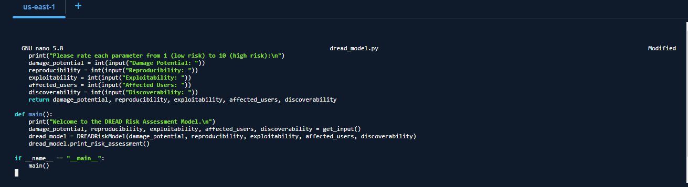
Note: To save and exit the script, use CTRL + O>> press enter>> CTRL + X

  - Once the Python script is created, run it using the following command and follow the prompts to input ratings for the DREAD parameters as shown below:
python3 dread_model.py
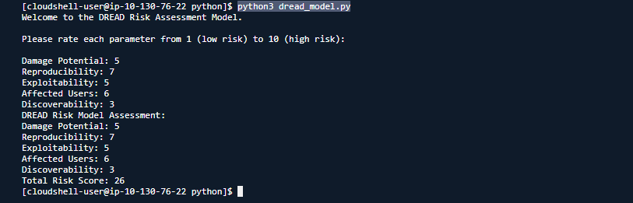

The script displays the total risk score and a detailed risk assessment.
By following these steps, you have successfully implemented a DREAD model for assessing the security risks and enabling systematic evaluation of vulnerabilities in web applications.

